BOARD OF ZONING ADJUSTMENT
November 28, 2023
Pre-meeting – 3:30 p.m. (7th Floor)
Meeting – 4:00 p.m. (Council Chambers)

Table Of Contents
Minutes October 2023 4
AGENDA 11
November 2023 11
CASE NO. 1 504 sOMERVILLE RoaD SE 13
case no. 2 1203 Sherman street se 14
LETTER 15
DIAGRAM 16
WARRANTY DEED 17
WARRANTY 18
case no. 3 2618 briar av sw 19
CERTIFICATE OF OCCUPANCY 20
DENIAL LETTER 21
CASE NO. 4 1809 BELTLINE RD SW 22
VARIANCE REQUEST 23
VARIANCE REQUEST 24
VARIANCE REQUEST 25
LETTER 26
LETTER 27
VARIANCE REQUEST 28
VARIANCE REQUEST 29
VARIANCE REQUEST 30
EXISTING SITE CONDITIONS 31
SITE PLAN 32
VICINITY MAP 33
PROPOSED SITE IMPROVEMENTS 34
VARIANCE JUSTIFICATION PG 1 35
VARIANCE JUSTIFICATION PG.2 36
Variance Results if Approved 37
case no. 5 1209 courtyard cir. sw 38
case no. 6 1626 runnymead av sw 39
Picture 40
Picture 41
Picture 42
Picture 43
Picture 44
Picture 45
Picture 46
Picture 47
Picture 48
Sign Permit 49
Letter 50
Picture 51
Picture 52
Picture 53
Picture 54
Picture 55
CASE NO. 7 2030 BELTLINE RD 56
Picture 57
Picture 58
Picture 59
SIGN PERMIT APPLICATION 60

Minutes October 2023

MEMBERS PRESENT: Delayne Dean, Mr. Brad Townson, Mr. Chester Ayers,

SUPERNUMERARIES: Mr. Mike Maurer, Mr. Mark McCurry

COPIED TO: Mr. George Allen

OTHERS PRESENT: Mrs. Ruth Priest, Asst. City Attorney
Mr. Chris Stone, Planning Department
Mr. Bob Sims, Building Inspector
Mrs. Nancy Whiteside. Recorder

Chair, Delayne Dean called the meeting to order at 4:00 p.m. in the council chambers on the first floor at City Hall.

Mr. Bob Sims, Building Department, called the roll.

The minutes from the September 2023 meeting were approved. Mr. Brad Townson motioned to approve the minutes Mr. Chester Ayers seconded the motion. On a voice vote, the motion carried.

CASE NO. 1

Application and appeal of Tressia Jones for a determination as allowed in Section 25-93 (b) and as defined in Article IV, as amended and adopted, of the Zoning Ordinance in order to operate a Group Nighttime Care Facility operating. The property is located at 620 Pumpkin Dr. SW in a R-2 Single-Family Residential District.

Ms. Tressia Jones presented this case to the Board. Ms. Jones stated her name was Tressia Jones and her address was 620 Pumpkin Dr. SW.

Ms. Jones stated she currently operates a daycare at her home and she would like to be able to operate the daycare with twelve children at a time and also be able to keep six children overnight.

Chair Dean, explained to Ms. Jones that this Board could not approve her to care for twelve children during the day because of the zoning where she lived.

Brad Townson explained to Ms. Jones the zoning for her address would allow for twelve children only after school hours and up to 7 p.m.

Mr. Townson explained to Ms. Jones after 7 p.m., under the Group Daycare description, only six children were allowed, Ms. Jones stated she understood.

Chair Dean again explained the rules for a Group Daycare under the R-2 zoning, Ms. Jones understood.

Chair Dean asked for questions from the Board or the public, there were no comments.

Mr. Bob Sims, Building Department, had no comments.

Mr. Chris Stone, Planning Department, had no comments.

Chair Dean closed public comments and presented this case to the Board for its ruling.

Mr. Brad Townson motioned to approve this case as submitted. Mr. Mark McCurry seconded the vote. On a roll call vote the motion carried.

CASE NO. 2

Application and appeal of Barry Strong/ Saint Andrew Church for a 4.1 foot front yard setback variance from Section 25-10 (2) (c) (1) of the Zoning Ordinance in order to install a building located at 105 Memorial Dr. NW. The property is located in a R-4 Multifamily Residential District.

Mr. Barry Strong presented this case to the Board. Mr. Strong stated he was representing Saint Andrew’s Church.

Mr. Strong stated that he and his wife, Demetri Strong, started a daycare center to help the youth in the community.

Mr. Strong stated as the daycare grew more space was needed and a modular building was purchased and placed on the property.

Mr. Strong stated the original daycare and the church sits approximately sixteen feet from the property line.

Mr. Strong stated that the property next door was also owned by them and that is where the new modular building was placed and that it is sitting twenty-one feet further back from the road line than the church and the original daycare.

Mr. Strong stated that the requirement for placing the modular building was twenty-five feet back from the property line and the building was placed twenty-one feet leaving a four foot difference.

Mr. Strong stated that the church and the existing daycare is sixteen feet from the road.

Mr. Strong stated he was asking for permission to operate in order for the older children to have an activity center with a bigger room and making it easier bringing infants in and out of the building protecting them better from the elements.
Mr. Strong asked the Board to help, so children were able to participate in the programs.
Chair Dean asked Mr. Strong to sign the permit application, Mr. Strong signed.

Chair Dean asked for questions from the Board.

Mr. Brad Townson verified that the new building is further away than what the existing building is, Mr. Strong agreed.

Chair Dean asked for further questions from the Board or the public, there were no more comments.

Mr. Bob Sims, Building Department, told Mr. Strong that the signs that are located on the corner for the People’s Market, the daycare the signs on the building, the Lovelace Heating and Air none of the signs had permits and all of the signs are in violation.

Mr. Bob Sims, Building Department, told all of the signs which are located on the fence cannot be permitted because they are considered to be off premises signs and they all need to be removed.

Mr. Bob Sims, Building Department, told Mr. Strong that the sign on the building could stay on the building if a permit is purchased for the sign.

Mr. Bob Sims, Building Department, explained to Mr. Strong that the sign for the daycare could only be placed right in front of the daycare.

Mr. Bob Sims, Building Department, explained to Mr. Strong that there could not be any signs on the fence because there is not a building located there.

Mr. Strong stated he would remove the signs but that the signs had been there for about fifteen years without anyone bringing that violation to his attention.

Mr. Strong stated he would not do anything in violation toward the city if he is aware of it and if someone would have let him know this was a violation he would have corrected the problem.

There was further discussion between Mr. Sims and Mr. Strong about a few of the signs.

Mr. Strong stated he would take down all of the signs and thanked Mr. Sims.

There was no further comment from the Building Department.

Mr. Chris Stone, Planning Department, had no comment.

Chair Dean closed public comments and presented this case to the Board for its ruling.

Mr. Mark McCurry motioned to approve this case as submitted. Mr. Mike Maury seconded the motion. On a roll call vote the motion carried
CASE NO. 3

Application and appeal of Trav-Ad- Signs for a 186 square foot variance from Section 25-77(e) (2) in order to install building signs consisting of two sets of 45 inch illuminated channel letters in order to be seen from the highway. The property is located at 23366 Bibb Garrett Rd, Tanner Al. 35761 in a M-1 Light Industrial Zoning District.

Mr. Ken Comer presented this case to the Board.

Mr. Comer stated he worked for Trav-Ad Signs out of Huntsville.

Mr. Comer stated Trav-Ad has been contracted to install signs for Inline Electric on Bibb Garrett Rd.

Mr. Comer stated Inline Electric is leasing approximately 250 linear feet of warehouse space and the larger letters are needed to be seen from Interstate 65.

Mr. Comer stated there is not any adverse effects on visibility because of the distance from the Interstate 65.

Mr. Comer stated the allowance of 150 square feet would make the letters be a readable height from Interstate 65.

Chair Dean asked for questions from the Board and the public, there were no comments.

Mr. Bob Sims, Building Department, had no comment.

Mr. Chris Stone, Planning Department, had no comment.

Mr. Chester Ayers motioned to approve this case as submitted. Mr. Mark McCurry seconded the motion. On a roll-call vote the motion carried.

CASE NO. 4

Application and appeal of Peyton Morris for a 26 foot rear yard setback variance from Section 25-10.10 (2) (d) of the Zoning Ordinance in order to build an attached garage located at 213 Cherry St NE. The property is located in a R3-H Historical Single Family Residential Zoning District.

Mr. Peyton Morris with Morris General Contractors presented this case to the Board. Mr. Morris stated his name was Peyton Morris and his address is 5519 Indian Hills Rd. Mr. Morris stated he was representing Joseph and Alicia Ryan of 213 Cherry St. NE.

Mr. Morris stated a twenty-six foot rear yard setback was being requested in order to build an attached garage.
Mr. Morris stated that the previous owner had enclosed the original garage for additional living space resulting in there not being enough space to build another garage.

Chair Dean stated to Mr. Morris that approval from the Historical Board would be needed before any construction work could begin, Mr. Morrris understood.

Chair Dean asked for questions from the Board or the public, there were no comments.

Mr. Bob Sims, Building Department, had no comments.

Mr. Chris Stone, Planning Department, had no comments.

Mr. Mark McCurry motioned to approve this case as submitted. Mr. Brad Townson seconded the motion. On a roll-call vote the motion carried.

CASE NO. 5

Application and appeal of Bruce Causey for Calhoun Community College for a 314 square foot area variance in order to install a new digital 23 foot by 18 foot sign. The property is located at 6250 US Highway 31, Tanner Al. The property is located in a I-D Institutional District.

Mr. Bruce Causey presented this case to the Board. Mr. Causey stated he was the Facility Director at Calhoun Community College (Calhoun).

Mr. Causey showed pictures of the sign that is currently located at Calhoun and described the dimensions of the sign and stated the current sign was not working and wanting to replace it with a larger sign.

Chair Dean asked Mr. Causey what the dimensions of the sign, including the existing brick base, would be with the new sign.

Mr. Causey stated the new sign would be approximately 330 square feet including both sides of the sign.

Mr. Causey stated that including the bottom of the brick base the sign would be approximately 26 square feet.

Chair Dean, verified the new sign would not extend out any further than what is currently there at this time. Mr. Causey agreed.

Chair Dean verified just the screen size would be larger, Mr. Causey agreed.

Chair Dean verified the size needed was fifteen by twenty-two not the advertised size twenty-three by eighteen, Mr. Causey agreed.

Chair Dean asked for questions from the Board or the public, there were no comments.
Mr. Bob Sims, Building Department, had no comment.

Mr. Chris Stone, Planning Department, had no comment.

Mr. Chester Ayers motioned to approve this case as submitted. Mr. Mark Mcurry seconded the vote. On a roll call vote the motion carried.

CASE NO. 6

Application and appeal of Champion of Decatur for a 11.5 foot setback variance from Section 25-77 (e) (3) of the Zoning Ordinance in order to move a pylon so traffic flow will not be impacted when coming off Highway 31 South. The property is located at 3831 Highway 31 South in a B-2 General Business District.

Mr. Nathan Tomberlin with the Civil Engineering Firm Pugh, Wright and McAnally, Inc. presented this case to the Board.

Mr. Tomberlin stated he was representing Champion of Decatur.

Mr. Tomberlin stated Champion of Decatur was asking for an eleven and a half by twelve foot setback variance for an existing sign that needs relocated due to a driveway realignment that was required by ALDOT (Alabama Department of Transportation).

Mr. Tomberlin explained that Champion of Decatur recently annexed into the city causing the signage to not meet the current ordinance.

Mr. Tomberlin stated the sign is being moved back as far as it can be moved without encroaching into the existing drive aisles and asphalt.

Mr. Tomberlin stated the same sign which is currently there will be used and a new footer will be added when the sign is moved.

Chair Dean verified the orientation of the sign.

Mr. Tomberlin stated the orientation of the sign would stay the same as originally designed making the sign more aesthetically pleasing.

Mr. Tomberlin stated with the flag facing outward the sign will be eighteen and a half feet from the right of way and currently the sign is approximately eleven feet from the right of way.

Chair Dean asked for question from the Board or the public, there were no comments.
Mr. Bob Sims, Building Department, had no comments.

Mr. Chris Stone, Planning Department, had no comments.

Mr. Brad Townson motioned to approve this case as submitted. Mr. Mark McCurry seconded the motion. On a roll-call vote the motion carried.

CASE NO. 7

Application and appeal of Maria Hernandez and Martin Gutierrez for a 10 foot lot width variance from Section 25-10.9 (2) (f) in order to create three new lots at 2314 and 2318 Spring Ave. SW. The properties are located in a R-2 Single Family Zoning District.

Mr. Chester Ayers motioned to dismiss this case when no one came forward present the case to the Board. Mr. Brad Townsend seconded the motion. On a roll call vote the motion passed.

New Business:

Motion was initiated by Brad Townson to cancel the December 26, 2023 meeting. Mr. Mark McCurry seconded the motion. On a roll-call vote the motion carried.

Meeting adjourned at 4:22 p.m.

_________________________
DeLayne Dean, Chair

AGENDA

November 2023

The Board of Zoning Adjustment of the City of Decatur will hold a public meeting in the COUNCIL CHAMBERS ON THE FIRST FLOOR OF City Hall, 402 Lee Street NE, on Tuesday, November 28, 2023 at 4:00 p.m. And, also broadcast live on City of Decatur You Tube Channel at https://www.youtube.com/c/Cityof DecaturAl for the purpose of hearing the following applications and appeals at which time all interested parties are requested to the be present and will be given an opportunity to be heard. Questions may be submitted via email at bozaquestions@decatur-al.gov.

CASE NO. 1

Application and appeal of Stephen Graham for a 200 square foot area variance from Section 25-10.11 (2) (a) of the Zoning Ordinance in order to build a multifamily dwelling unit located at 504 Somerville Rd. Property is located in a R-4 Multifamily Residential District.

CASE NO. 2

Application and appeal of Stephen Graham for a 200 square foot area variance from Section 25-10.11 (2) (a) of the Zoning Ordinance in order to build a multifamily dwelling unit located at 1203 Sherman St. SE. Property is located in a R-4 Multifamily Residential District.

CASE NO. 3

Application and appeal of an administration decision of Cortez Elliott as allowed in Section 25-11 of the Zoning Ordinance in order to have a daycare located at 2618 Briar Av. SW. Property is located in a B-6 Business Office District.

CASE NO. 4

Application and appeal of Interplan, LLC for a 29 parking space variance from Section 25-16 of the Zoning Ordinance and a 9 foot setback variance from 25-12 and 25.21.1 (2) in order to install a canopy located at 1809 Beltline Road. Property is located B-4 Regional Shopping Business District.

CASE NO. 5

Application and appeal of an administration decision of Trav-Ad Signs from Section 25-76 (p) in order to install a directional sign for Marriott Courtyard located at the corner of Old Moulton Rd and Courtyard Circle, this property is located at 1209 Courtyard Circle in a B-2 General Business District.

CASE NO. 6

Application and appeal of Trav-Ad Signs from Section 25-77 (a) (3) in order to install a second attached sign on the Westmeade Baptist Church Building located at 1626 Runnymead Avenue. The property is located in a R-4 Multifamily Residential Zoning District.

CASE NO. 7

Application and appeal of Trav-Ad Signs from Section 25-73 (2) for an area variance for on premises directional signs as follows located at Westmeade Baptist Church Building located at 1626 Runnymead Avenue. The property is located in a R-4 Multifamily Residential Zoning District.
- 26 square foot area variance to install 1 30 square foot directional sign.
- 8 square foot area variance to install 6 directional signs.

The property is located in a R-4 Multifamily Residential Zoning District.

CASE NO. 8

Application and appeal Two Capital Partners (C/O Zach Moore) for a 28 foot front yard setback variance from Section 25-12 and 25.21.1 of the Zoning Ordinance in order to allow:

- The proposed building align with the Krispy Kreme building.
- Allow stacking of cars on lot 2 allowing access to the property from the rear of the property.

The property is located at 1646 Beltline Road SW in a M-1A Expressway Commercial Zoning District.

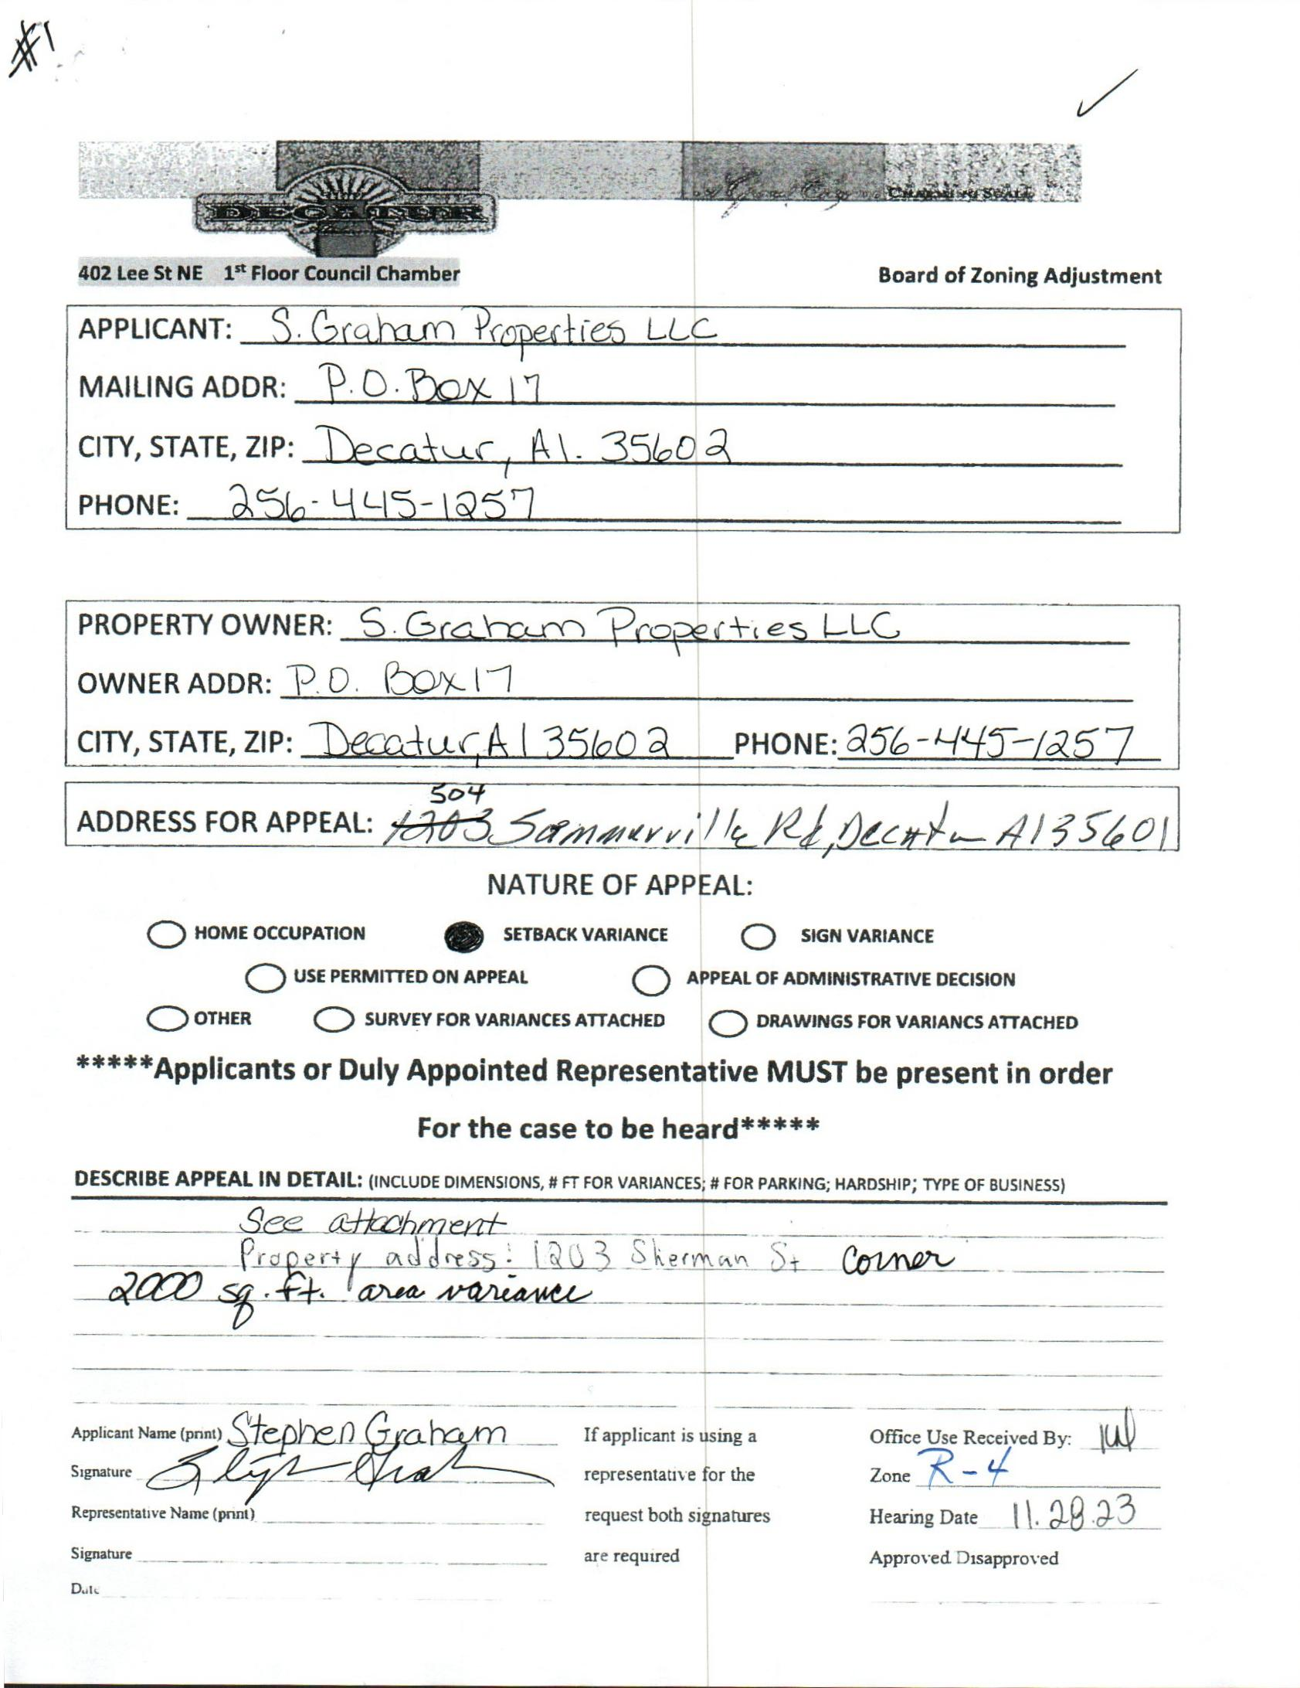

CASE NO. 1 504 sOMERVILLE RoaD SE
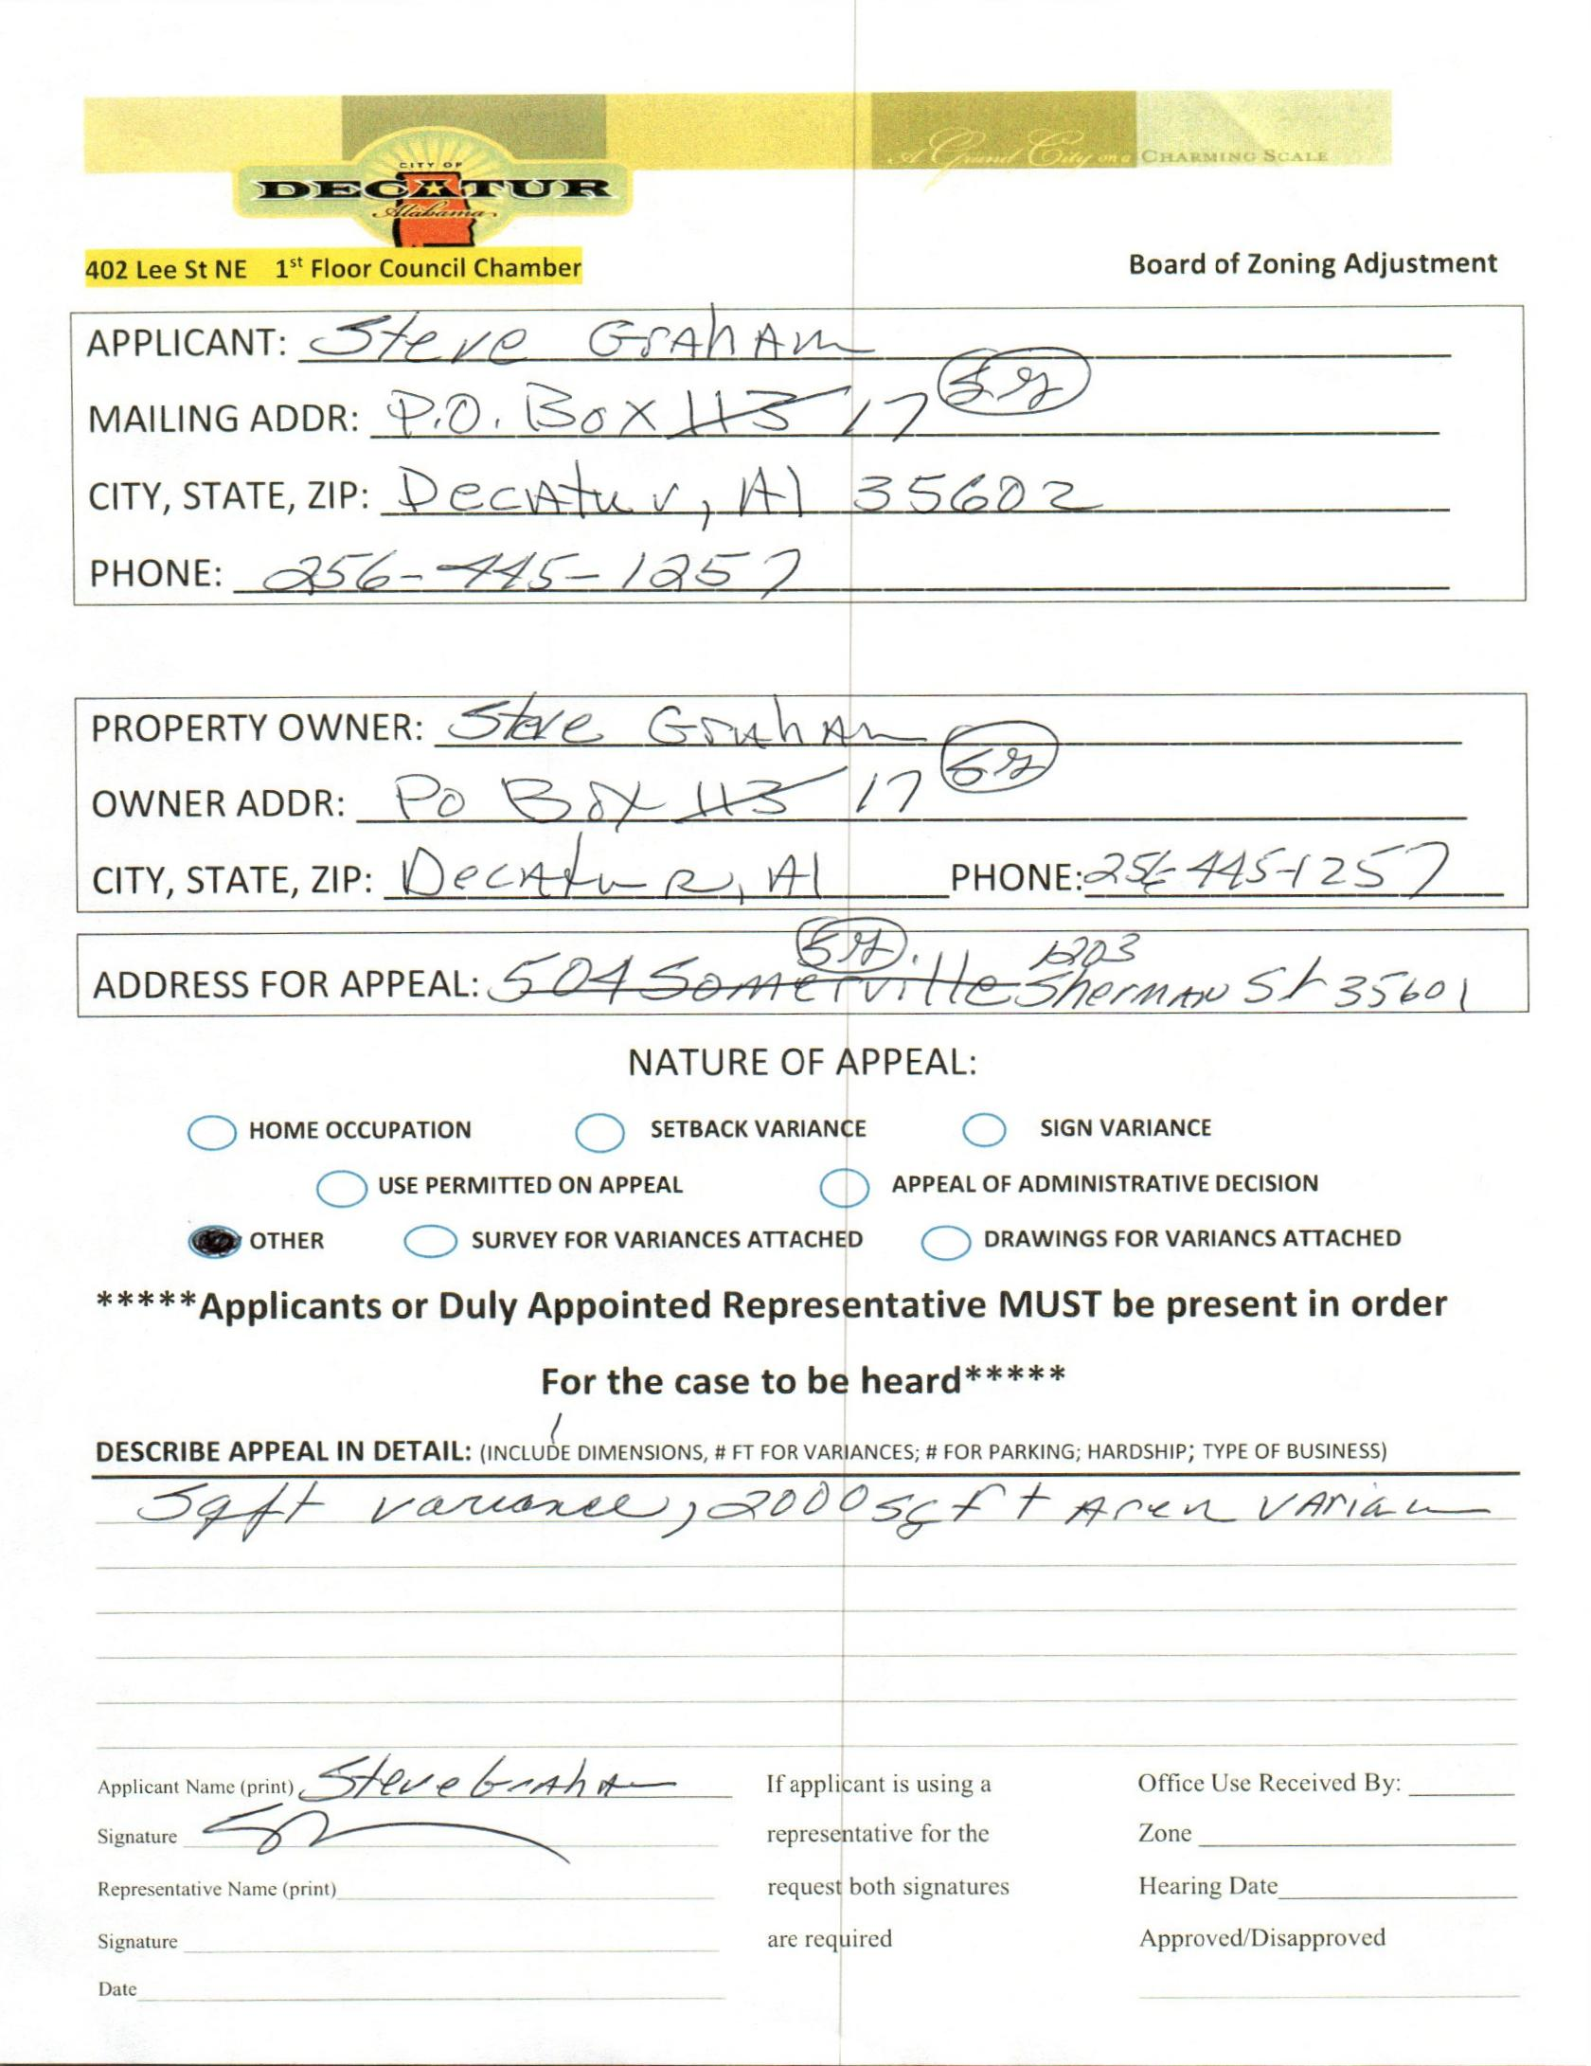

case no. 2 1203 Sherman street se
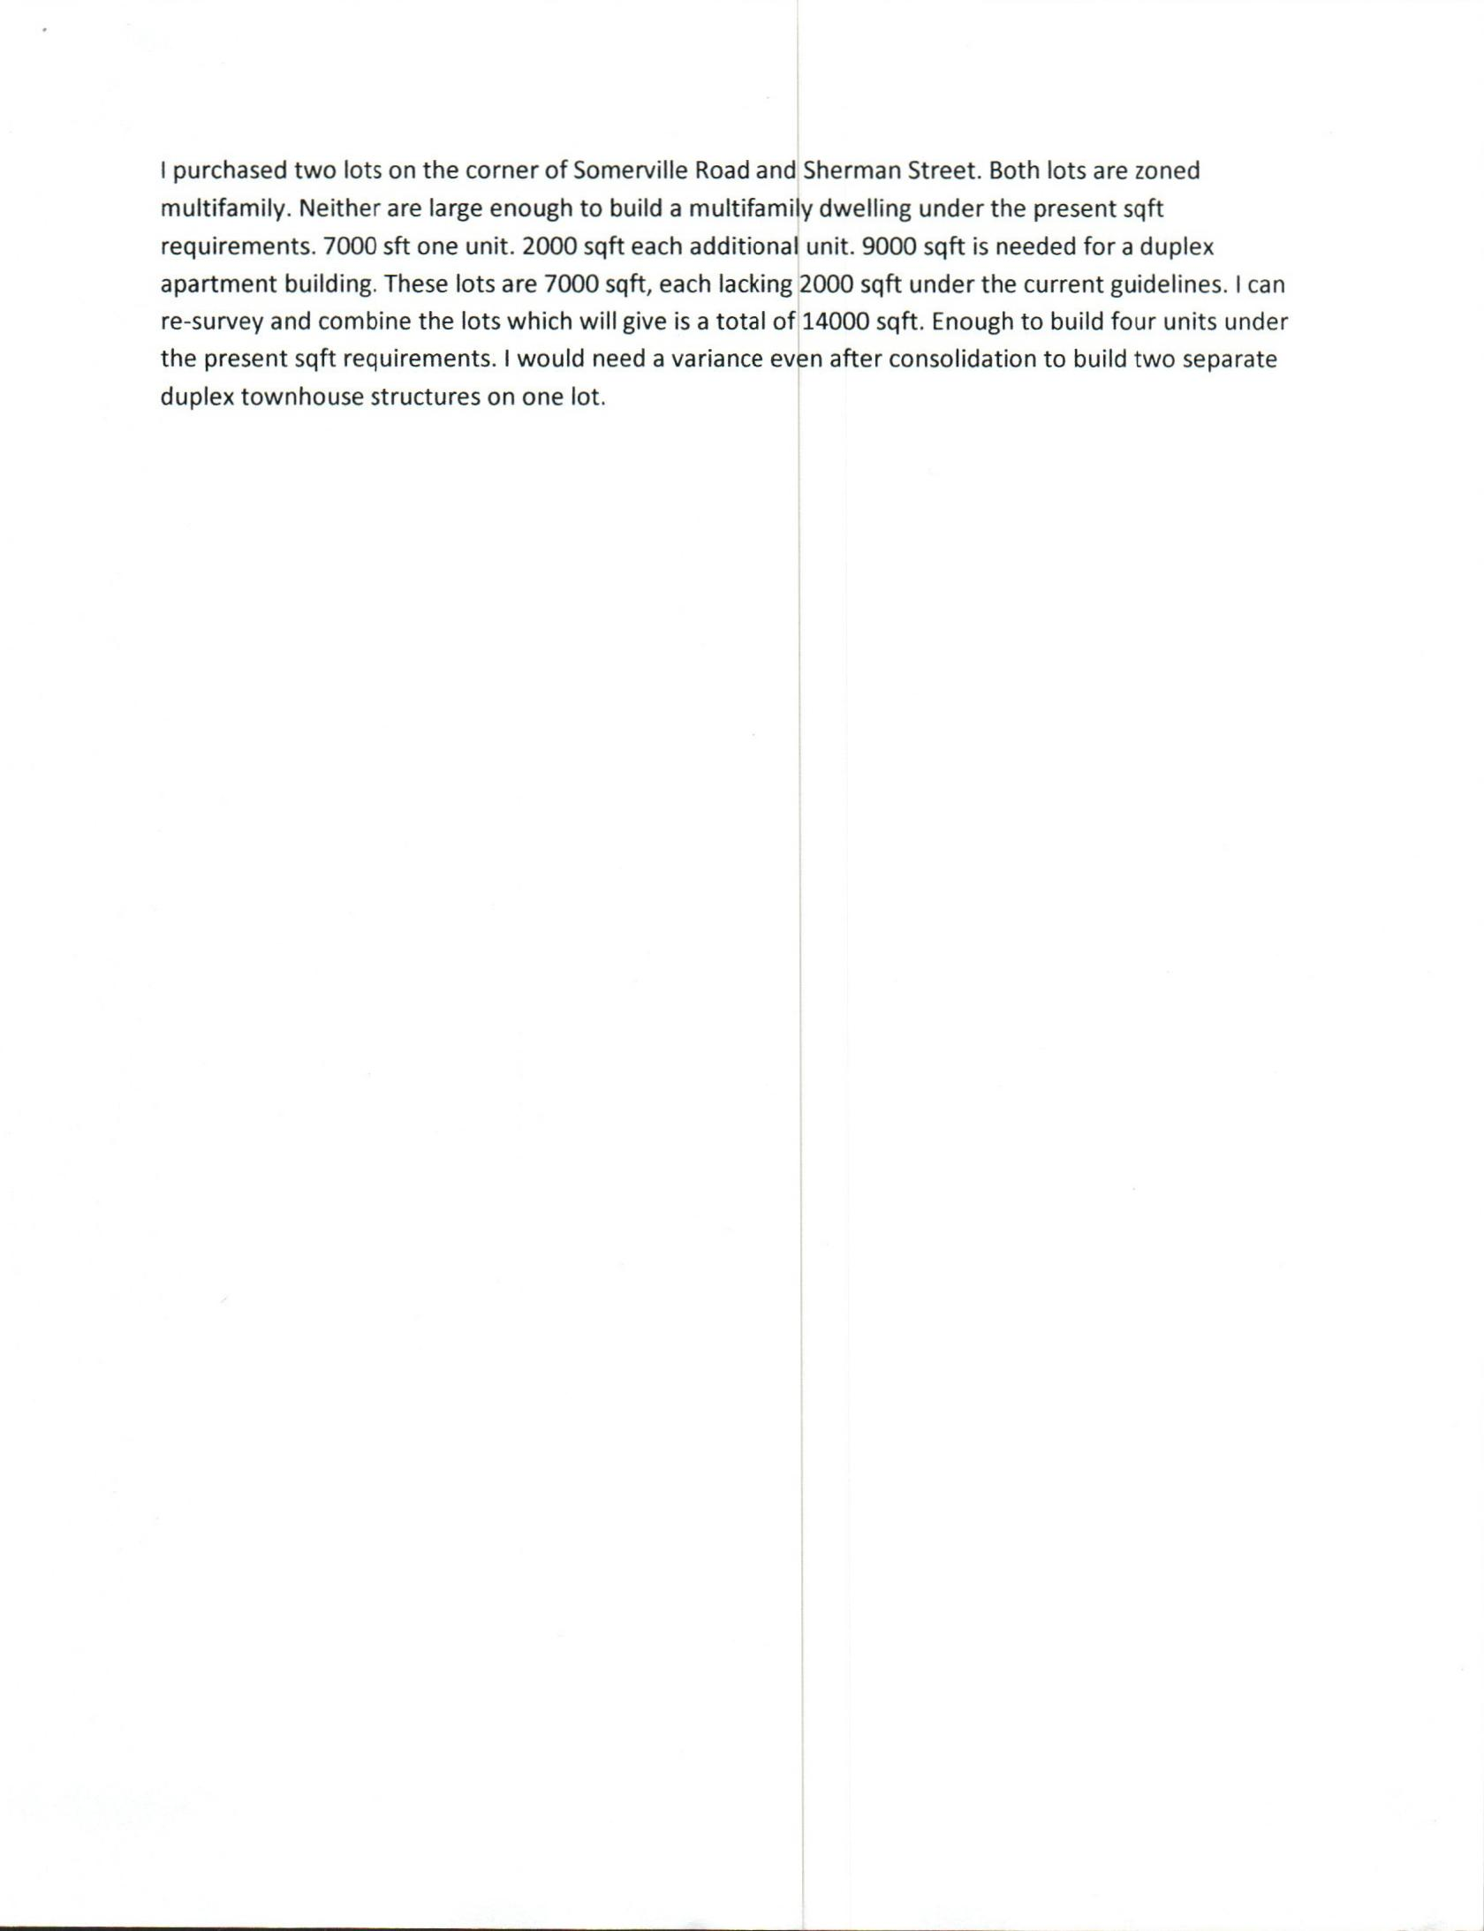

LETTER
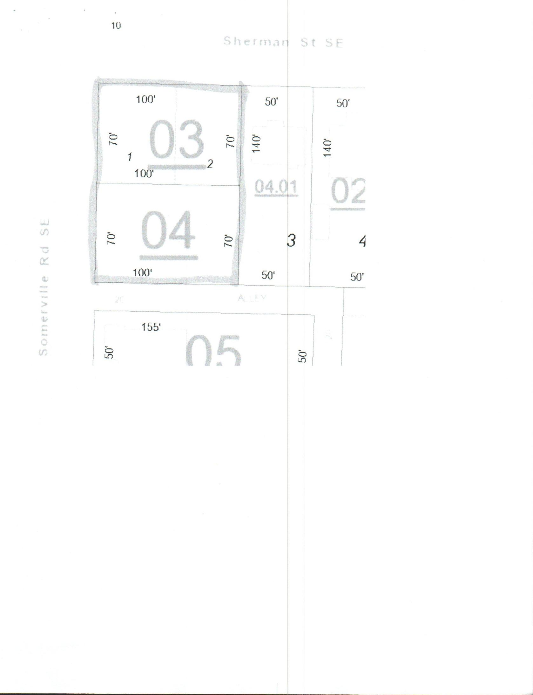

DIAGRAM
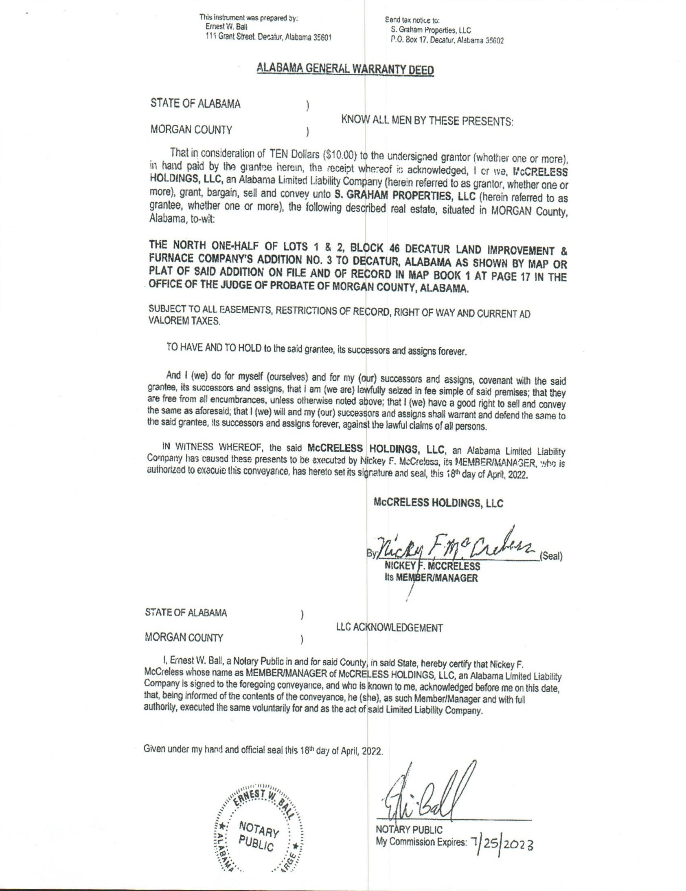

WARRANTY DEED
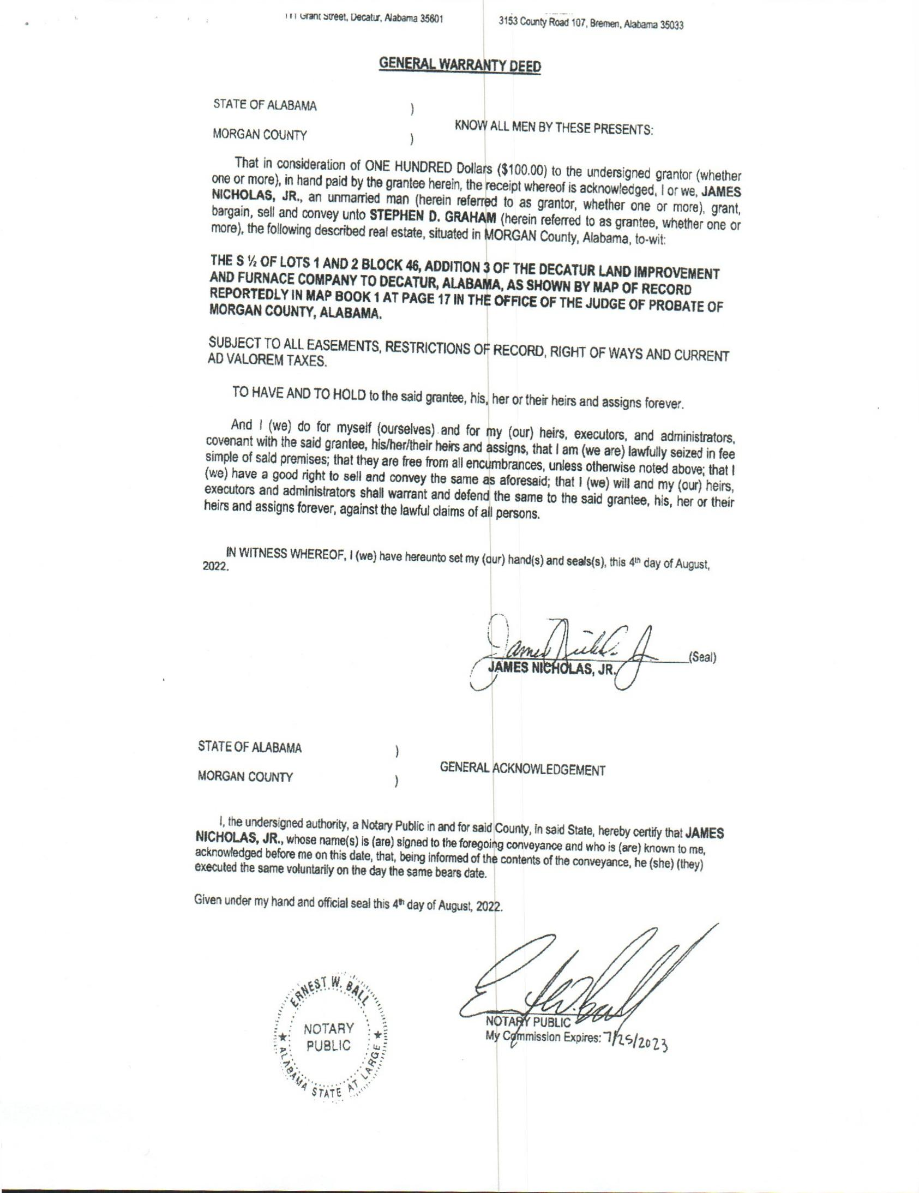

WARRANTY
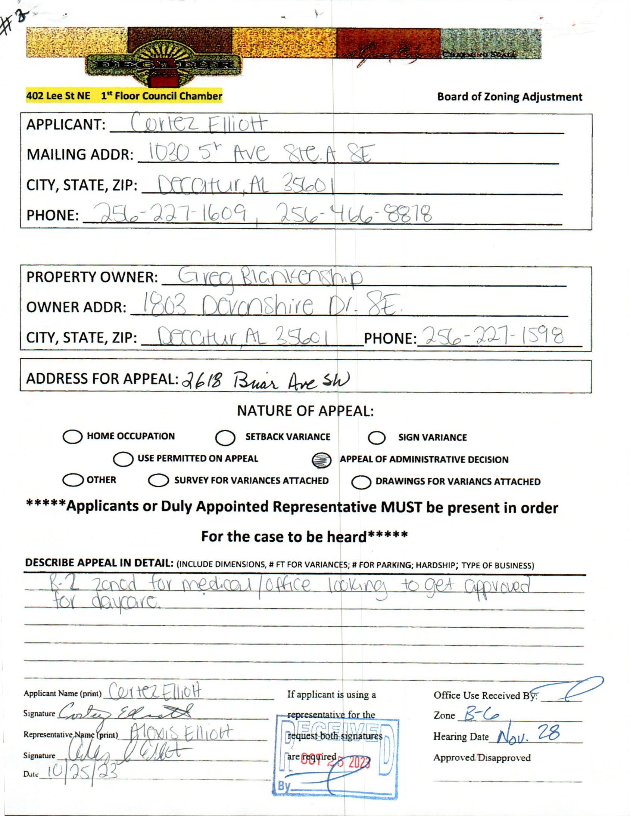

case no. 3 2618 briar av sw
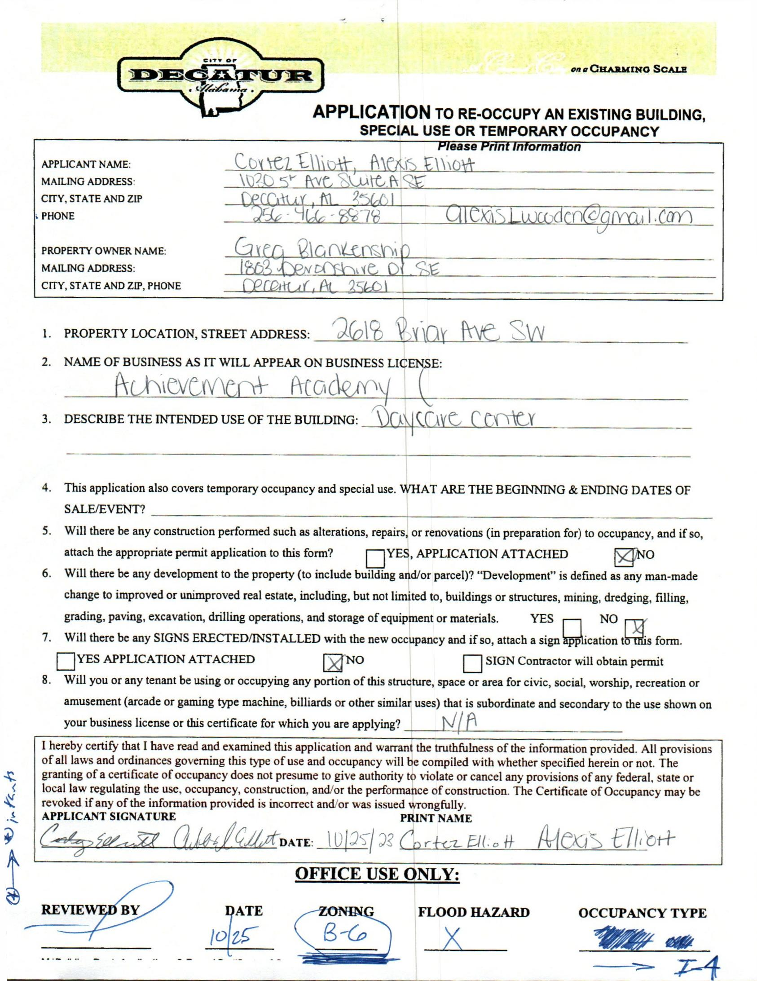

CERTIFICATE OF OCCUPANCY
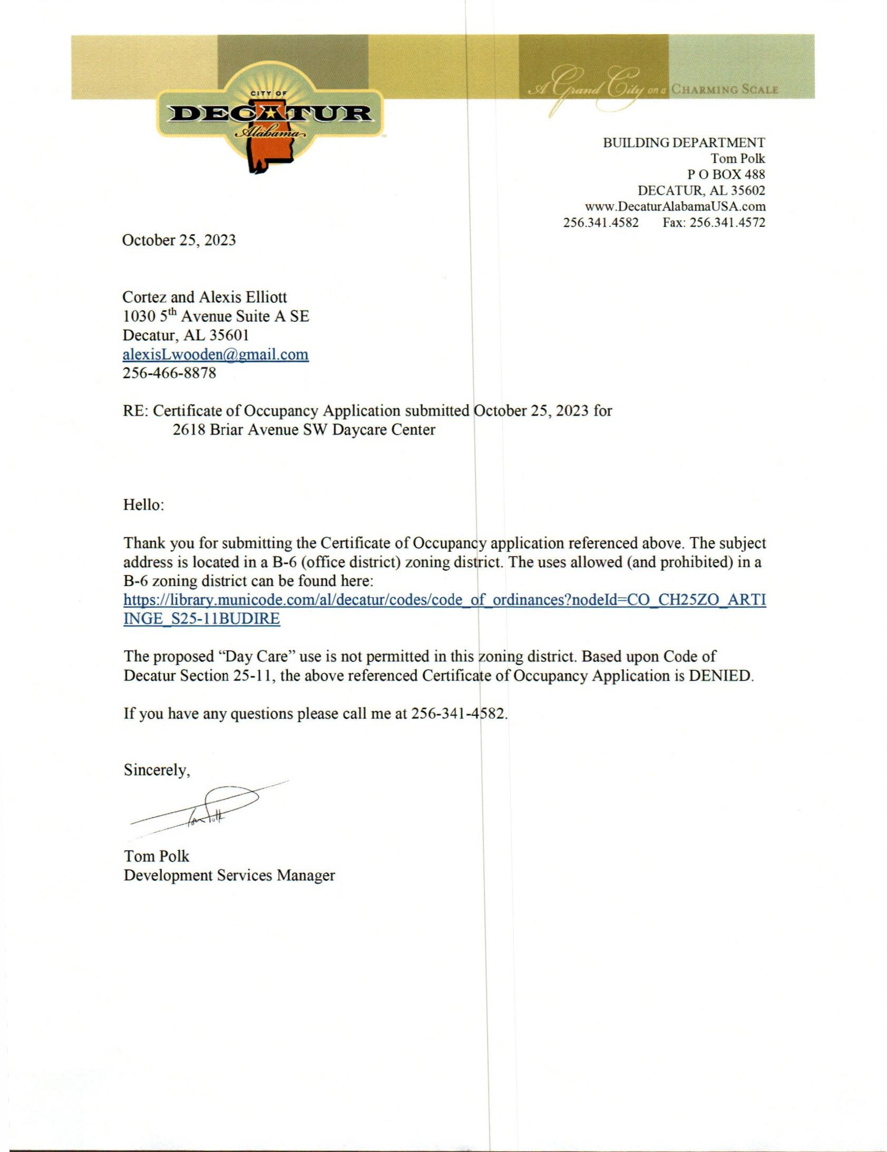

DENIAL LETTER
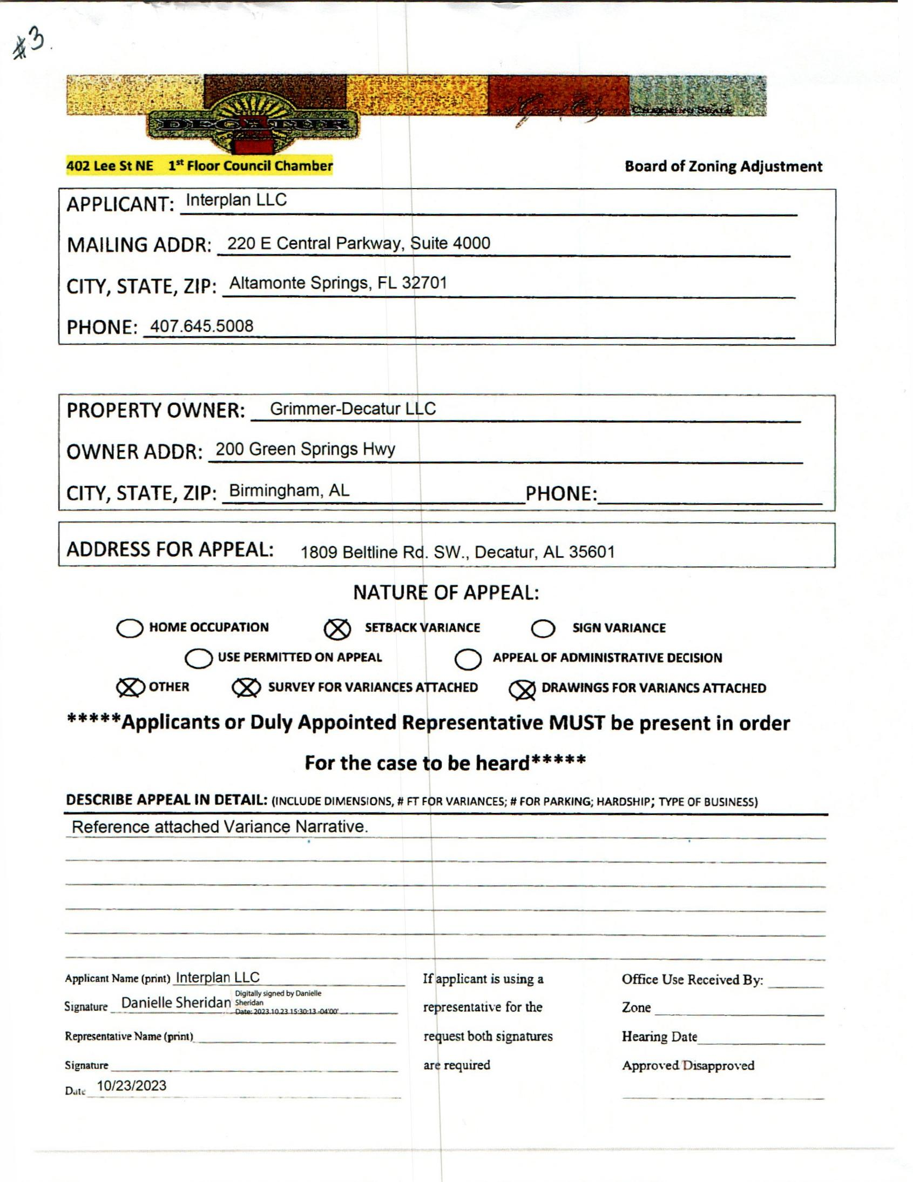

CASE NO. 4 1809 BELTLINE RD SW
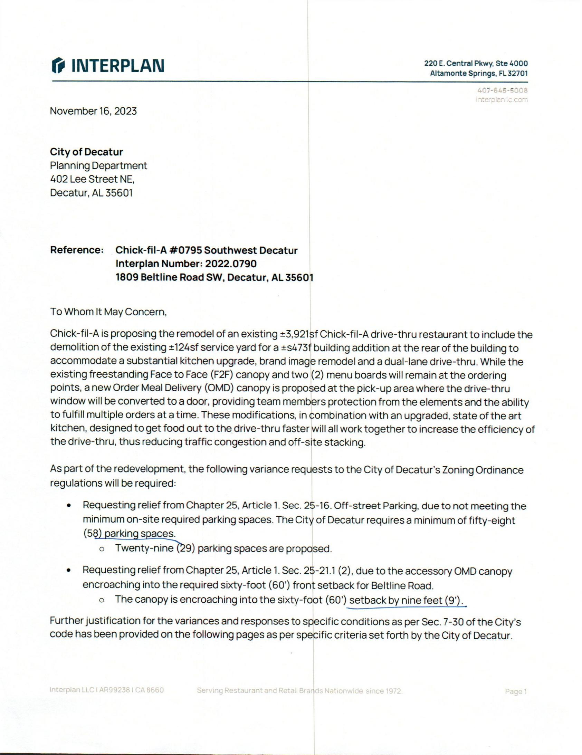

VARIANCE REQUEST
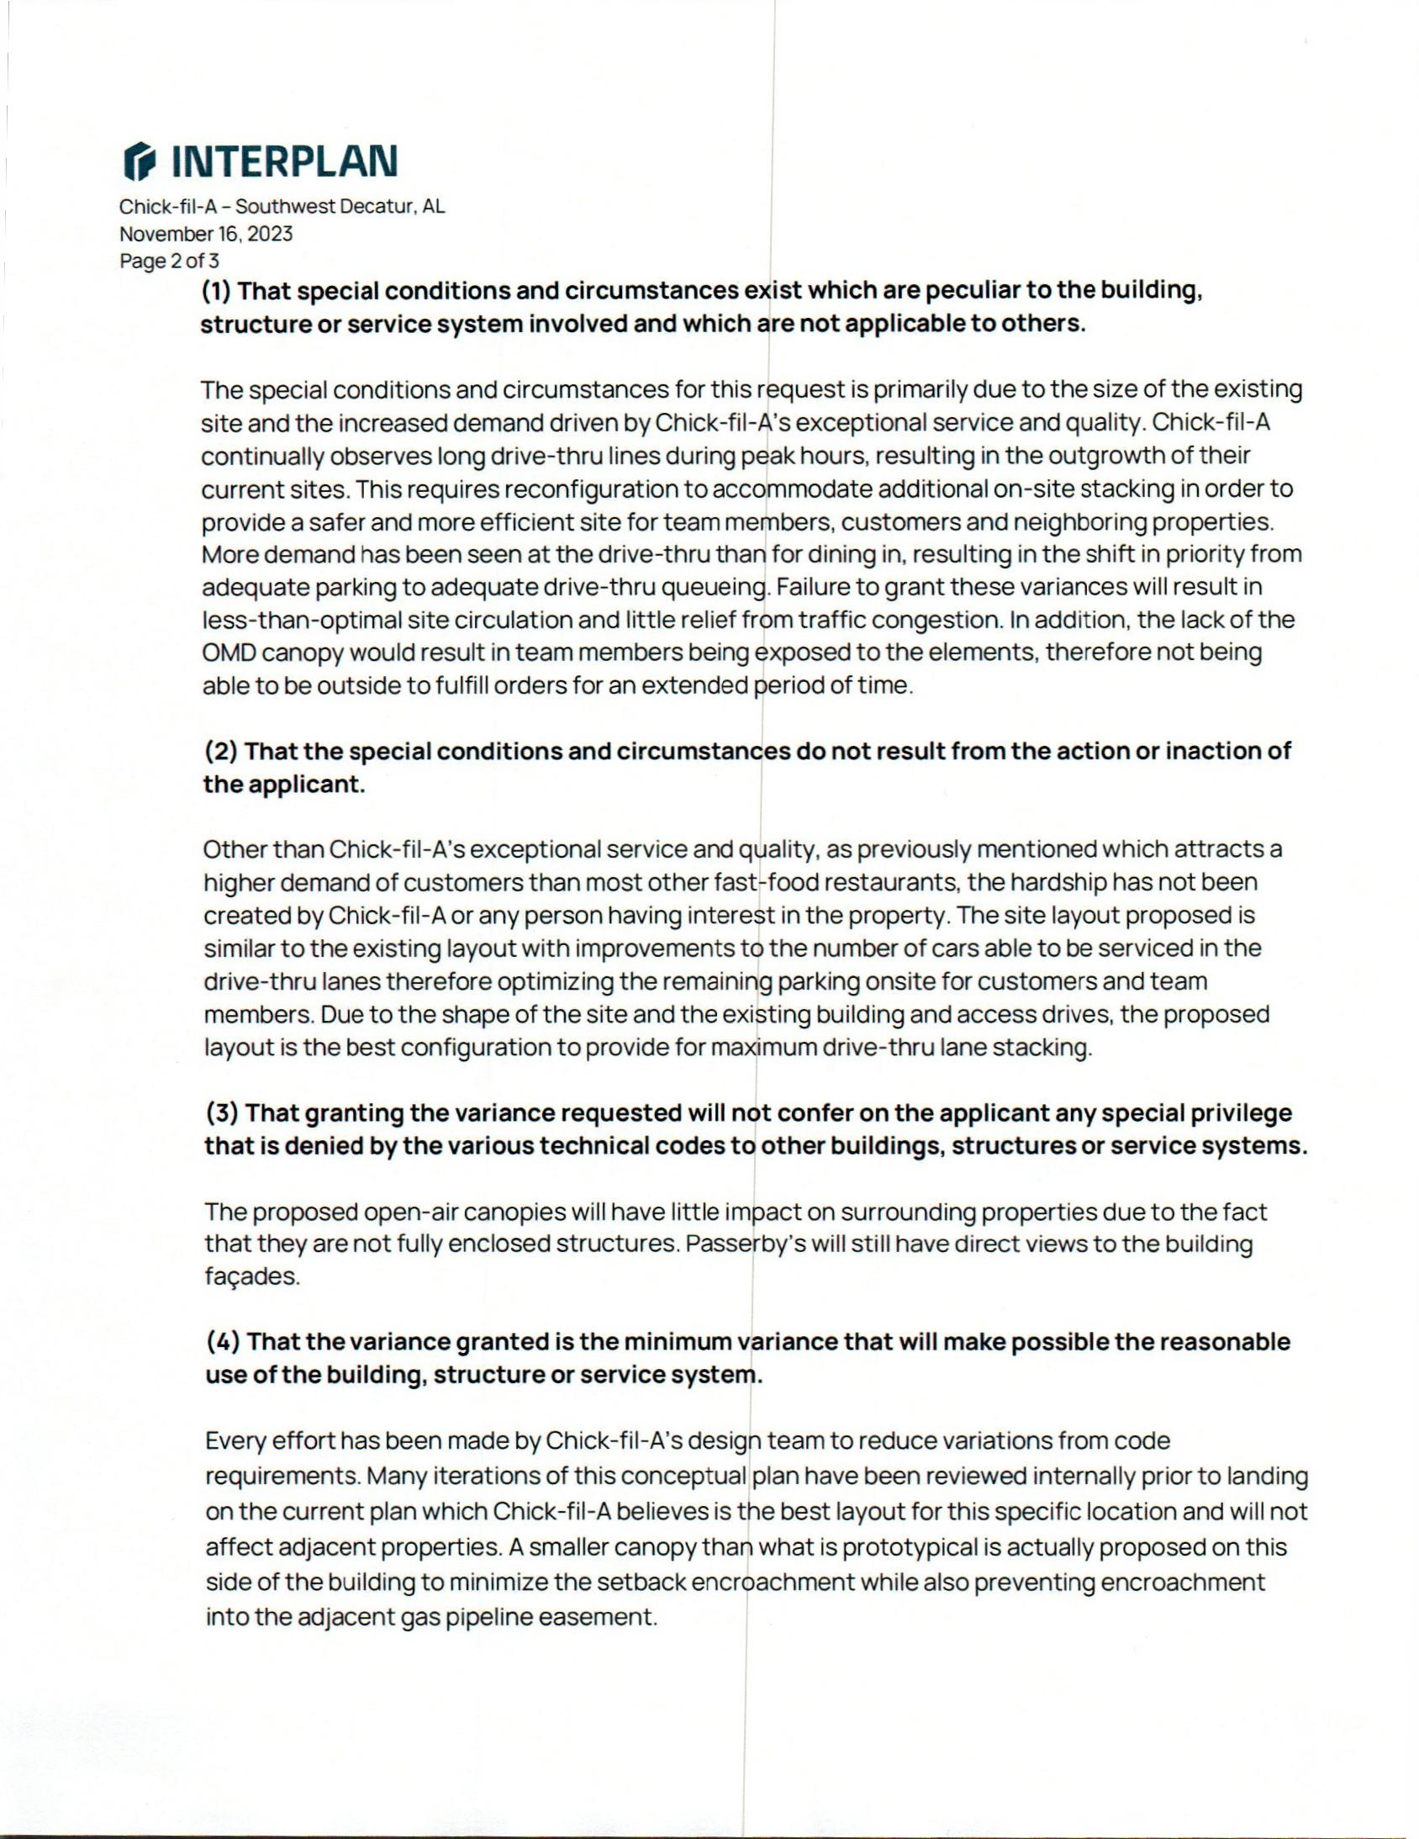

VARIANCE REQUEST
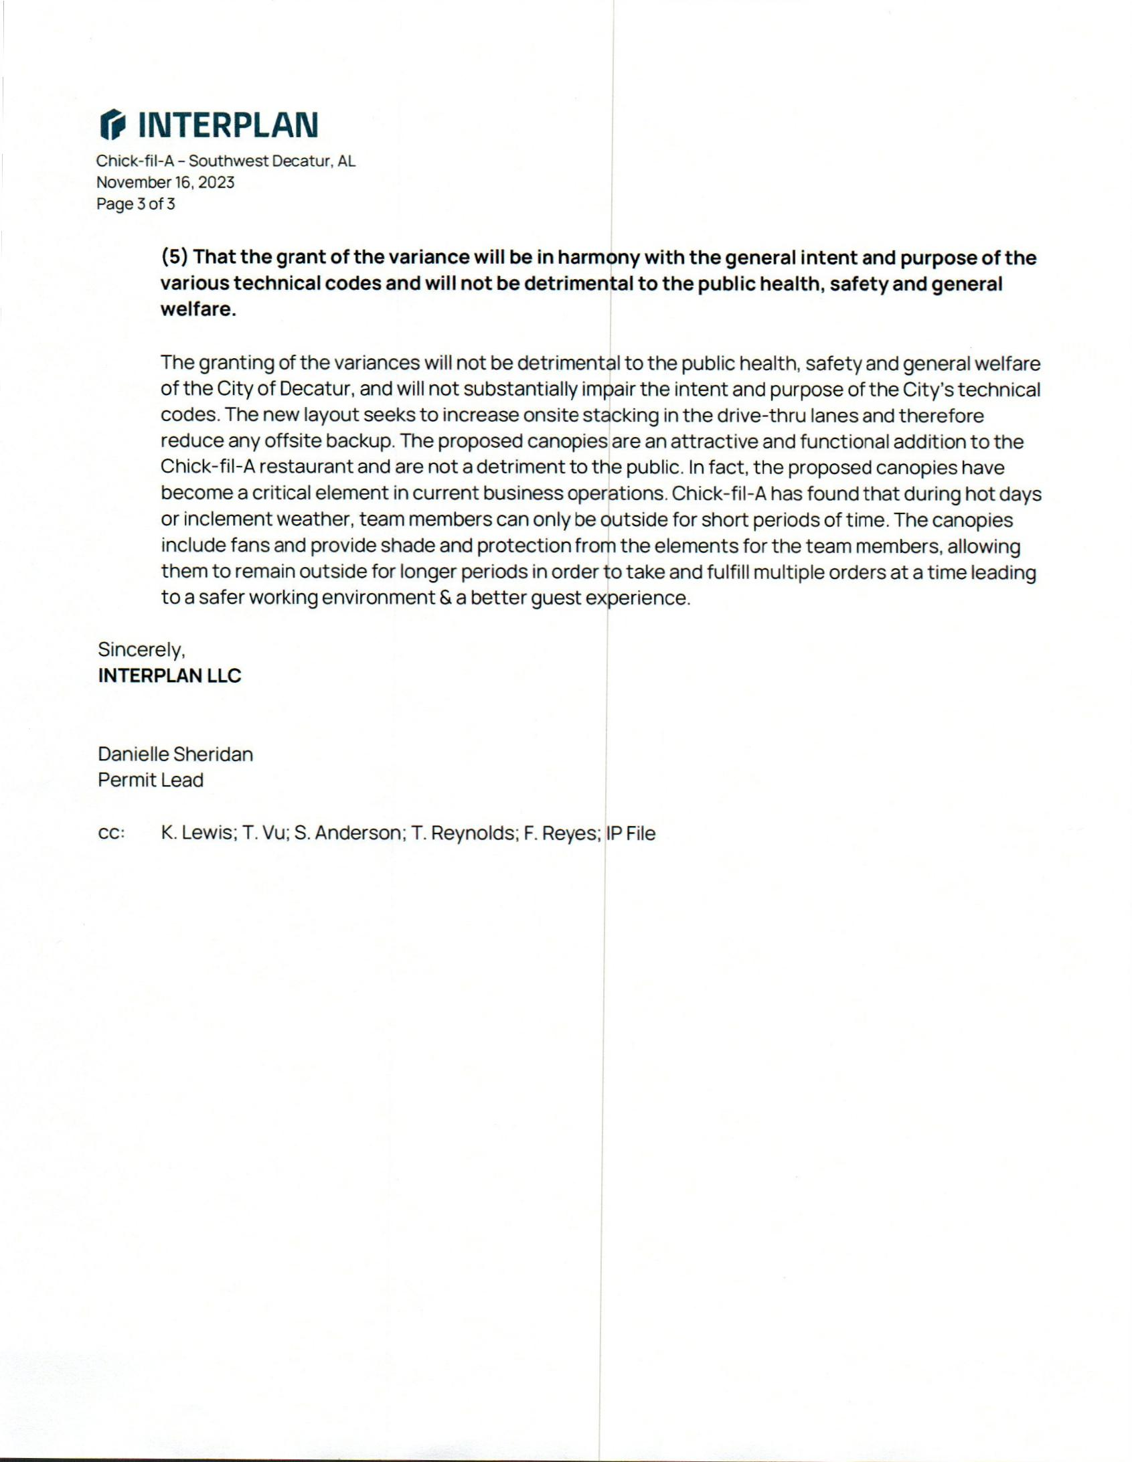

VARIANCE REQUEST
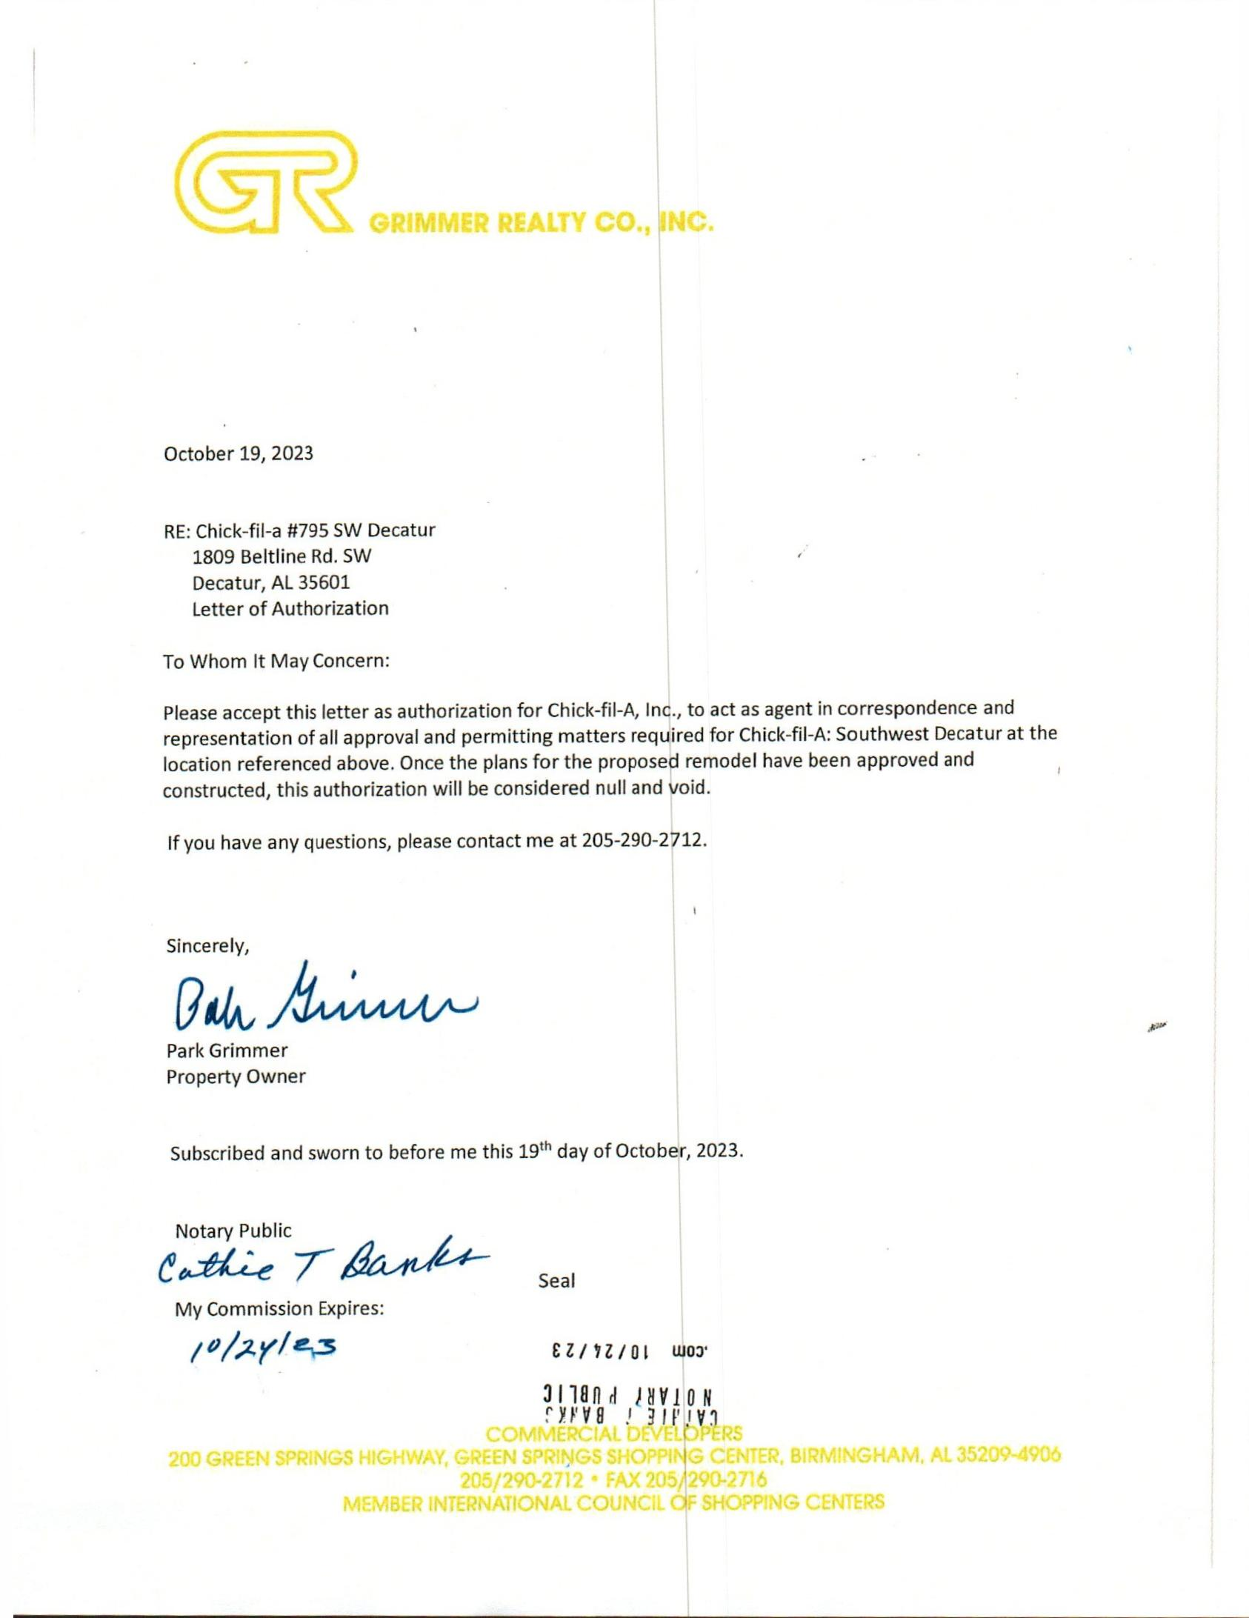

LETTER
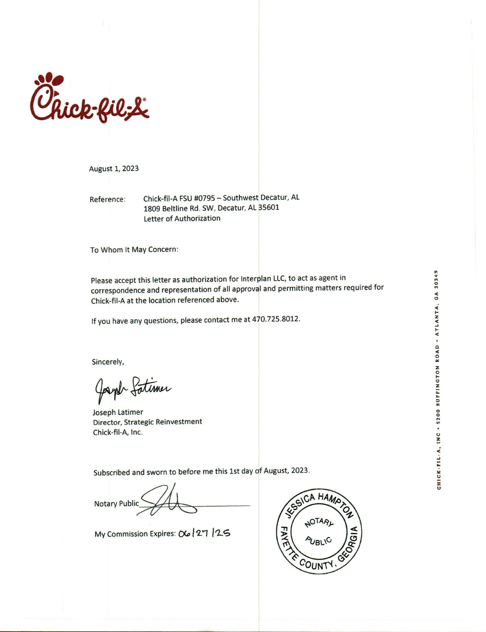

LETTER
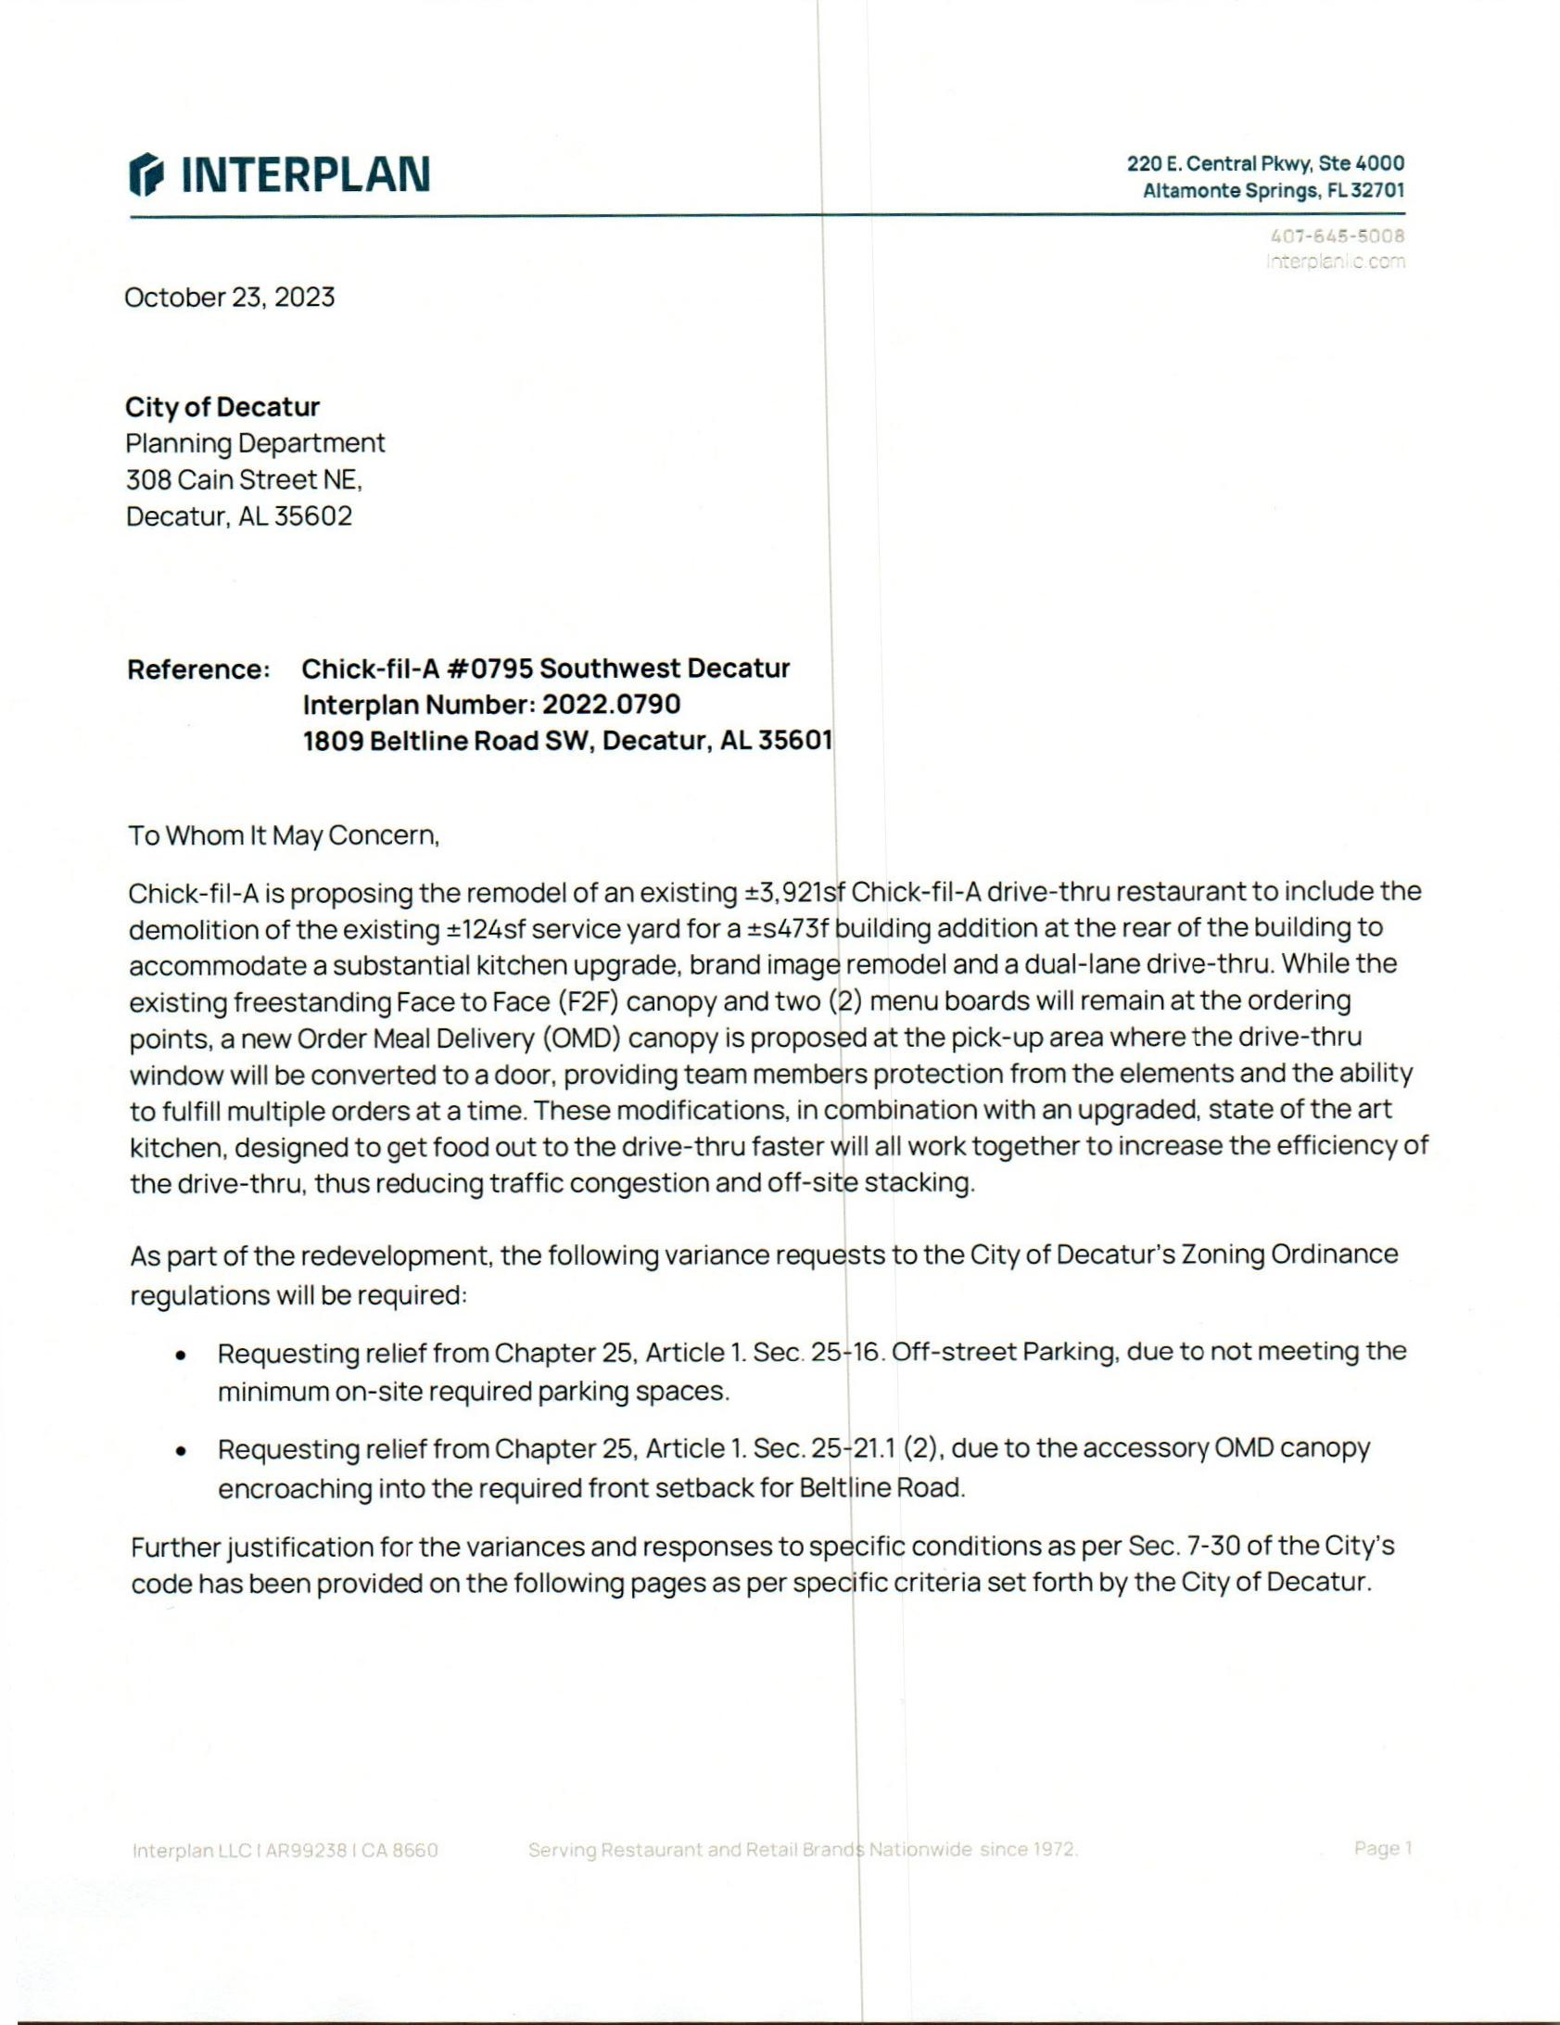

VARIANCE REQUEST
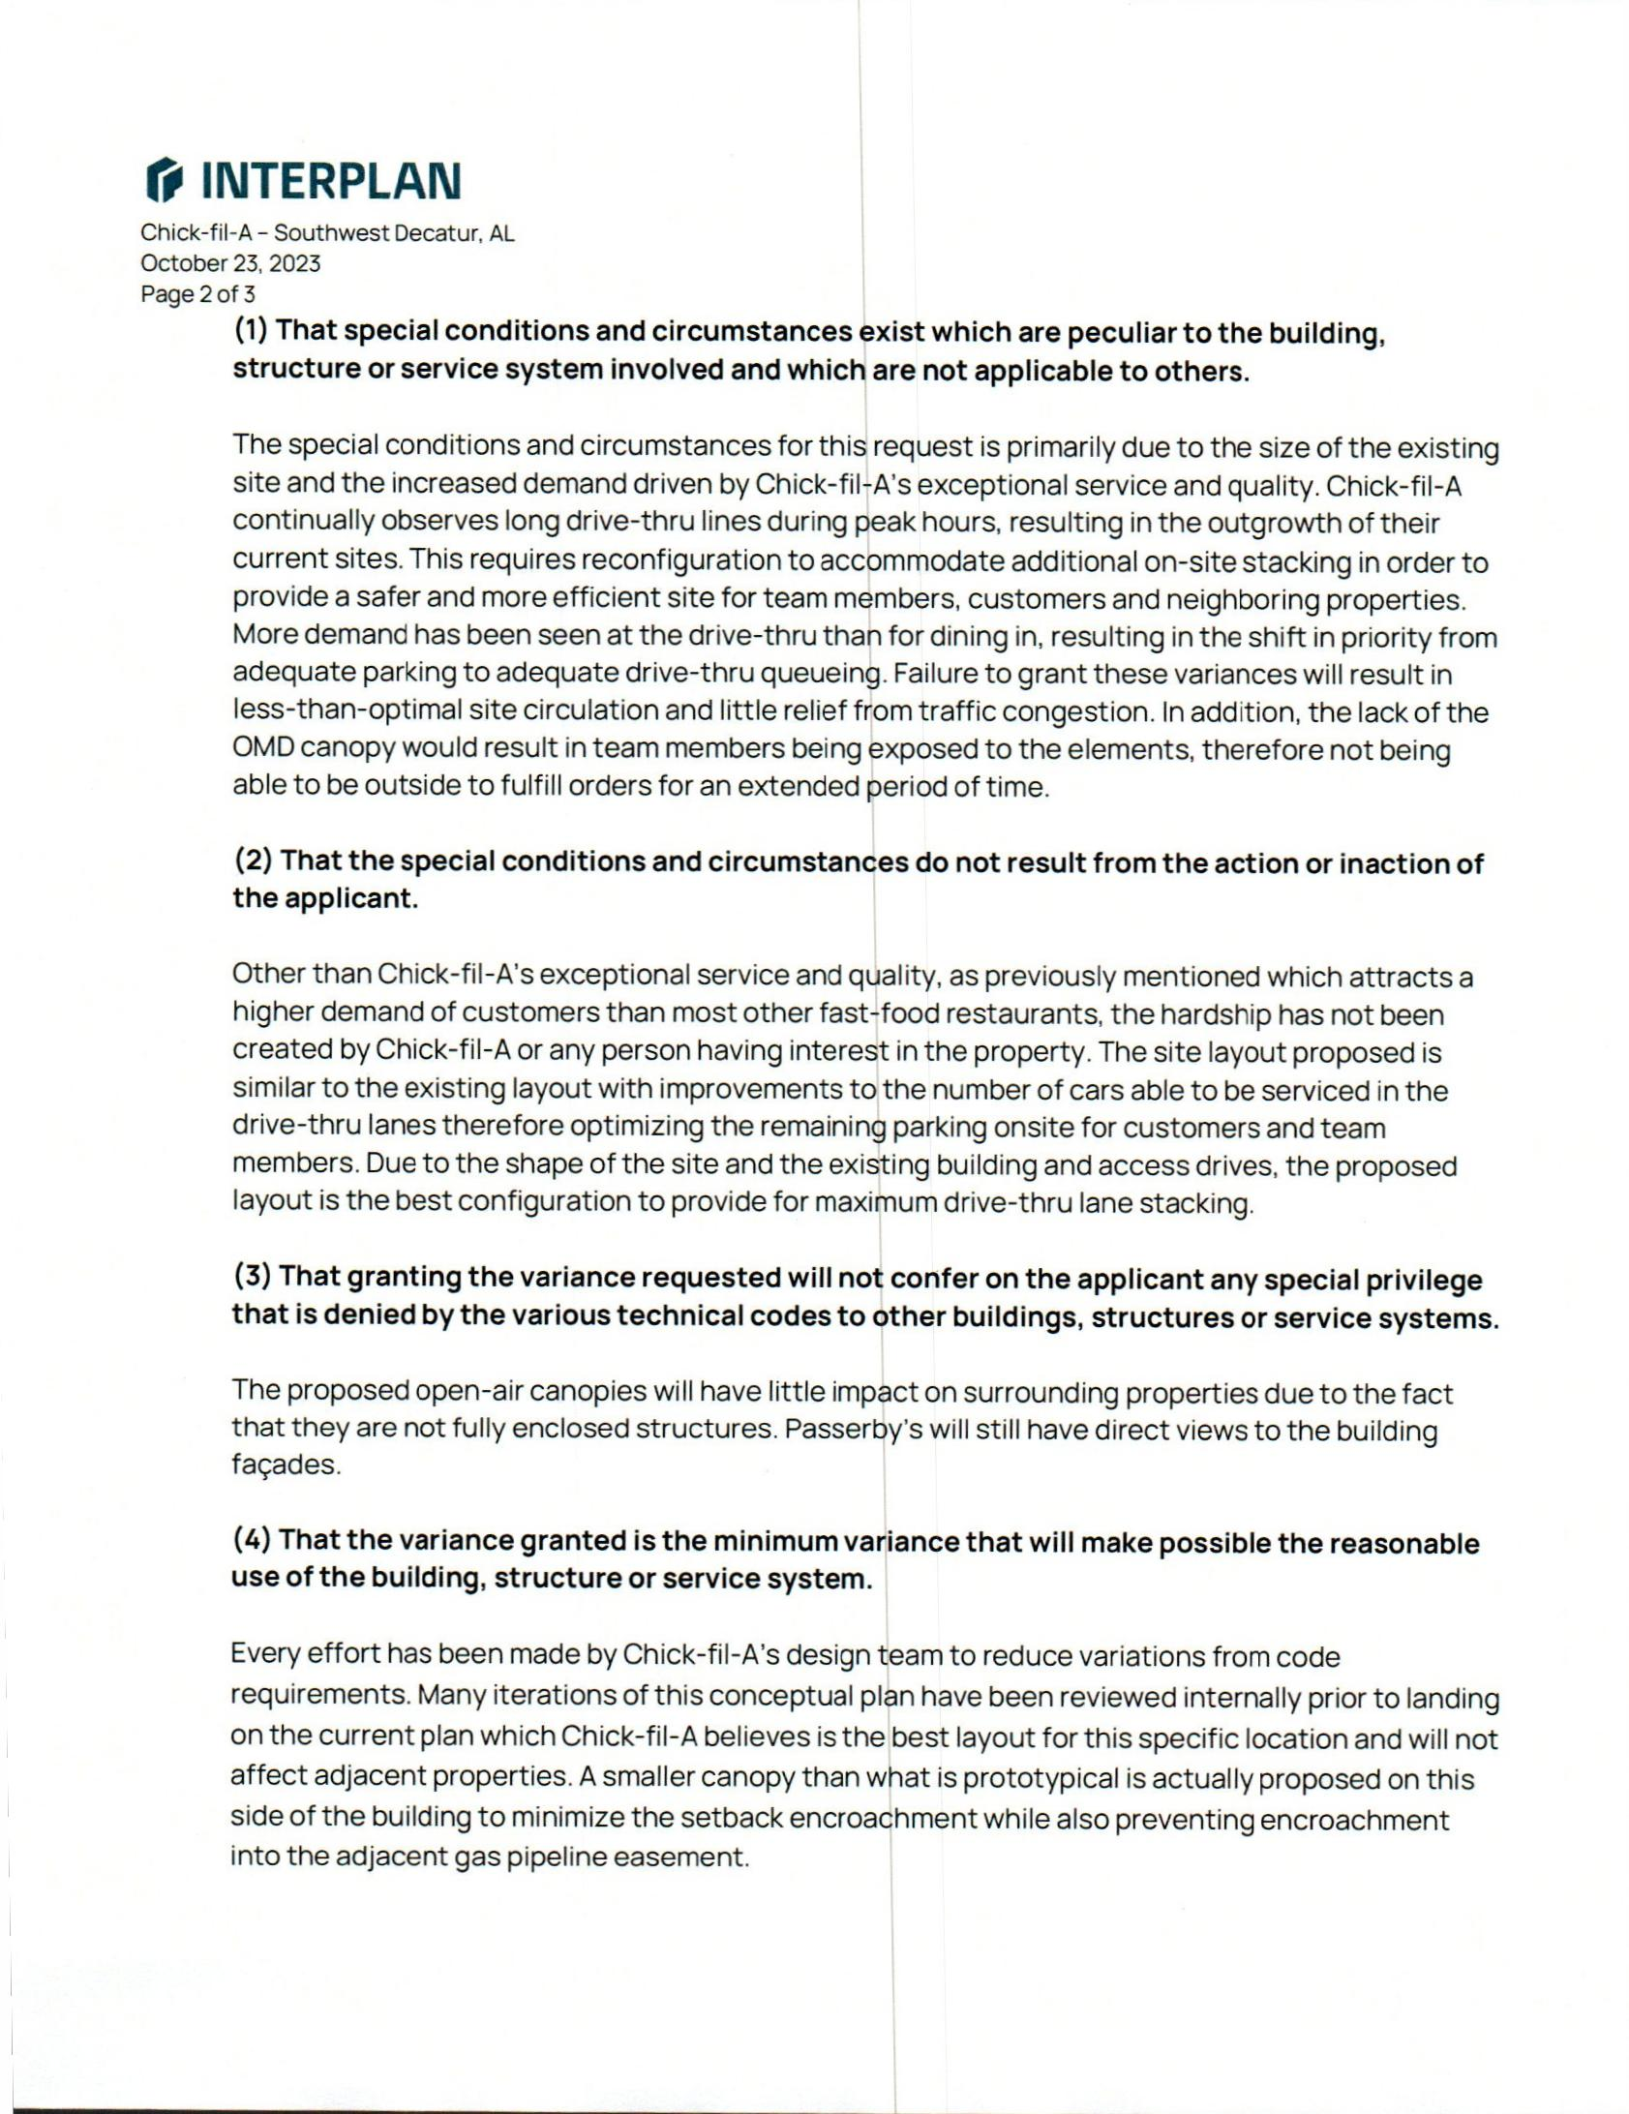

VARIANCE REQUEST
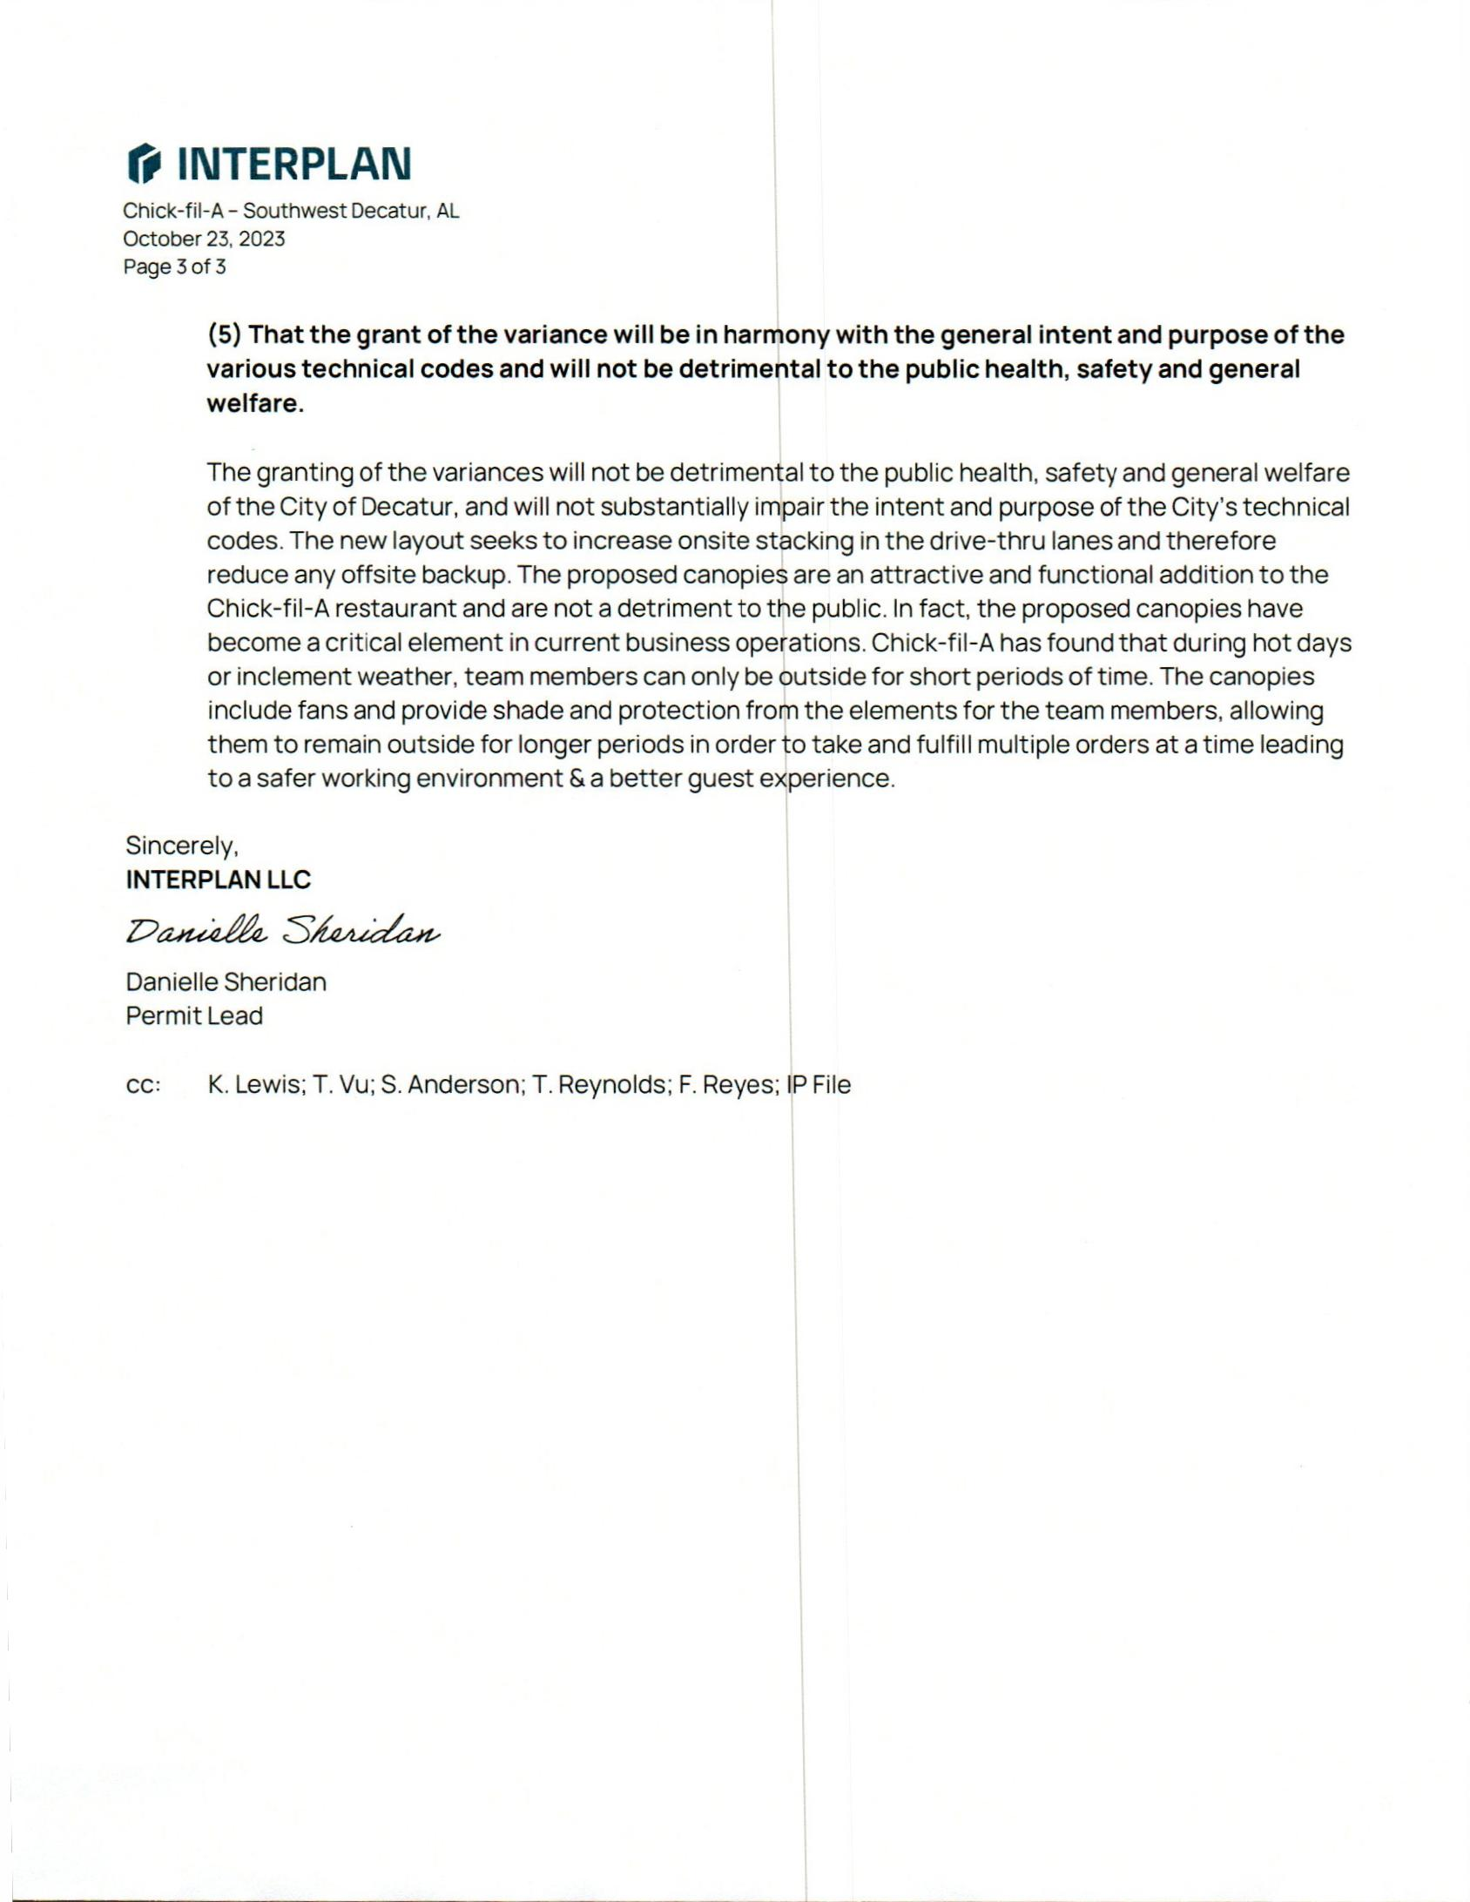

VARIANCE REQUEST
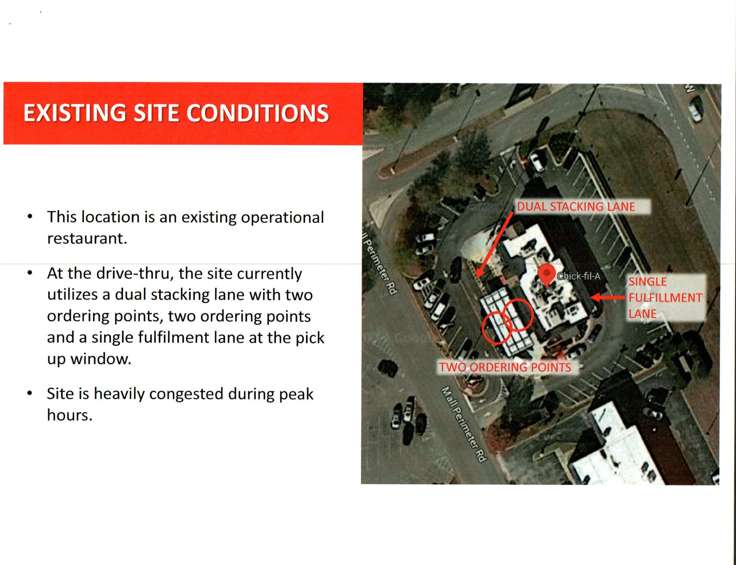

EXISTING SITE CONDITIONS
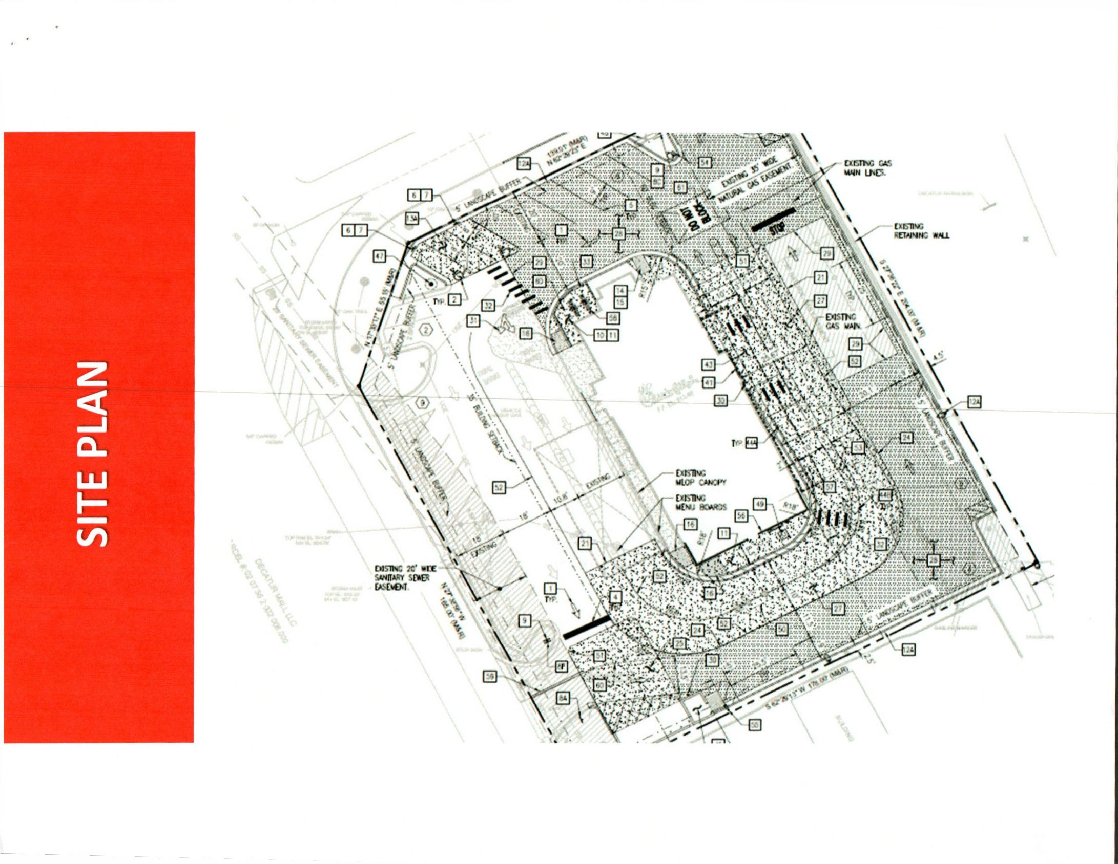

SITE PLAN
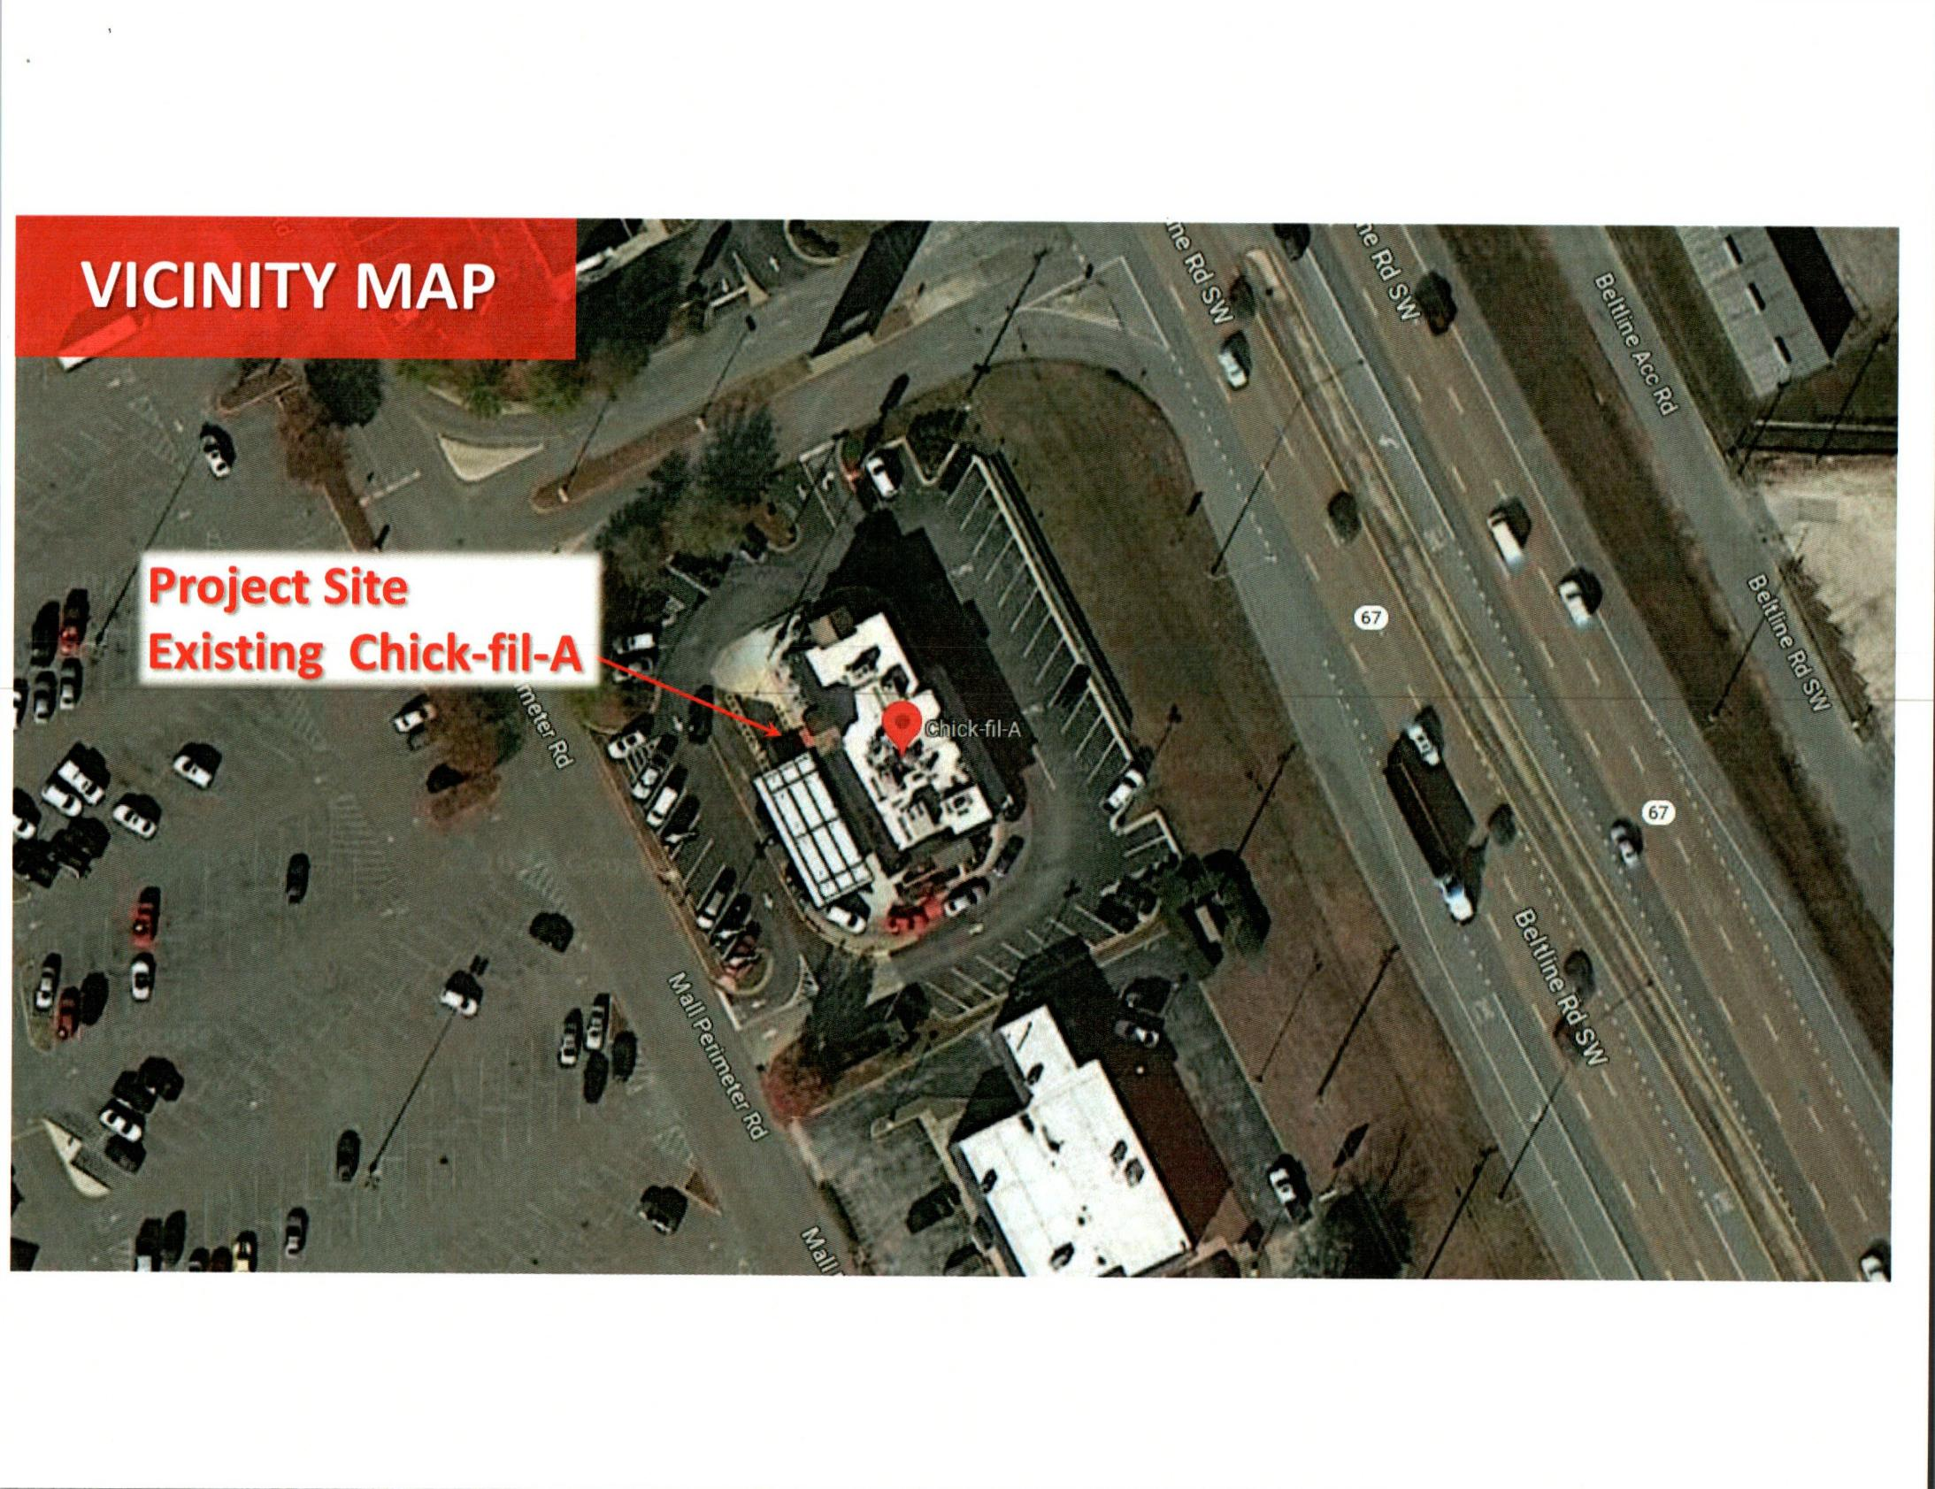

VICINITY MAP
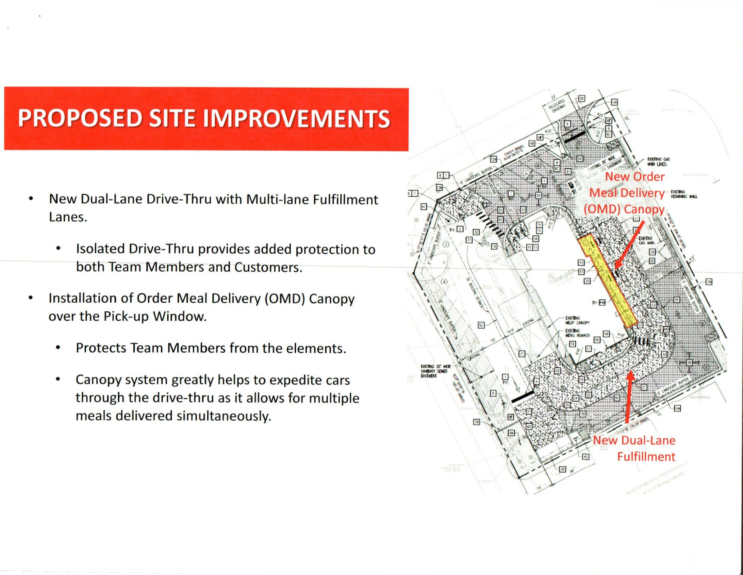

PROPOSED SITE IMPROVEMENTS
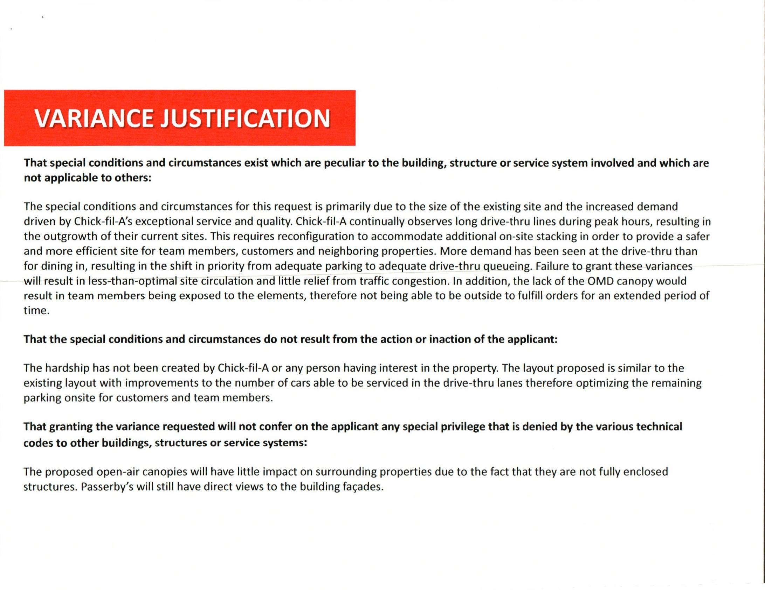

VARIANCE JUSTIFICATION PG 1
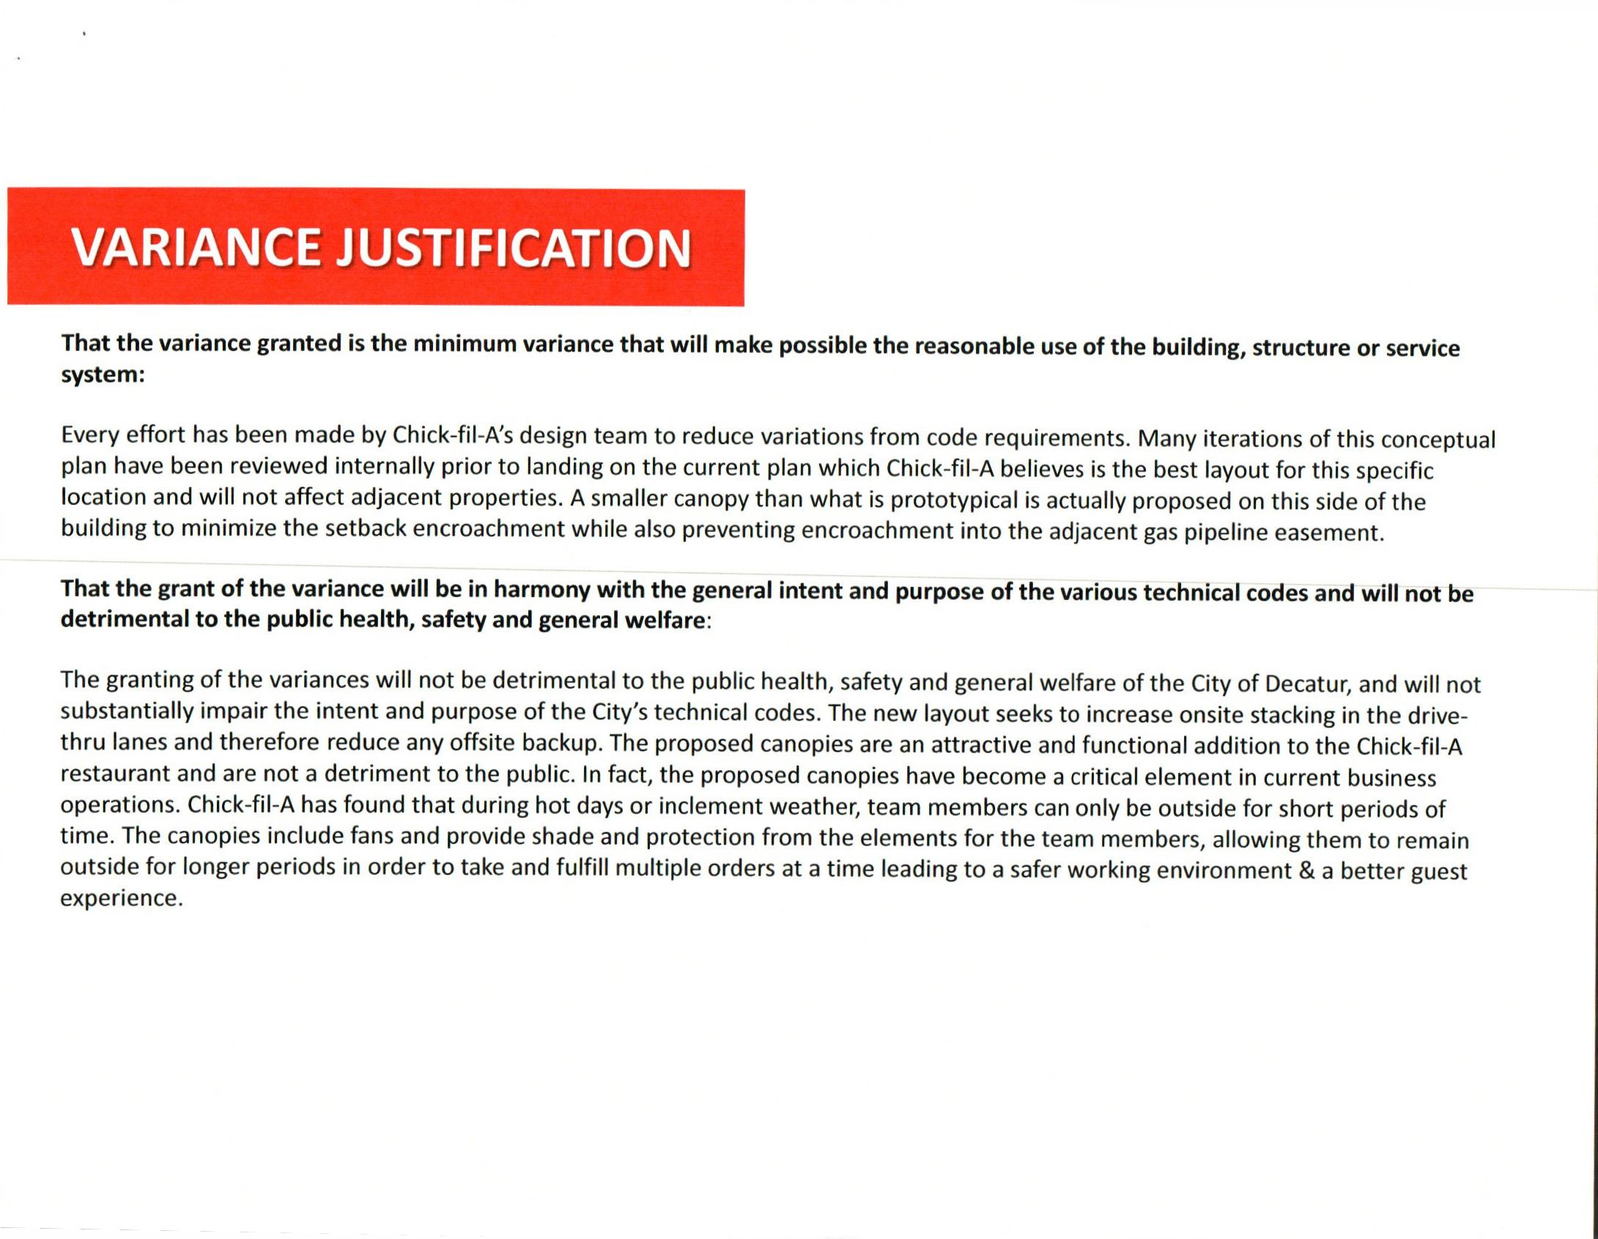

VARIANCE JUSTIFICATION PG.2
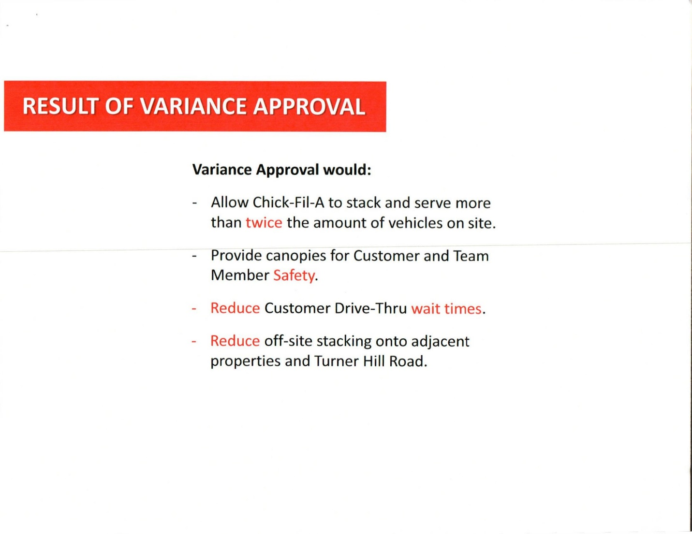

Variance Results if Approved

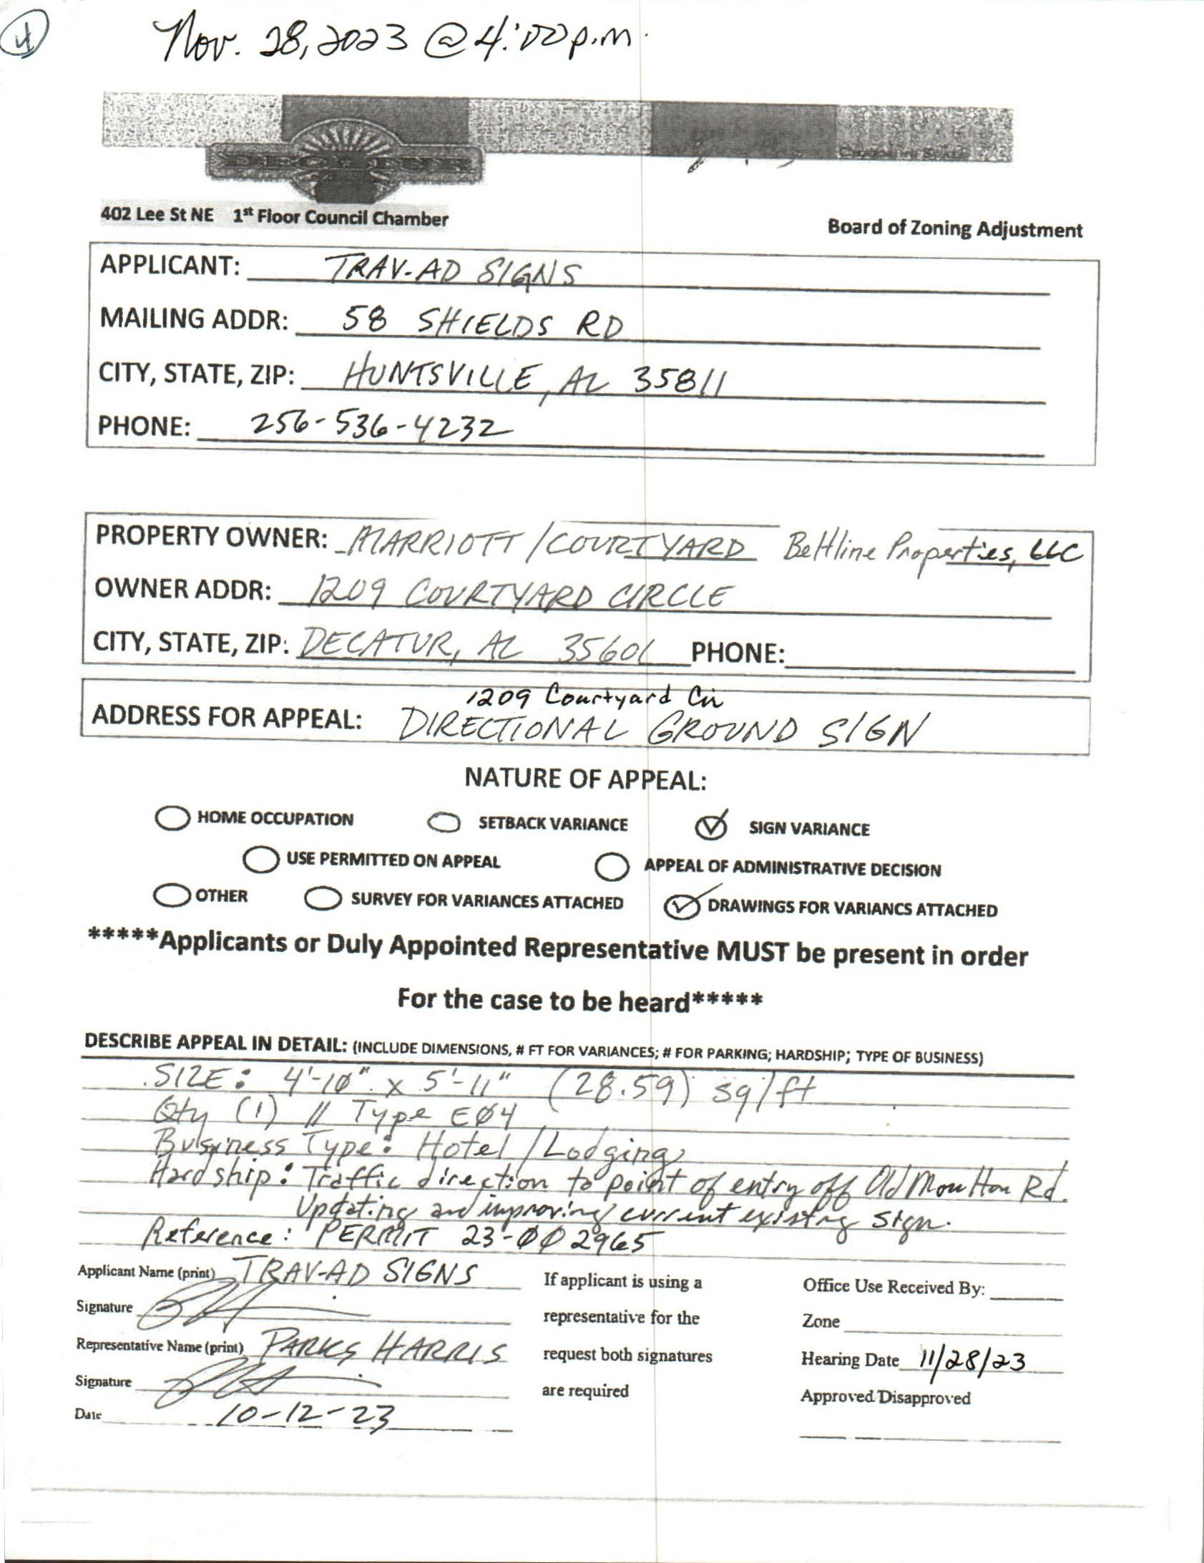

case no. 5 1209 courtyard cir. sw
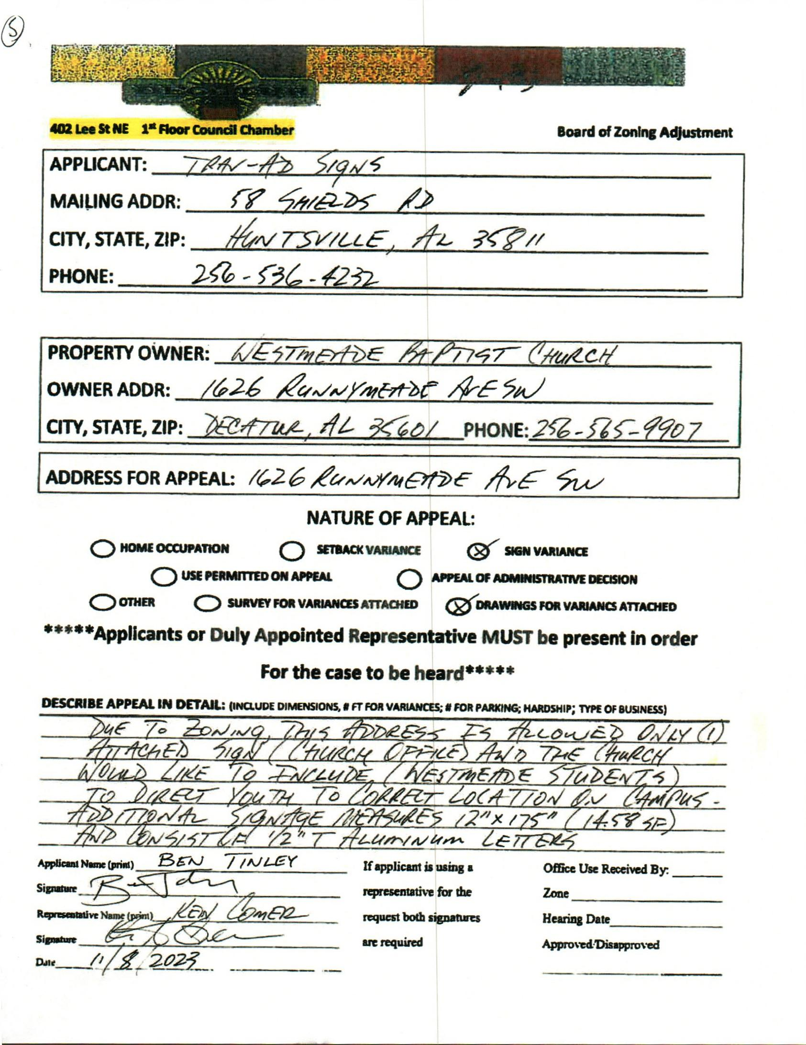

case no. 6 1626 runnymead av sw
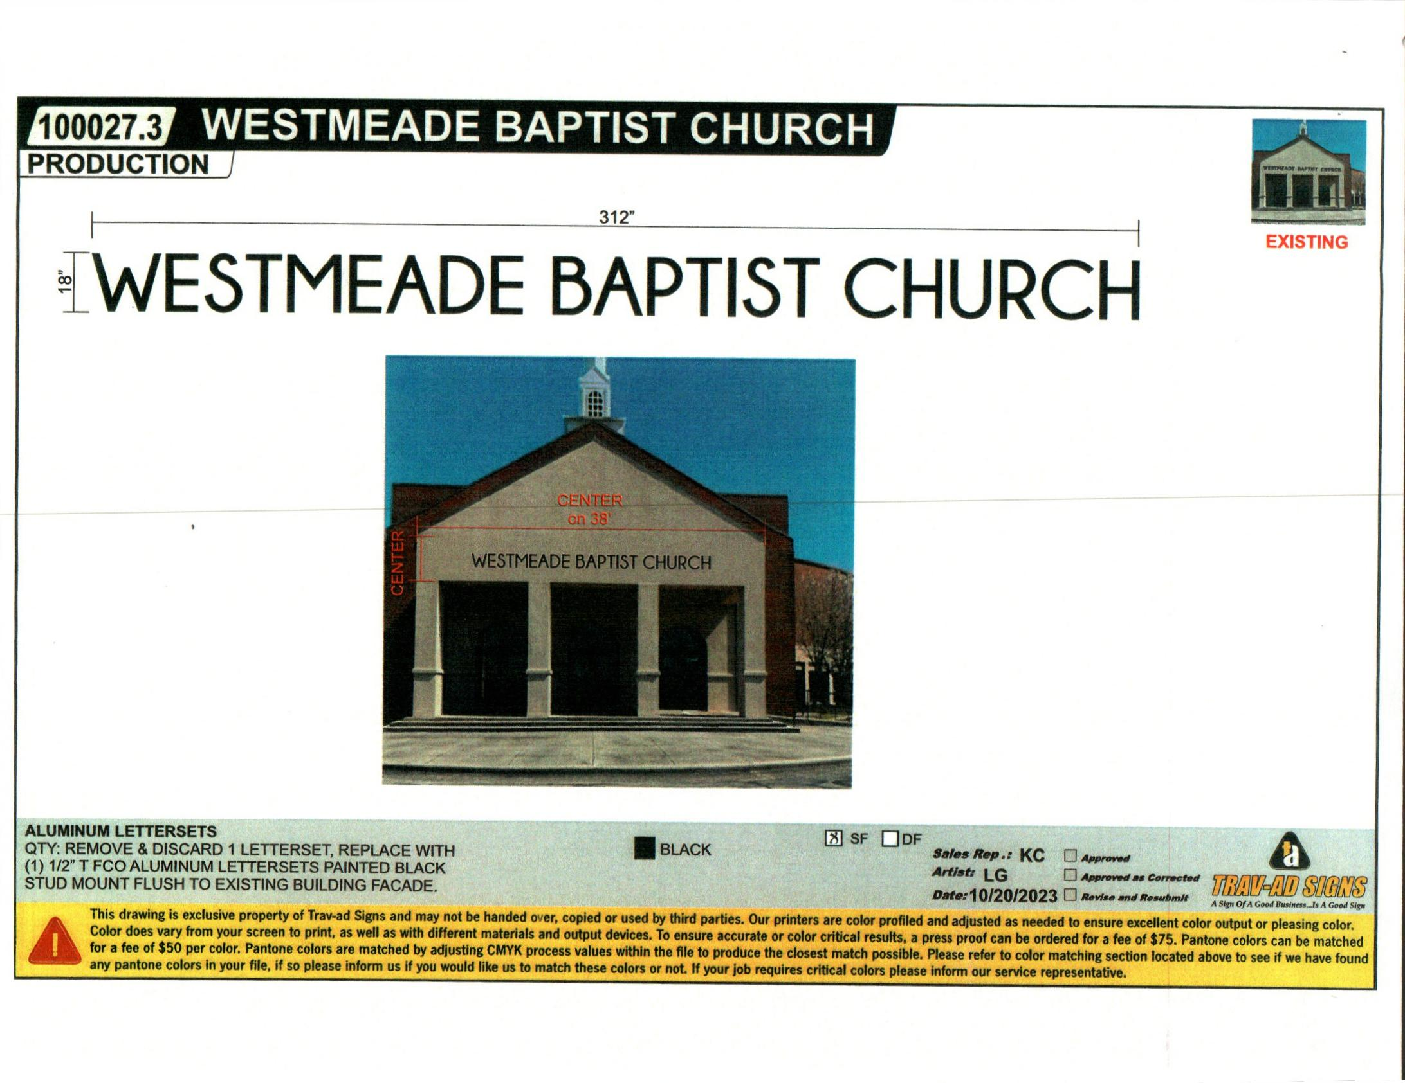

Picture
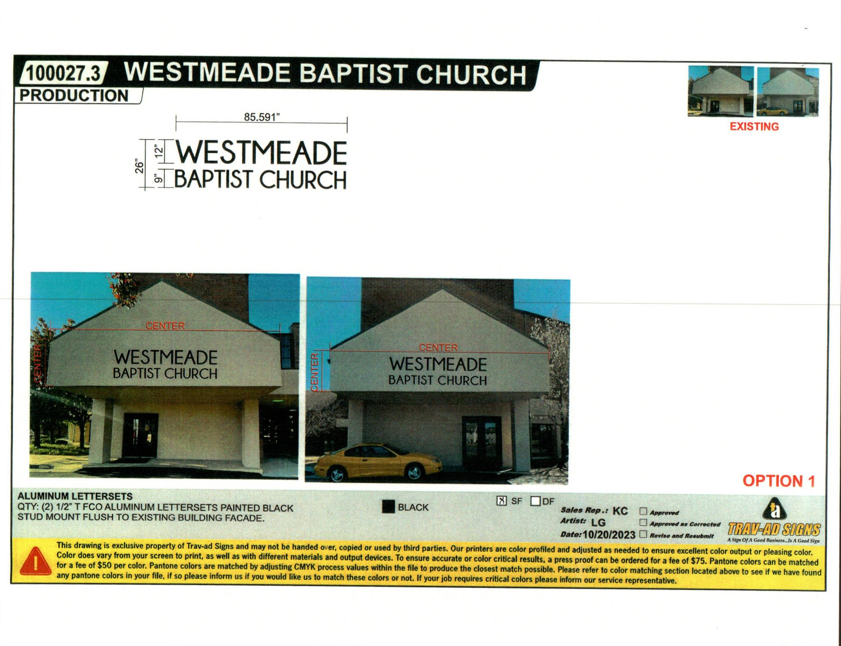

Picture
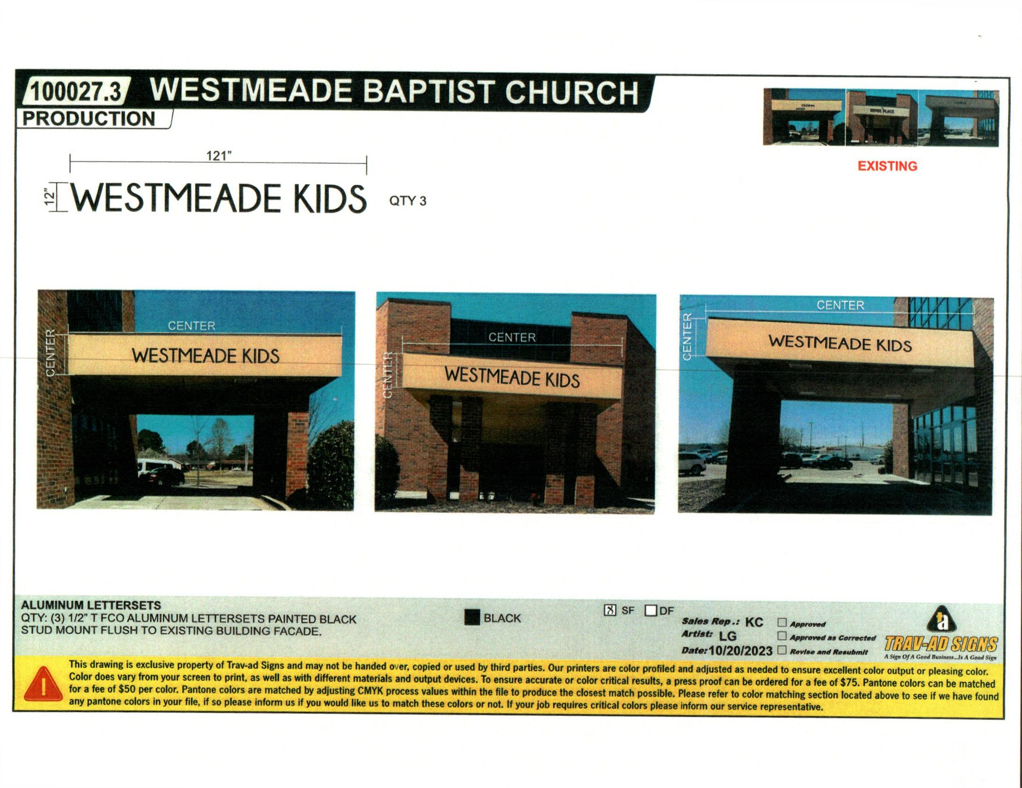

Picture
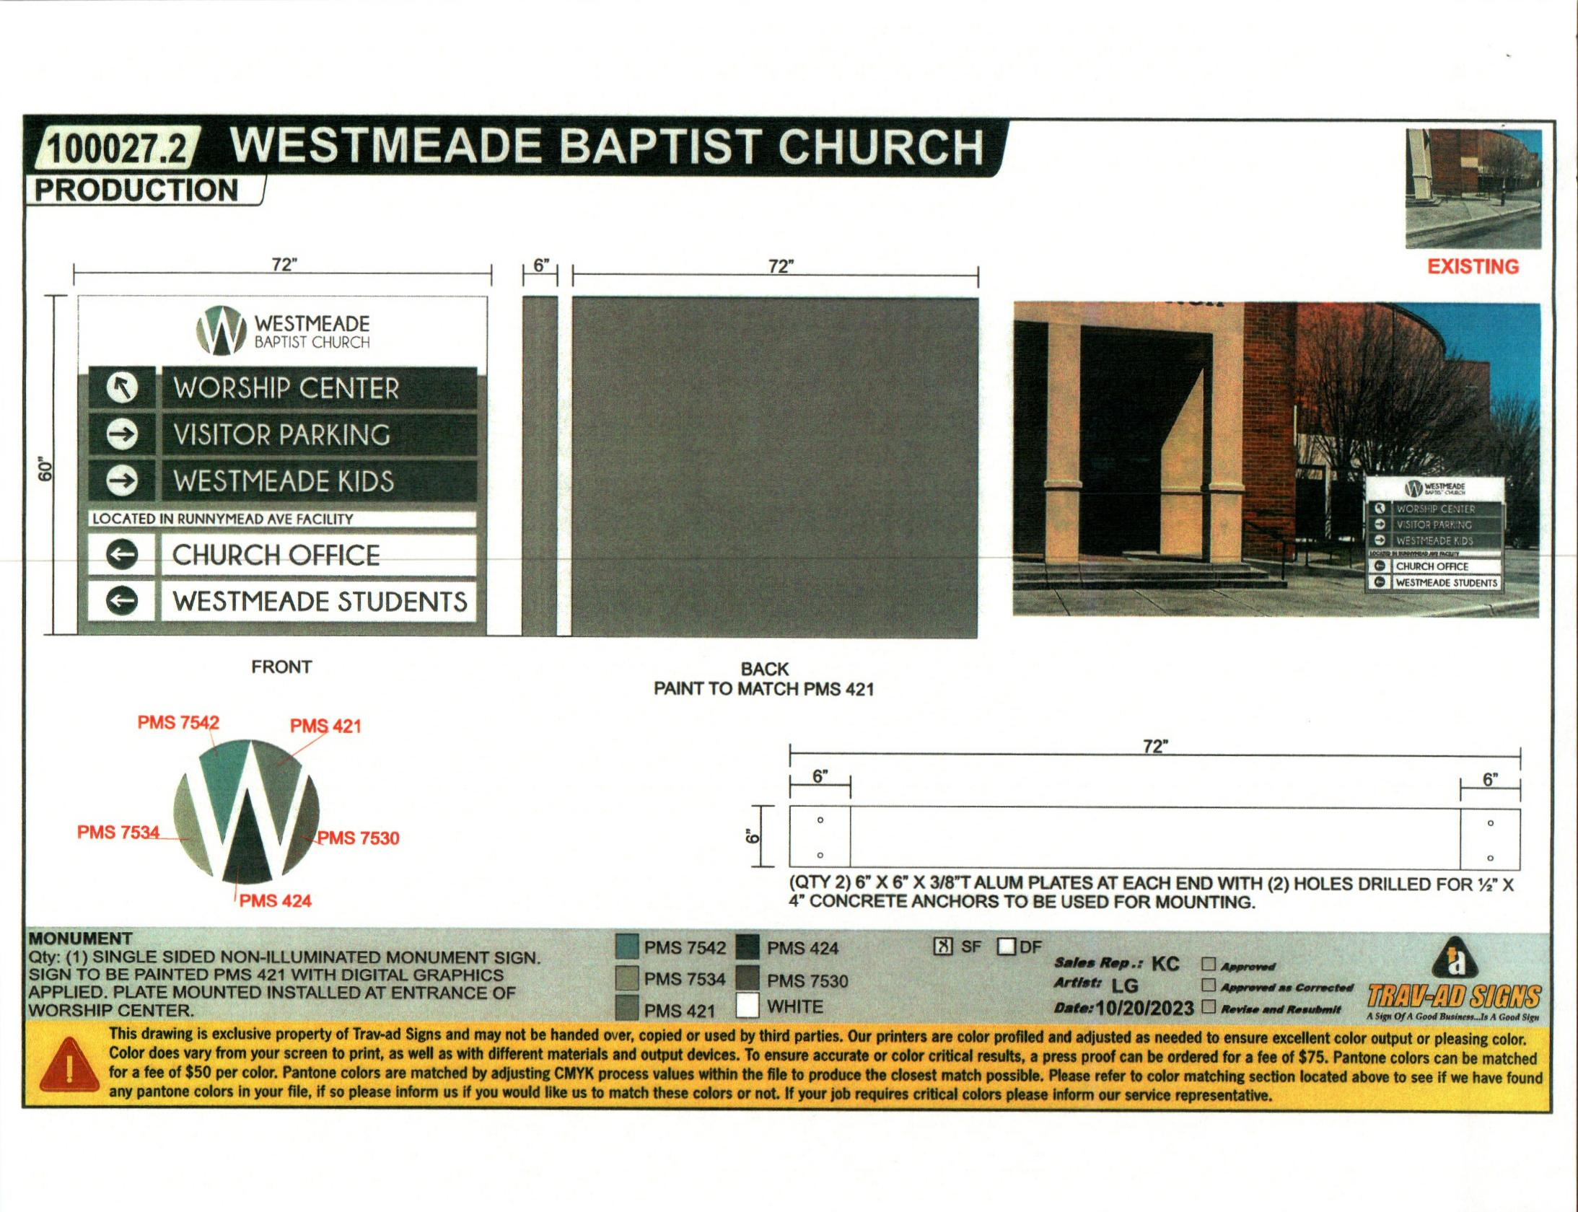

Picture
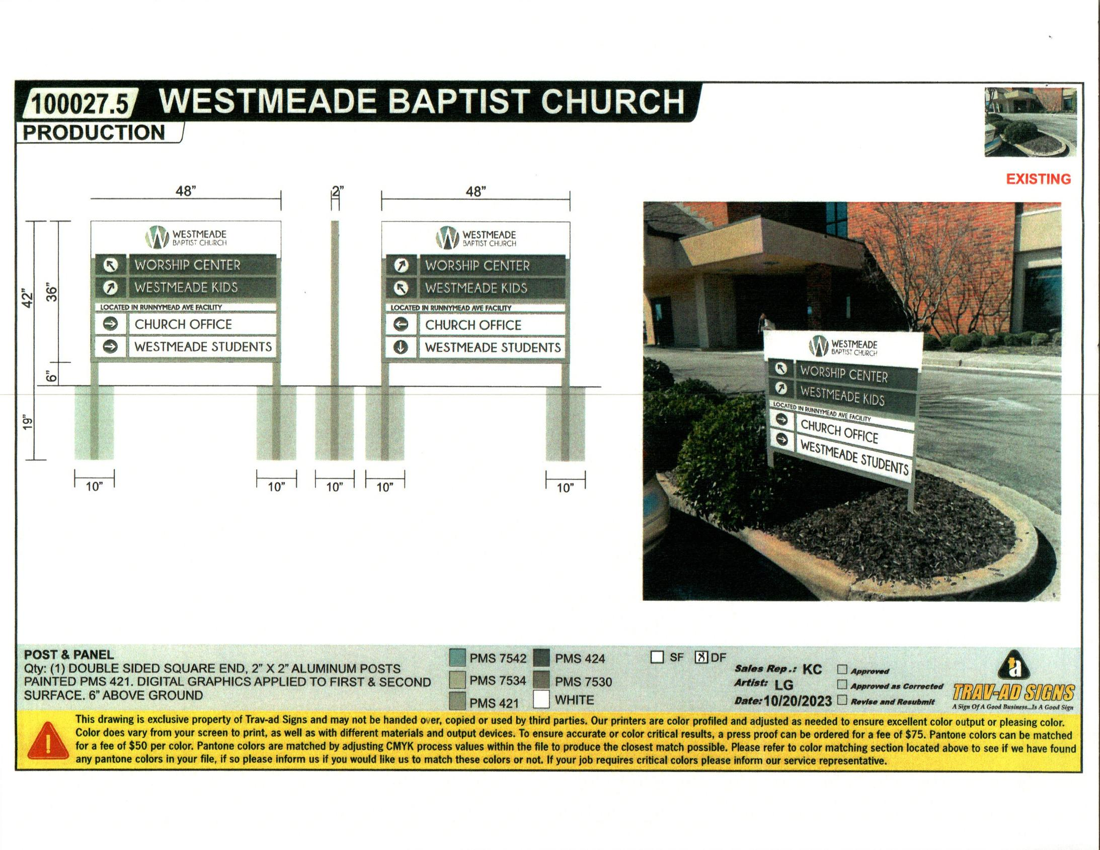

Picture
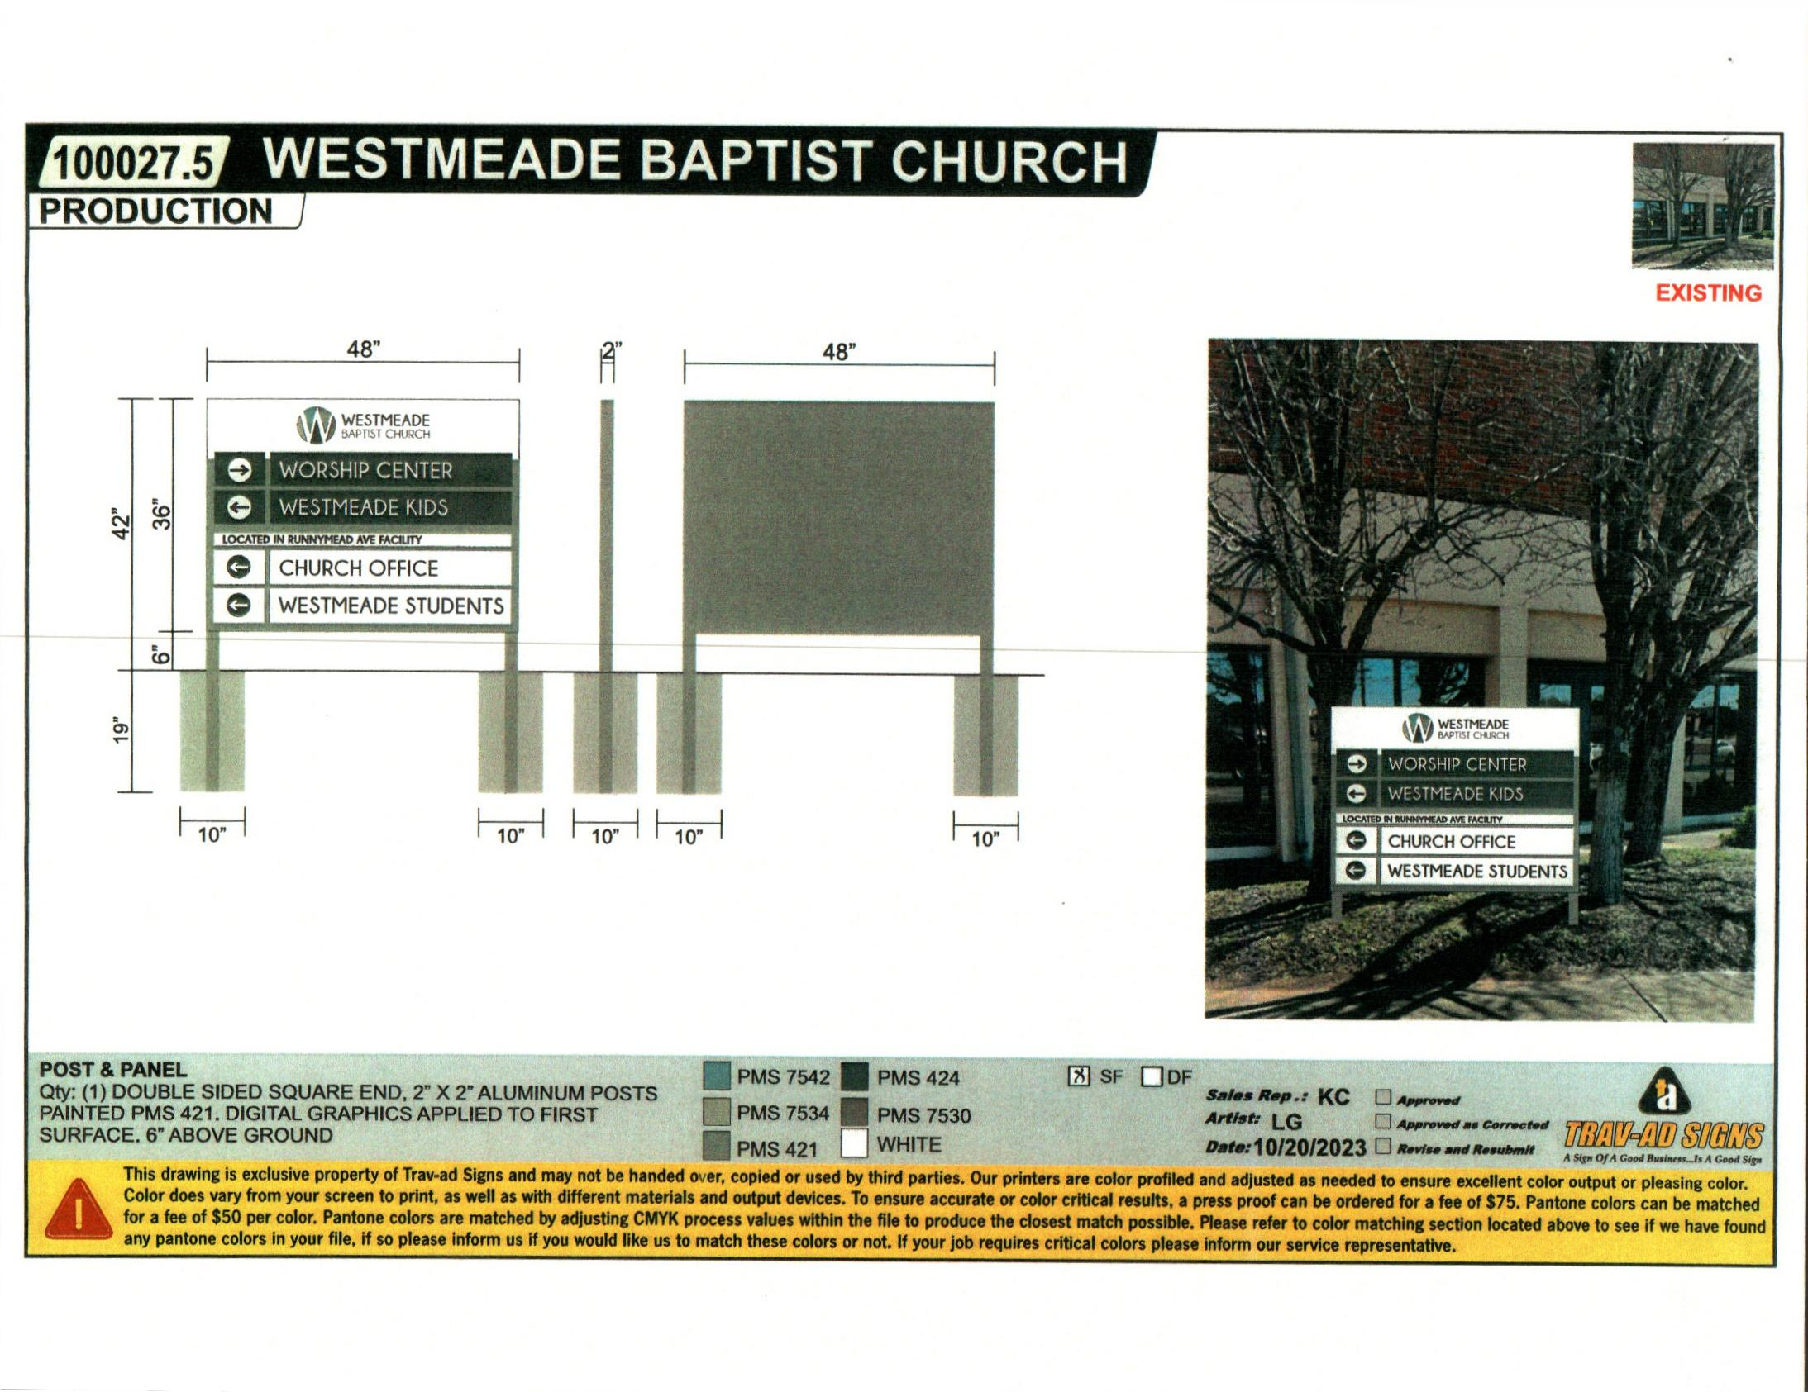

Picture
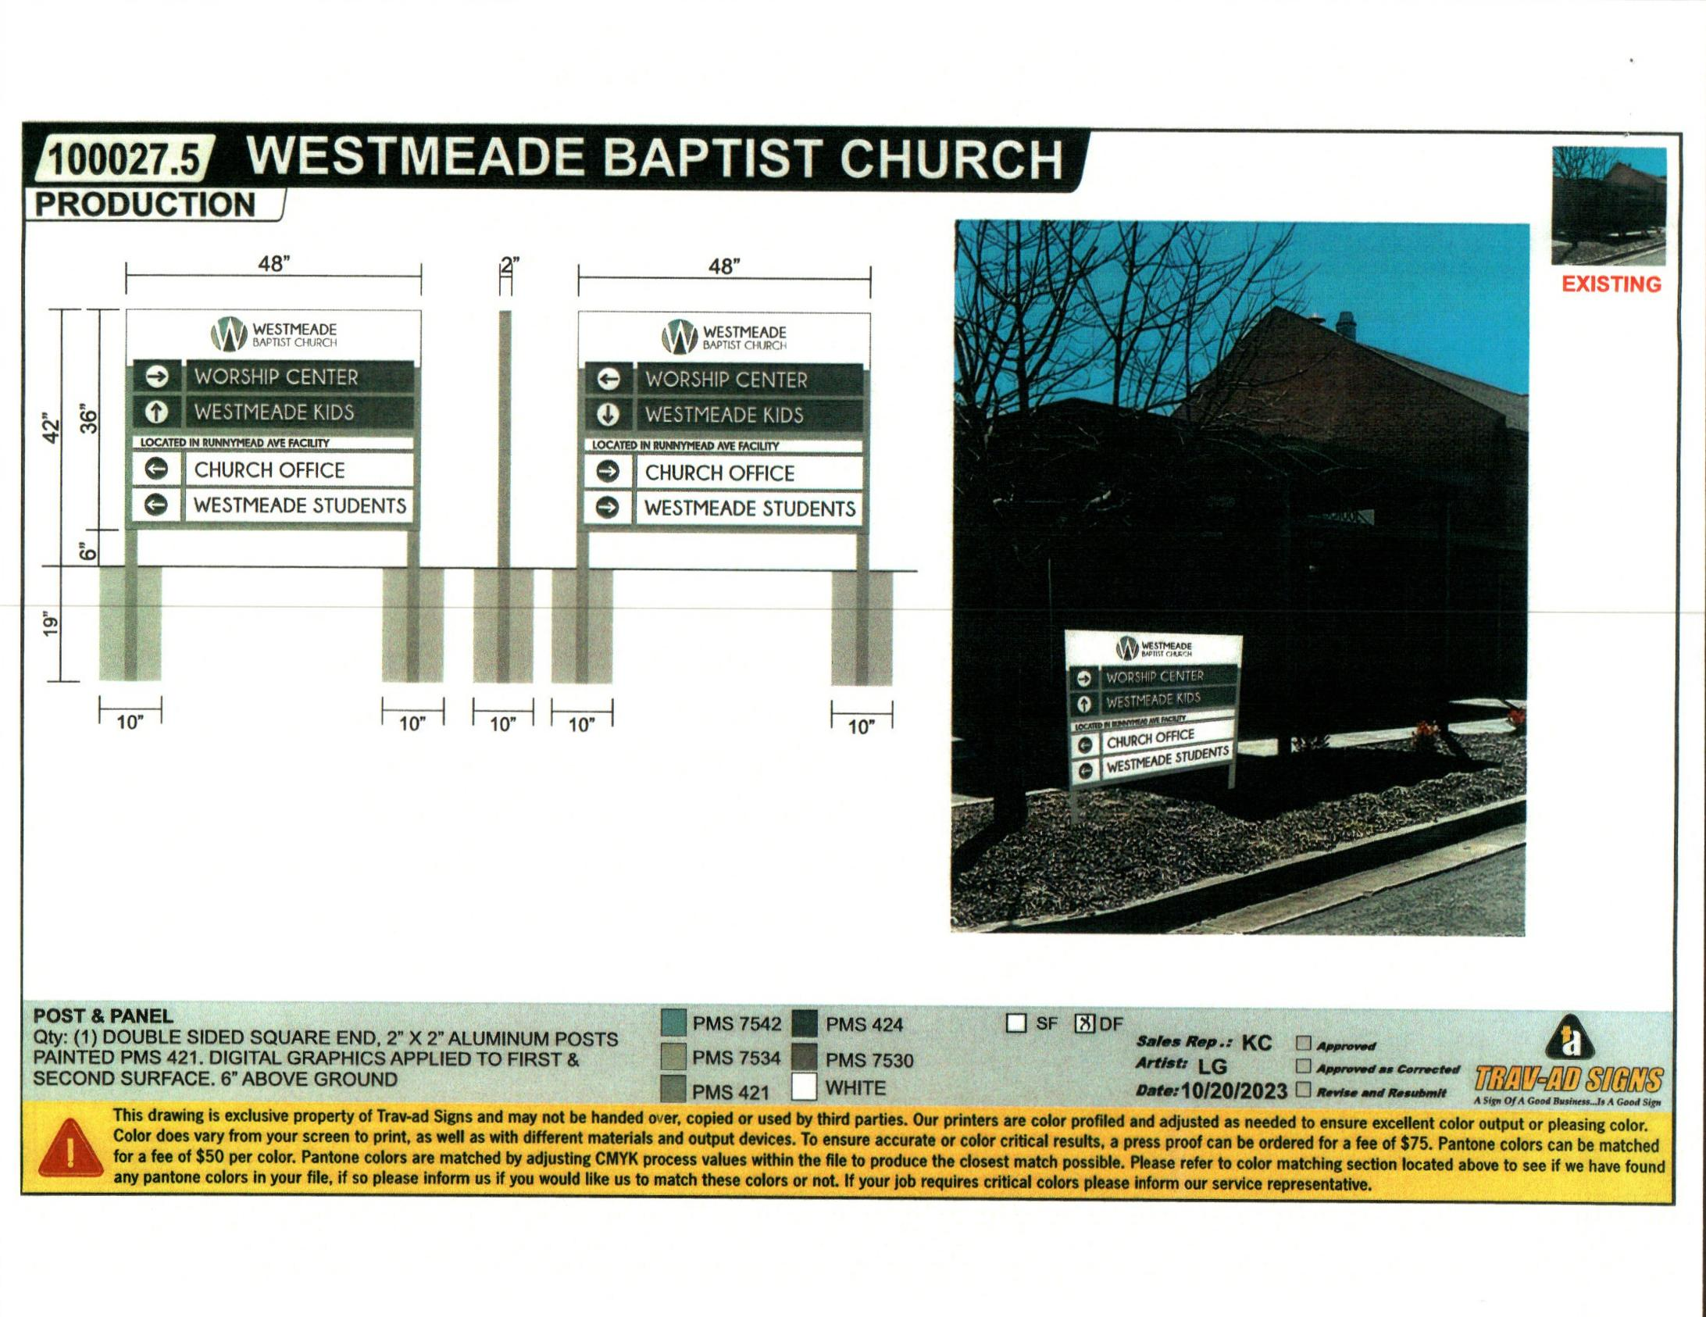

Picture
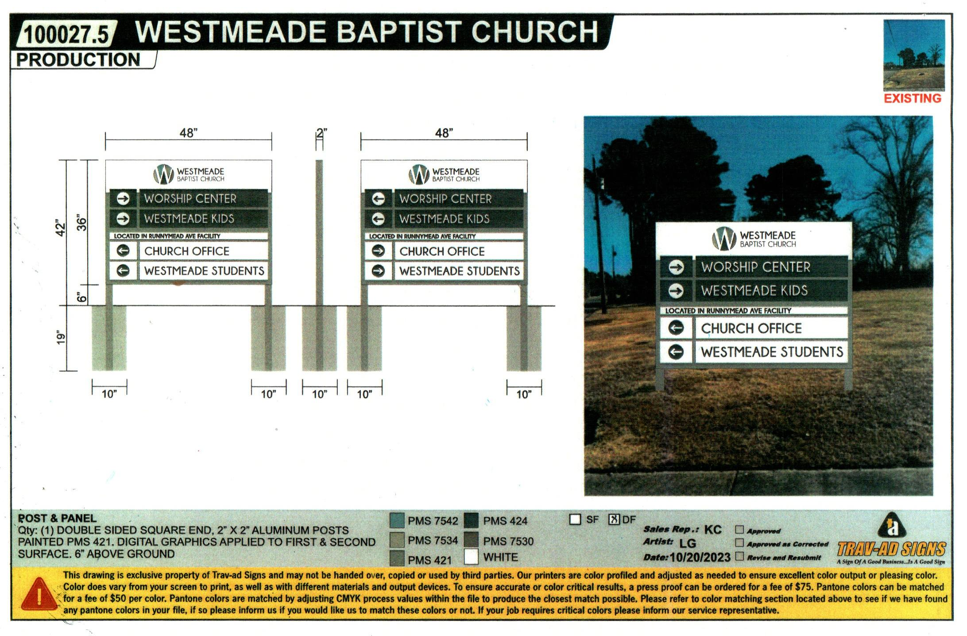

Picture

Picture
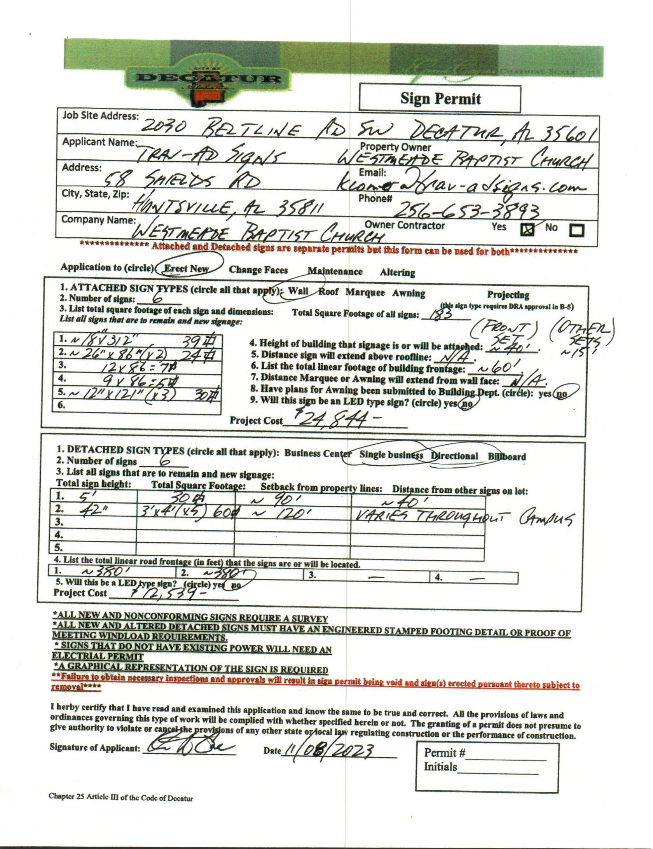

Sign Permit
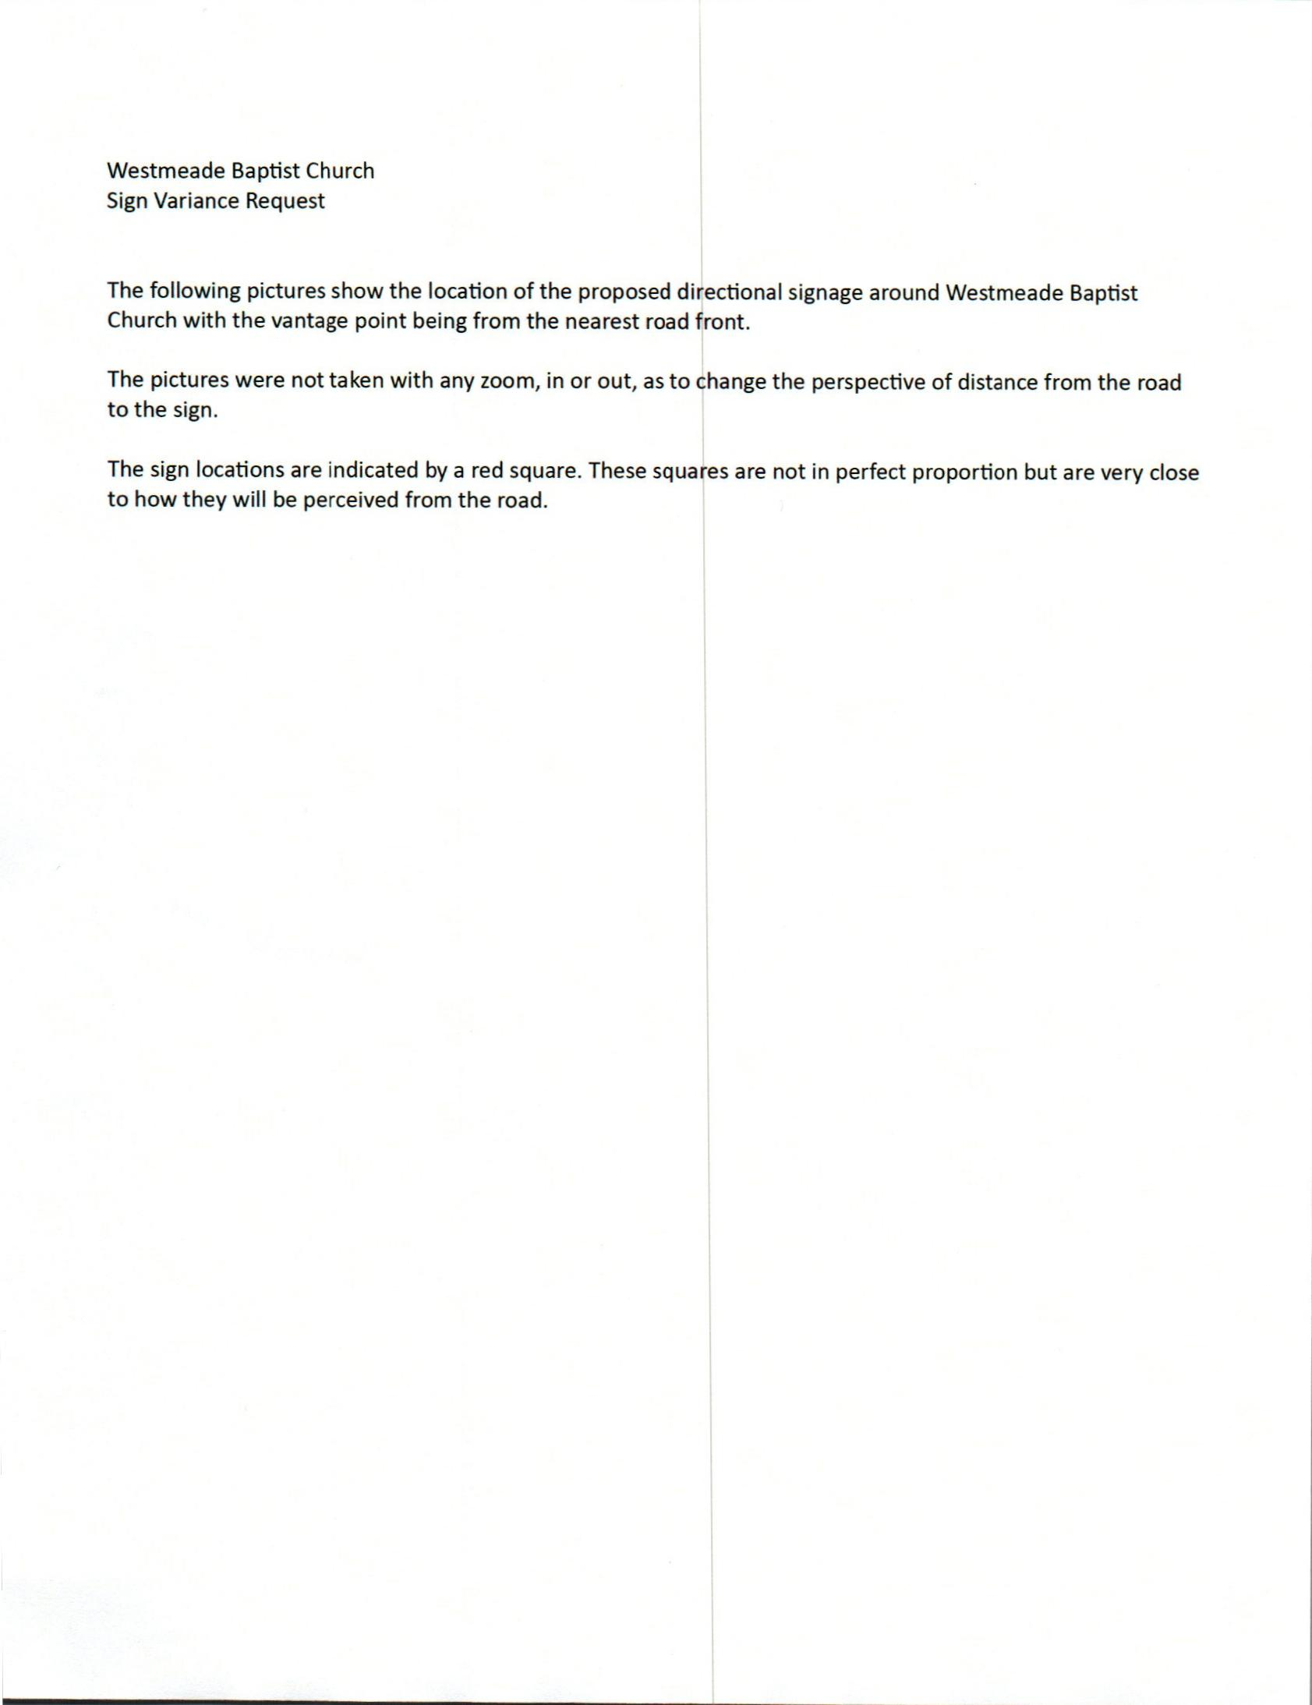

Letter
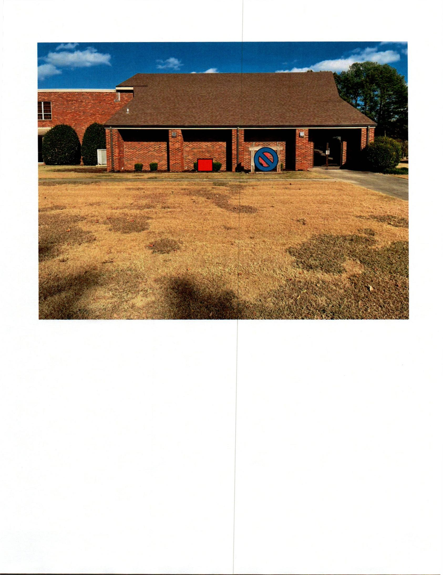

Picture
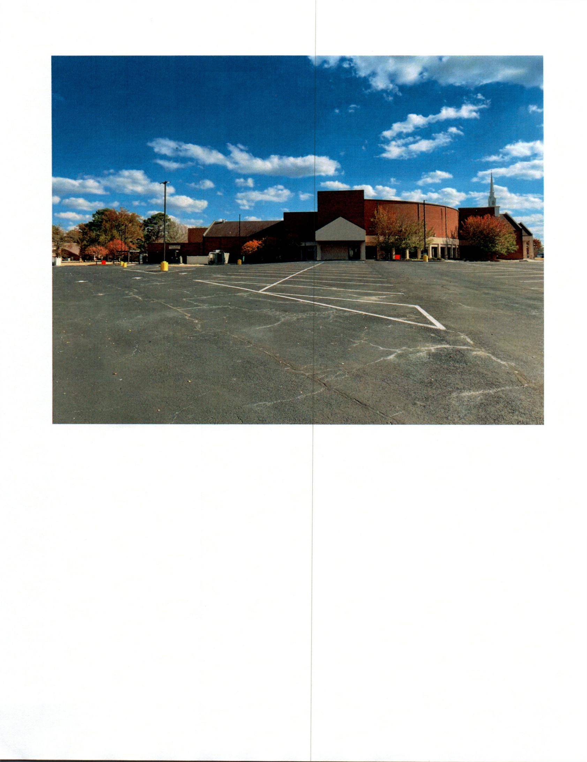

Picture
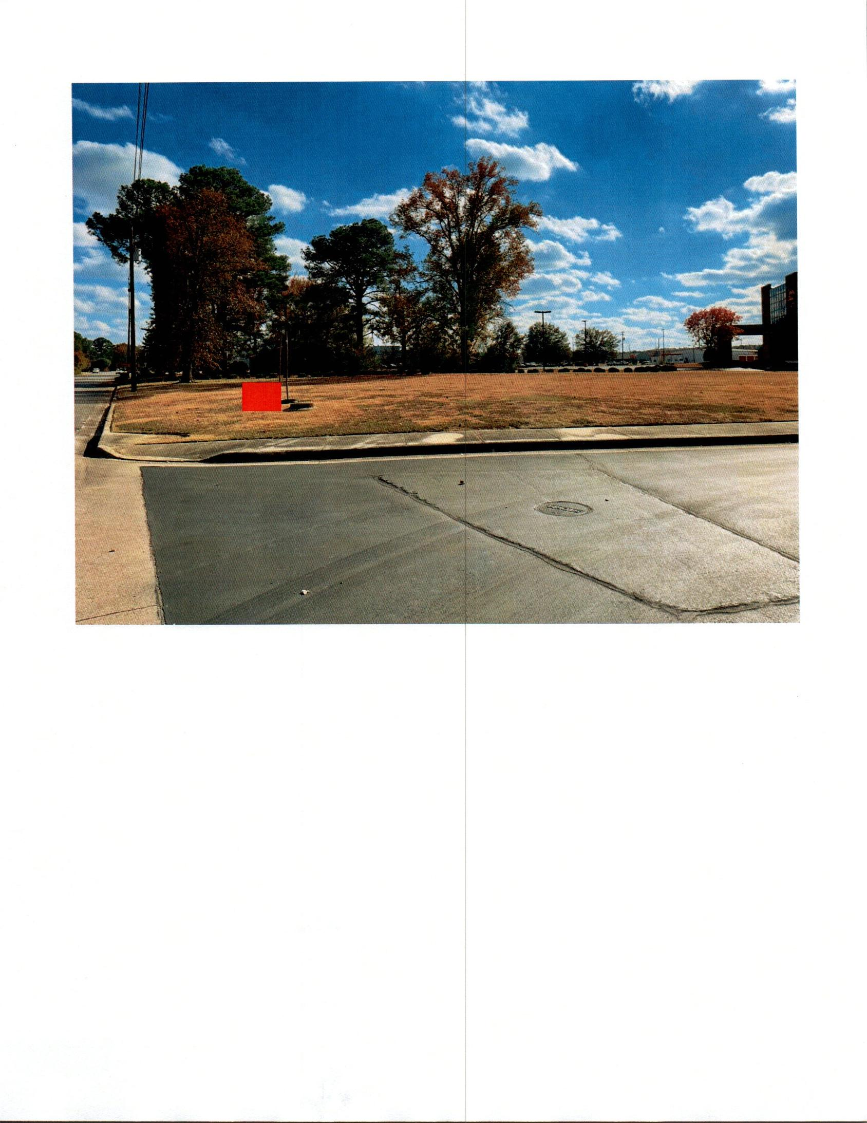

Picture
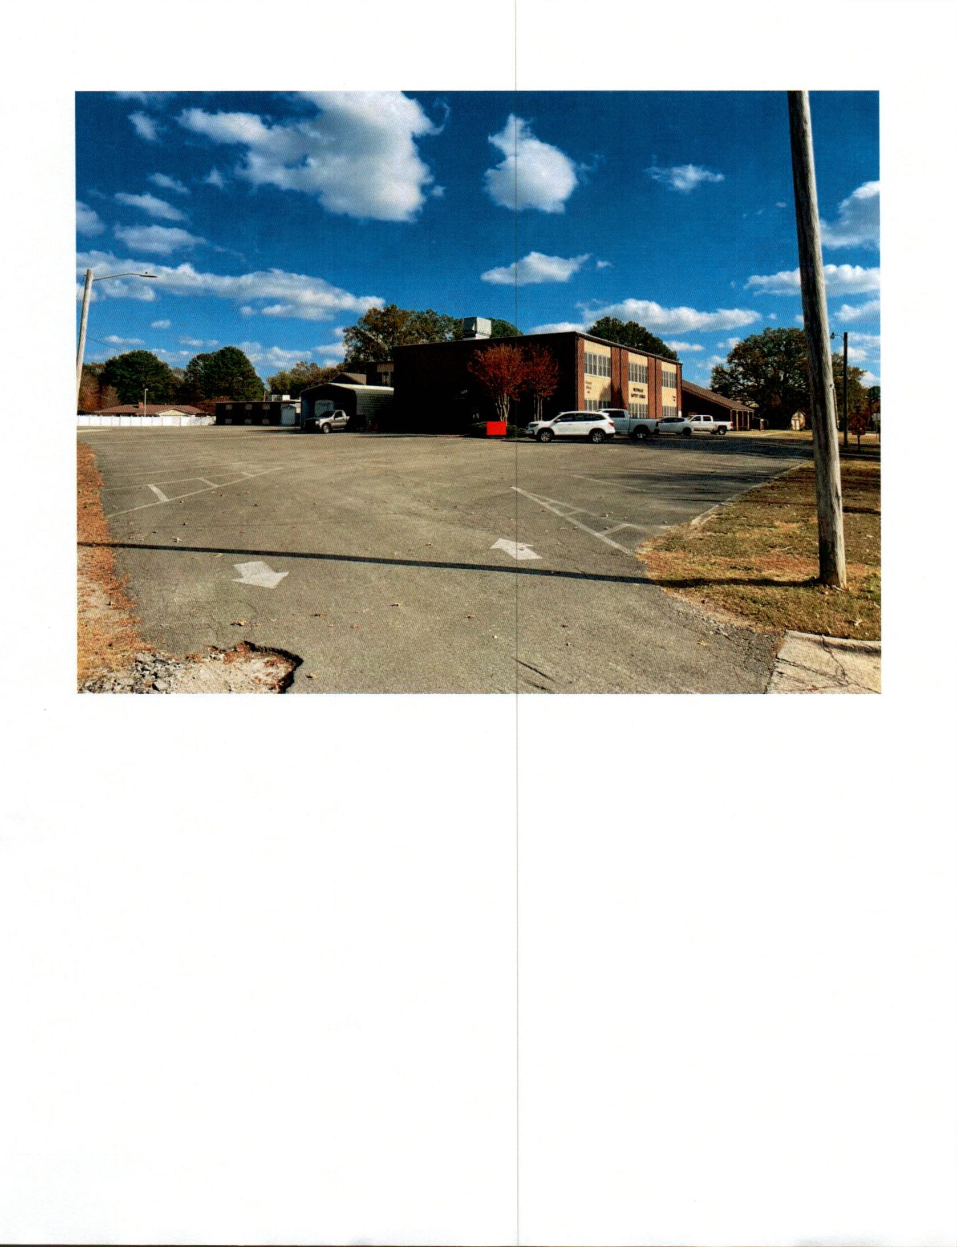

Picture
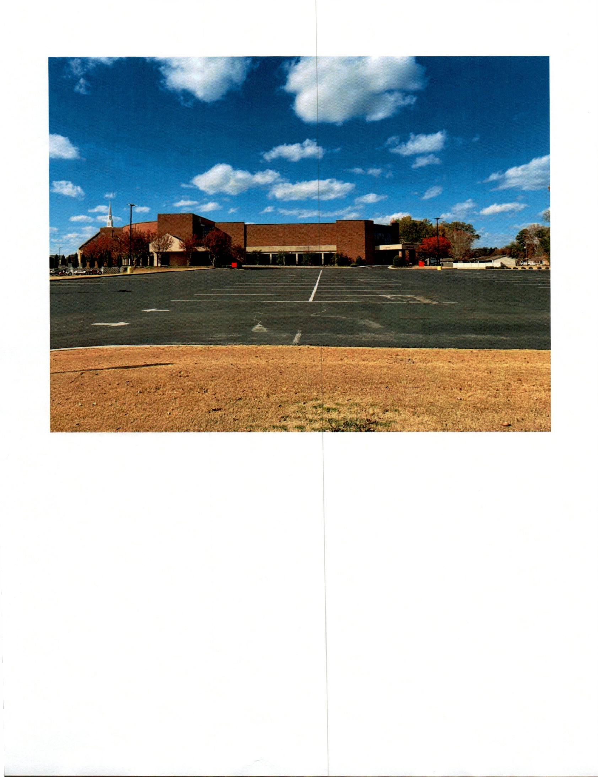

Picture
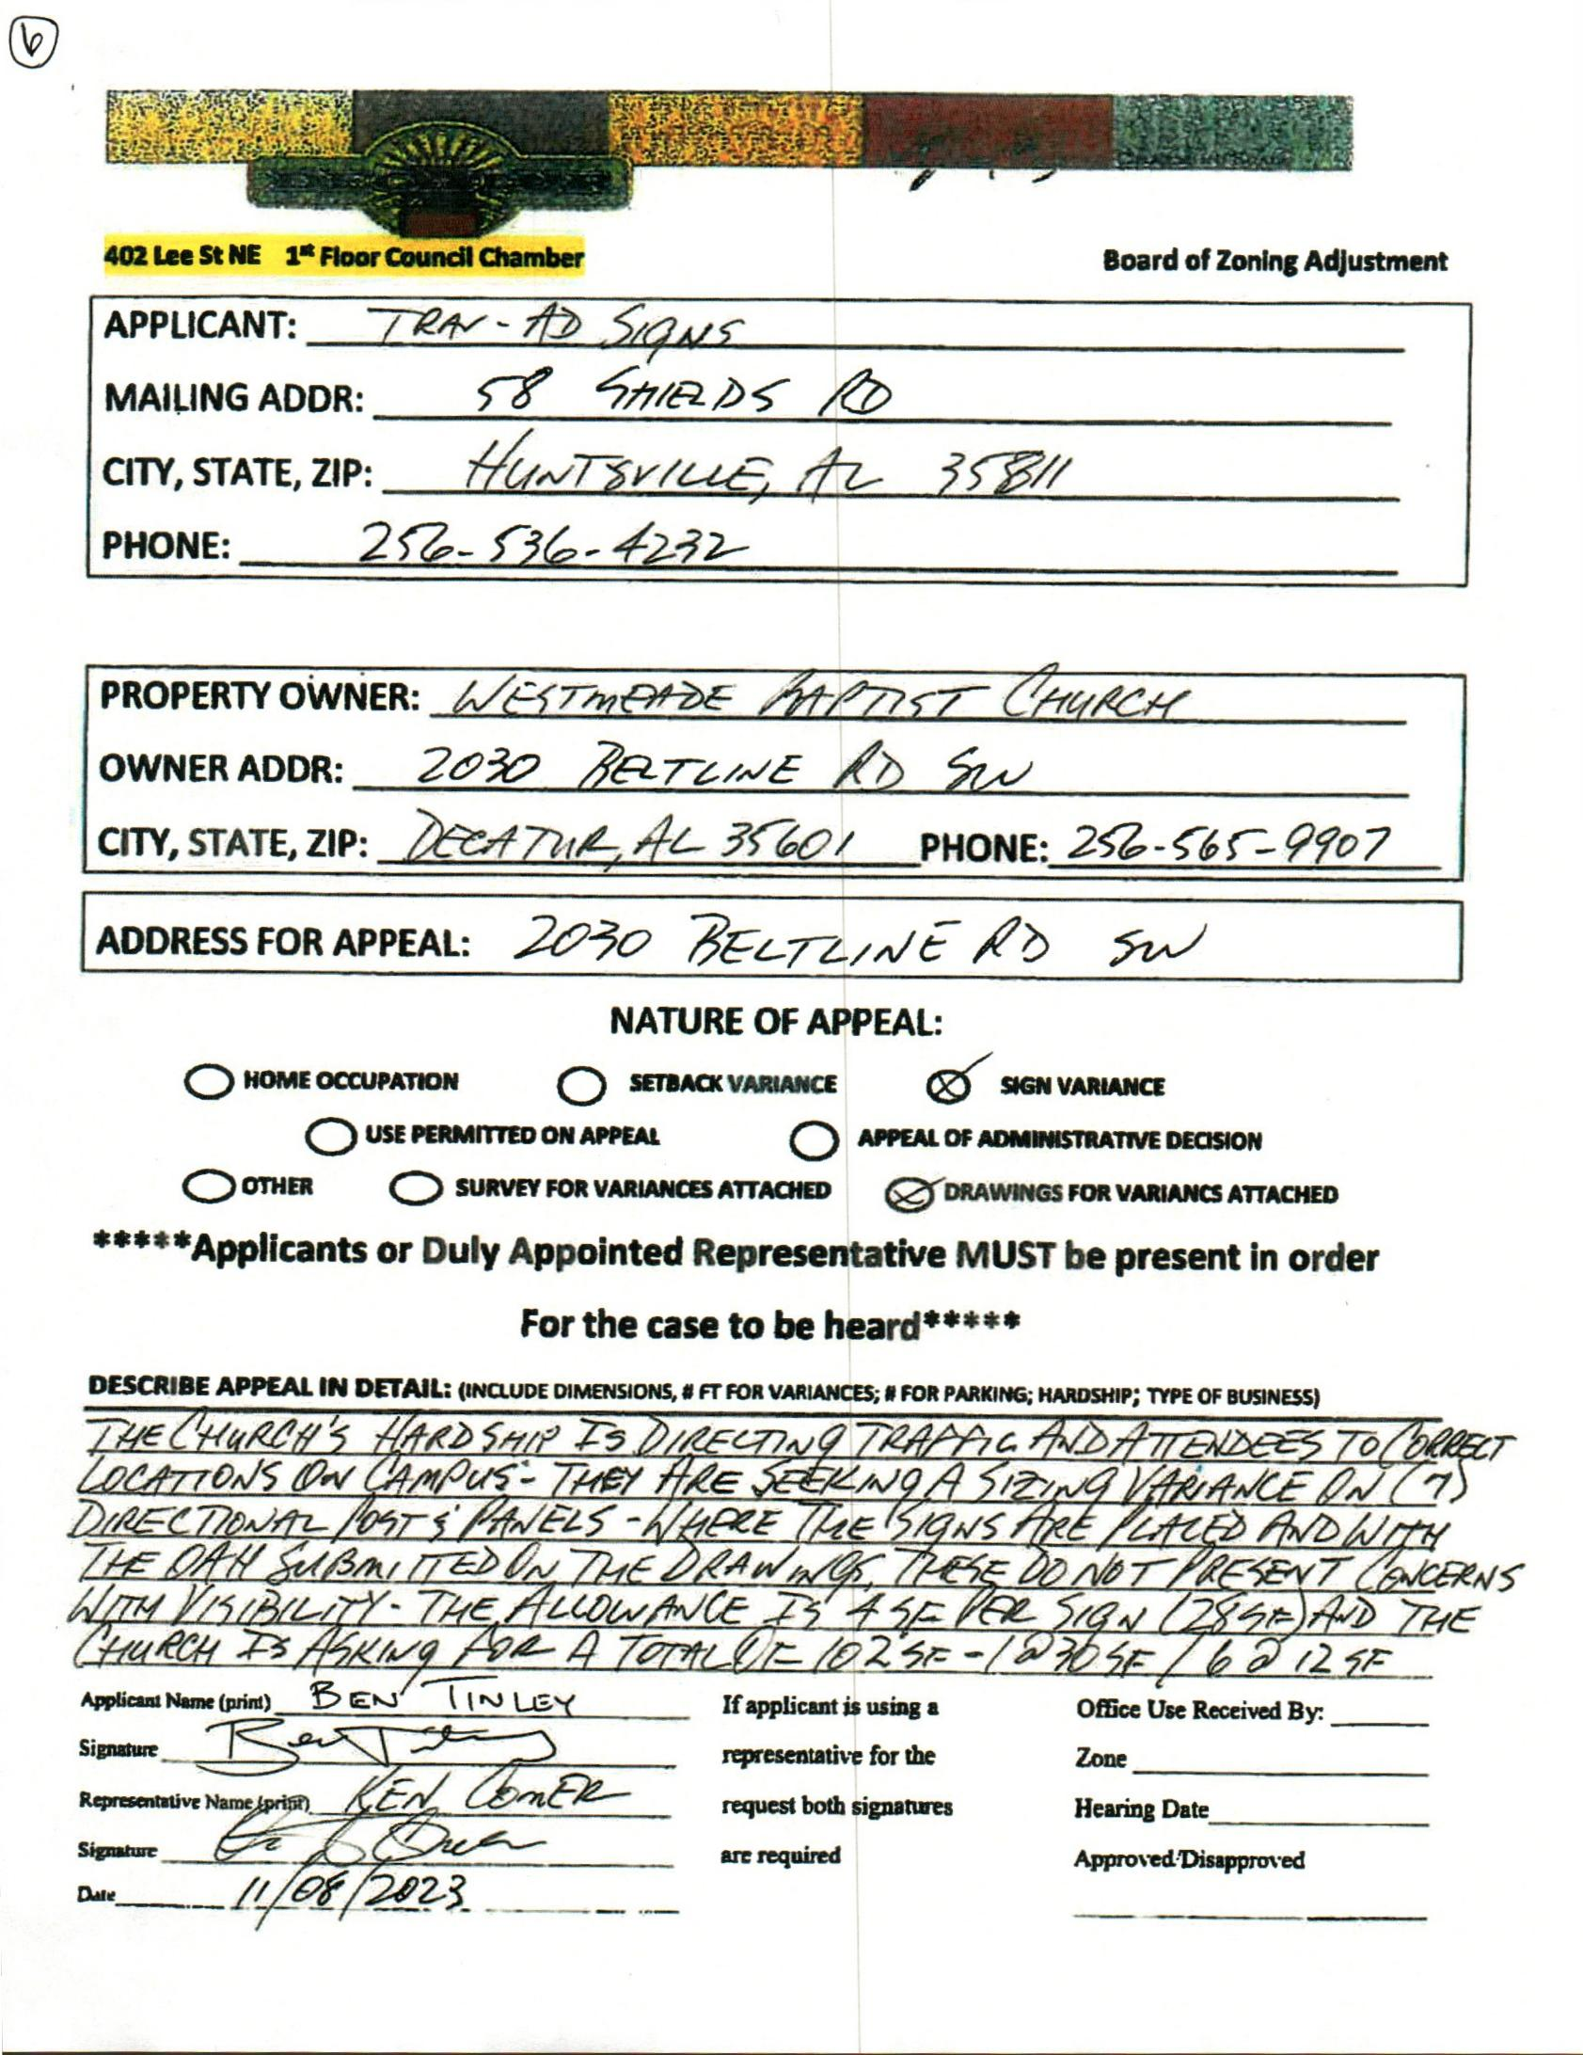

CASE NO. 7 2030 BELTLINE RD
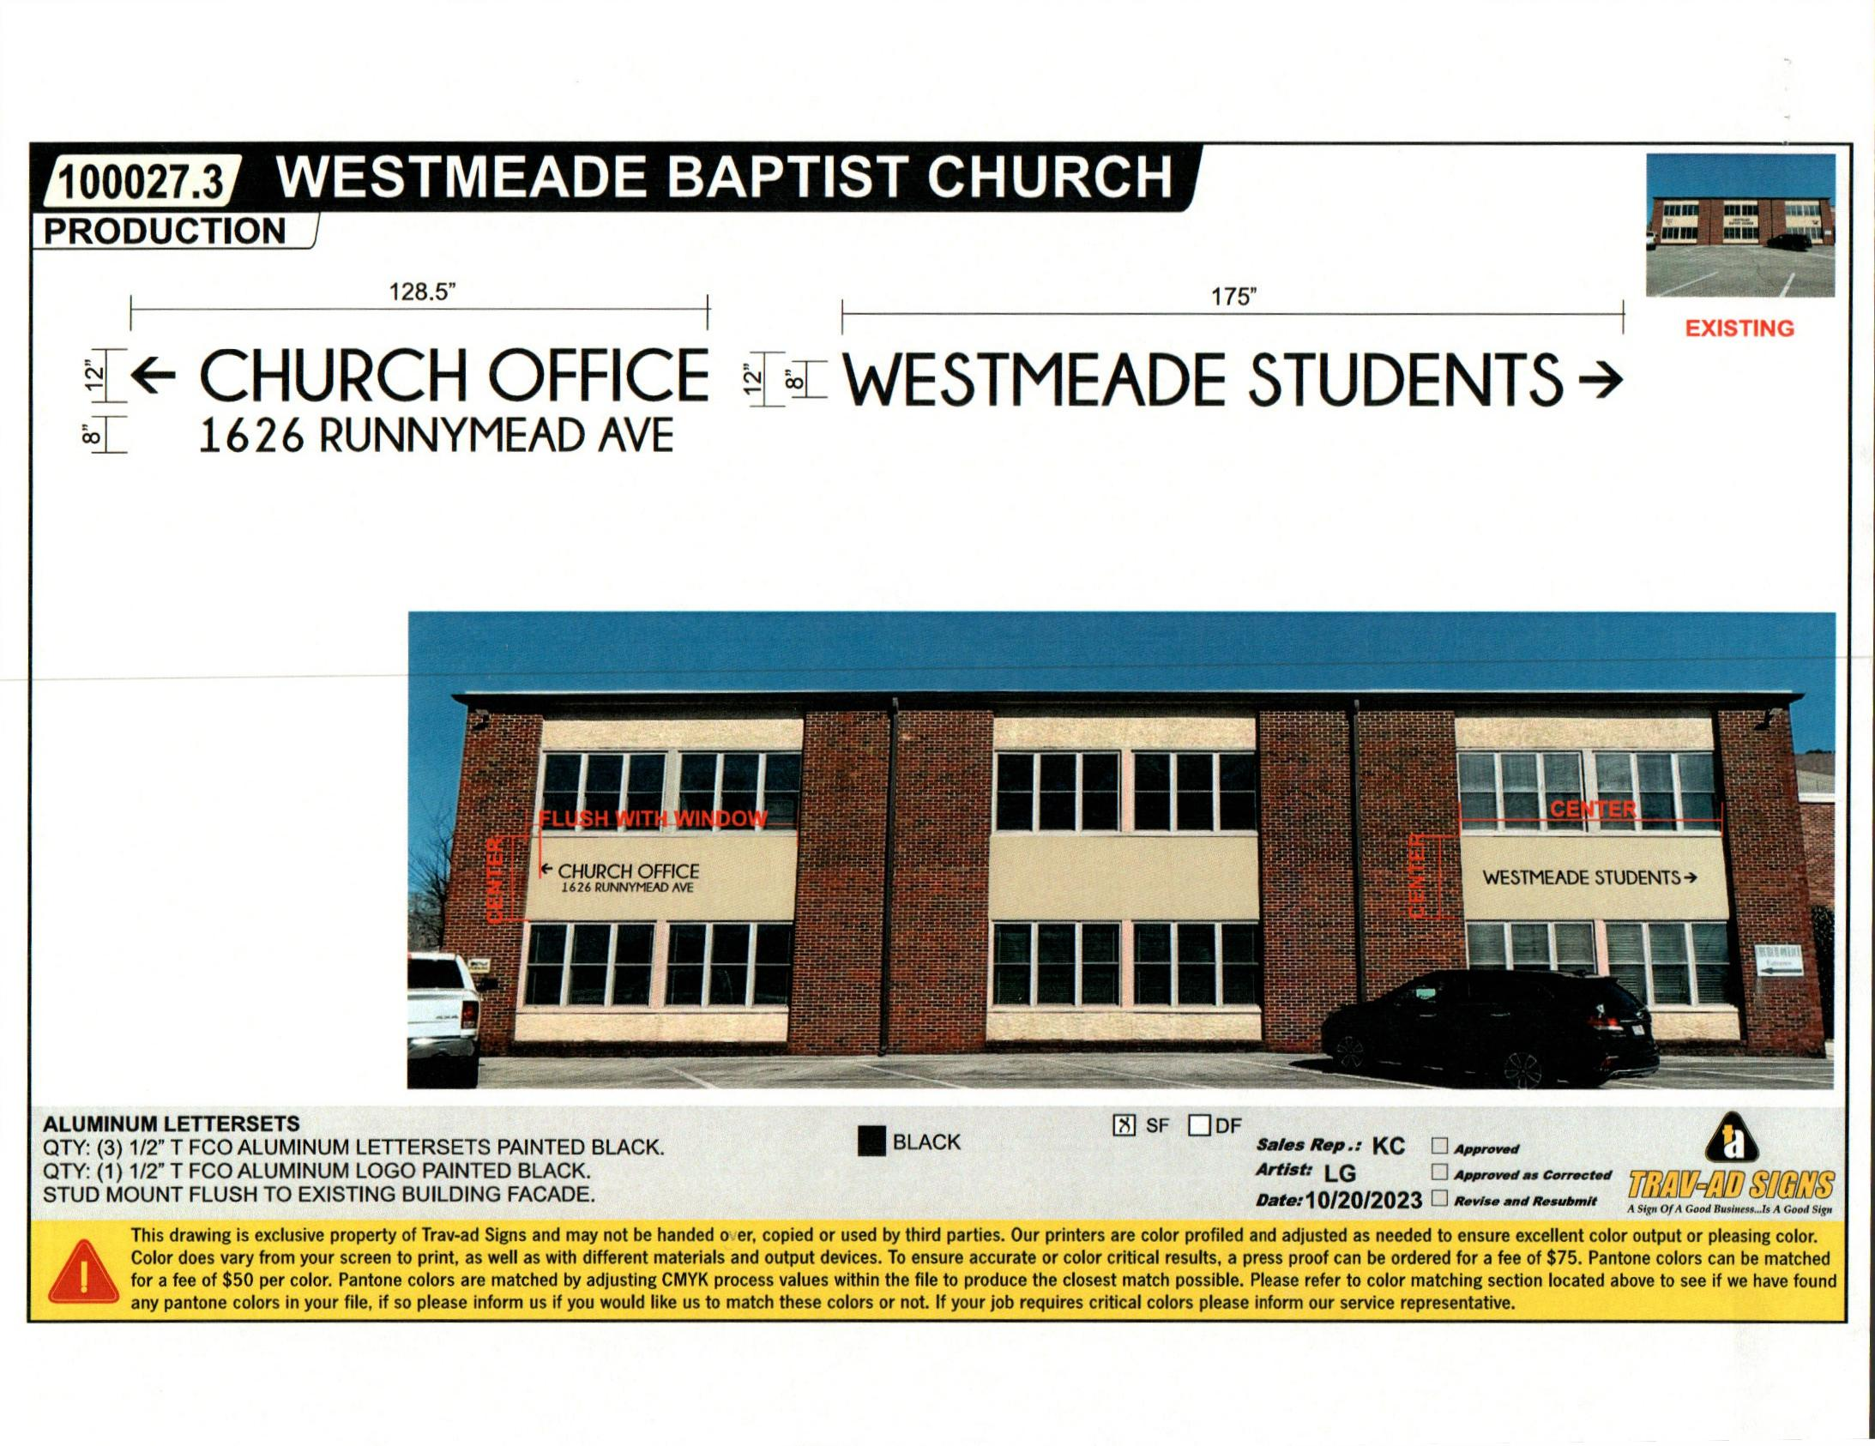

Picture
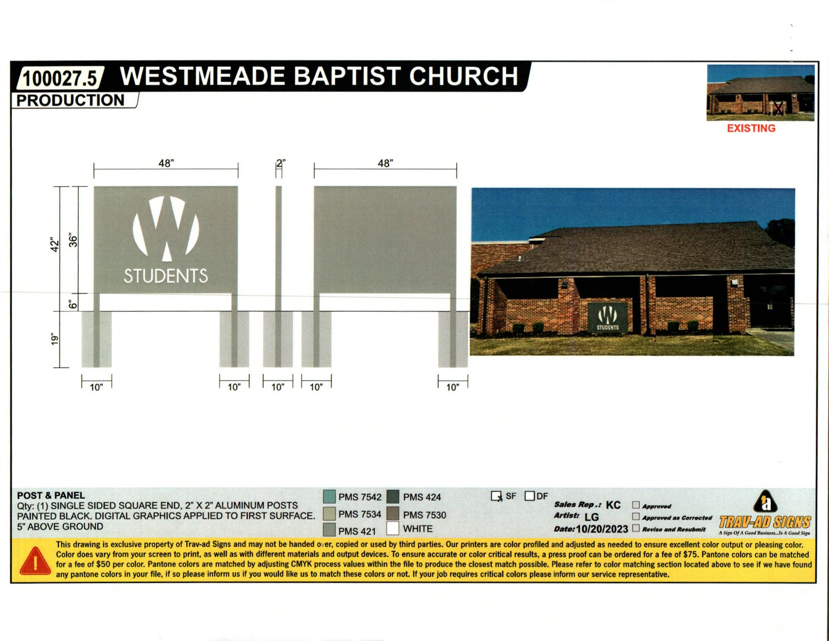

Picture

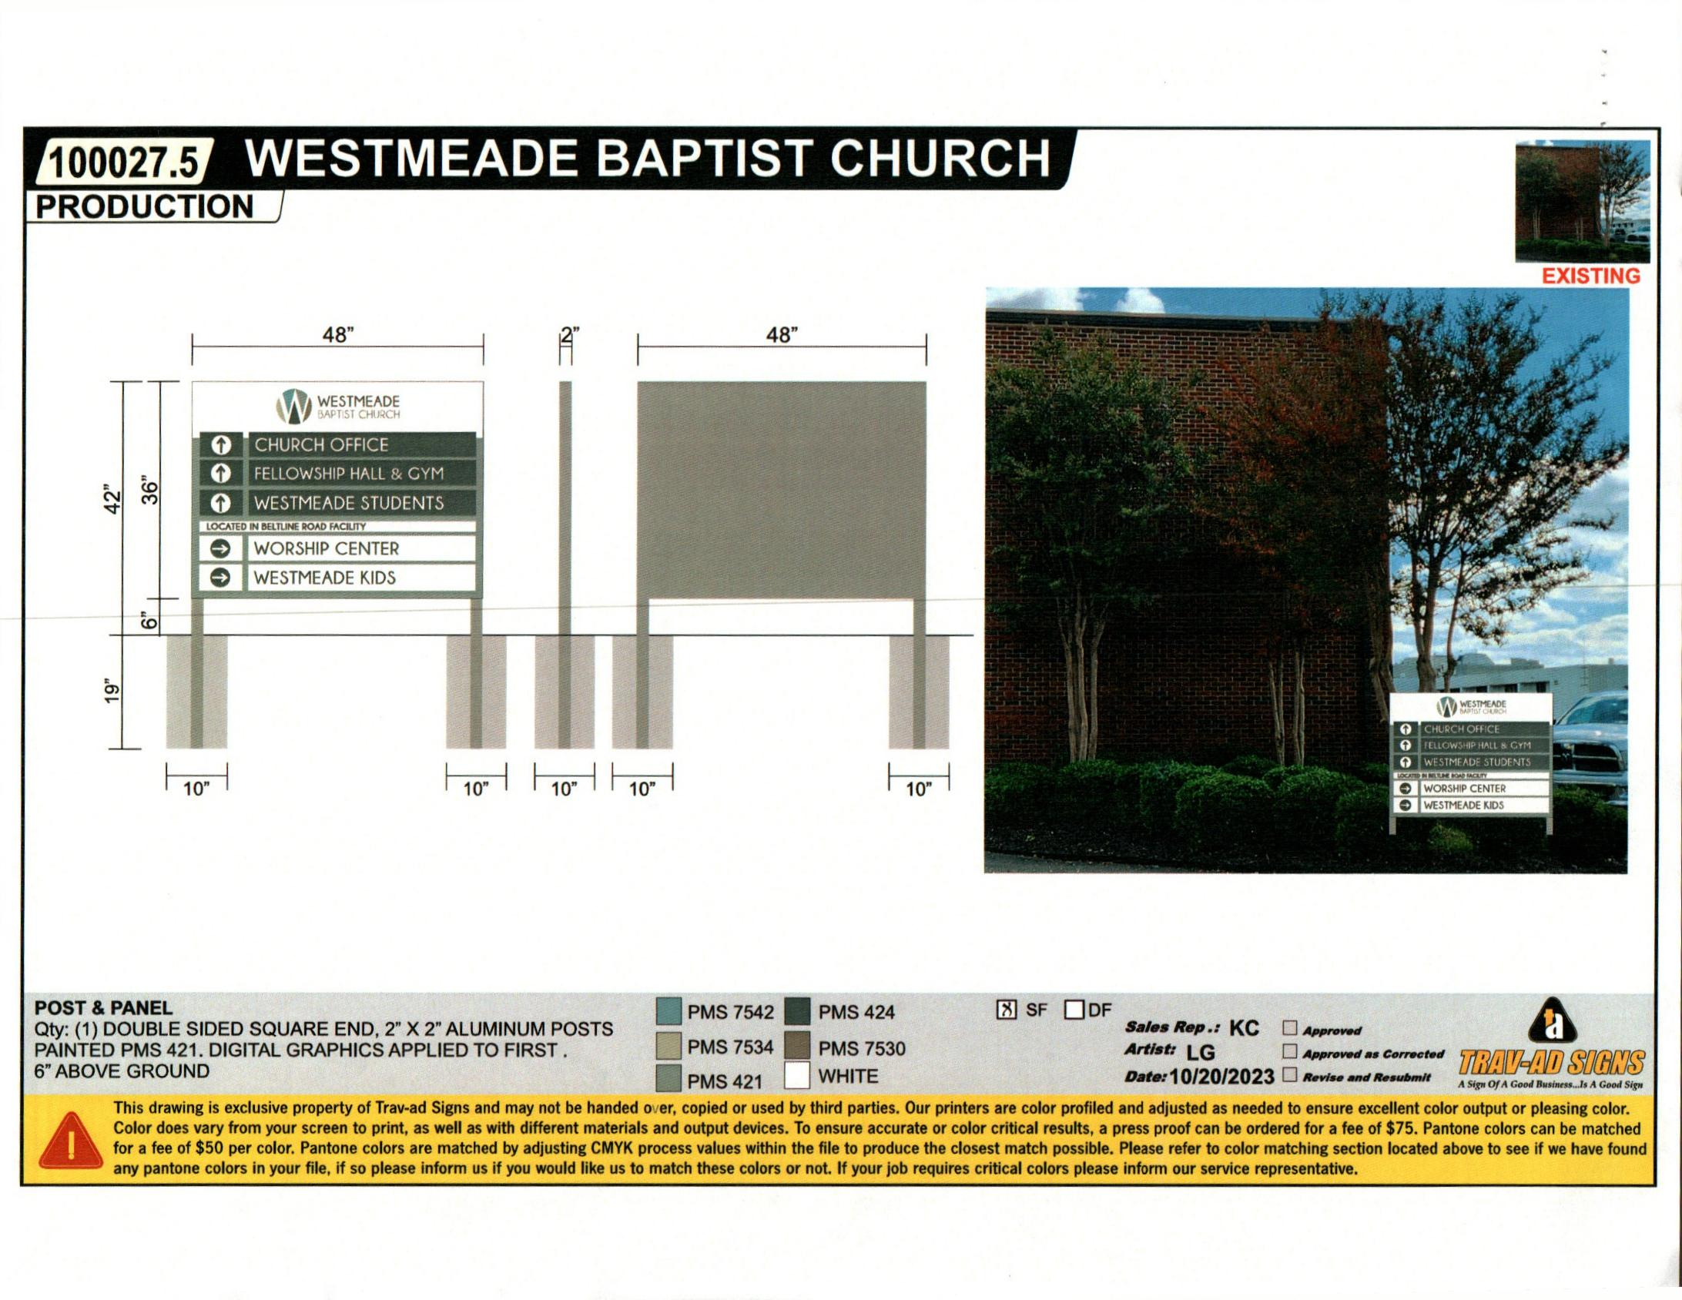

Picture
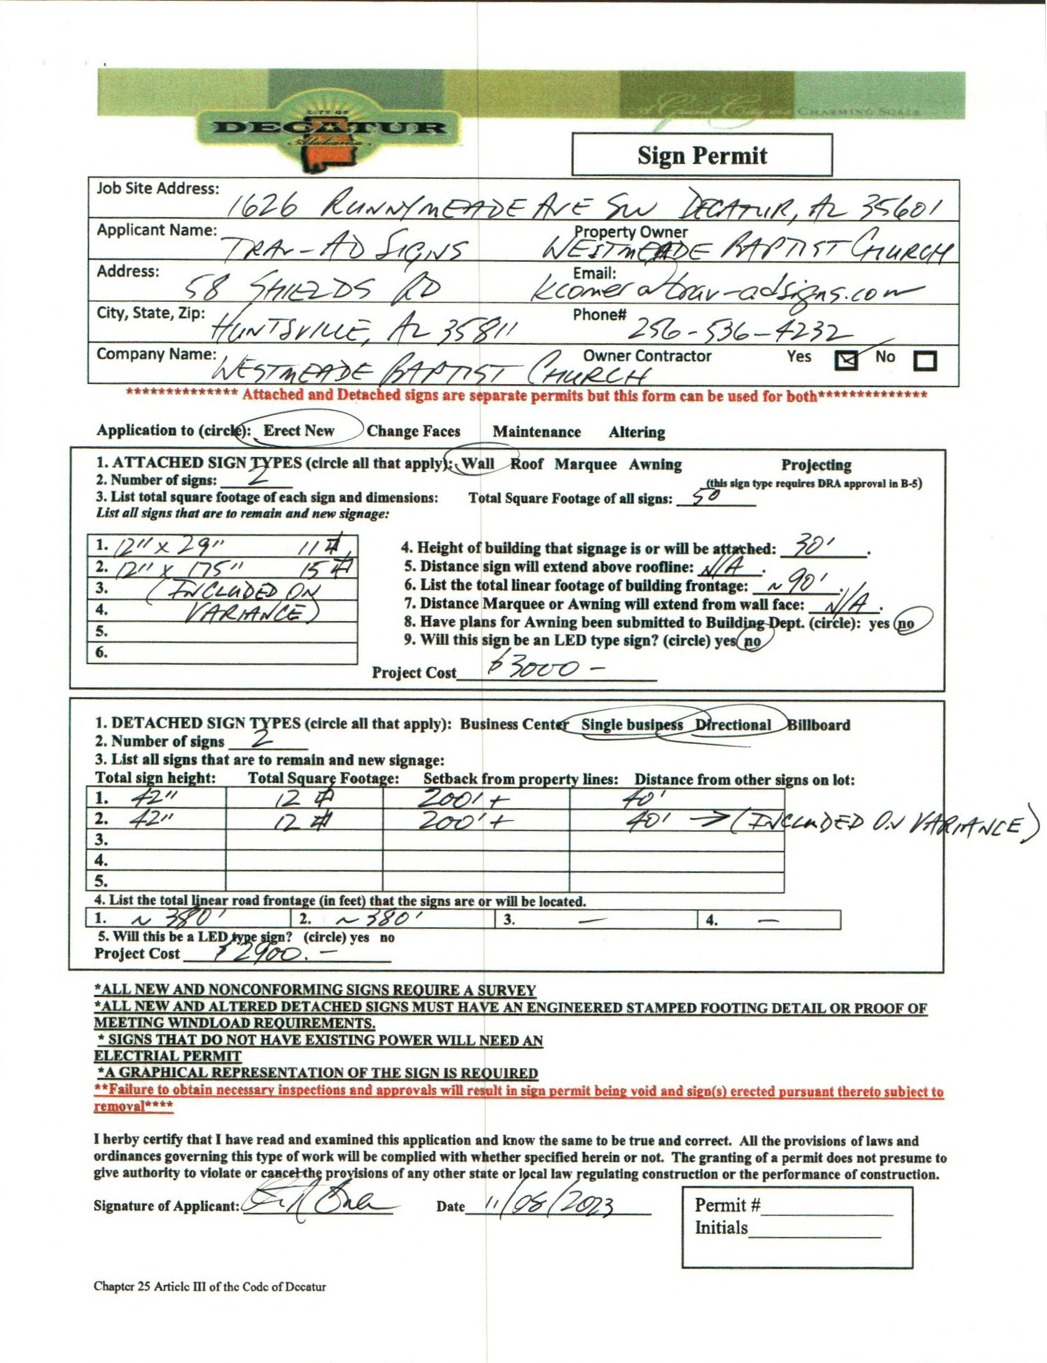

SIGN PERMIT APPLICATION

