Board of Zoning Adjustment
DATE: October 31, 2023
TO: Board of Zoning and Adjustments: Delayne Dean, Chair, Brad Townson, Chester Ayers, George Allen, Michael Maurer, and Mark McCurry

BOARD OF ZONING ADJUSTMENT
October 31, 2023
Pre-meeting – 3:30 p.m. (7th Floor)
Meeting – 4:00 p.m. (Council Chambers)

Table of Contents

Table of Contents 2
Minutes September 26, 2023 3
October Agenda 7
case no. 1 620 pumpkin dr. sw 9
case no. 2 105 memorial dr. Nw 10
survey 11
case no. 3 23366 bibb garrett rd 12
sign permit 13
picture 14
picture 15
picture 16
picture 17
picture 18
case no. 4 213 cherry st ne 19
case no. 5 6250 US Hwy 31 N. Tanner, Al. 20
case no. 6 3831 Hwy. 31 S. 21
Sign exceptions 22
survey 23
case No. 7 Application 24
survey 25
warranty deed 26
warranty deed pg. 2 27

Minutes September 26, 2023

MEMBERS PRESENT: Delayne Dean, Mr. Brad Townson, Mr. Chester Ayers,
SUPERNUMERARIES: Mr. Mike Maurer, Mr. Mark McCurry
COPIED TO: Mr. George Allen
OTHERS PRESENT: Mrs. Ruth Priest, Asst. City Attorney
Mr. Chris Stone, Planning Department
Mr. Bob Sims, Building Inspector
Mrs. Nancy Whiteside. Recorder
Chair, Delayne Dean called the meeting to order at 4:00 p.m. in the council chambers on the first floor at City Hall.
Mr. Bob Sims, Building Department, called the roll.
The minutes from the July 2023 meeting were approved Mr. Brad Townson motioned to approve the minutes Mr. Mike Maurer seconded the motion. On a voice vote, the motion carried.
CASE NO. 1
Application and appeal of Tressia Jones for a determination as allowed in Section 25-93 (b) and as defined in Article IV, as amended and adopted, of the Zoning Ordinance in order to operate a Group Nighttime Care Facility operating. The property is located at 620 Pumpkin Dr. SW in a R-2 Single-Family Residential District.
This case was moved to the end of the docket when no one came forward to present the case.
CASE NO. 2
Application and appeal of Charles L. Collier for a 3.3 foot front yard setback variance from Section 25-10.9 (2) (c) of the Zoning Ordinance in order to build a new house located at 2704 Friar Tuck Ct. SW, the property is located in a R-2 Single-Family Residential District.
Mr. Charles Collier presented this case to the Board. Mr. Collier stated he was asking for a 3.3 yard front yard setback located at 2704 Friar Tuck Ct. SW in order to build a new house.
Mr. Collier stated he would like to set the new house where it is shown on the survey.
Chair Dean asked if the extra space was going to be used as a front porch. Mr. Collier stated it would be used for a garage.
Mr. Brad Townson asked Mr. Collier if the radius of the cul-de-sac was going to impact the front corner of the garage, Mr. Collier stated yes.
Chair Dean asked for further questions from the Board.
Chair Dean verified that the aesthetics of the house would coincide with the other houses in the neighborhood, Mr. Collier stated it would.
Chair Dean asked for comments from the public, there were no comments.
Mr. Bob Sims, Building Department, had no comments.
Mr. Chris Stone, Planning Department, asked if the topography of the lot was such that the house may be moved back 3 feet to have the house fit on the lot.
Mr. Collier stated he was wanting to preserve as much of the back yard as possible.
Chair Dean asked if moving the house up 3 feet, would the house still be lined up with the house closest to Mr. Collier’s home in the front as well as in the back. Mr. Collier stated yes.
Chair Dean asked for any other questions, there were no more comments.
Chair Dean closed public testimony.
Mr. Brad Townson motioned to approve this case as submitted. Mr. Chester Ayers seconded the vote. On a roll-call vote the motion carried.
CASE NO. 3
Application and appeal of Champion of Decatur for a 3.5 foot setback variance from Section 25-77 (e) (3) of the Zoning Ordinance in order to move a pylon so traffic flow will not be impacted when coming off Highway 31 South. The property is located at 3831 Highway 31 South in a B-2 General Business District.
Mr. Nathan Tomberlin with the Civil Engineering Firm Pugh, Wright and McAnally, Inc. presented this case to the Board.
Mr. Tomberlin stated he was representing Champion of Decatur.
Mr. Tomberlin gave a brief history stating why this request was being presented.
Mr. Tomberlin stated that Champion of Decatur had recently been annexed into the City of Decatur and improvements were being made to the facilities and a new dealership was being built north of the existing location.
Mr. Tomberlin stated Alabama Department of Transportation (ALDOT) had specifications which had to be met to allow access to the existing building.
Mr. Tomberlin stated that the sign has been pushed back as far as it could be to meet as much of the zoning ordinance that could be however, the zoning requirement was not being met.
Mr. Tomberlin stated the drawing presented was confusing because the drawing was showing a worst case scenario showing the sign could be pushed back twenty-six and a half feet back.
Mr. Tomberlin stated the illustration in the packet shows flipping the flag light in the opposite direction to get it further back from the right of way to meet the zoning ordinance.
Mr. Tomberlin stated it would be more advantageous if the orientation of the sign could stay as it is now and move it back further.
Mr. Tomberlin proposed taking the existing sign location, the same orientation, double the distance then push it back sixteen feet.
Mr. Tomberlin stated if that proposal was not approved then the sign could be flipped the other way giving them the distance of twenty-six and a half feet which is shown in the sketch provided.
Mr. Tomberlin stated the sign total width is ten and a half feet.
Mr. Tomberlin stated an additional ten and a half feet would be added.
Mr. Tomberlin stated the different exercises were performed to meet as much of the setback as possible without getting into the existing parking and drive aisles.
Chair Dean stated to Mr. Tomberlin to verify what the hardship was.
Mr. Tomberlin stated the hardship.
Mr. Tomberlin stated the access that had to be installed per DOT requirements which required the sign to be moved.
Chair Dean asked for further questions from the Board or the public, there were no comments.
Mr. Bob Sims, Building Department, had no comments.
Mr. Chris Stone, Planning Department, had no comments.
Chair Dean verified the distance being approved.
There was a discussion among the Board and Mr. Sims.
Mr. Sims stated that only the advertised distance could be approved however, they could resubmit for the difference at a later date.
Mr. Tomberlin understood and agreed to go forward with the advertised request.
Chair Dean open the discussion to the public once again, there were no comments.
Mr. Brad Townson motioned to approve this case as submitted. Mr. Chester Ayers seconded the motion. On a roll-call vote the motion carried.
CASE NO. 4
Application and appeal of Champion of Decatur for a 2.16 foot setback variance from Section 25-77 (e) (3) of the Zoning Ordinance in order to install a sign at 3831 Highway 31 South, the property is located in a B-2 General Business District.
Mr. Nathan Tomberlin, Pugh, Wright and McAnally, Civil Engineering Firm Inc. 310 8th Av SE presented this case to the Board representing Champion of Decatur.
Mr. Tomberlin stated Champion of Decatur was asking for relief in order to place a new sign to supplement the development to the North.
Mr. Tomberlin stated the hardship.
Mr. Tomberlin stated the site was already existing and the parking lot was already in place and the only placement of the sign would almost twenty feet back and the zoning ordinance requires twenty two feet which would be 4.5 feet.
Chair Dean verified that the location for this sign was not relevant to the previous request, Mr. Tomberlin agreed the two locations were separate.
Chair Dean asked for questions from the Board or the public, there were no comments.
Mr. Bob Sims, Building Department, had no comments.
Mr. Chris Stone, Planning Department, had no comments.
Mr. Mark McCurry motioned to approve the case as submitted. Mr. Mike Maurer seconded the vote. On a roll-call vote the motion carried..
CASE NO. 1
Application and appeal of Tressia Jones for a determination as allowed in Section 25-93 (b) and as defined in Article IV, as amended and adopted, of the Zoning Ordinance in order to operate a Group Nighttime Care Facility operating. The property is located at 620 Pumpkin Dr. SW in a R-2 Single-Family Residential District.
Mr. Chester Ayers motioned to dismiss this case for failure to appear.
All in favor stated “Aye”.
The motion passed.
Chair Dean asked for any new business. There was no new business.
Motion to adjourn by Mr. Chester Ayers.
All in favor stated “Aye”.
Chair Dean adjourned the meeting at 4:16 p.m.
__________________________
Delayne Dean, Chair

October Agenda

The Board of Zoning Adjustment of the City of Decatur will hold a public meeting in the COUNCIL CHAMBERS ON THE FIRST FLOOR OF City Hall, 402 Lee Street NE, on Tuesday, October 31, 2023 at 4:00 p.m. And, also broadcast live on City of Decatur You Tube Channel at https://www.youtube.com/c/Cityof DecaturAl for the purpose of hearing the following applications and appeals at which time all interested parties are requested to the be present and will be given an opportunity to be heard. Questions may be submitted via email at bozaquestions@decatur-al.gov.
CASE NO. 1
Application and appeal of Tressia Jones for a determination as allowed in Section 25-93 (b) and as defined in Article IV, as amended and adopted, of the Zoning Ordinance in order to operate a Group Nighttime Care Facility operating. The property is located at 620 Pumpkin Dr. SW in a R-2 Single-Family Residential District
CASE NO. 2
Application and appeal of Barry Strong/ Saint Andrew Church for a 14 foot front yard setback variance from Section 25-10 (2) (c) (1) of the Zoning Ordinance and a 35 foot side yard setback on both sides of the building from Section 25-10 (2) (e) (1) of the Zoning Ordinance in order to operate a daycare located at 105 Memorial Dr. NW. The property is located in a R-4 Multifamily Residential District.
CASE NO. 3
Application and appeal of Trav-Ad- Signs for a 186 square foot variance from Section 25-77(e) (2) in order to install building signs consisting of two sets of 45 inch illuminated channel letters in order to be seen from the highway. The property is located at 23366 Bibb Garrett Rd, Tanner Al. 35761 in a M-1 Light Industrial Zoning District.
CASE NO. 4
Application and appeal of Peyton Morris for a 26 foot rear yard setback variance from Section 25-10.10 (2) (d) of the Zoning Ordinance in order to build an attached garage located at 213 Cherry St NE. The property is located in a R3-H Historical Single Family Residential Zoning District.
CASE NO. 5
Application and appeal of Bruce Causey for Calhoun Community College for a 314 square foot area variance in order to install a new digital 23 foot by 18 foot sign. The property is located at 6250 US Highway 31, Tanner Al. The property is located in a I-D Institutional District.
CASE NO. 6
Application and appeal of Champion of Decatur for a 11.5 foot setback variance from Section 25-77 (e) (3) of the Zoning Ordinance in order to move a pylon so traffic flow will not be impacted when coming off Highway 31 South. The property is located at 3831 Highway 31 South in a B-2 General Business District.

CASE NO. 7
Application and appeal of Maria Hernandez and Martin Gutierrez for a 10 foot lot width variance from Section 25-10.9 (2) (f) in order to create three new lots at 2314 and 2318 Spring Ave. SW. The properties are located in a R-2 Single Family Zoning District.

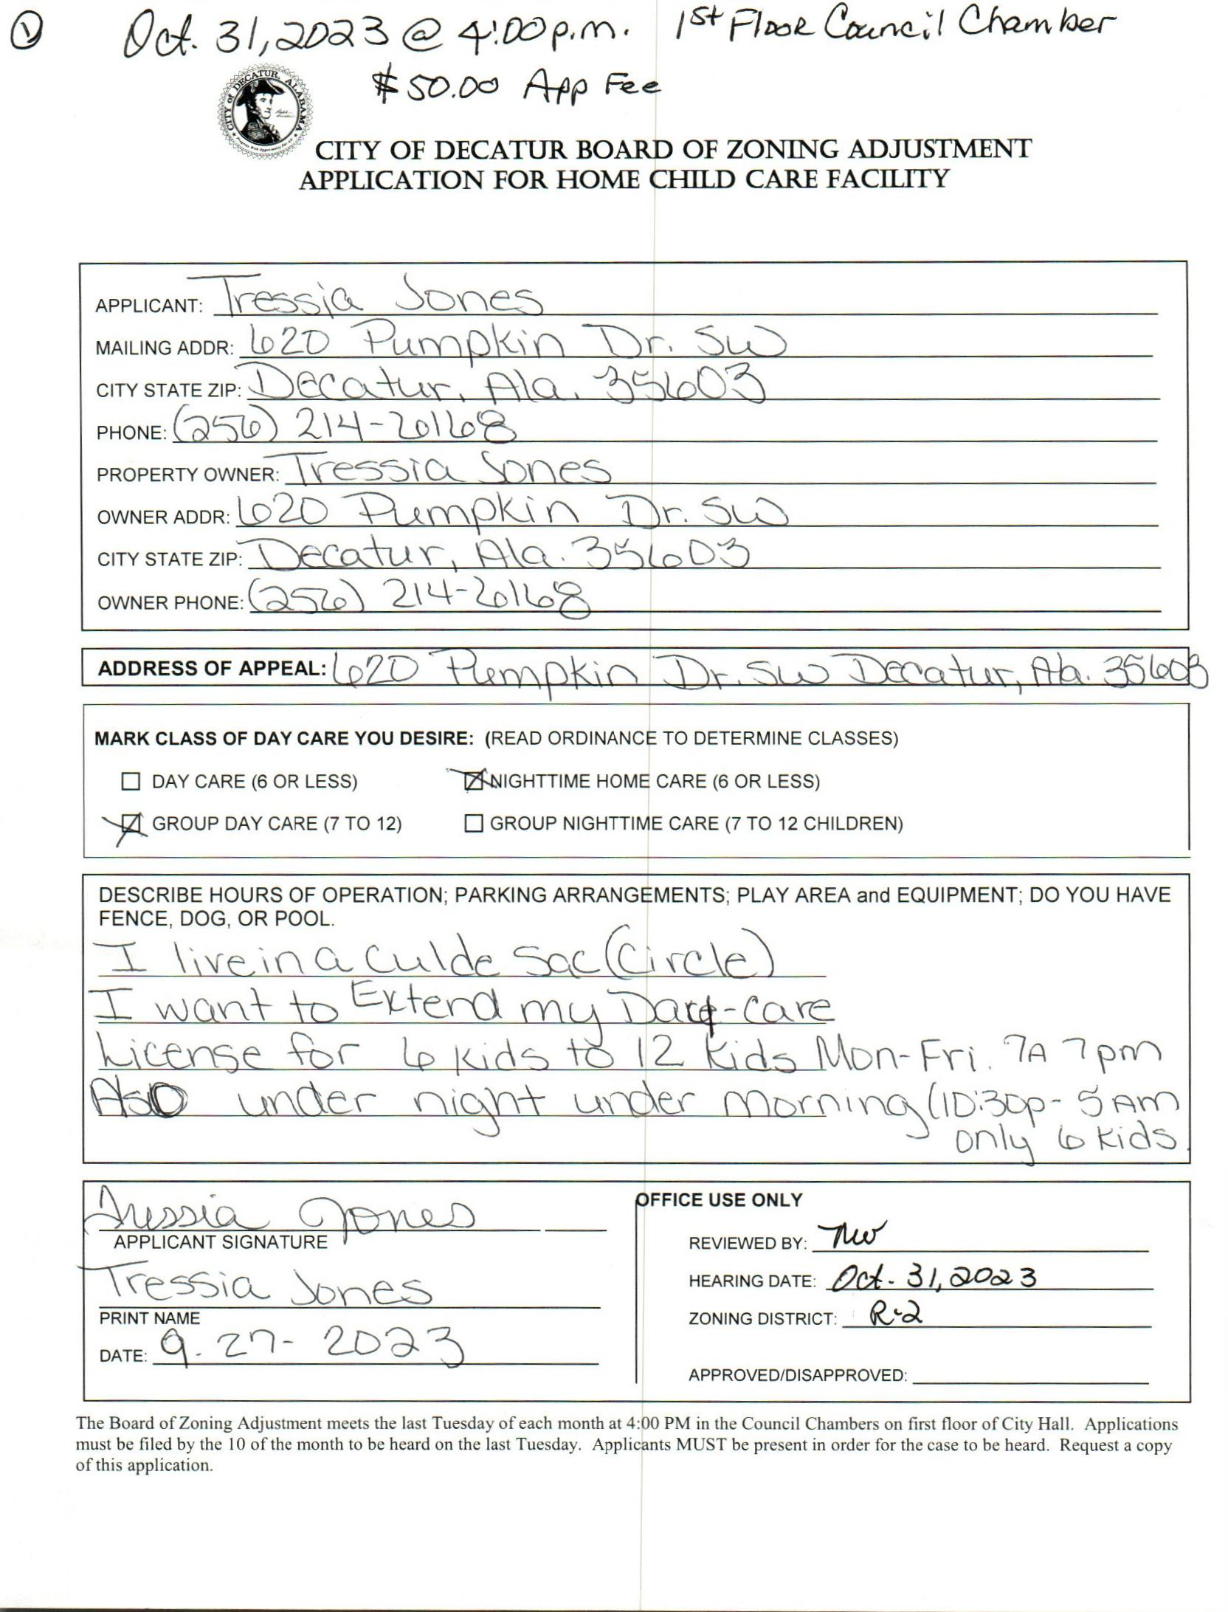

case no. 1 620 pumpkin dr. sw

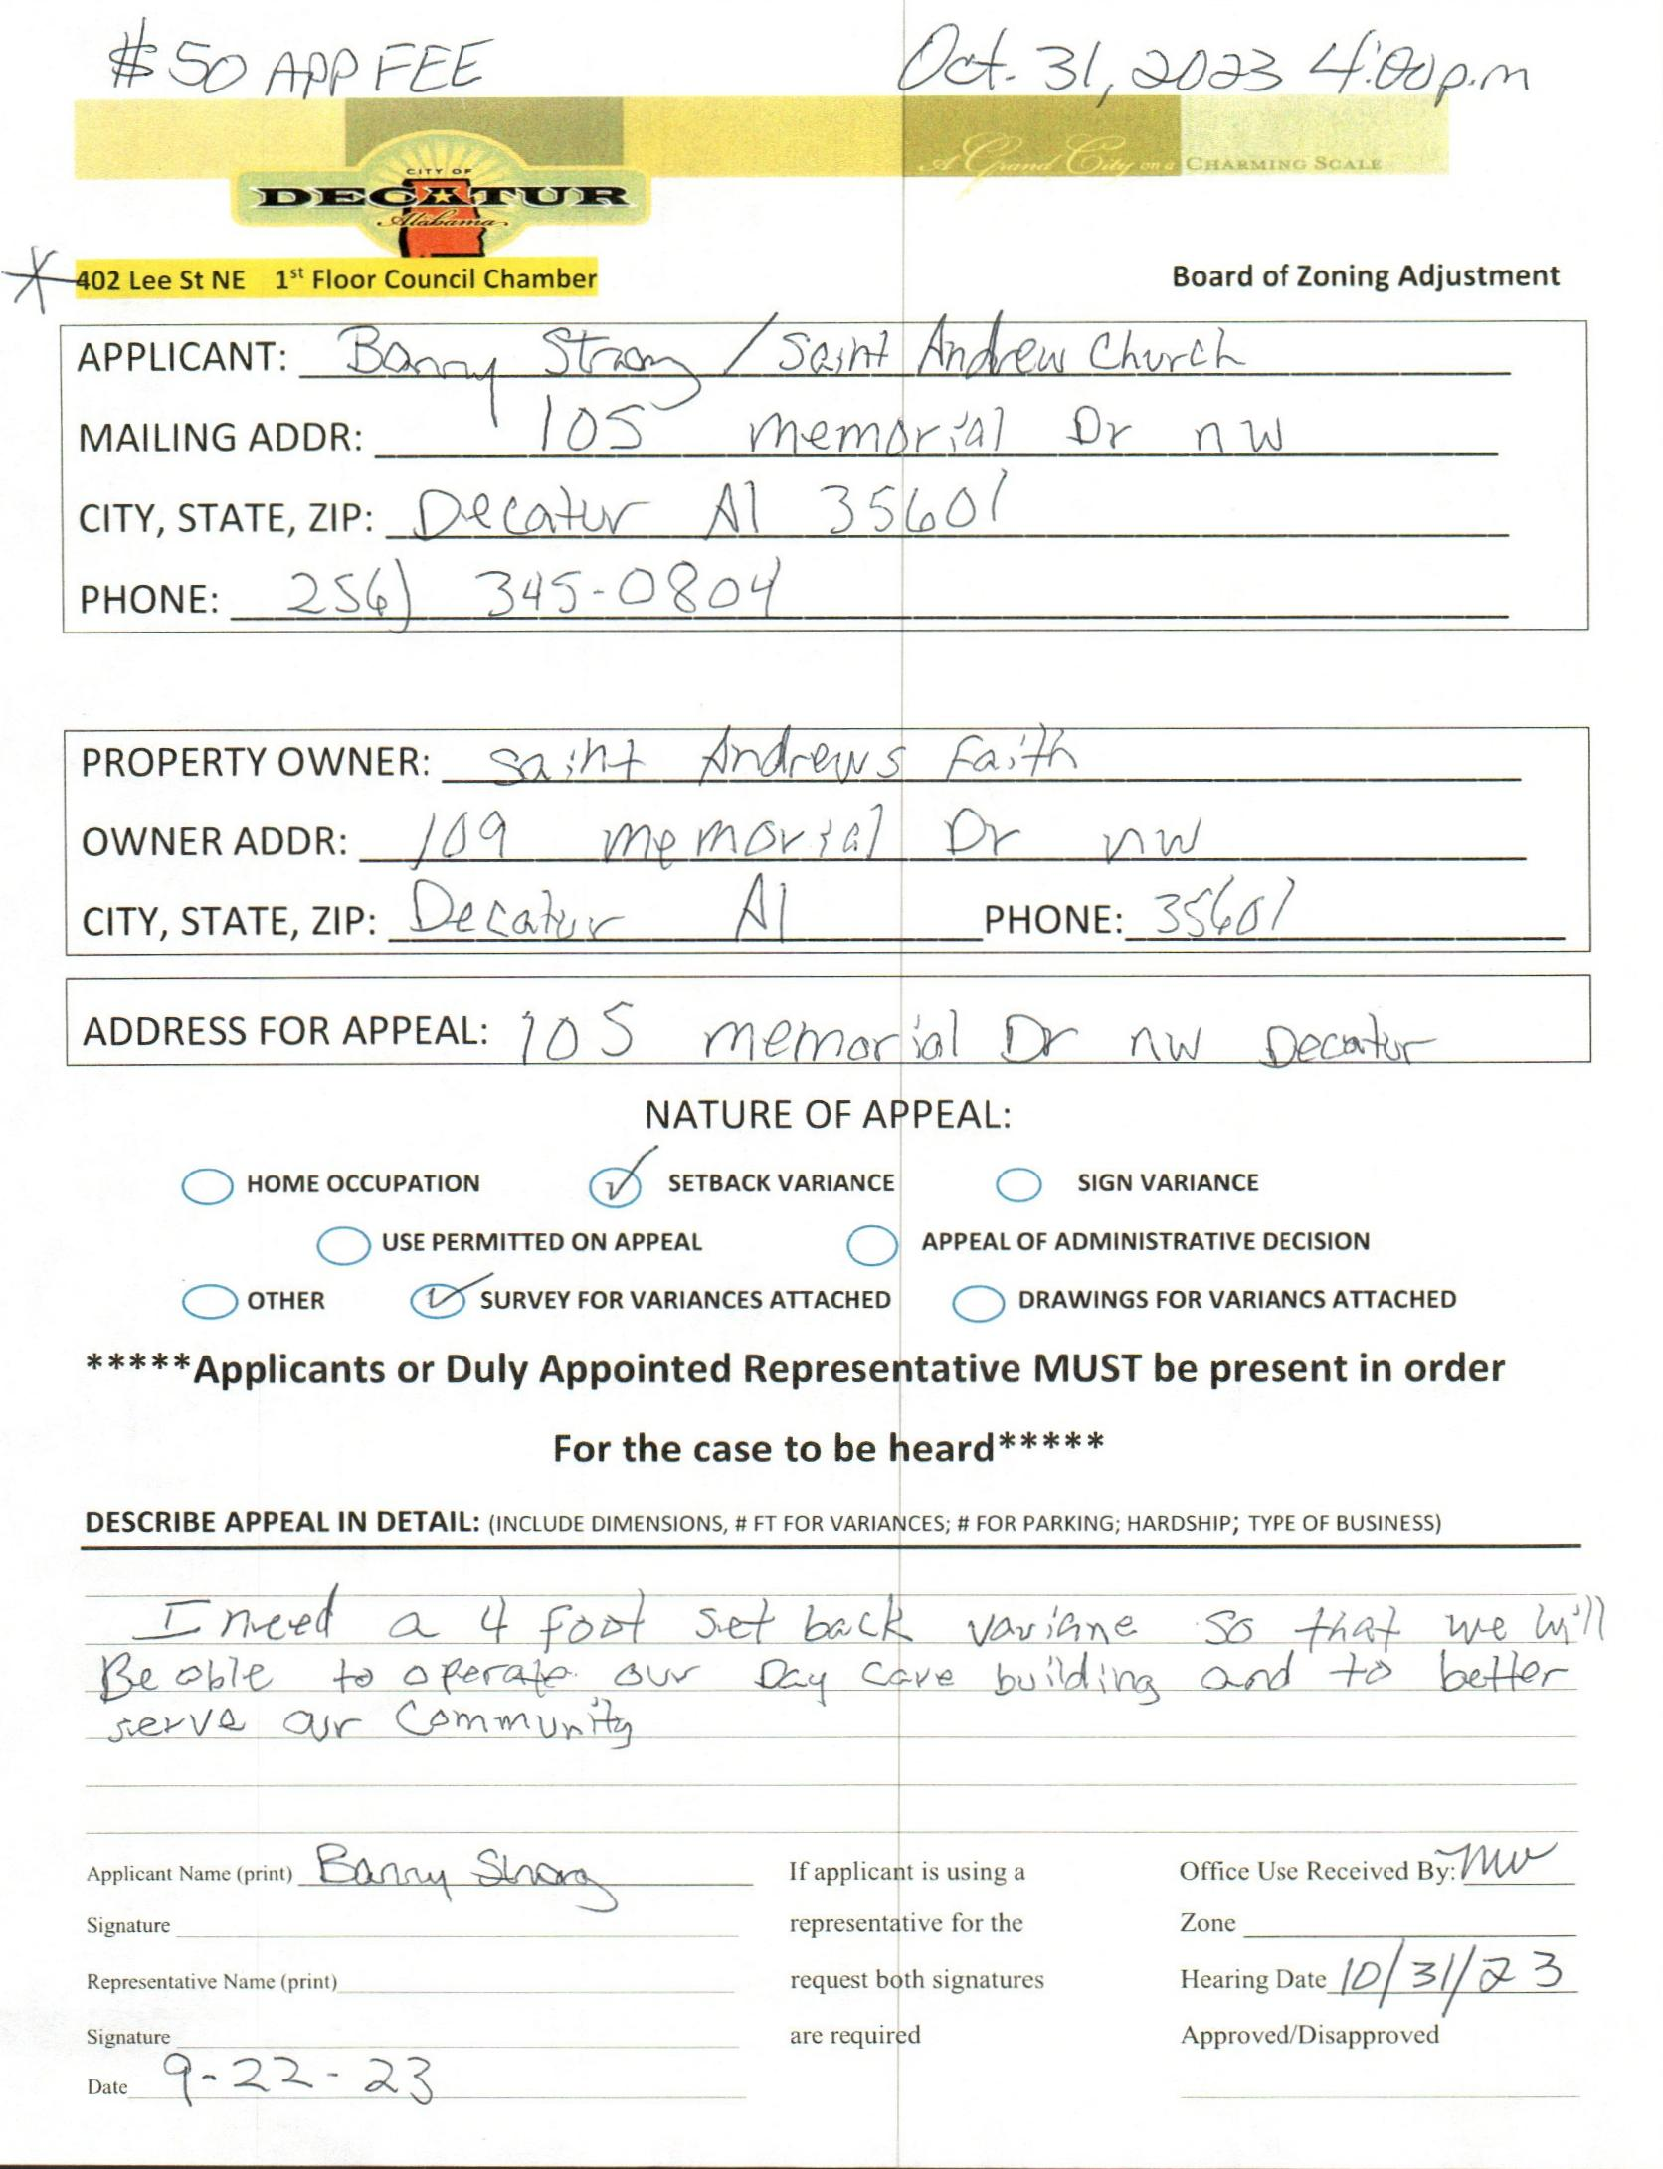

case no. 2 105 memorial dr. Nw

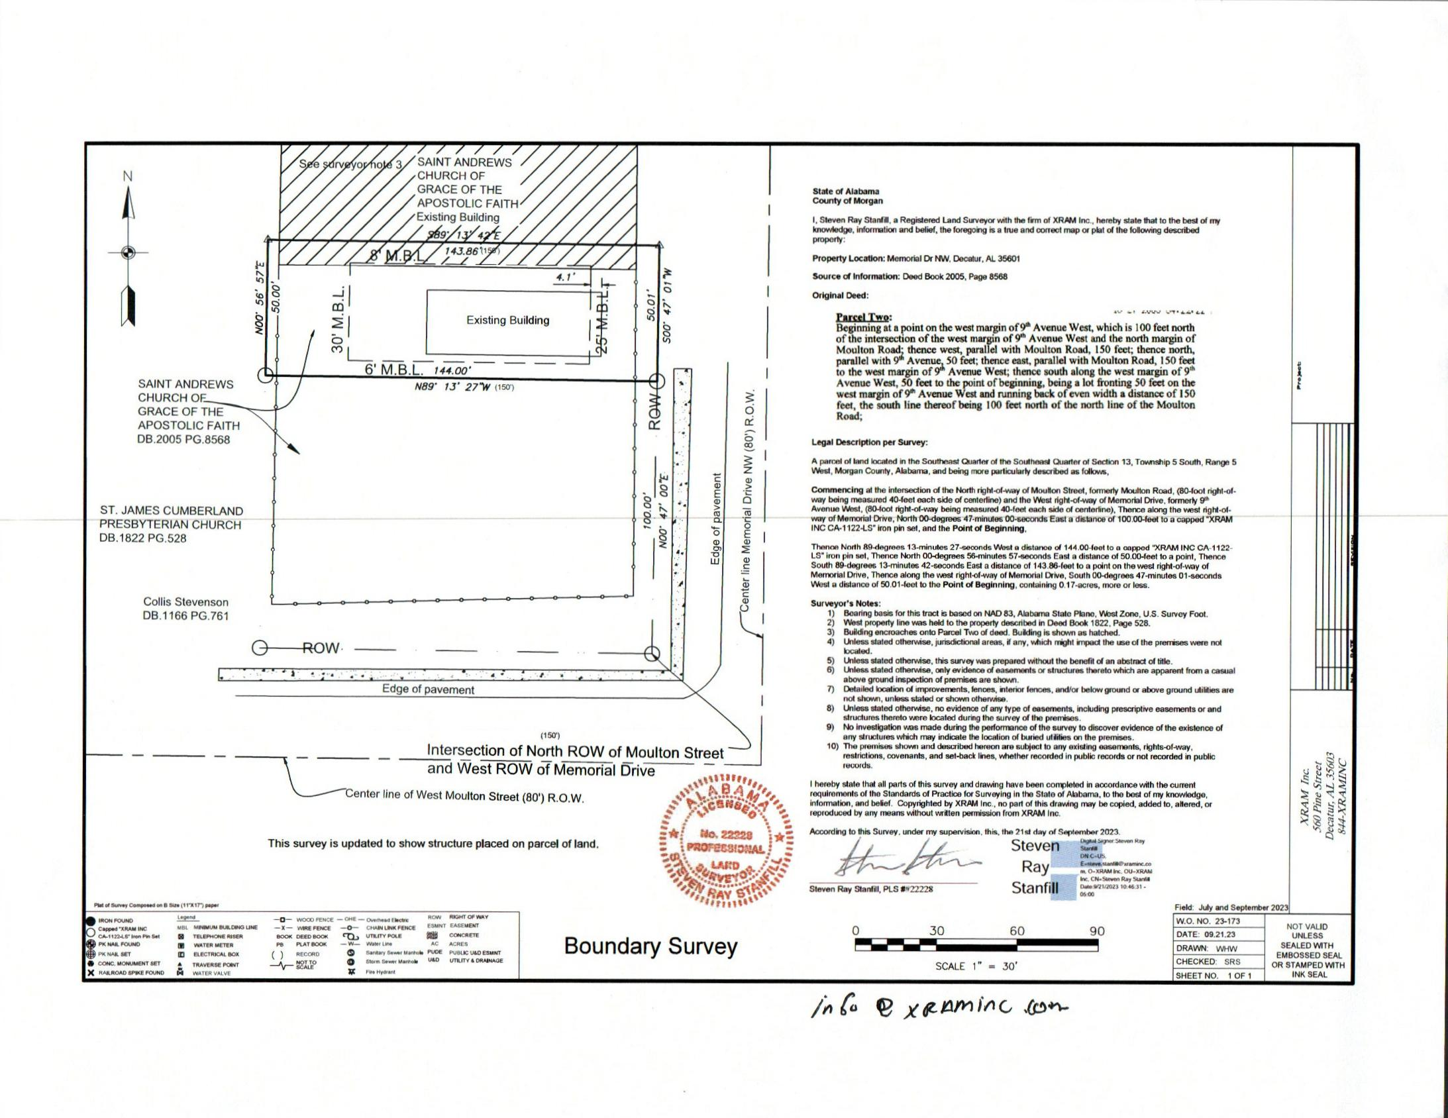

survey

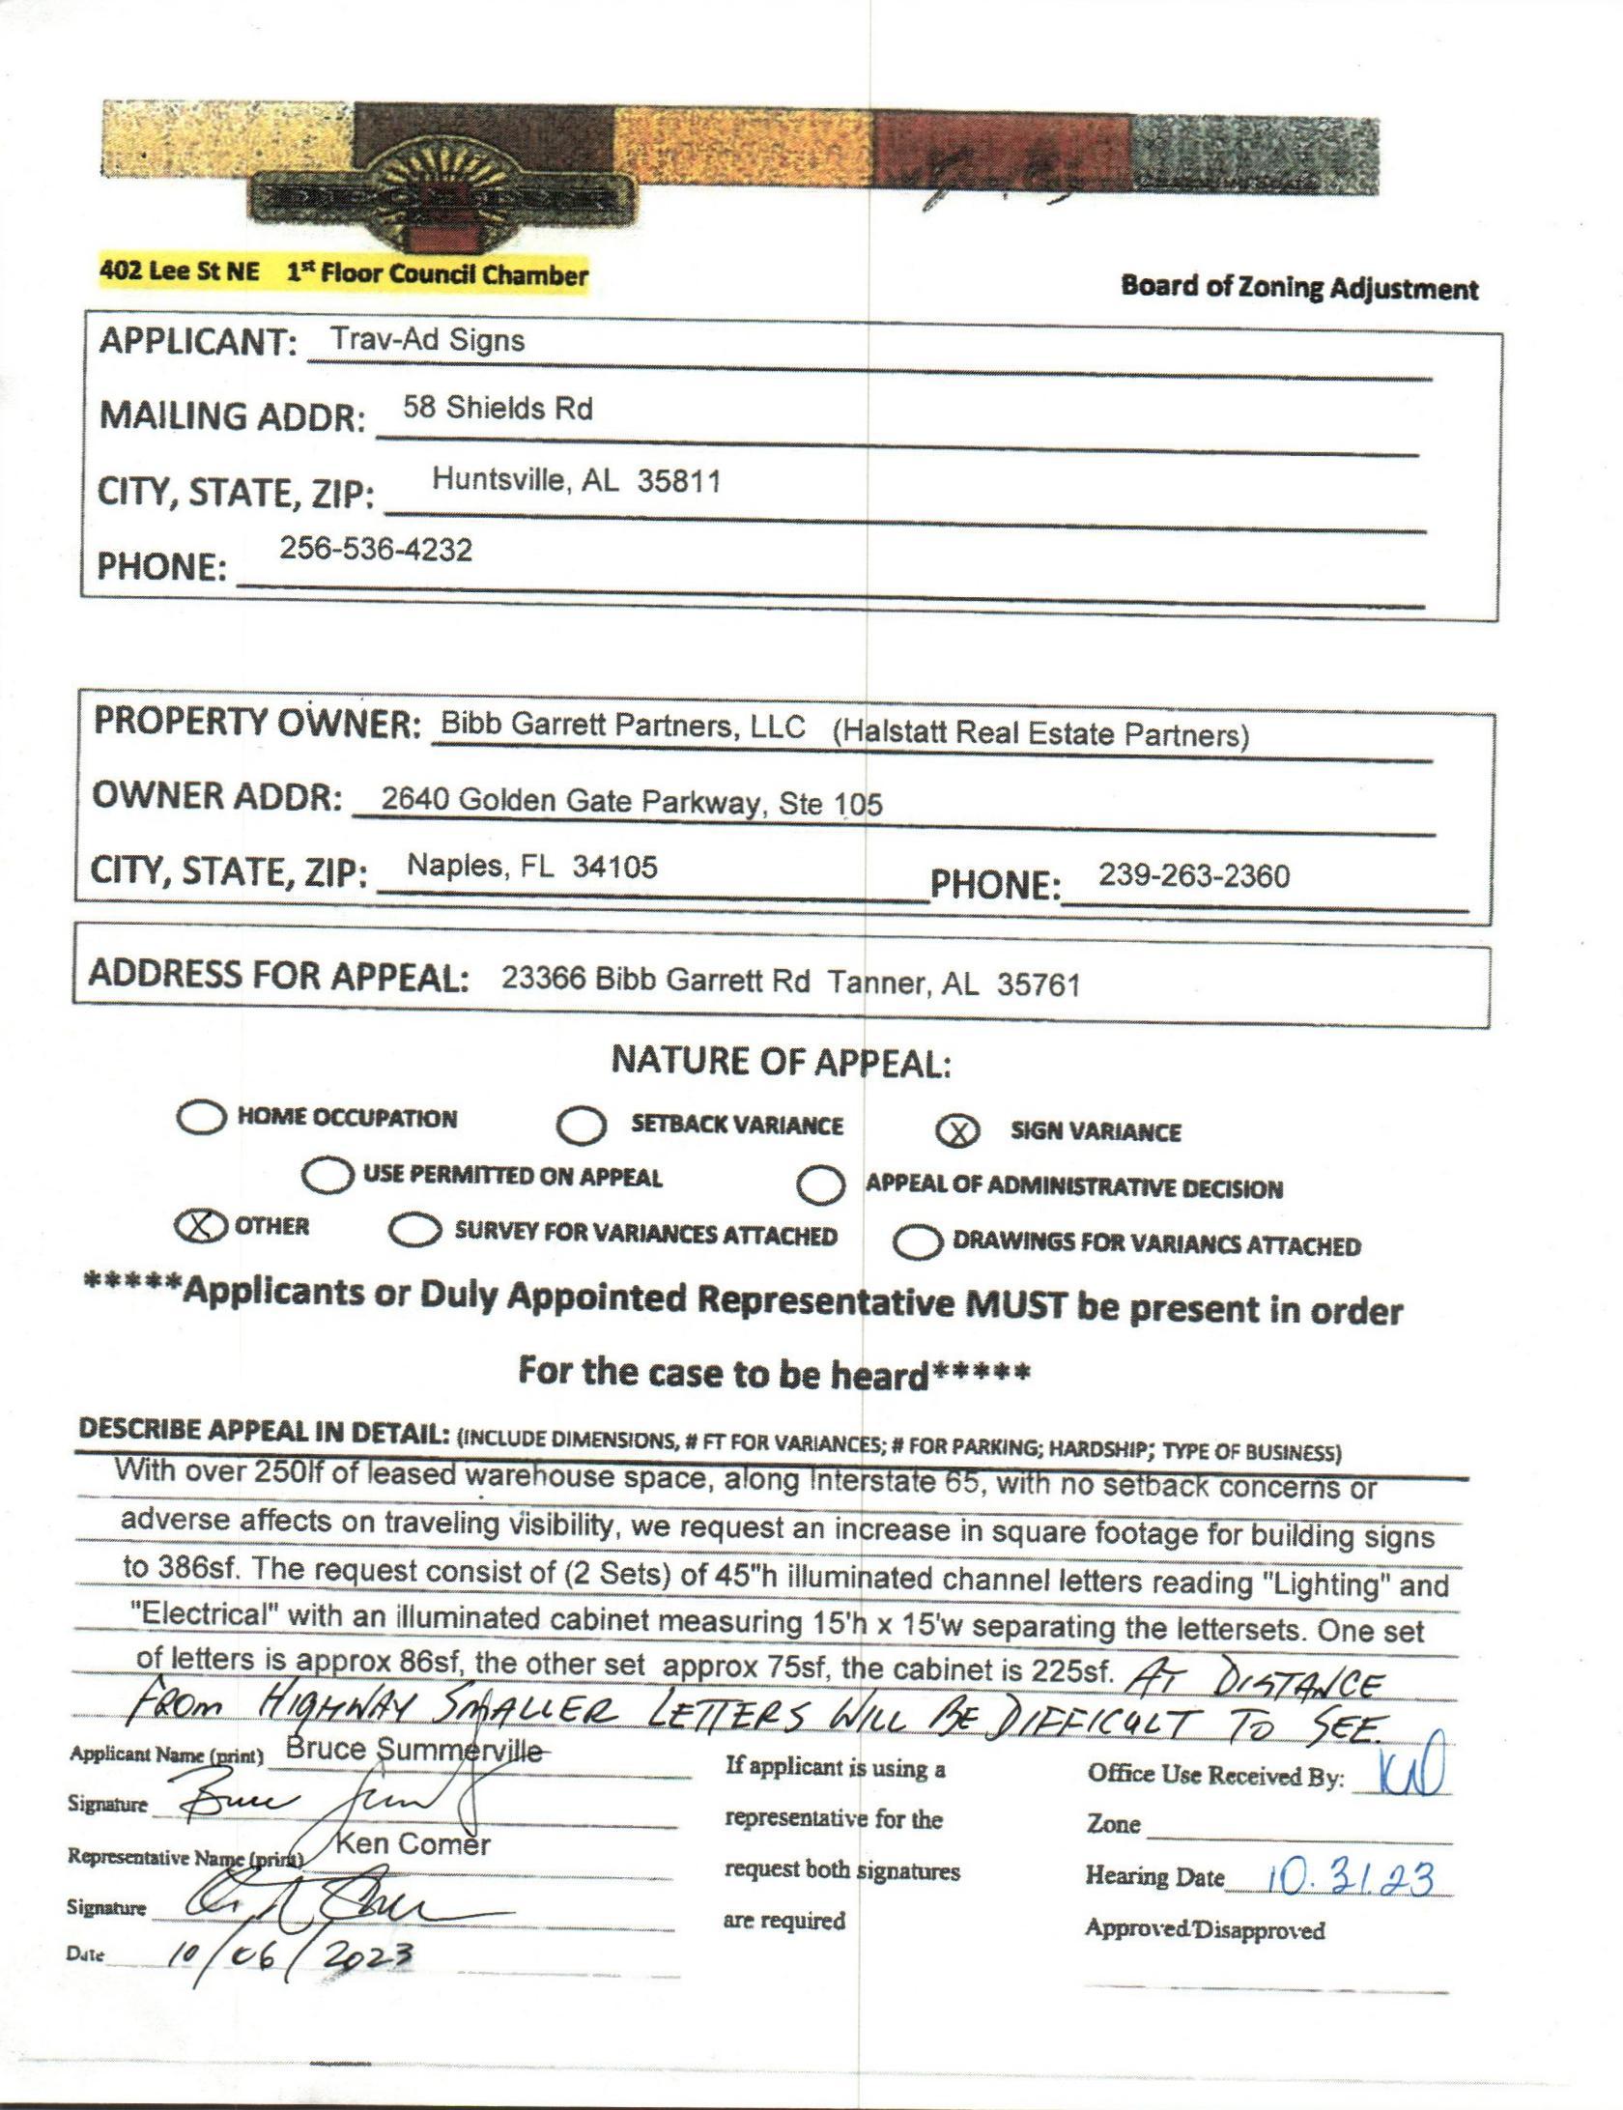

case no. 3 23366 bibb garrett rd

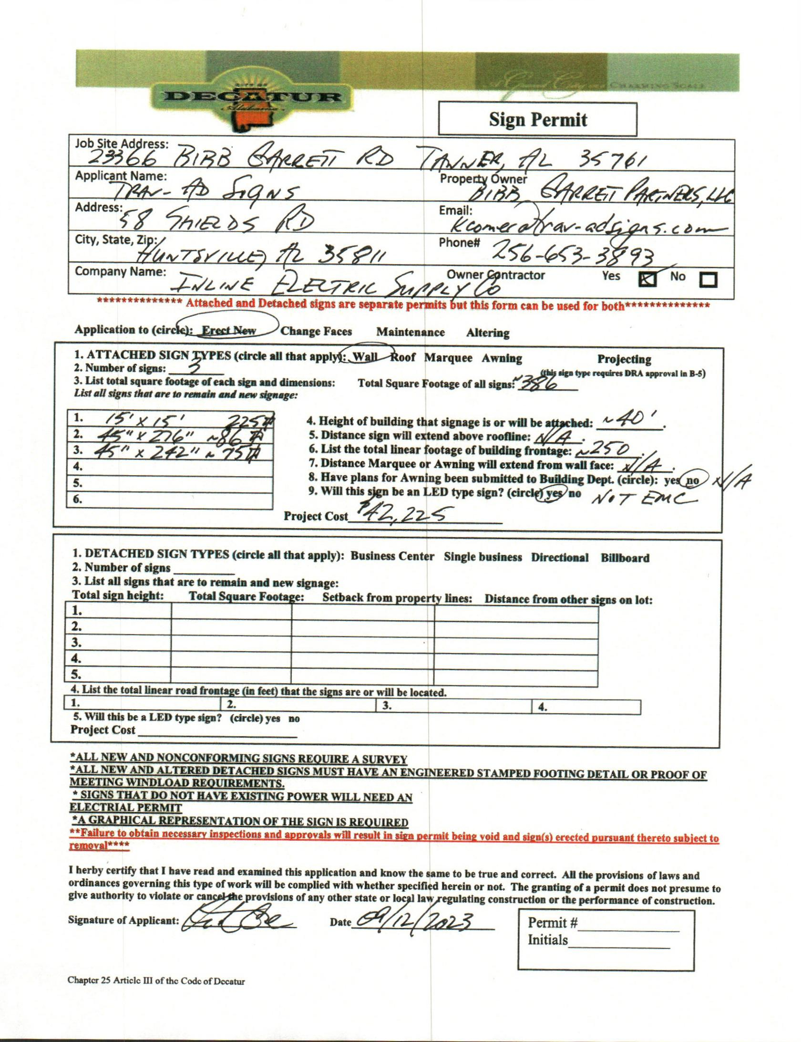

sign permit

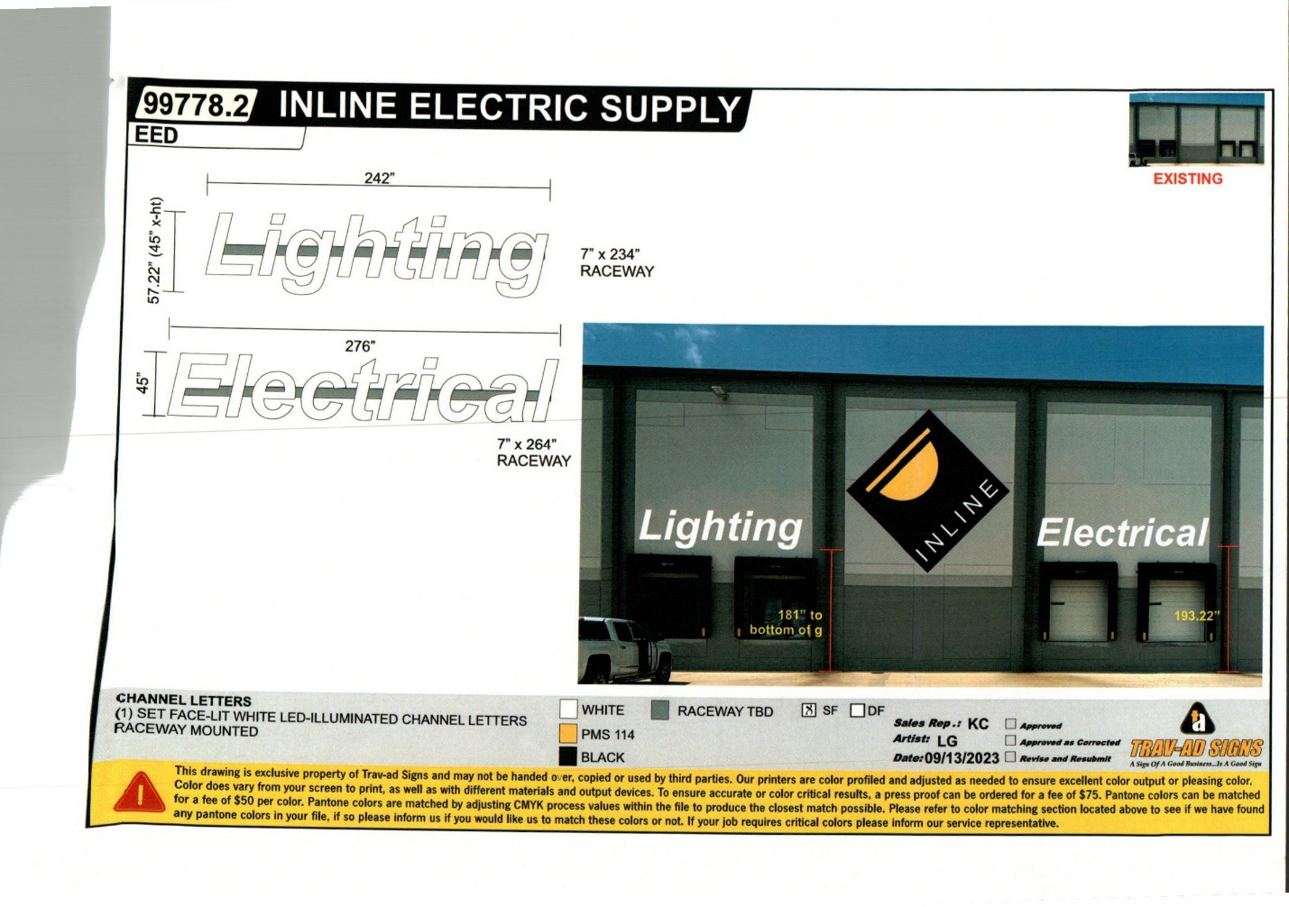

picture

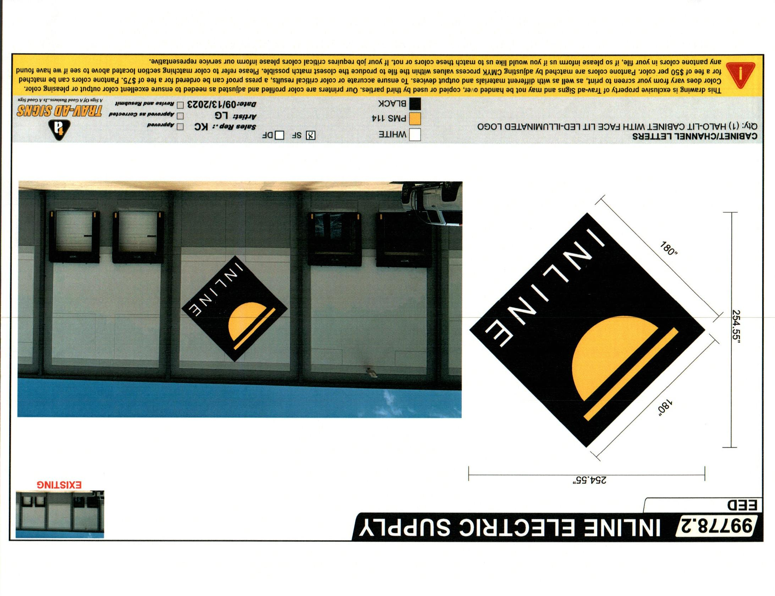

picture

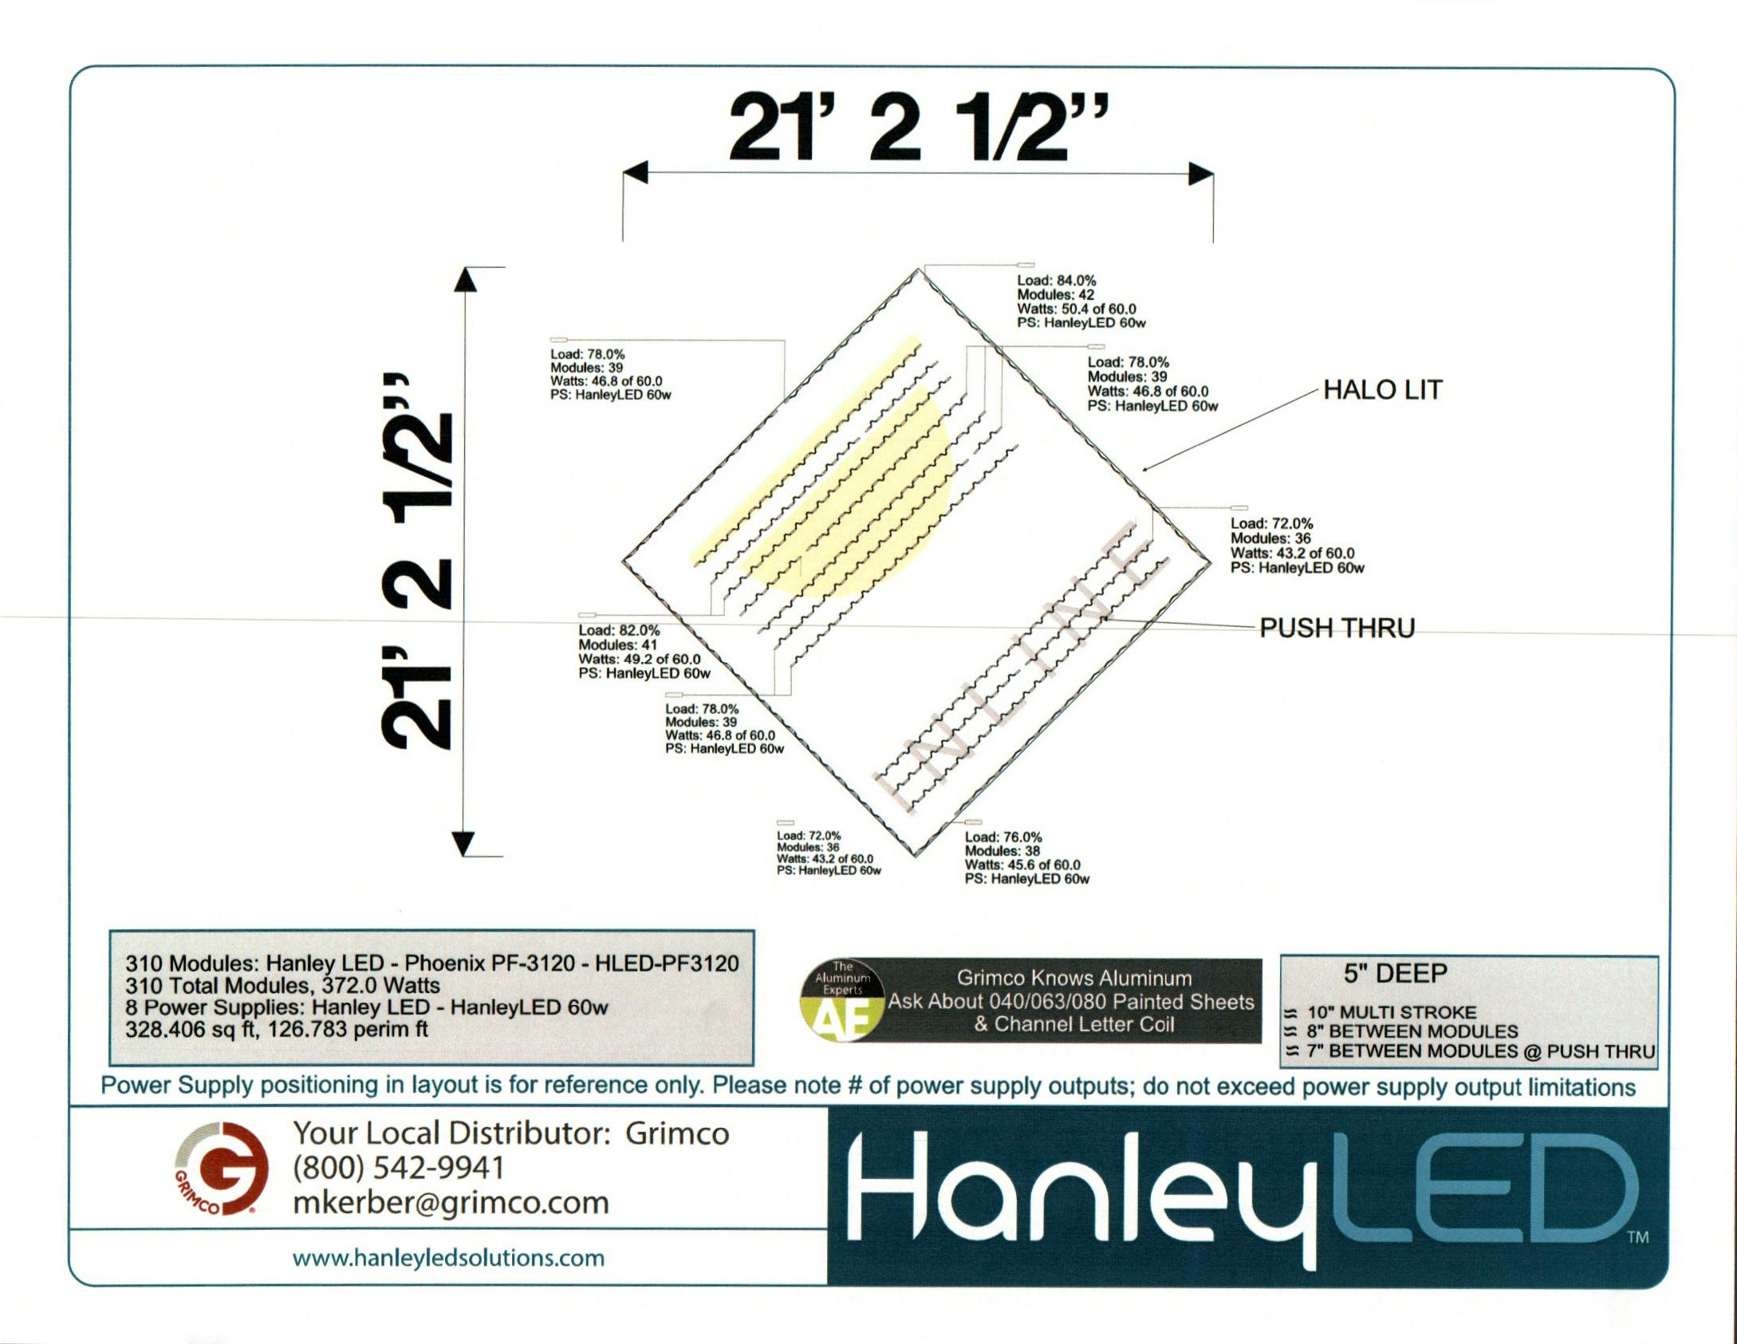

picture

picture

picture

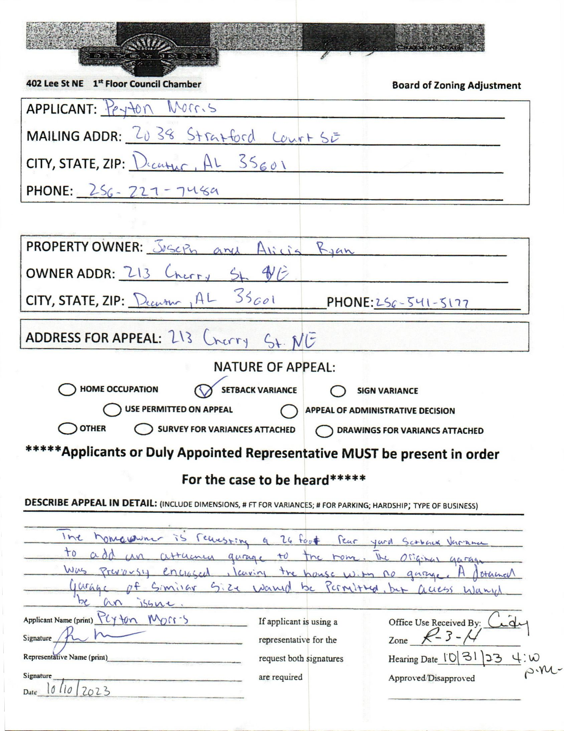

case no. 4 213 cherry st ne

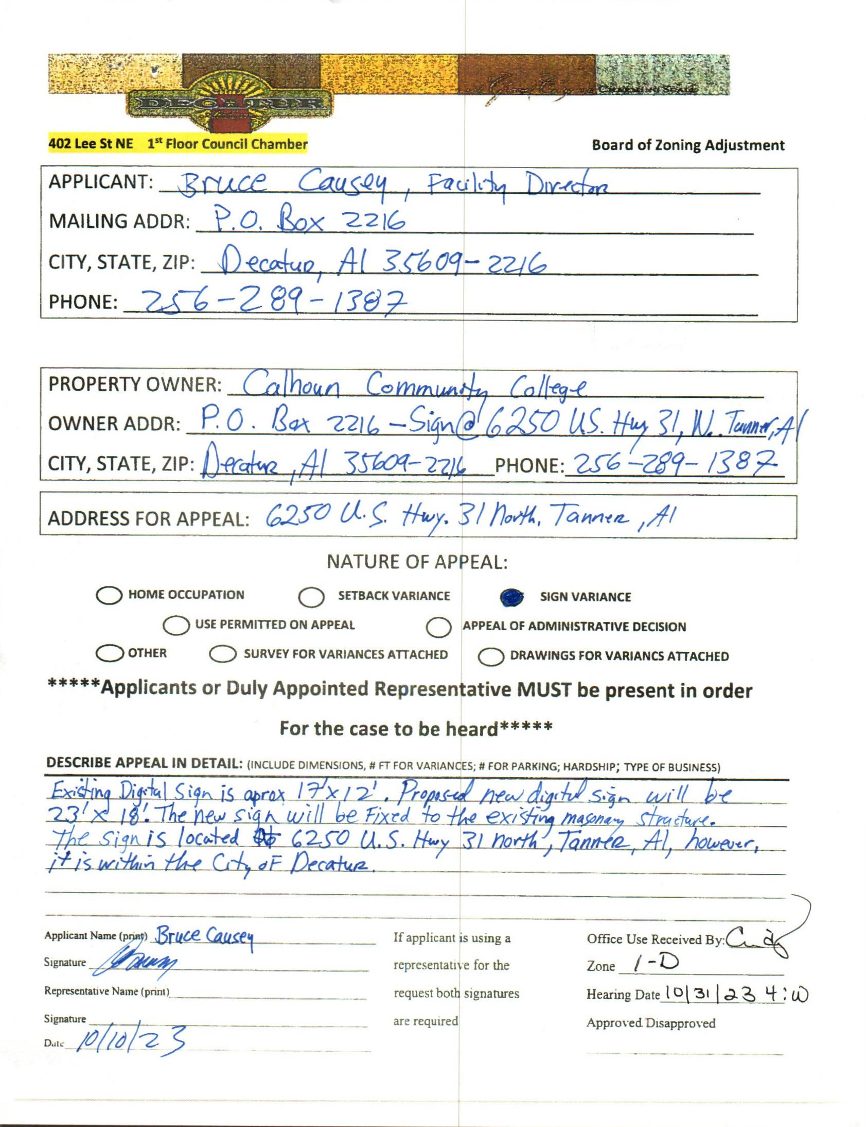

case no. 5 6250 US Hwy 31 N. Tanner, Al.

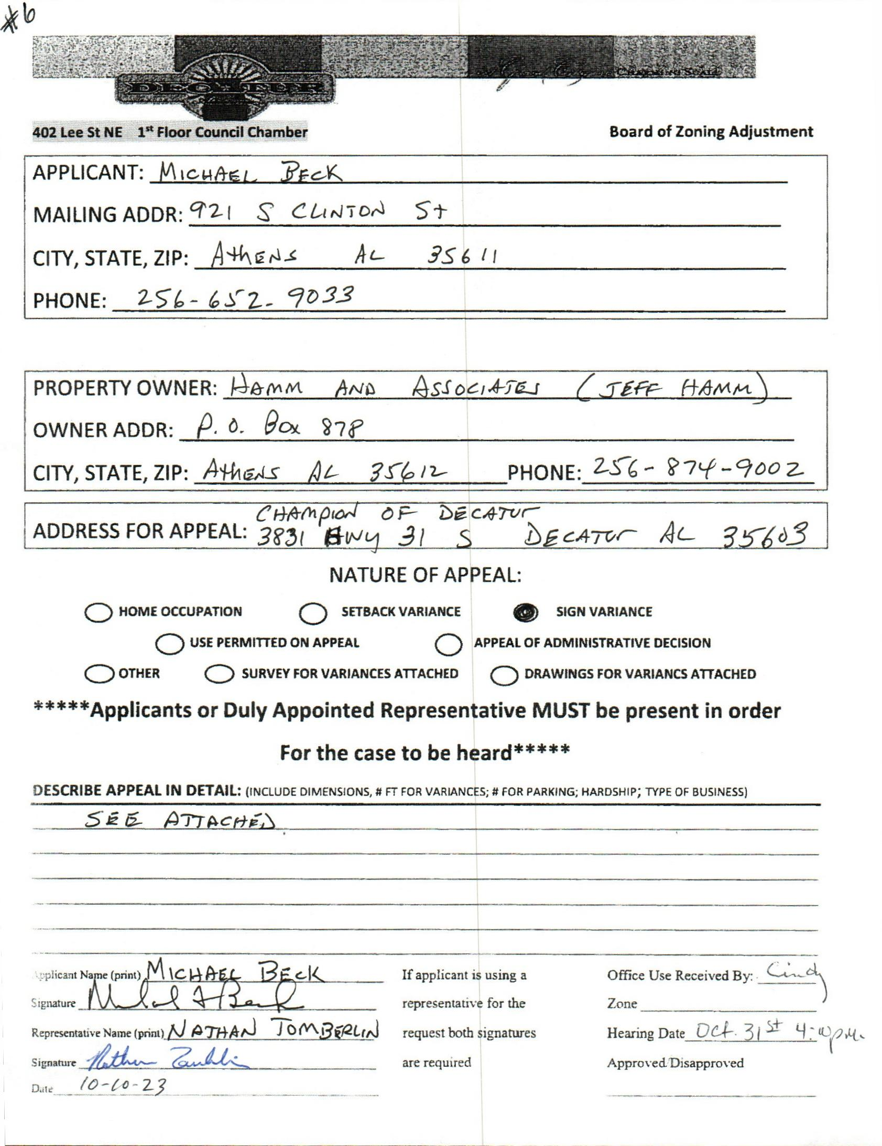

case no. 6 3831 Hwy. 31 S.

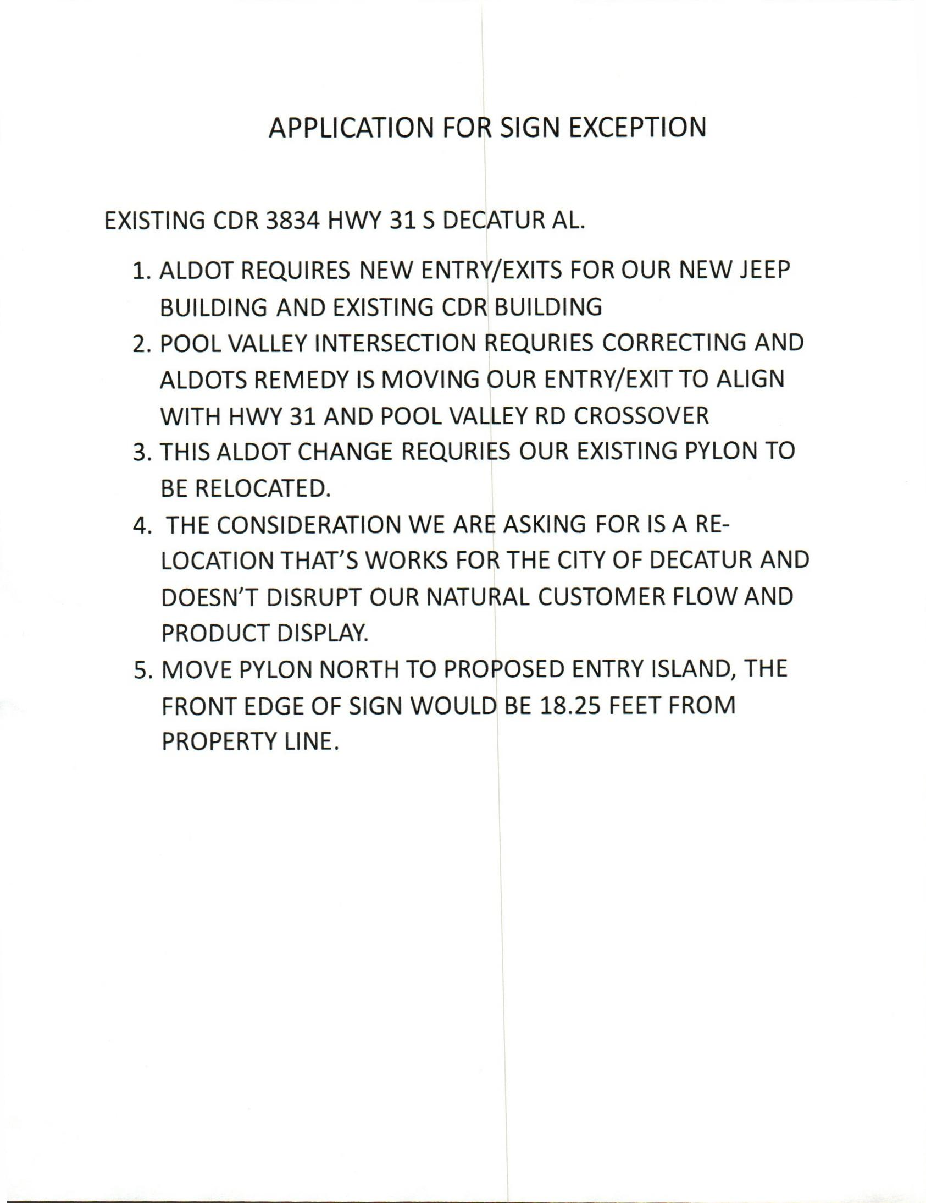

Sign exceptions

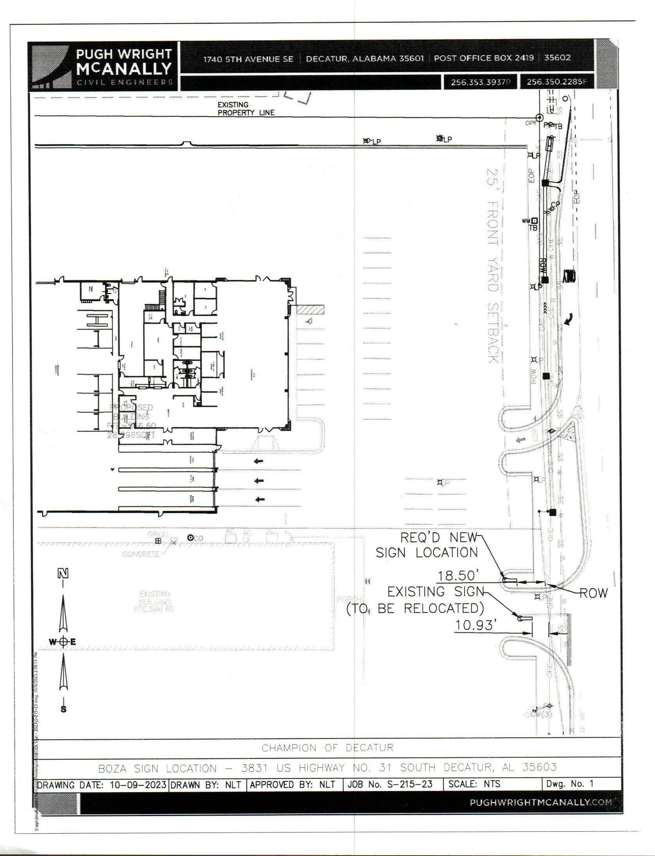

survey

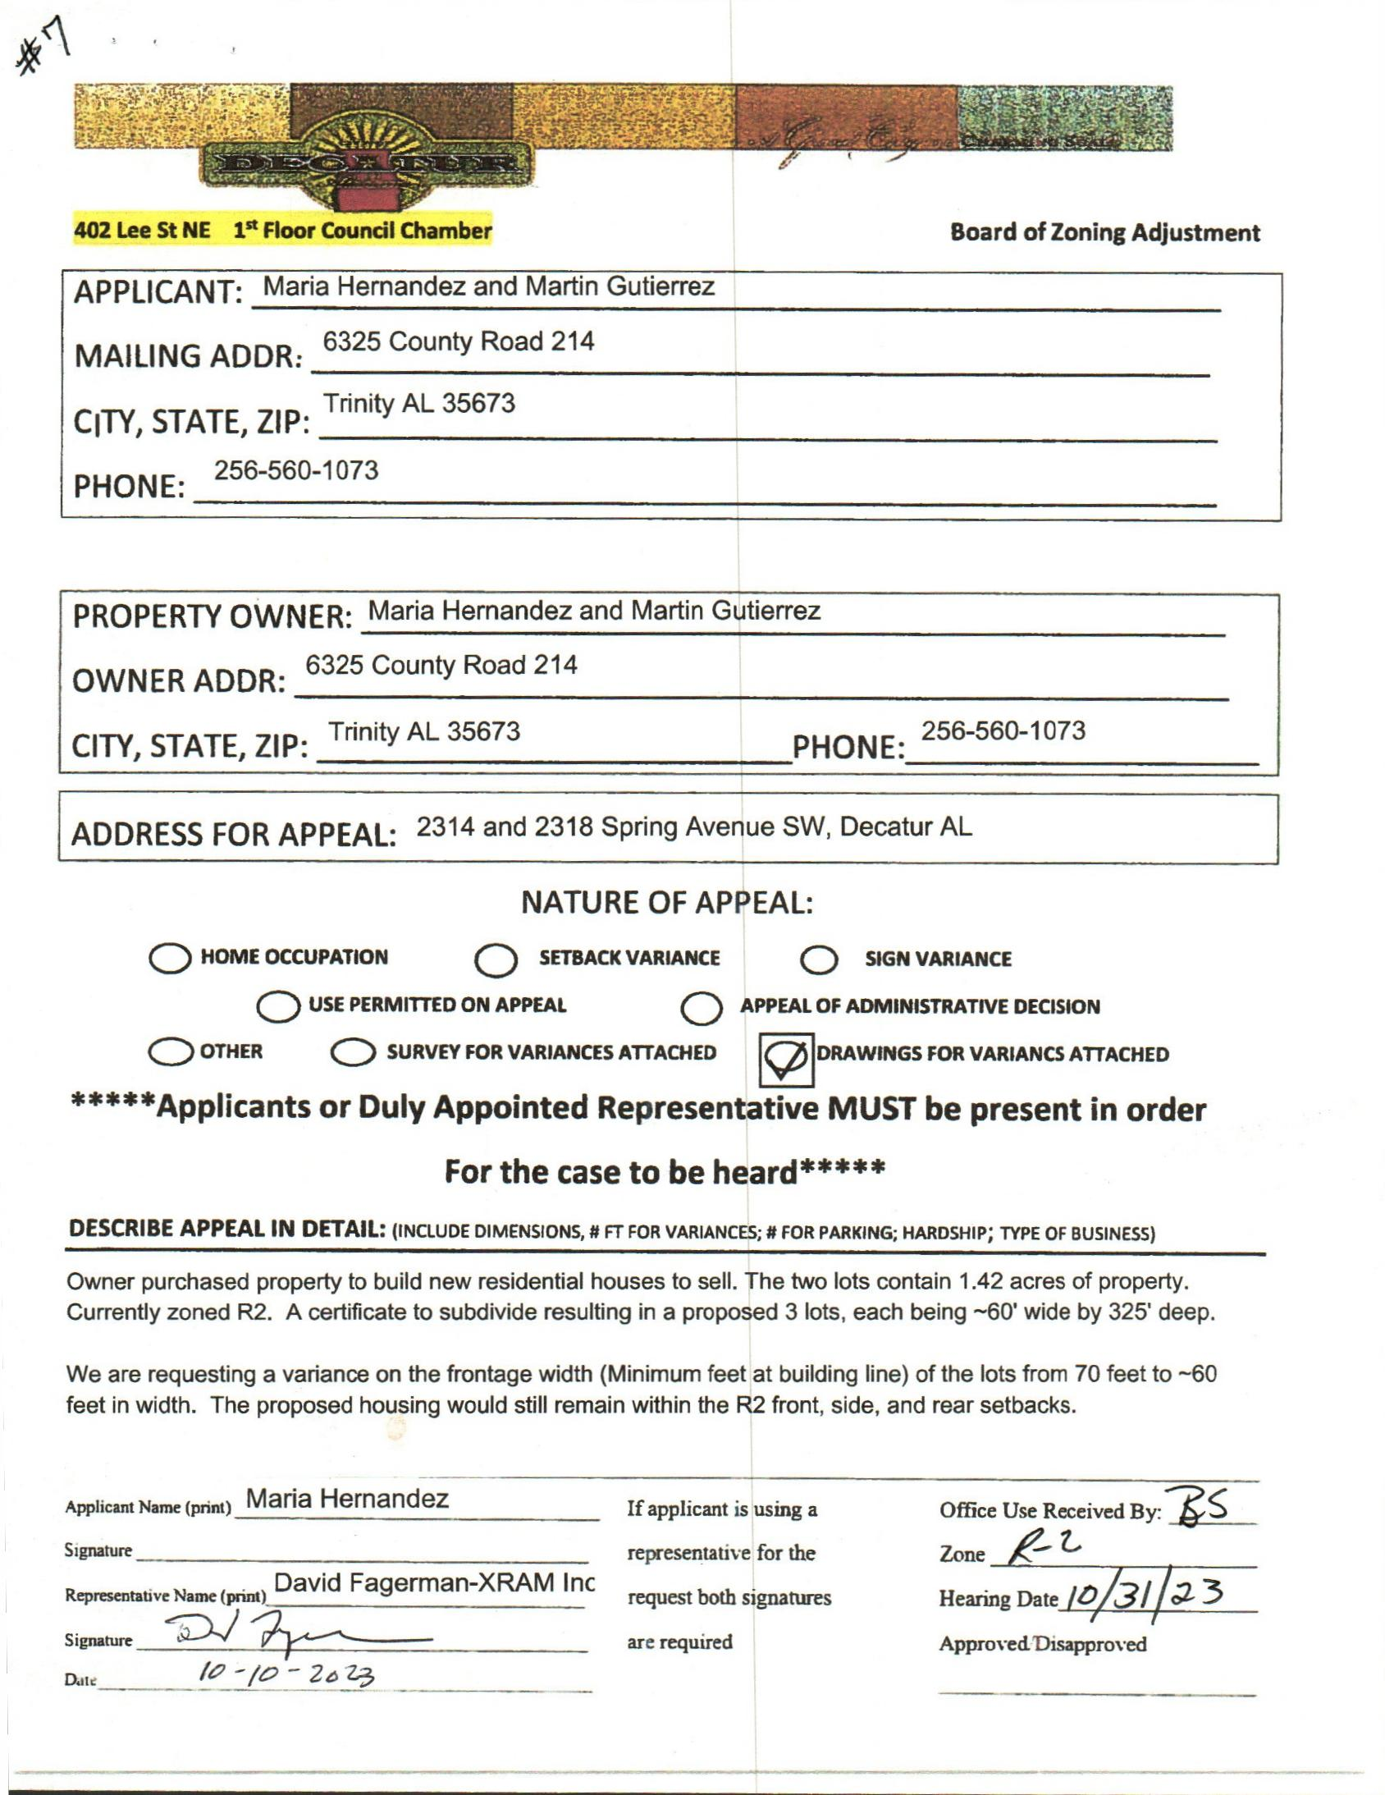

case No. 7 Application

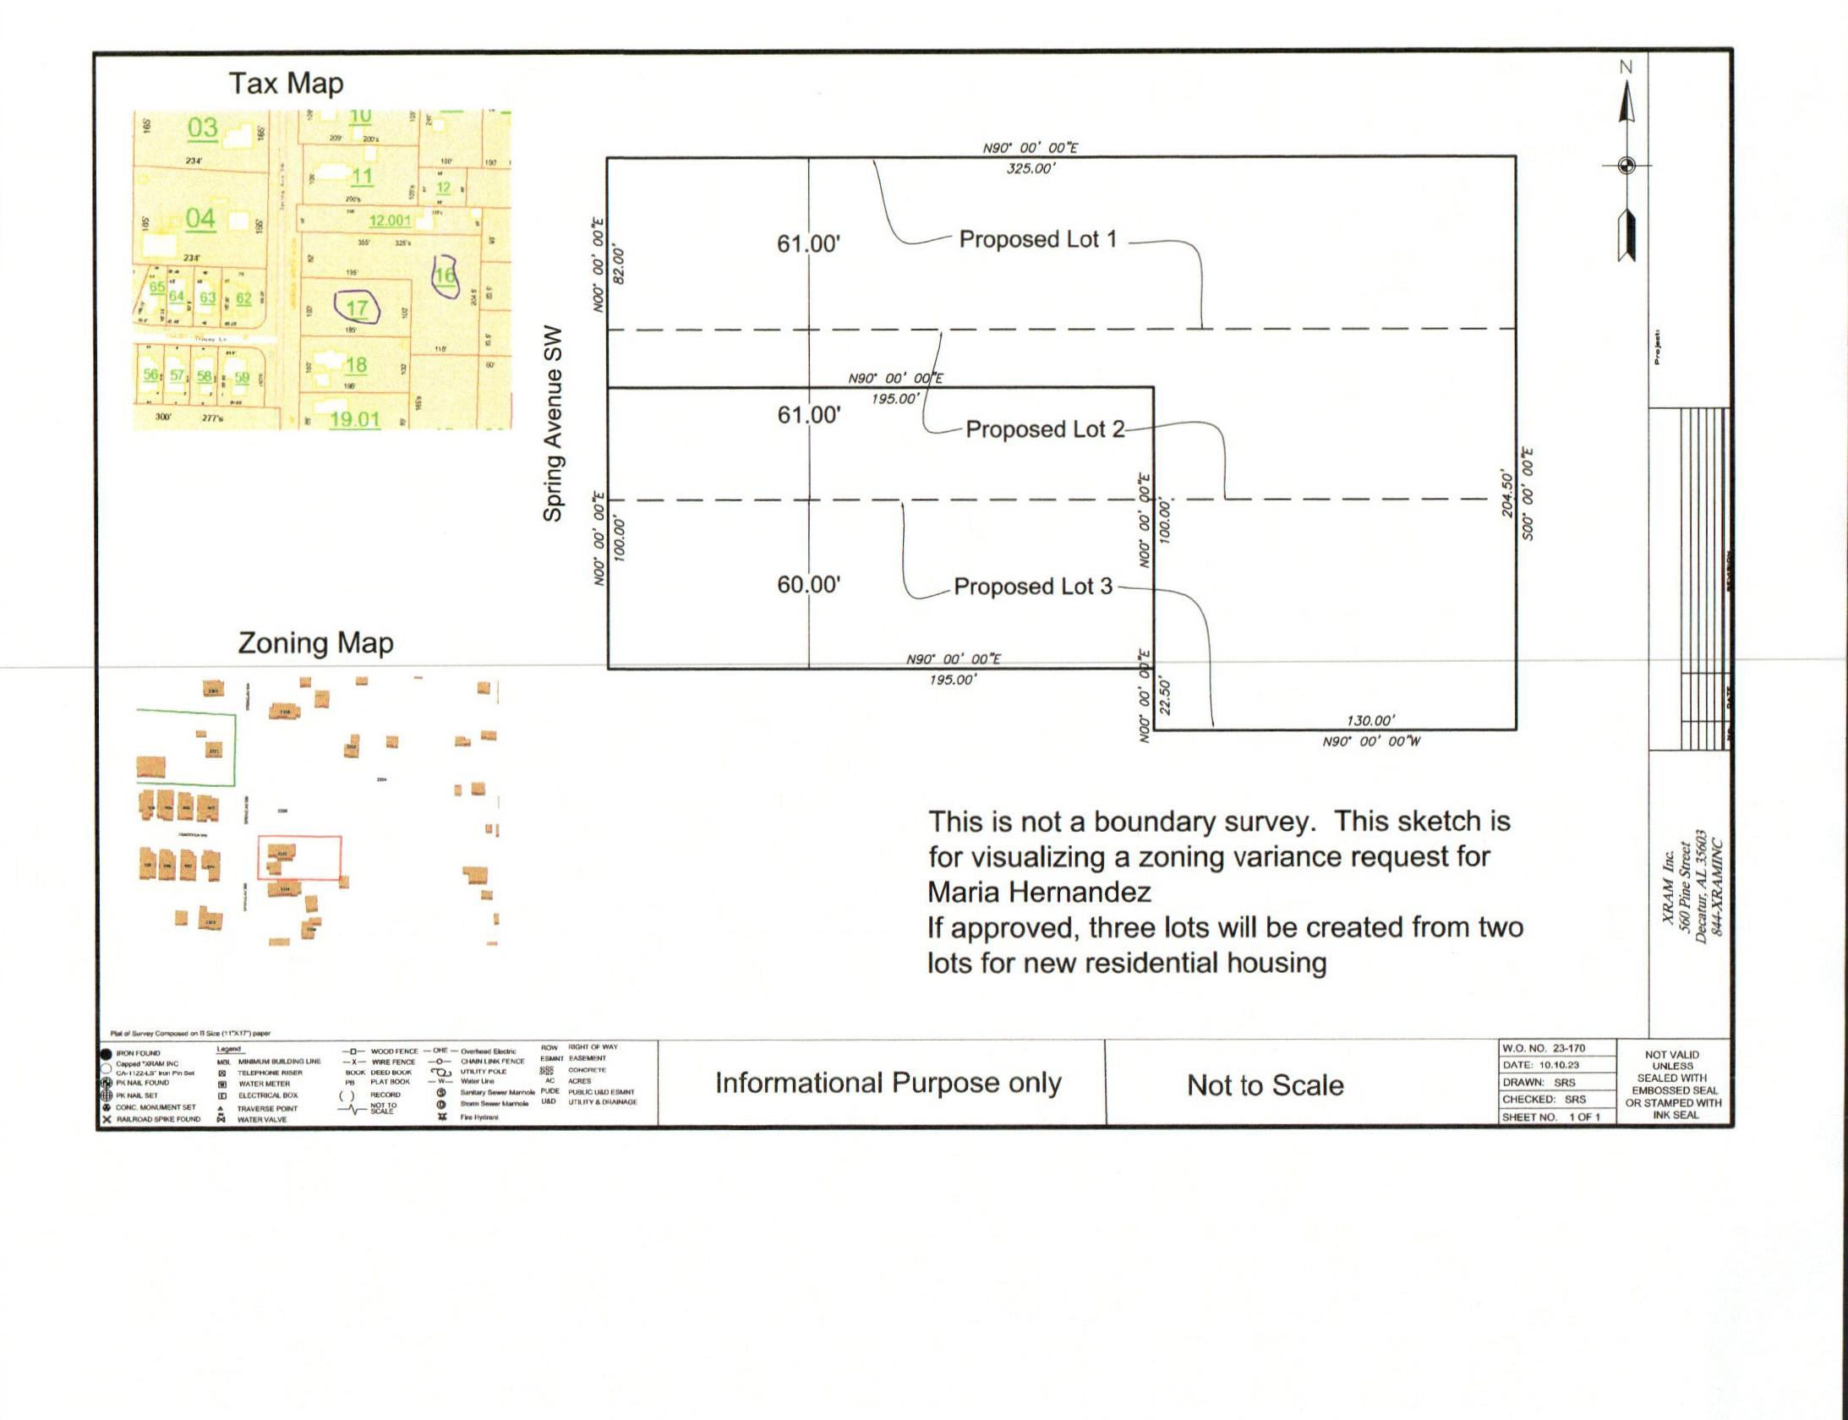

survey

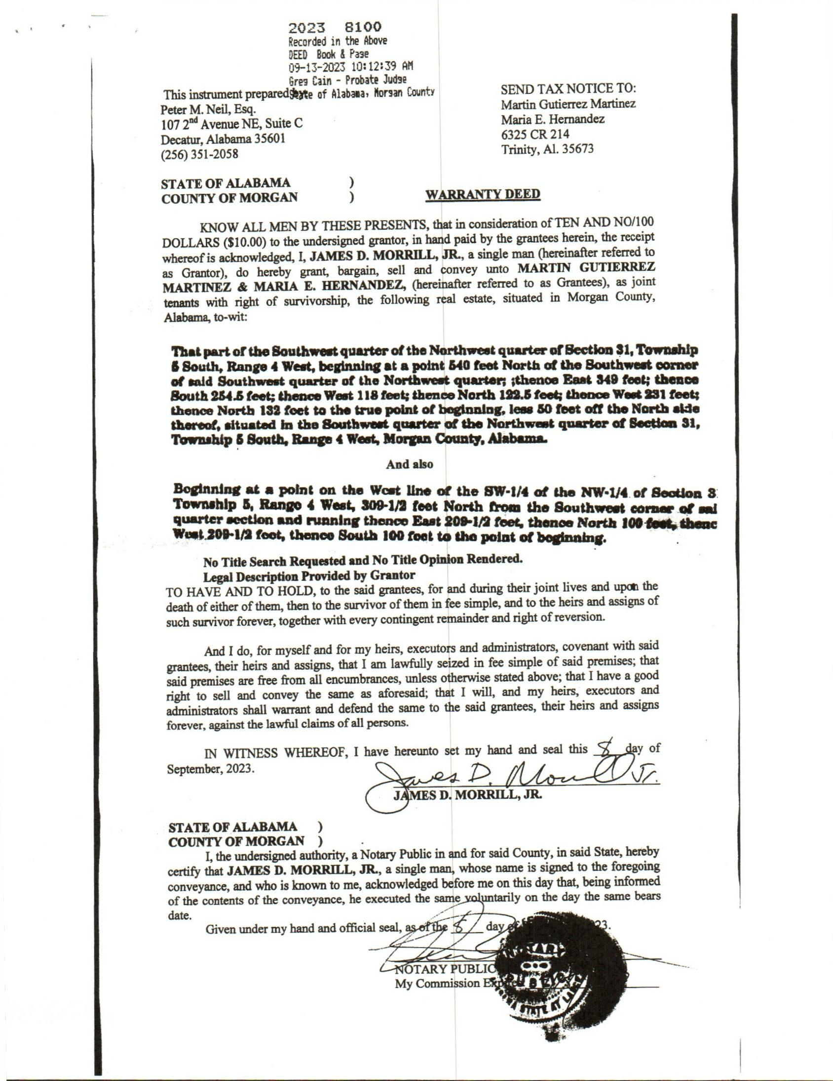

warranty deed

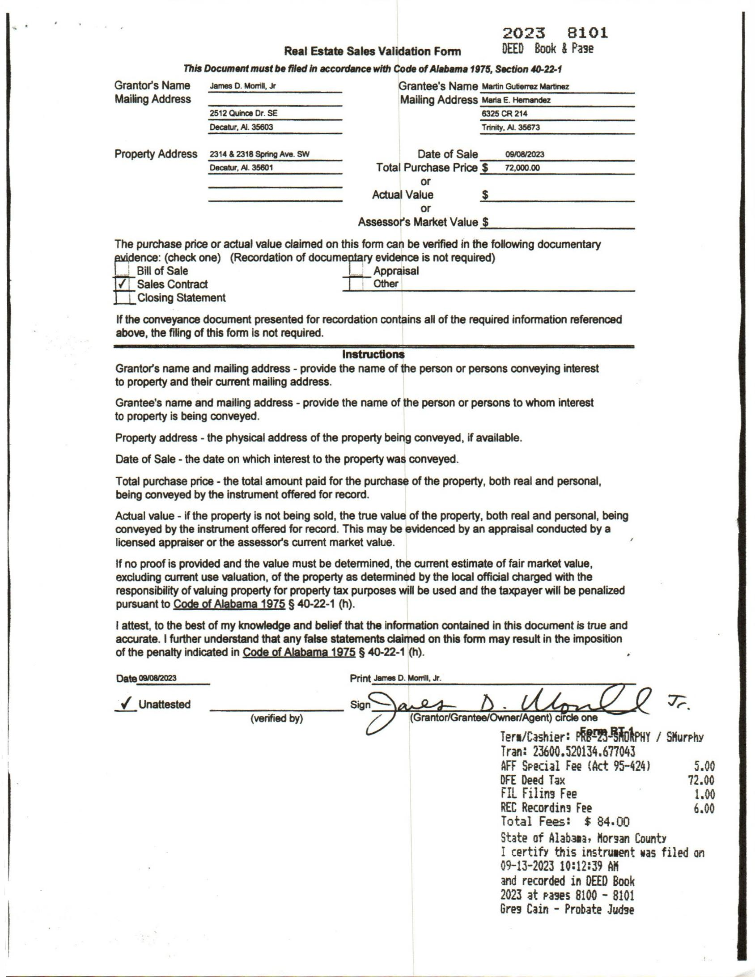

warranty deed pg. 2

