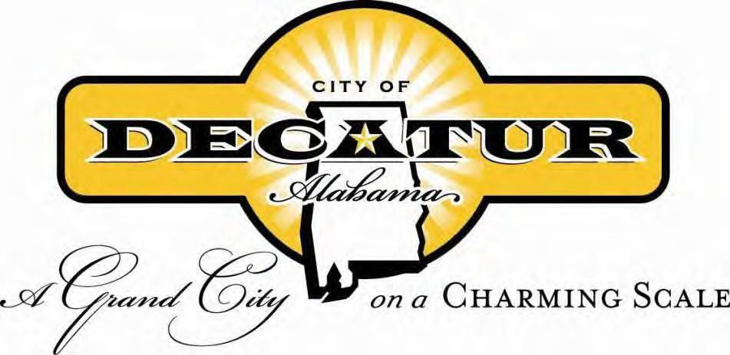
MEMORANDUM
DATE: July 6th, 2023
TO: Planning Commissioners
CC: Mayor Tab Bowling; Ruth Priest; Herman Marks; Tom Polk; Dane Shaw, Carl Prewitt; Planning Staff

SPECIAL CALLED PLANNING COMMISSION MEETING
July 6th, 2023

Meeting – 2:00 p.m. (Council Chambers)

Agenda
Planning Commission
City of Decatur, AL
July 6th, 2023
Time: 2:00 PM
City Council Chambers

Commissioners: Kent Lawrence, Chairman; Gary Borden, Vice Chairman; Larry Waye, Secretary; Hunter Pepper; Frances Tate; Joseph Wynn; Eddie Pike; Myrna Burroughs; Forrest Temple

CALL MEETING TO ORDER

OTHER BUSINESS
Sidewalk Café License Review PAGE NO.

A. The Little Cigar Shoppe LLC 1-3

FILE NAME OR NUMBER: The Little Cigar Shoppe LLC Sidewalk Café License
APPLICANT: Jason Pitts, owner
LOCATION AND OR PROPERTY ADDRESS: 110 2nd Avenue NE
REQUEST: Recommend to City Council for Approval: Sidewalk Café Revocable License for The Little Cigar Shoppe, LLC

COMMENTS AND RECOMMENDATIONS FROM TECHNICAL REVIEW COMMITTEE:
Conditions to be met:

Pt. of Info:

COMMENTS AND RECOMMENDATIONS FROM PLANNING COMMISSION:

RESOLUTION 010-23

BE IT RESOLVED by the City of Decatur Planning Commission that the Application for a sidewalk café for The Little Cigar Shoppe LLC., located at 110 2nd Avenue NE, has been submitted for review.
BE IT ALSO RESOLVED the Planning Commission has received a copy of each of the following for review and approval: Sidewalk Café Application, 2022 Business License, Certificate of Liability Insurance, Layout of Sidewalk Café, and Approved Sidewalk Café Review Committee Form.
The City of Decatur Planning Commission hereby recommends approval of the Sidewalk Café license to the City Council.

Adopted this 6th day of July, 2023.

_____________________________
Kent Lawrence, Chairman
Decatur Planning Commission

STATE OF ALABAMA )
MORGAN COUNTY )

I, _________________________________, the undersigned authority, a notary public in and for said county in said state, hereby certify that Kent Lawrence, whose name as Chairman of the City of Decatur Planning Commission, is signed to the foregoing instrument and who is known to me, acknowledged before me on this day that, being informed of the contents of the instrument, he in his capacity as such officer executed the same voluntarily on the day the same bears date.
Given under my hand and official seal this _______ day of _______________________, 2023.

________________________________
Michelle Stinnett Notary Public

