BOARD OF ZONING ADJUSTMENT

AGENDA

October 2022

Table of Contents

Minutes September 2022 3
AGENDA 12
CASE NO. 1 502 Church St NW 14
DIAGRAM 15
CASE NO. 2 1843 wEST bROWNSTONE cT. SW 16
SURVEY 17
CASE NO. 3 1536 GEORGETOWN ST. SW 18
SURVEY 19
CASE NO. 4 1801 BELTLINE RD #410 20
CASE NO. 5 1317 14TH AV SE 21
CASE NO. 6 1306 SOMERVILLE RD SE 22
DESCRIPTION 23
case No. 7 1201 7th st. SE 24
NORTHEAST CORNER SIGN 25
SOUTHEAST CORNER SIGN 26
LAYOUT 27
LAYOUT (2) 28
DIAGRAM 29
DIAGRAM 2 30
DIAGRAM 3 31
case no. 8 1101 beltline rd se 32
LANDLORD APPROVAL 33
PROPOSED CONDITION: NORTH ELEVATION 34
PROPOSED TENANT PANEL for EXISITING PYLON SIGN #2 35
case no. 9 602 church st. nw 36
SURVEY 37

Minutes September 2022

MEMBERS PRESENT: Chair, Delayne Dean, Mr. Steven Thomas, Mr. Brad Townsend

SUPERNUMERARIES: Mr. Larry Waye, Mr. Chester Ayers

COPIED TO: Rev. George Allen

OTHERS PRESENT: Mrs. Ruth Priest, Asst. City Attorney
Mr. Lee Terry, Planning Department
Mr. Bob Sims, Building Inspector
Mrs. Nancy Whiteside, Recorder

Chairperson, Delayne Dean called the meeting to order at 4:00 p.m. in the council chambers on the first floor at City Hall.

Mr. Bob Sims, Building Department, called the roll.

The minutes from the August 2022 meeting were approved with one change. Mr. Steven Thomas motioned to approve the minutes with the change. Mr. Larry Waye seconded the motion. On a voice vote, the motion carried.

CASE NO. 7

Application and appeal of JRKG Properties, LLC from Section 25-14, 25-10.10 (2) (c), 25-10.10 (2) (d) and 25-10.10(2) (a) of the Zoning Ordinance in order to create two non-conforming lots. With both having a 15 foot front and rear yard setback and only 5,000 square feet in area facing Eighth Av SE and a 25 foot rear yard setback for the property facing Prospect Dr. SE. Property is located in a R-3 Single Family Residential District.

This case was dismissed at the request of Brandon Price.

Mr. Larry Waye motioned to approve the request. Mr. Brad Townsend seconded the motion. On a roll call vote the motion carried.

Chair Dean explained to the audience that there was negative feedback from the public on this property being built on and the applicant decided to remove the request.

CASE NO. 1

Application and appeal of Tressia A. Jones for a determination as a use permitted on appeal as allowed in Section 25-95 and as defined in Article VI, as amended and adopted, of the Zoning Ordinance to operate a Day Care Facility. Operating from 7:00 a.m. to 5:00 pm located at 620 Pumpkin Dr. SW, property is located in a R-2 Single-Family Residential District.

Ms. Tressia A. Jones presented this case to the Board. Ms. Jones stated her name was Tressia Jones and her address was 620 Pumpkin Dr. SW. Ms. Jones stated she would like to open a home daycare at her home.

Chair Dean verified that Ms. Jones would only have six or less children at the daycare, Ms. Jones agreed.

Chair Dean asked for question from the Board.

Mr. Brad Townsend verified the hours of operation would be 7:00 a.m. to 5:00 p.m. Ms. Jones agreed.

Chair Dean asked Ms. Jones if she would have adequate space for drop off and pick-up.

Ms. Jones stated she would have plenty of space because she lives in a cul-de sac.

Chair Dean asked for any further questions from the Board or the public, there were no comments.

Mr. Bob Sims, Building Department had no comments.

Mr. Lee Terry, Planning Department had no comments.

Mr. Larry Waye motioned to approve the request. Mr. Steven Thomas seconded the motion. On a roll-call vote the motion carried.

CASE NO. 2

Application and appeal of Spence Searcy and Sam Bryan for a use permitted on appeal from Section 25-11 for an R-4 Multi-family use in a B-2 General Business District for multiple properties located at 1401 Point Mallard Parkway SE. The properties are located in a B-2 General Business District. The parcel numbers for this case are the following:

Parcel: 03-09-32-4-002-007.000
Parcel: 12-03-05-1-001-002.000
Parcel: 12-03-05-1-001-001.000

Mr. Sam Bryan presented this case to the Board. Mr. Bryan stated his address was 85 Town Center Dr. Huntsville, Al. 35806.

Mr. Bryan stated the request was to build townhomes in the area presented in the map.

Mr. Bryan stated the area is zoned as multi-family. In order to build the townhomes the property has to be zoned as one piece of property.

Chair Dean verified Mr. Bryan was requesting only part of the property to be zoned be rezoned from a B-2 General Business District to a R-4 District Multi-family Residential District, Mr. Bryan agreed and stated the rest of the property was already properly.

Chair Dean asked for questions from the Board or the public.
There were no comments.

Mr. Bob Sims, Building Department had no comments.

Mr. Lee Terry, Planning Department had no comments.

Mr. Brad Townsend motioned to approve the request. Mr. Larry Waye seconded the motion. On a roll call vote the motion carried.

CASE NO. 3

Application and appeal of Johnny E. Coker from section 25-10.10 (2) (e) of the Zoning Ordinance for a 24.8 foot setback variance on the west side of the addition and a 1.3 foot side yard setback on the east side addition located at 901 Prospect Dr. SE, property is located in a R-3 Single Family Zoning District.

Mr. Tyler Boyd presented this case to the Board. Mr. Boyd explained the addition, which the Coker’s wanted to add to the back of the house. In addition, that a variance of .8 was needed on the west side of the house and a 1.3-foot setback was needed on the backside of the house.

Mr. Bob Sims, Building Department explained why the variance had to be requested as 24.8-foot setback and a 1.3-foot setback. Mr. Sims explained that the house has a double front yard setback, which is not shown on the survey and the variance had to come from that section.

Mr. Boyd corrected the application to reflect a request for 24.8 setback variance instead of .8 setback variance.

Chair Dean asked for question from the Board.

There were no comments.

Mr. Bob Sims, Building Department had no comments.

Mr. Lee Terry, Planning Department had no comments.

Mr. Steven Thomas motioned to approve the request. Mr. Larry Waye seconded the motion. On a roll-call vote the motion carried.

CASE NO. 4

Application and appeal of Michael B. Butler of an appeal of an administrative decision from Section 25-2(1) of the Zoning Ordinance in order to place an accessory structure in the side yard. Property is located at 1312 Cedar ST SW in a R-3 Single Family Residential District.

Mr. Michael Butler presented this case to the Board. Mr. Butler stated his name was Michael Butler and his address 1312 Cedar St SW. Mr. Butler stated he would like to place a structure in his back yard the size of a two car garage to use for storage.

Mr. Butler stated the house runs east to west and he has approximately 58 feet from the house to the fence, which is inside the borders of the property line.

Mr. Butler stated the shed would be a 40 x 30 tubular metal building.

Mr. Larry Waye asked Mr. Butler about the height of the building.

Mr. Butler stated the building would be about 10 feet tall.

Mr. Steven Thomas stated to Mr. Butler that the maximum height for an accessory structure in a neighborhood is 35 feet.

Mr. Butler stated that the building would be lower than the 35 feet.

Chair Dean asked if the height of the building would higher than the pitch of the residence.

Mr. Butler stated it would not be taller than the house.

Mr. Steven Thomas asked Mr. Butler if he was planning on taking down the fence and using the building as a drive in garage or as a storage.

Mr. Butler stated he already has a double gate on the fence on the East side of the property, which is where the garage is and that is how he will access the back yard, Mr. Thomas understood.

Mr. Butler showed the Board using Google maps where the unit will sit and how it would be accessed.

Chair Dean asked for further questions from the Board or the public.

Mr. Bob Sims, Building Department had no comment.

Mr. Lee Terry, Planning Department had no comment.

Mr. Brad Townsend motioned to approve the request. Mr. Chester Ayers seconded the motion. On a roll-call vote the motion carried.

CASE NO. 5

Application and appeal of Florentino Leyva of an administrative decision from Section 25-10.9 of the Zoning Ordinance in order to have a second residence on the same lot as an existing residence, located at 930 Cedar St. SW, property is located in a R-2 Single Family Residential District.

Mr. Florentino Leyva presented this case to the Board. Mr. Leyva stated his name was Florentino Leyva and his address is 930 Cedar St SW. Mr. Leyva had an interpreter who did not give his name or address.

The interpreter stated they were there today to ask to have a second dwelling in the back of the existing home.

The interpreter stated the property owner was not aware permission was needed to build a second dwelling behind existing home.

The interpreter stated Mr. Leyva had built the residence to ensure his parents had a place to live.

Chair Dean stated she believed that the Board is being asked to approve a variance for a second residence on a R-2 Single Family Residential District where only one residence is allowed, it was agreed.

Chair Dean asked for questions from the Board.

Mr. Larry Waye verified that the residence was intended for the parents, it was agreed.

Mr. Larry Waye verified that the structure was detached from the existing house, it was agreed.

The interpreter said Mr. Leyva did not understand the procedure for obtaining the permits.

Chair Dean stated she understood the original permit request was to build a shed and permission was granted for to build a shed not a residence.

Chair Dean asked for further questions.

Mr. Steven Thomas repeated the request to verified he understood the request.

Mr. Larry Waye explained to the interpreter that if the request was approved then the lot would no longer be a single-family lot it could then be used as rental property or other multi-family uses.

Mr. Bob Sims, Building Department, explained the request was an appeal of the Building Department’s administrative decision saying that a second residence on a single lot. is not allowed and it is being requested that an exception be made to this ruling, and if it were granted here today, it would be rezoning to a multiuse property.
This Board can not grant this type of request only the Planning Department and the city council can grant rezoning request.

There was a lengthy discussion between Bob Sims and the Board about what an accessory dwelling unit must have to be consider as such. Mr. Sims explained there must be a cooking area, eating area and sleeping quarters.

Chair Dean asked for further questions from the Board or the public, there were no comment.

Mr. Bob Sims, Building Department, recommended disapproval.

Mr. Lee Terry, Planning Department, recommended disapproval.

Mr. Larry Waye motioned to approve the request. Mr. Steven Thomas seconded the motion. On a roll-call vote the motion was disapproved with a vote of five against the motion and zero for the approval of the motion. Therefore, this request was denied.

Chair Dean explained to the applicants this request was denied and means the structure can not be used as a residence.

The interpreter asked what should happen to the structure.

It was explained to him, by Bob Sims, Building Department, the structure can stay where it is but no one can occupy the structure unless it has a certificate of occupancy and gone through the inspection process and will need to talk to John Waggoner or David Price in the Building Department to make that determination.

Chair Dean explained to the applicants to meet with the Building Department to obtain proper permitting and get the proper inspections to ensure the structure can stay.

CASE NO. 6

Application and appeal of JRKG Properties, LLC from Section 25-20 of the Zoning Ordinance in order to place a fence on the corner of Eighth Av. NE and Market St. NE property is located in a M-2 General Industrial District.

Mr. Brandon Price presented this case to the Board. Mr. Price stated his name was Brandon Price and his address was 620 Wilson St NE.

Mr. Price stated they had recently bought the property at the corner of Wilson and 8th Av NW and they have relocated their offices to that location for Building Construction Associates.

Mr. Price stated improvements had been made to the property, and one of the improvements was adding a fence around the property.

Mr. Price stated he was not aware the fence could not run to the corner of the property line on the corner of Wilson St. and 8th Av NE because of the stop sign on the left hand side and someone hadfiled a complaint.

Mr. Price stated it had been explained to him that the fence could not be placed within 20 feet of the corner and, needed to be setback 20 feet on each corner.

Mr. Price stated they are a construction company and in need of all the space possible, to store supplies.

Mr. Price stated previously, the business was located on Pride Lane where the property had over two acres of yard space to store material.

Mr. Price stated he is asking for the variance because of the lack of space at this location for the construction materials.

Mr. Brad Townsend asked Mr. Price if the fence was chain link, Mr. Price stated yes it was a black chain link fence.

Mr. Price explained to the Board that the fence was a vinyl coated chain link fence not a solid.

Mr. Steven Thomas verified with Mr. Price if there would be any type of wave slats installed through the fence links to discourage thefts.

Mr. Price stated there would not be wave slats installed and spoke of a construction mesh that has been added to different sites that cannot be seen through and stated this would not be added to the fence either.

Mr. Price stated he would like to add the mesh to the fence; that has the company logo on it, closer to the office on the 8th street side so clients who come to the office cannot see the construction material stored on the yard. Mr. Price stated he was trying to clean up the area and improve the look of the area.

Chair Dean verified again the 20 feet in question and Mr. Bob Sims, Building Department, and Mr. Price explained it to Chair Dean, she understood.

Mr. Bob Sims, Building Department explained that within the 20 foot area there could not be anything over 3.5 feet.

Mr. Price hands out a survey for the Board.

Chair Dean verifies that the distance to 8th Street would not be a concern because it is on the property line.

Mr. Price agreed that the 20 feet is on the property line.

Mr. Price stated to the Board that the old survey shows an old fence going down the curb line.

Mr. Price stated the new fence replaced the old fence that was there previously.

Chair Dean verified if the guide wire was inside or outside of the fence and Mr. Price stated it is outside of the fence.

Mr. Steven Thomas verified the distance Mr. Price was out of variance and it was verified a 20- foot variance is needed.

Mr. Price showed an example of how the stop bar coming on to 8th Street is so far back vehicles have to pull up past the stop bar to view oncoming traffic to show how traffic has to move up to see regardless if the fence is there or not.

Chair Dean asked for any further questions from the Board or public, there were no comments.

Mr. Bob Sims, Building Department, asked Mr. Price if he was sure the fence was built on his side of the property line all the way down 8th Avenue.

Mr. Price stated he put the fence back in the same place it was at originally.

Mr. Bob Sims, Building Department, told Mr. Price he could not have anything in the right of way.

Mr. Price, stated in this case he had learned from Decatur Utilities, who had a power pole located on a front porch of a townhouse his company had built, that the power pole could stay there. Because it had always been located there it was allowed to stay there.

Mr. Sims referred to Mrs. Ruth Priest, Asst. City Attorney, who asked Mr. Price if he had the same fence or replaced the fence.

Mrs. Ruth Priest, Asst. City Attorney, stated, in general, if the fence is a replacement under the same ordinance then typically the non-conforming is no longer grandfathered in.

Mr. Price stated the fence was a replacement.

Chair Dean, stated what was being asked here today did not have anything to do with this subject, it was agreed

Mr. Lee Terry, Planning Department, had no comment.

Public testimony was closed.

Mr. Brad Townsend motioned to approve this case as submitted. Mr. Larry Waye seconded the motion. On a roll call vote the motion carried.

Meeting adjourned at 4:52 p.m.

__________________________
Delayne Dean, Chair

AGENDA October 2022
The Board of Zoning Adjustment of the City of Decatur will hold a public meeting in the COUNCIL CHAMBERS ON THE FIRST FLOOR OF City Hall, 402 Lee Street NE, on Tuesday, October 25, 2022 at 4:00 p.m. And, also broadcast live on City of Decatur You Tube Channel at https://www.youtube.com/c/Cityof DecaturAl for the purpose of hearing the following applications and appeals at which time all interested parties are requested to the be present and will be given an opportunity to be heard. Questions may be submitted via email at bozaquestions@decatur-al.gov.

CASE NO. 1

Application and appeal of Carey D. Wiggins for a use permitted on appeal for a 15-foot setback variance from Section 25-10.10 (2) (d) of the Zoning Ordinance in order to build a house located at 205 Church St. NW, property is located in a R-3 Single Family Residential District.

CASE NO. 2

Application and appeal of Joshua Wilshusen for a use permitted on appeal for a 6-foot side yard variance from Section 25-10.2 (2) (d) of the Zoning Ordinance in order add exterior access stairs to convert the attic to useable space, located at 1843 W. Brownstone Ct. SW, property is located in a R-6 Single Family Semi-Attached Residential District.

CASE NO. 3

Application and appeal of Merry Albro for a use permitted on appeal for an 11.2-foot rear yard setback variance from Section 25-10.2 (2) ( e) of the Zoning Ordinance in order to place a 12-foot by 15-foot metal carport located at 1536 Georgetown St. SW, property is located in a R-6 Single Family Semi-Attached Residential District.

CASE NO. 4

Application and appeal of Letco Medical, LLC. for an administration decision from Section 25-11 of the Zoning Ordinance in order to operate a warehouse located at 1801 Beltline Rd. #410, property of located in a B-4 Regional Shopping Business District.

CASE NO. 5

Application and appeal of Dewayne Eddy for INW, LLC. for an from Section 25-11 of the Zoning Ordinance in order to operate a hair salon located at 1317 14th Av SE, property is located in a MC Medical Center District.

CASE NO. 6

Application and appeal of Samuel T. Sharp for a use permitted on appeal from Section 25-12 from the Zoning Ordinance in order to have a group home located at 1306 Somerville Rd. SE, property is located in a MC Medical Center District

CASE NO. 7

Application and appeal of Decatur Morgan Hospital for the following variances in order to install a 9-foot tall, 90 square foot on premise directional signs at 1201 7th St. SE, property is located in a MC-Medical Center District.

- Sign A located at the corner of 7th St. and 14th Ave.
- 6.5 foot height variance from Section 25-73 (2) (ii)
- 86 square foot area variance from Section 25-73 (2)
- 20 foot setback variance from Section 25-20
- Sign B located at the corner of 8th St and 14th Ave.
- 6.5 foot height variance from Section 25-73 (2) (i)
- 86 square foot area variance from Section 25-73 (2)
- 20 foot setback variance from Section 25-20

CASE NO. 8

Application and appeal of BNB Sign & Lighting Maintenance for a use permitted on appeal from Section 25-77 (e) (2) for a16.31 square foot area variance in order to install an additional signage to the building located at 1101 Beltline Rd. SE, property is located in a B-2 General Business District.

CASE NO. 9

Application and appeal of Johntez and Nashanda Aldridge for a use permitted on appeal for a 14- foot front yard setback variance from Section 25-10.10 (2) (c) in order to build a new house located at 602 Church St. NW, property is located in a R-3 Single-Family Residential District.

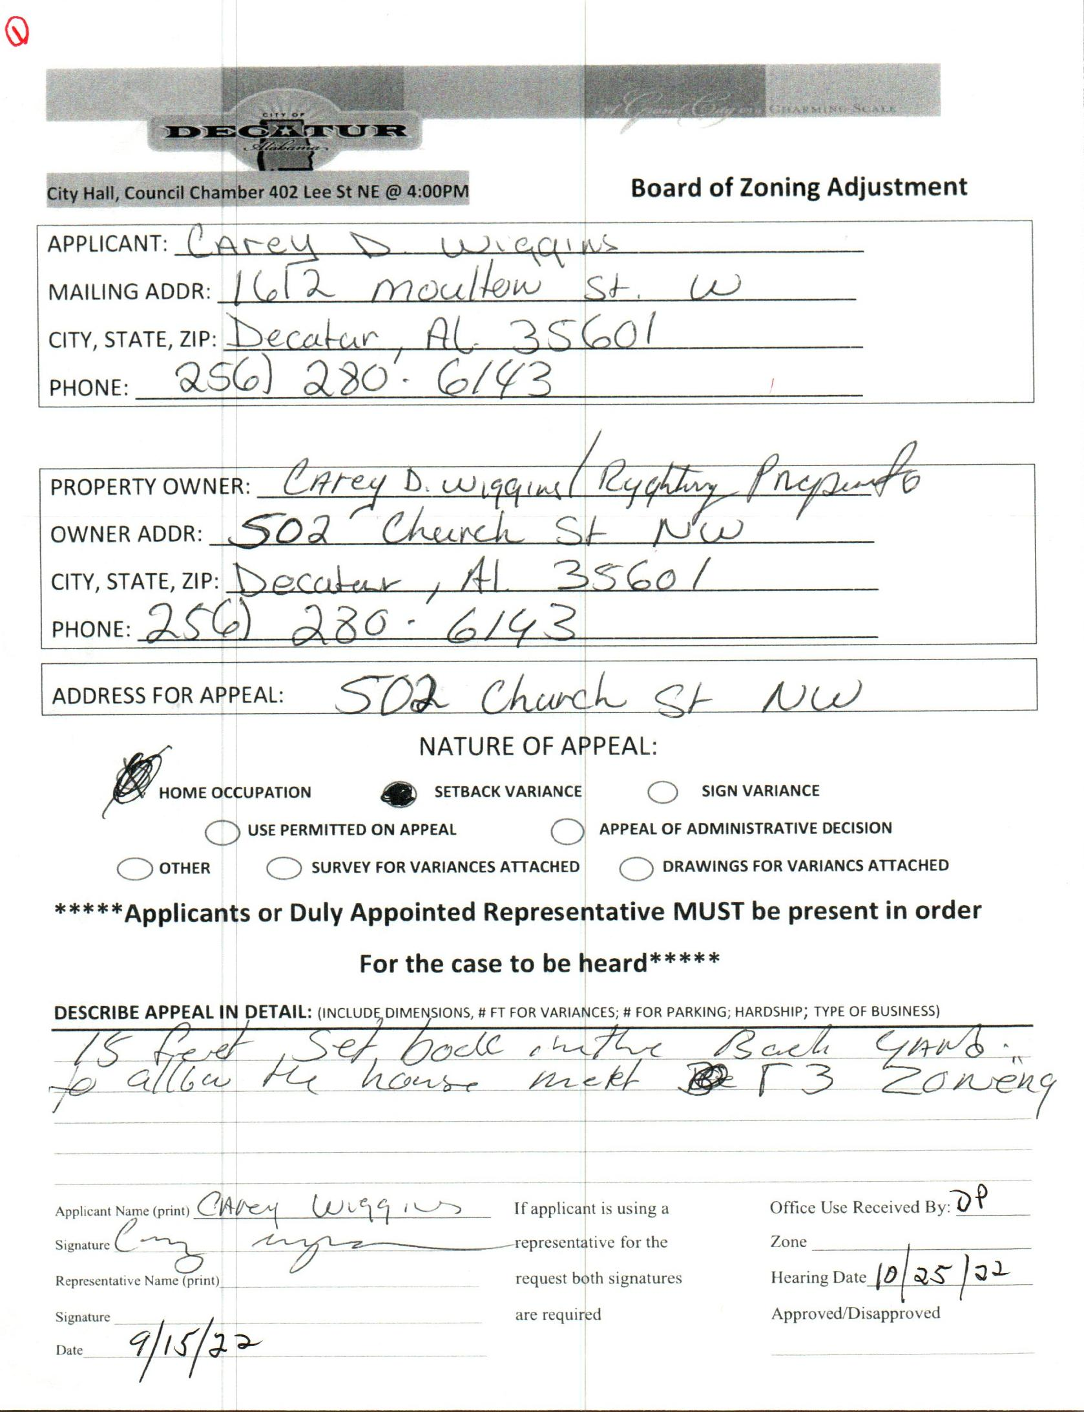

CASE NO. 1 502 Church St NW

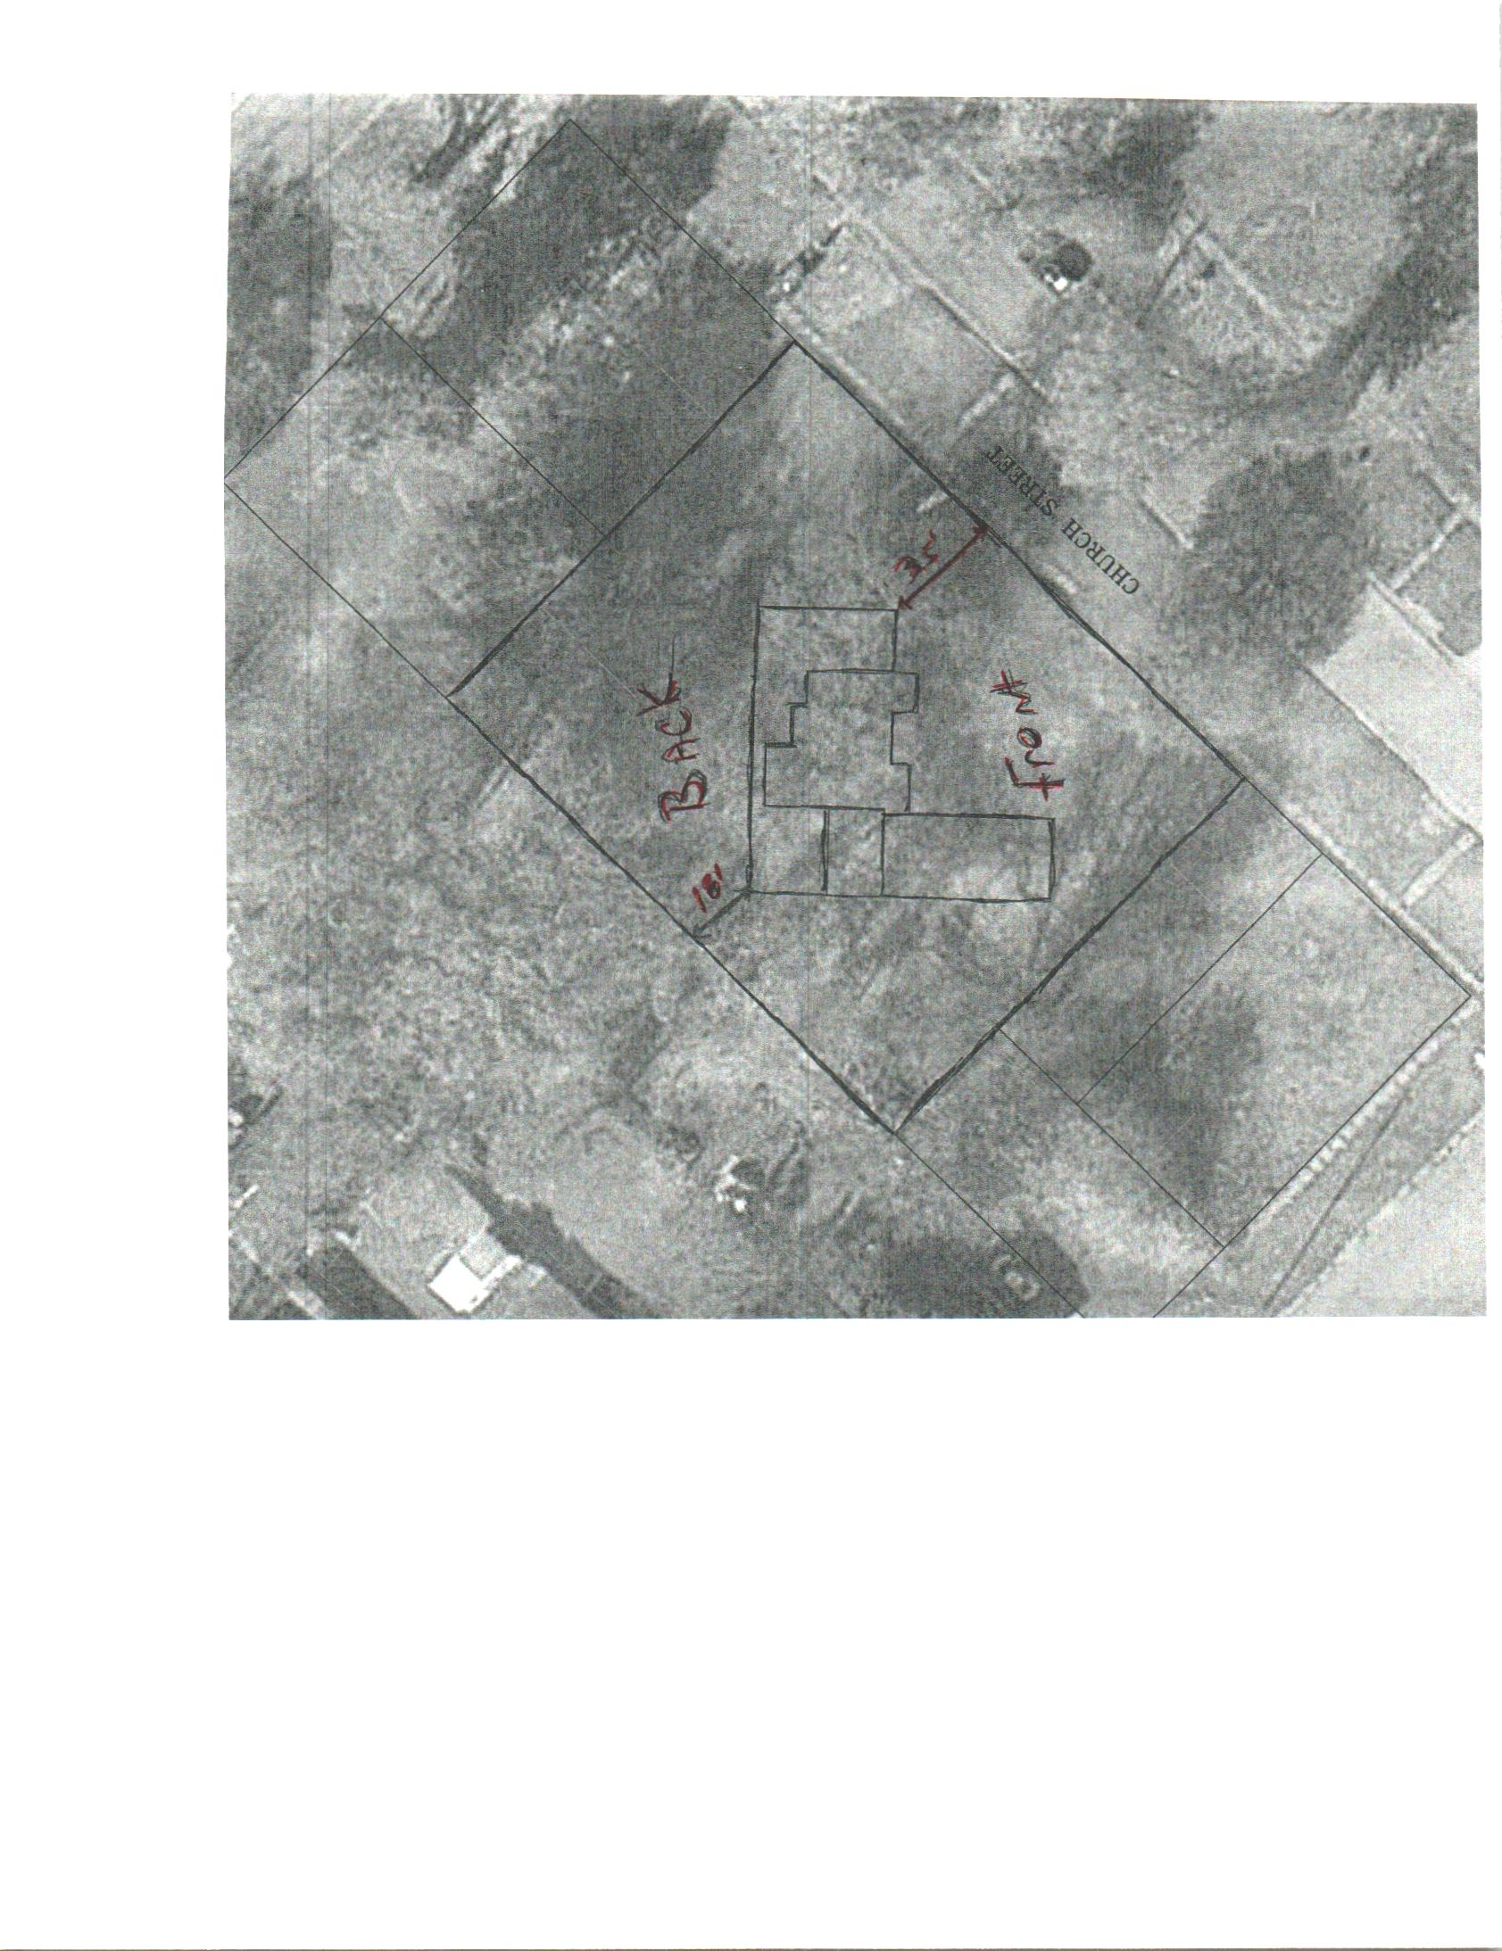

DIAGRAM
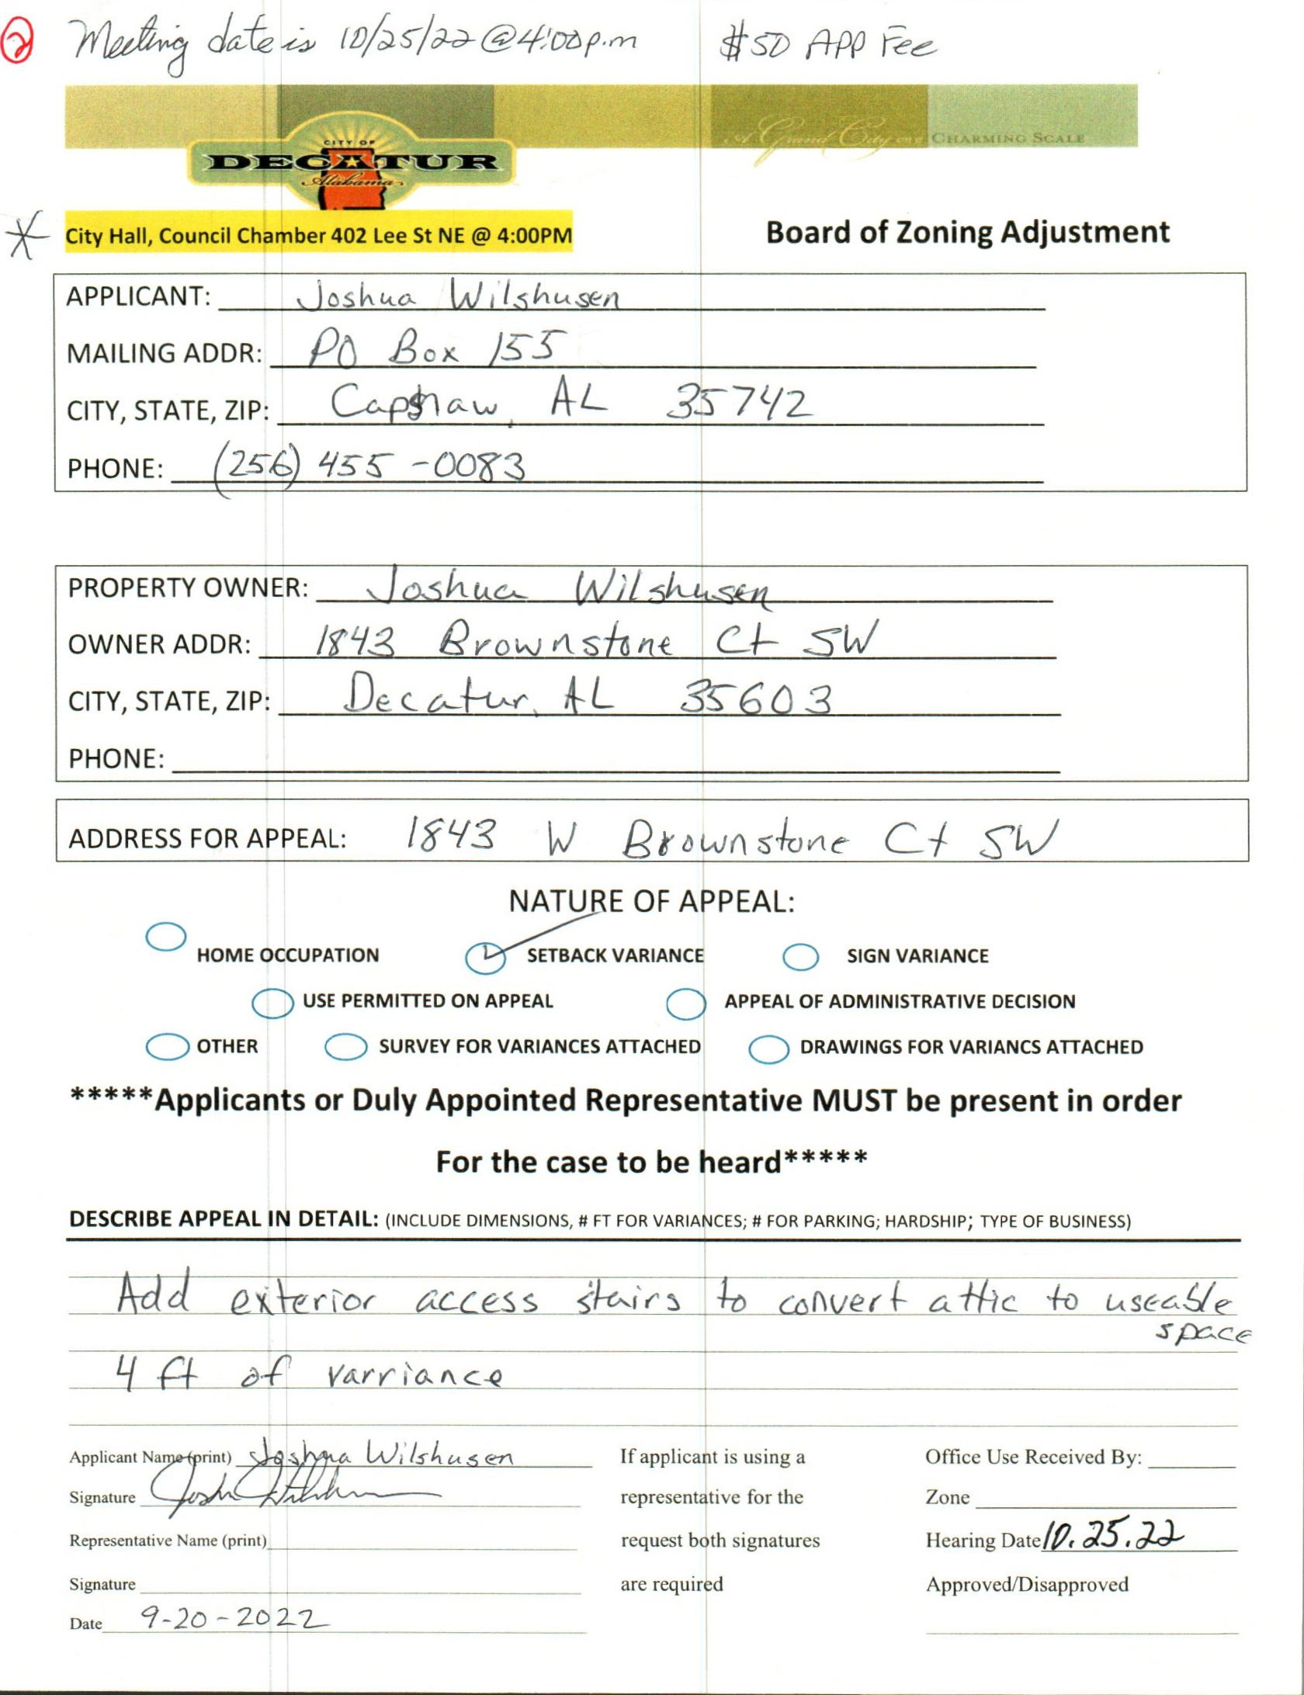

CASE NO. 2 1843 wEST bROWNSTONE cT. SW
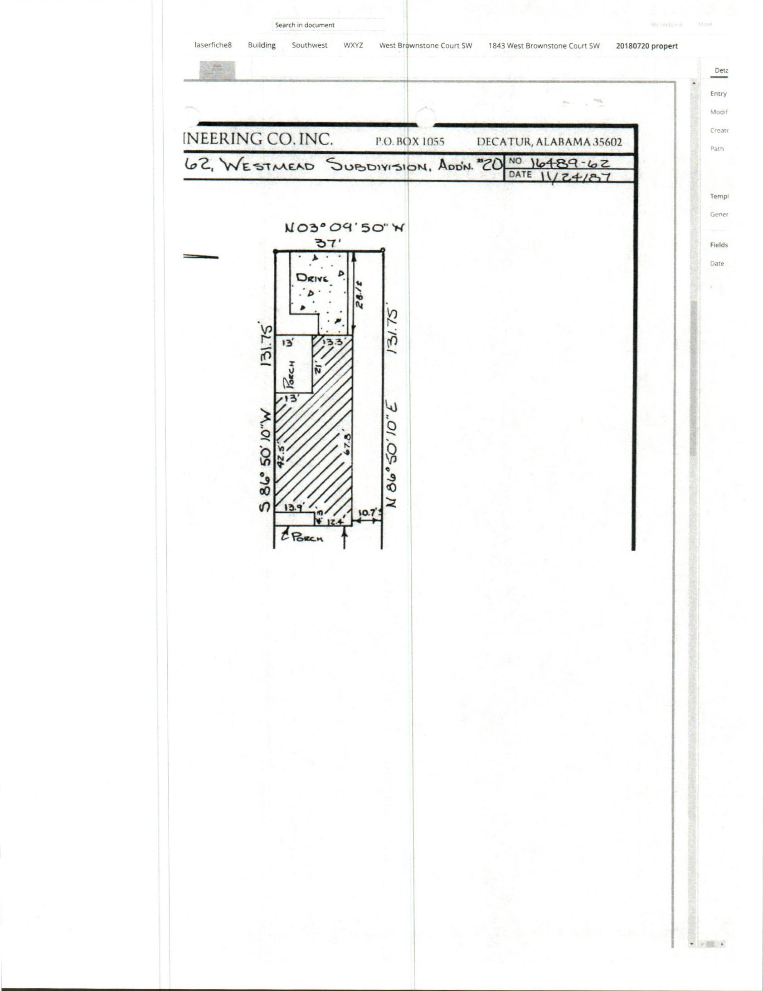

SURVEY
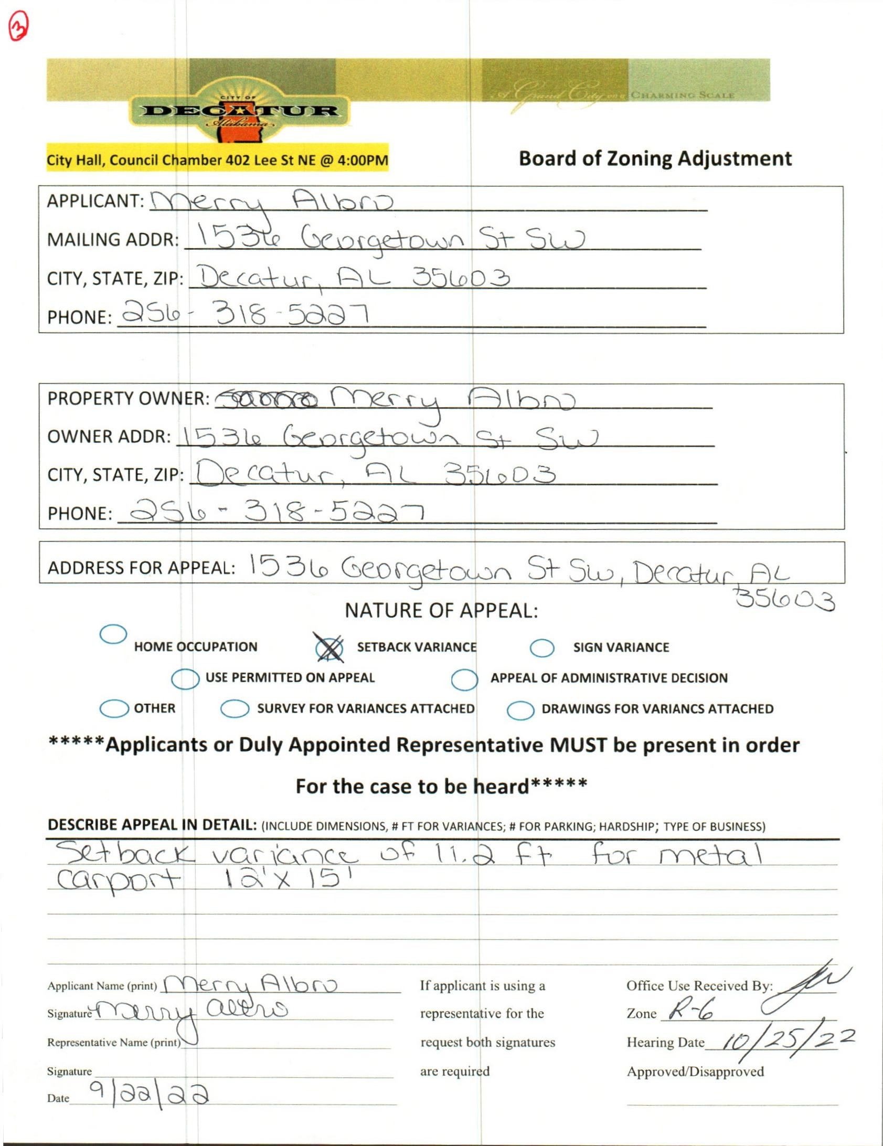

CASE NO. 3 1536 GEORGETOWN ST. SW
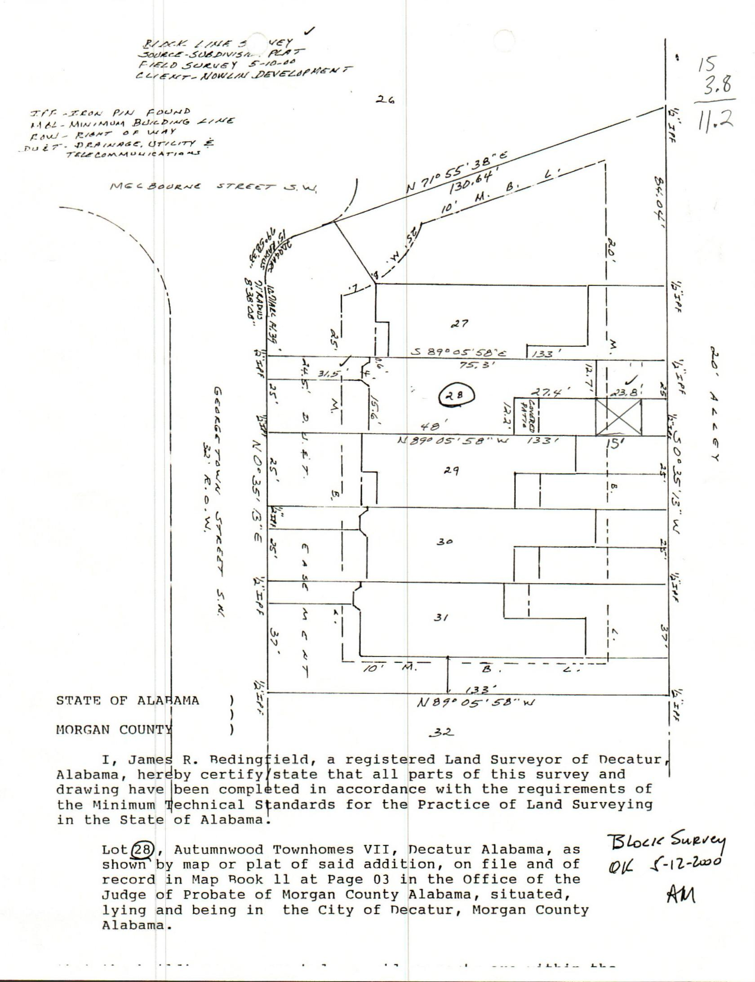

SURVEY
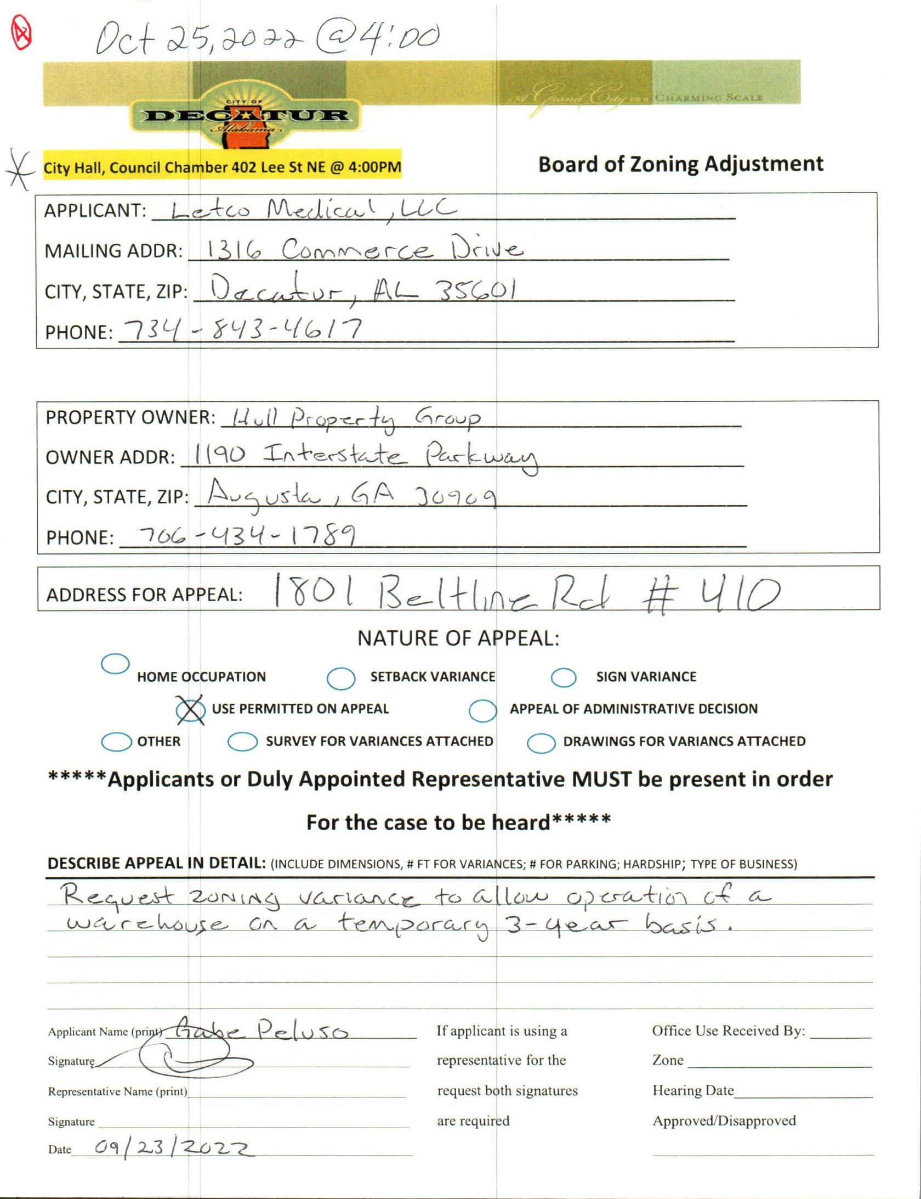

CASE NO. 4 1801 BELTLINE RD #410
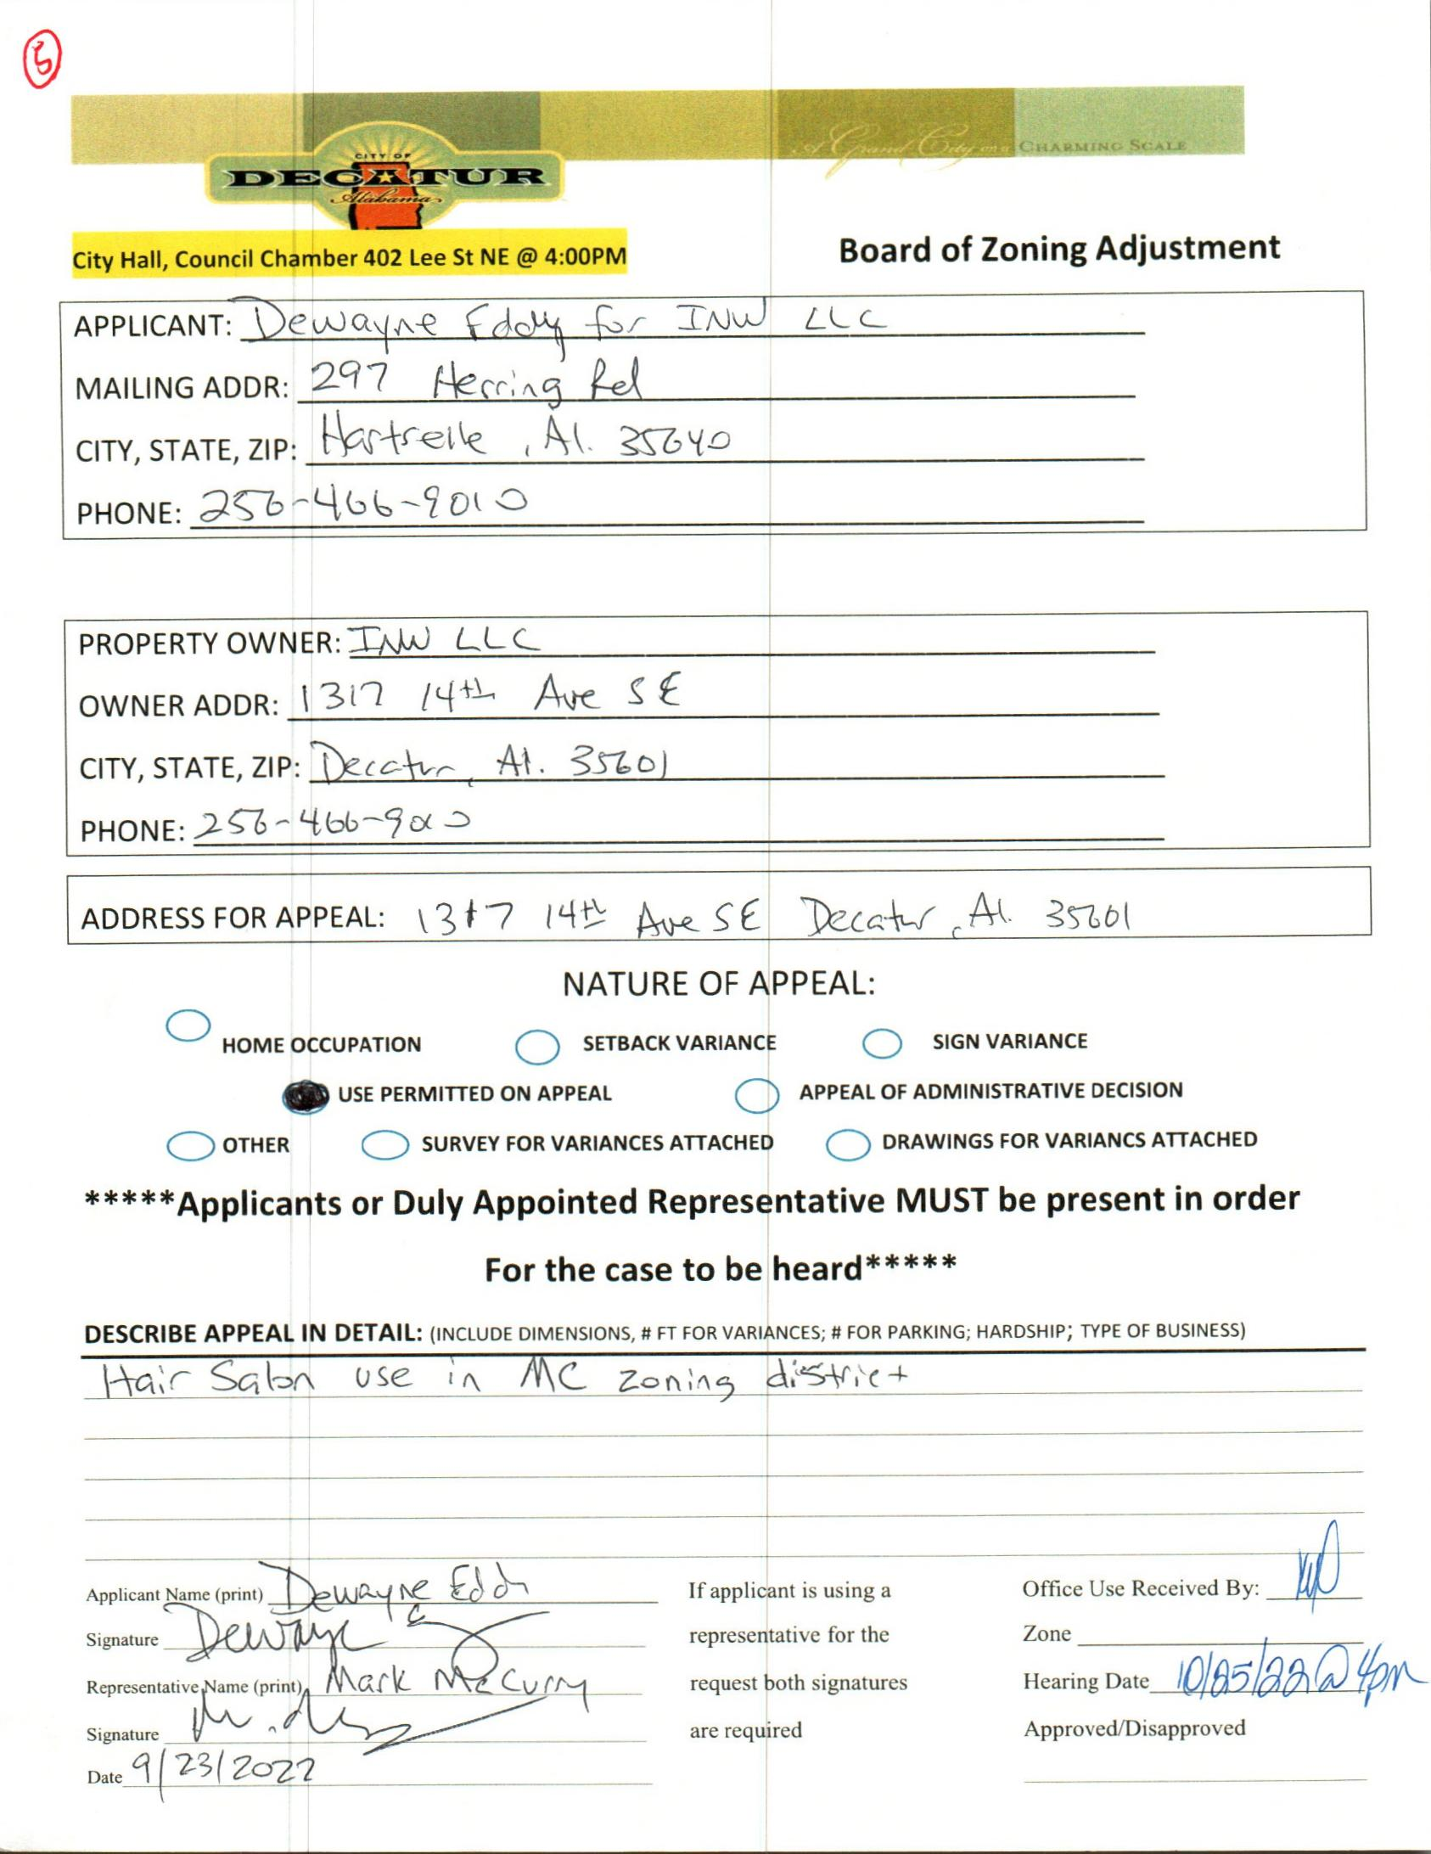

CASE NO. 5 1317 14TH AV SE
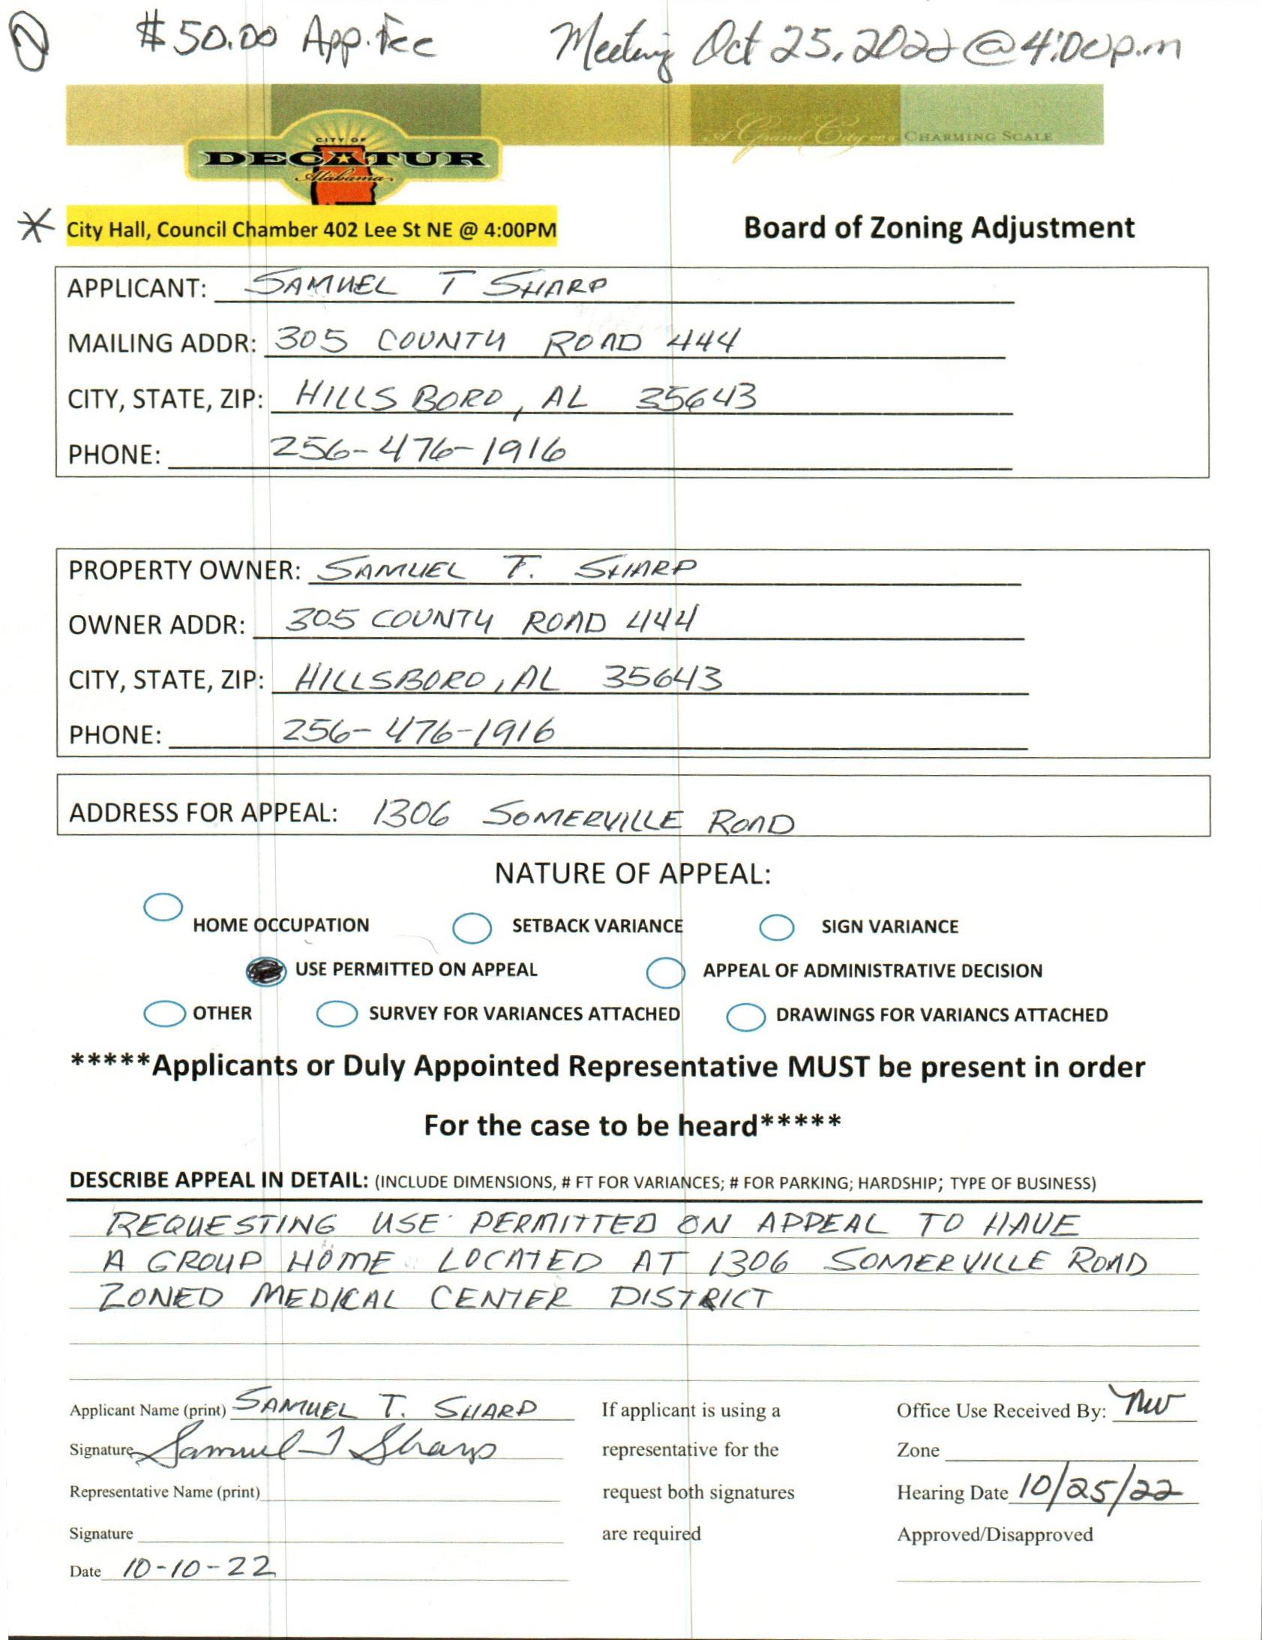

CASE NO. 6 1306 SOMERVILLE RD SE
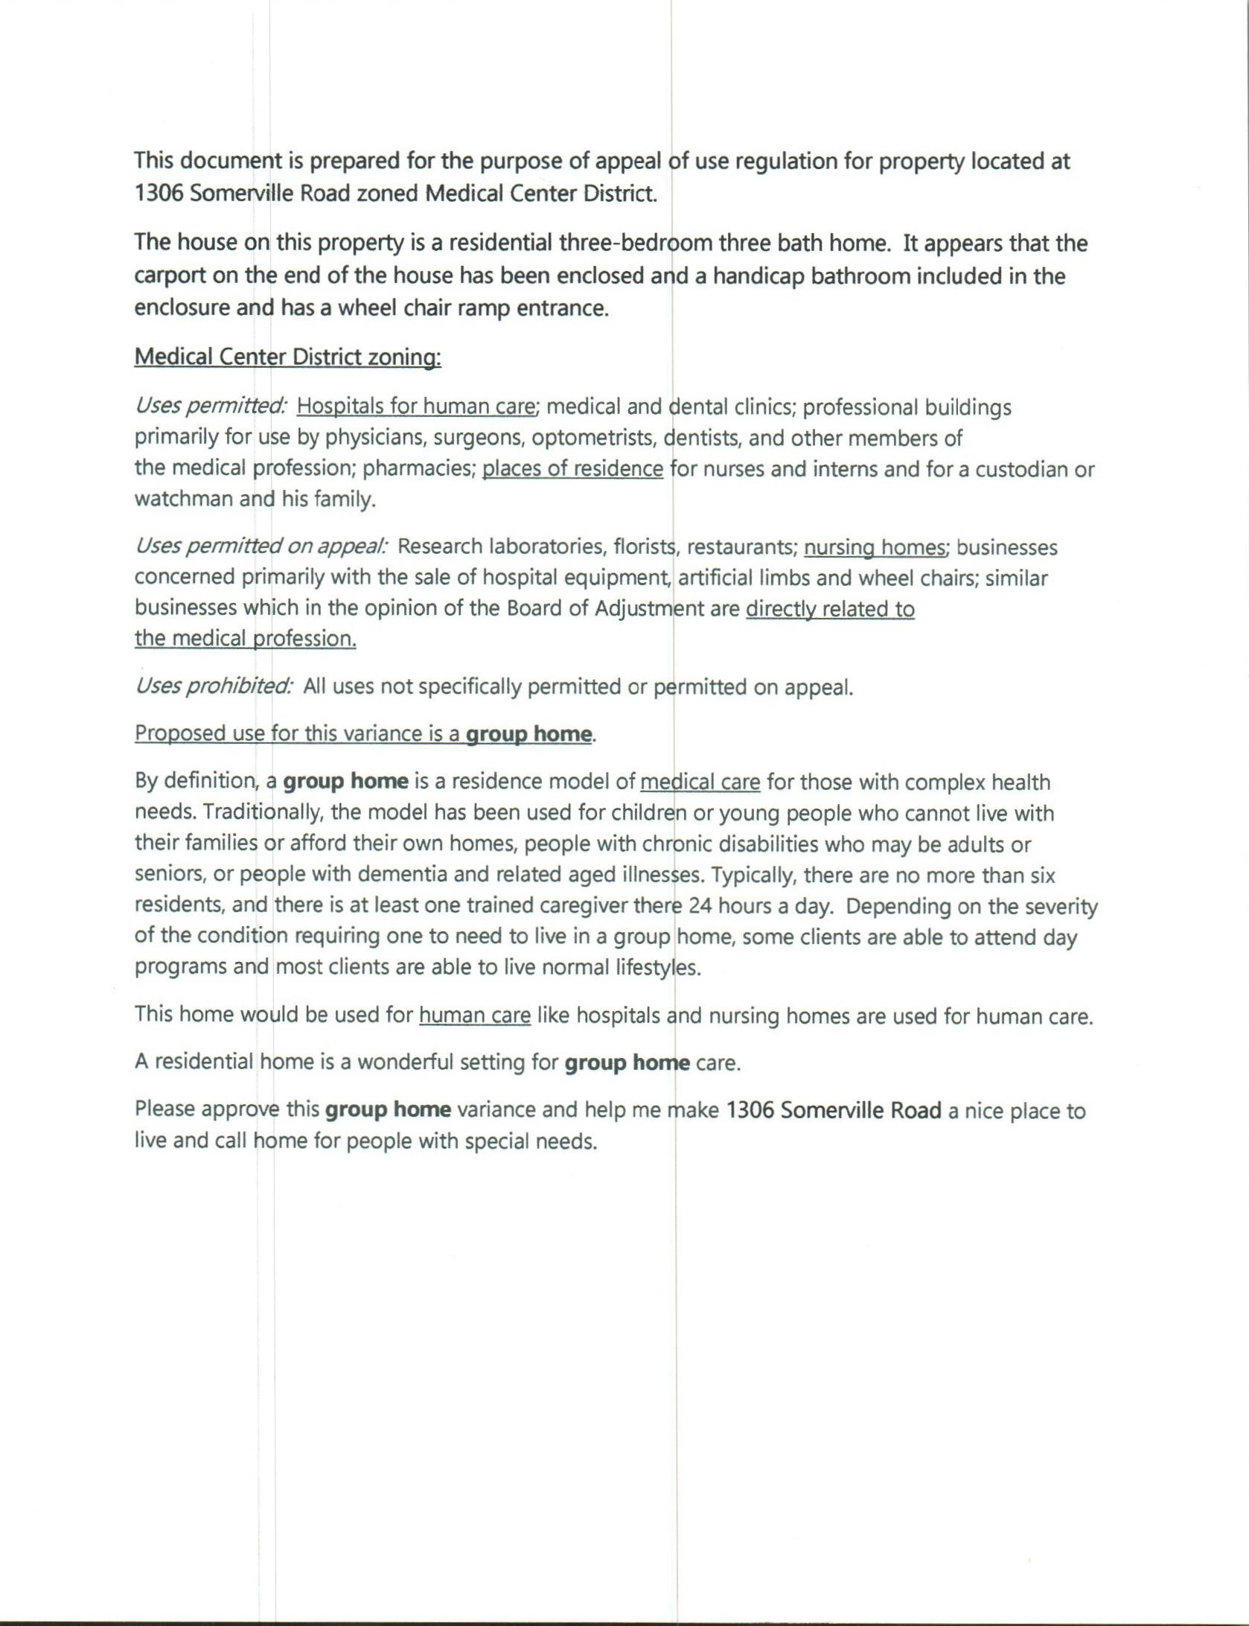

DESCRIPTION
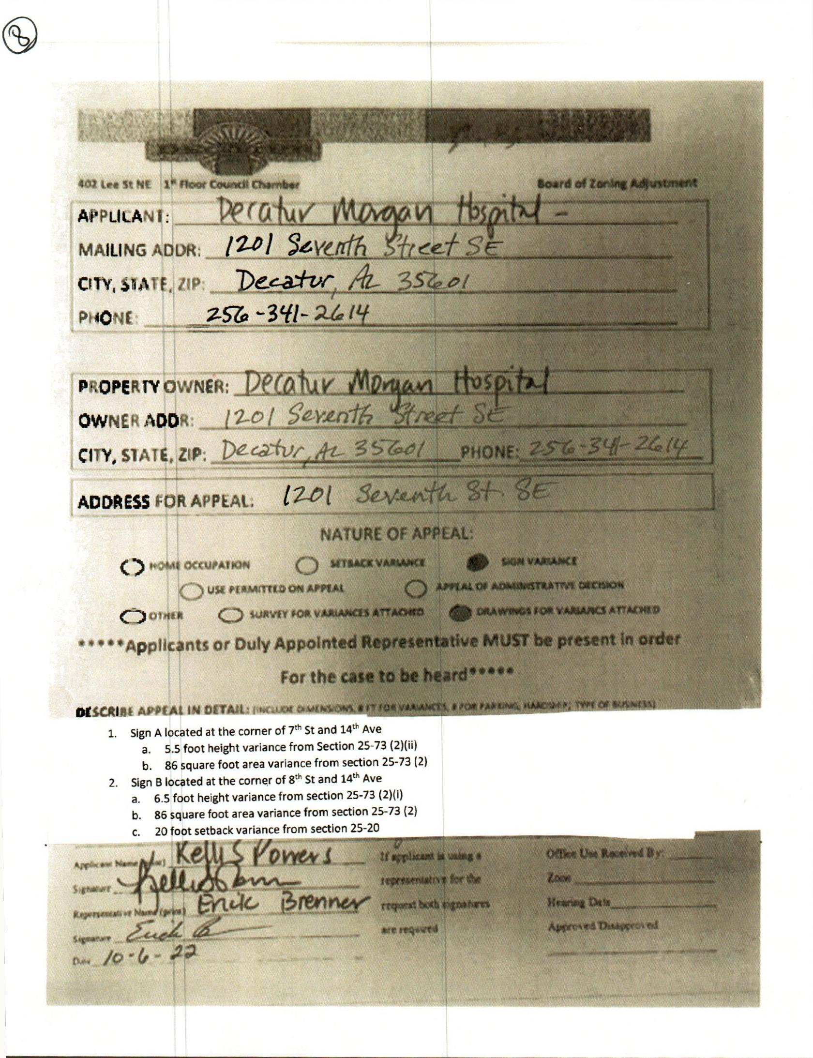

case No. 7 1201 7th st. SE
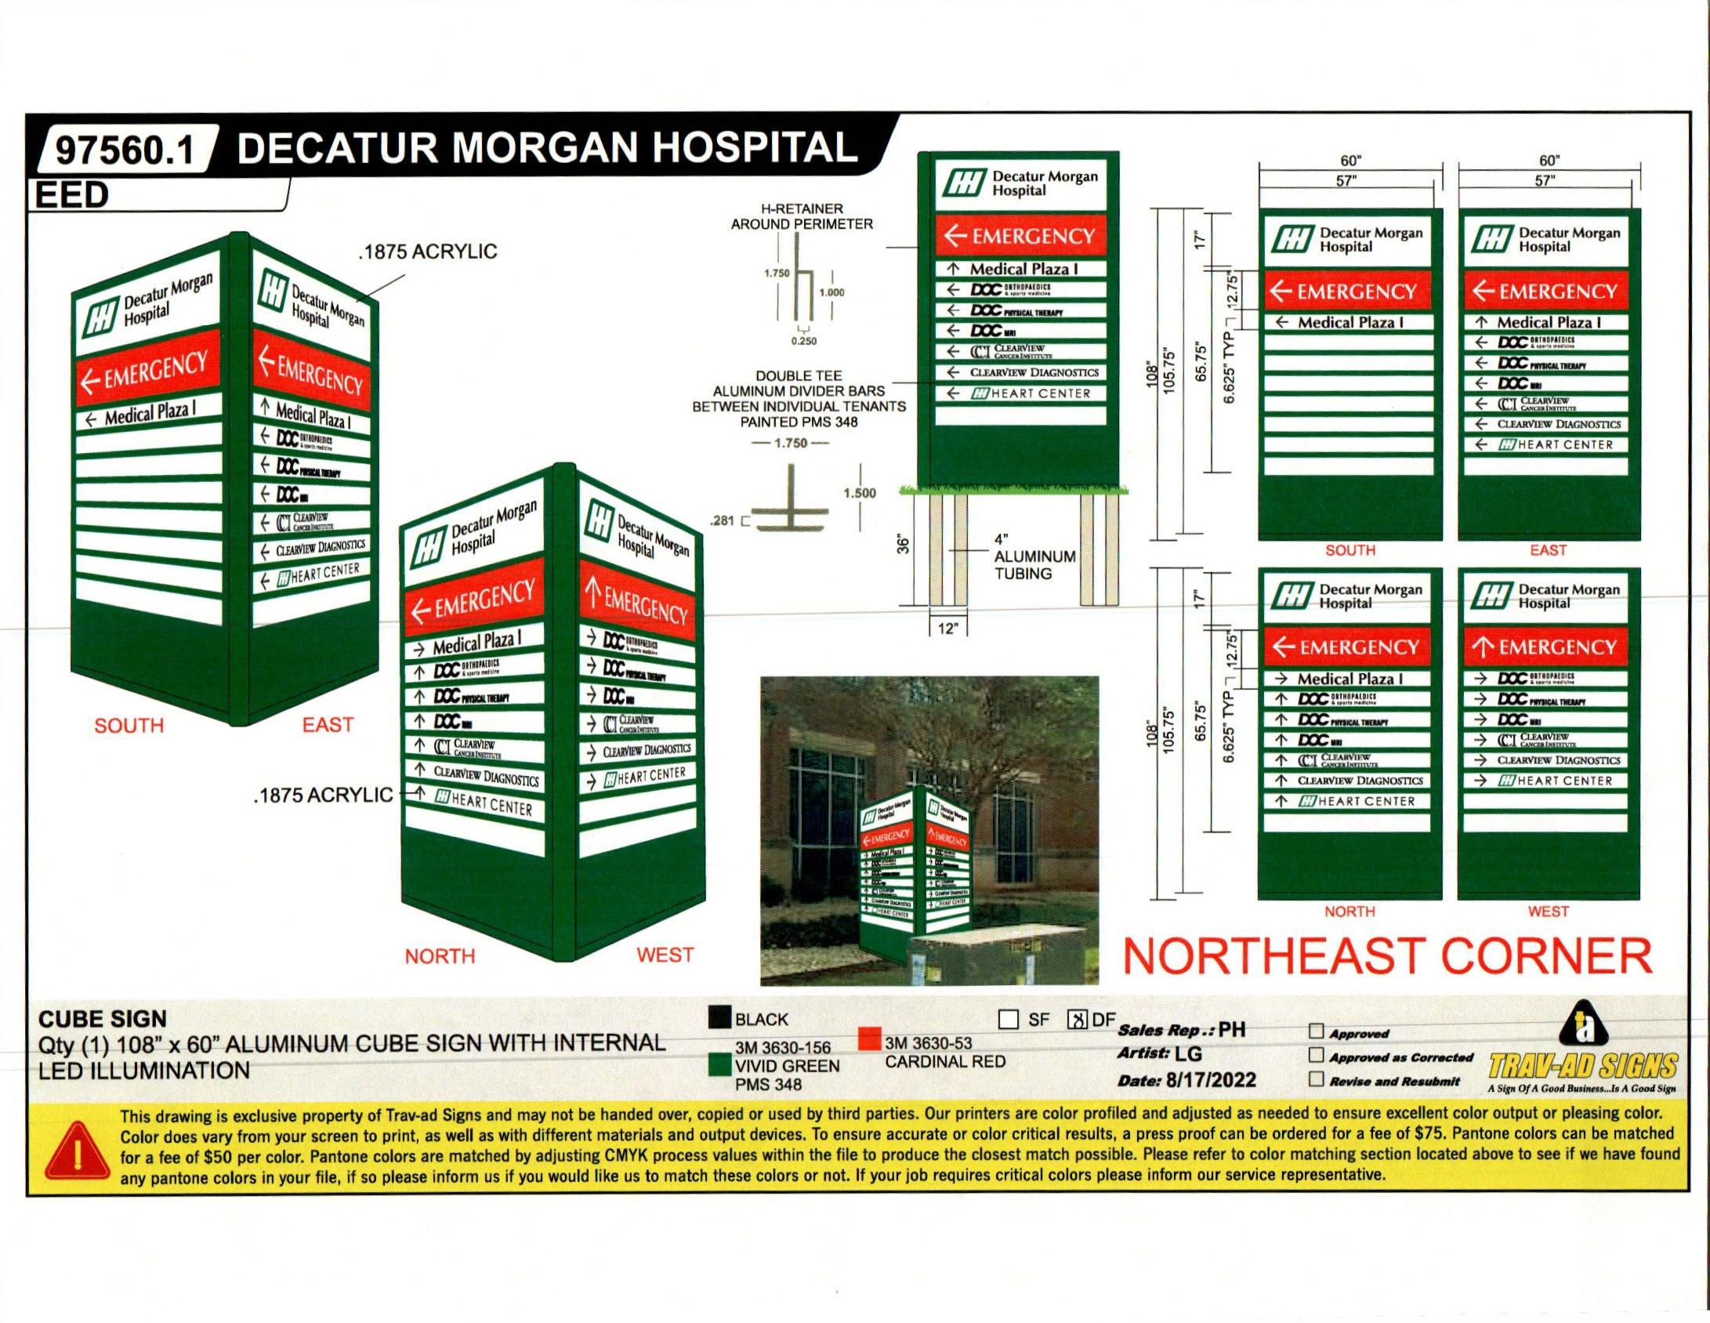

NORTHEAST CORNER SIGN
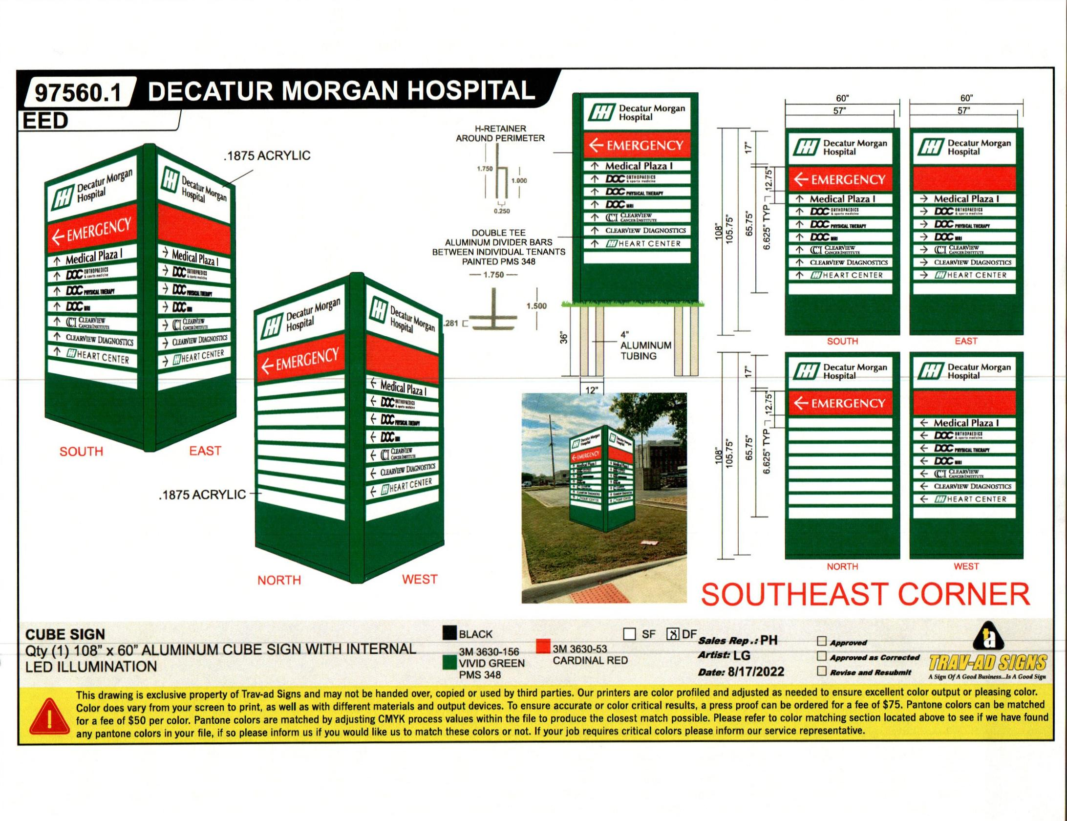

SOUTHEAST CORNER SIGN
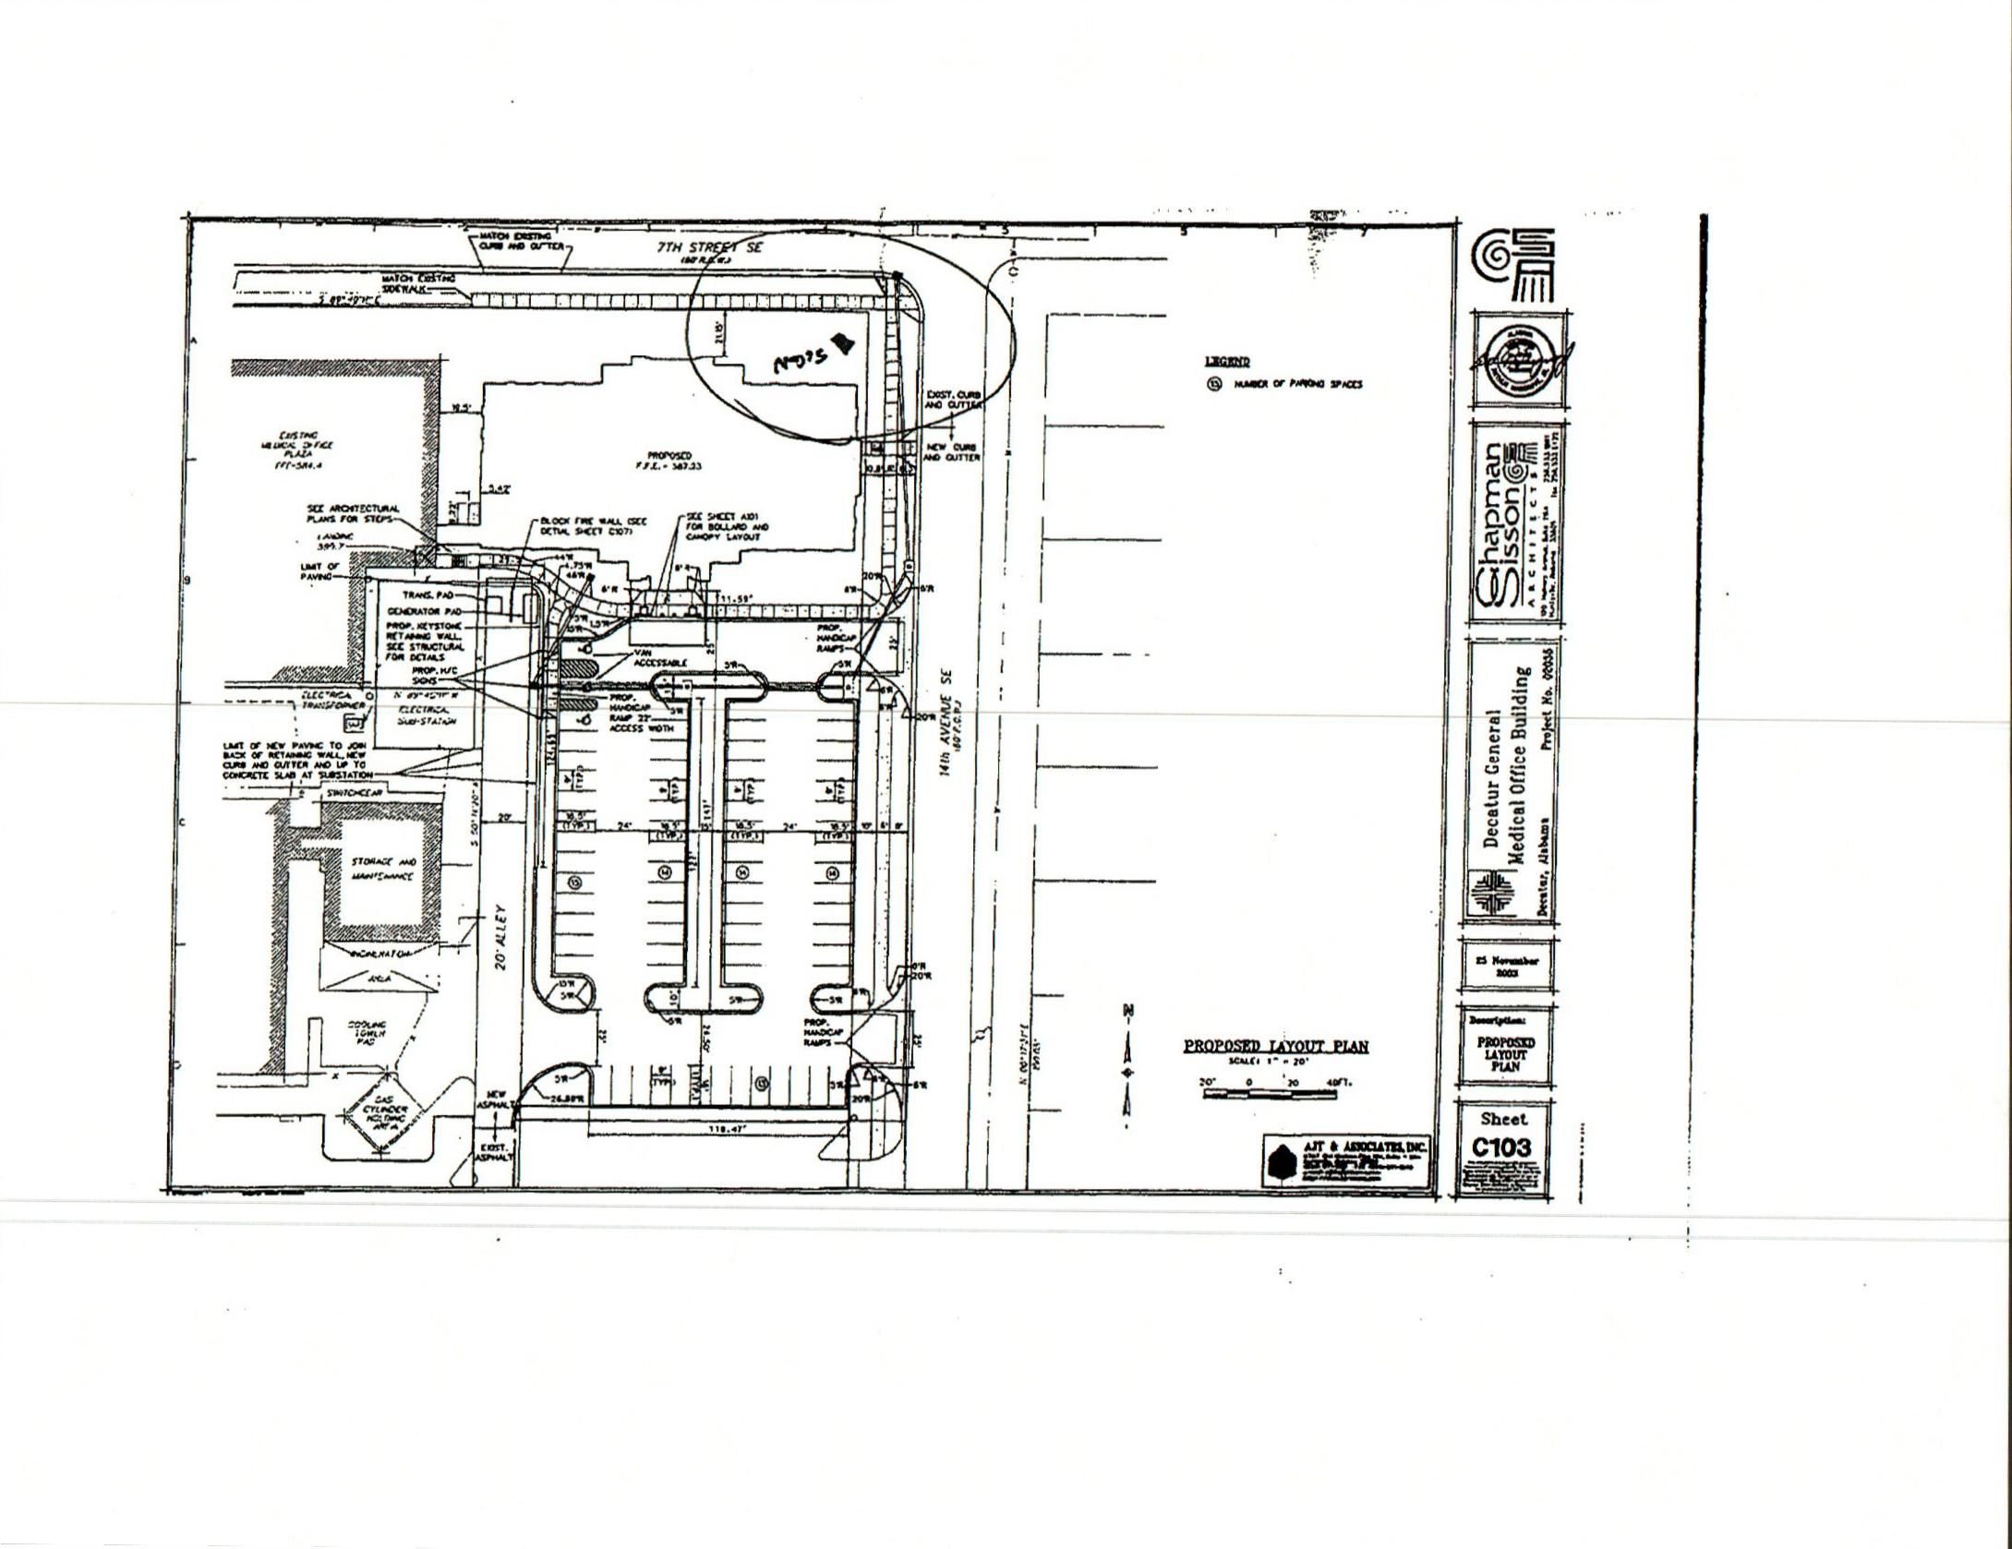

LAYOUT
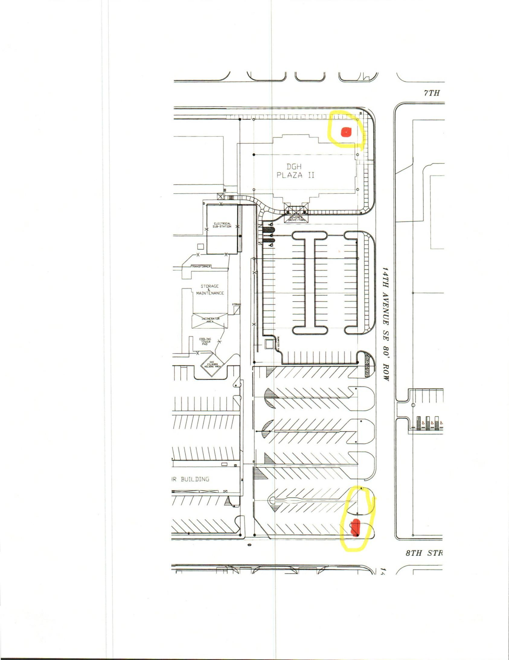

LAYOUT (2)
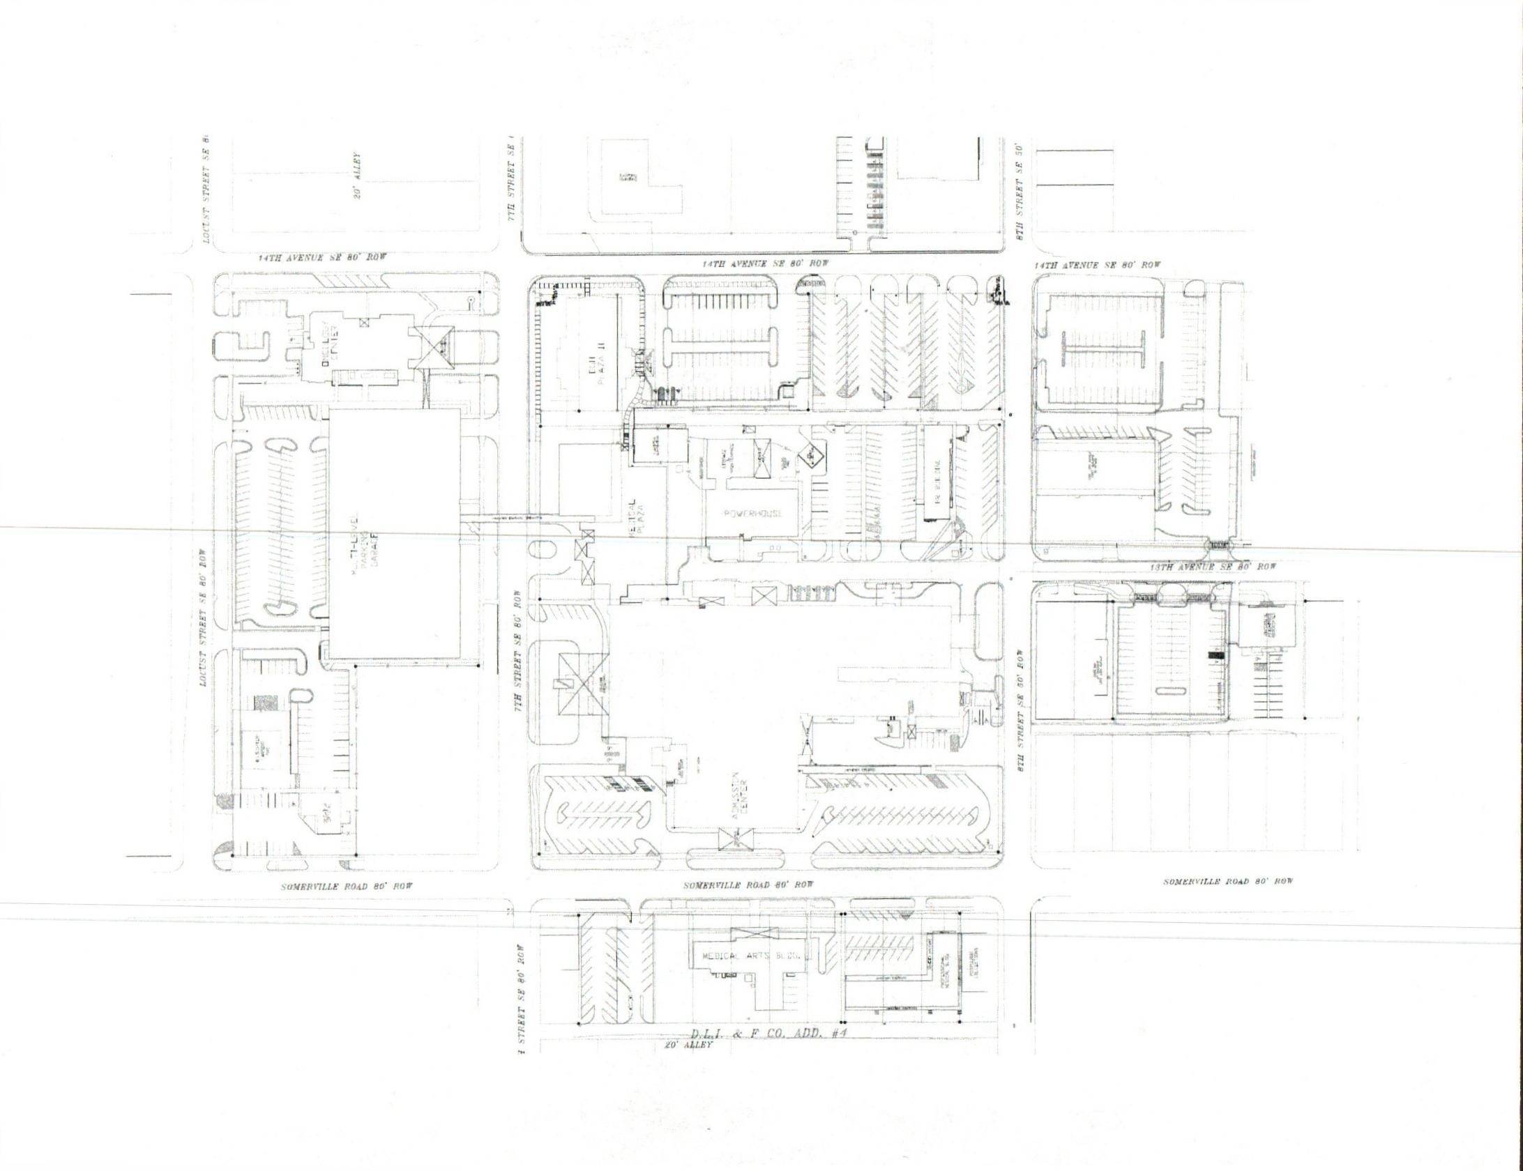

DIAGRAM
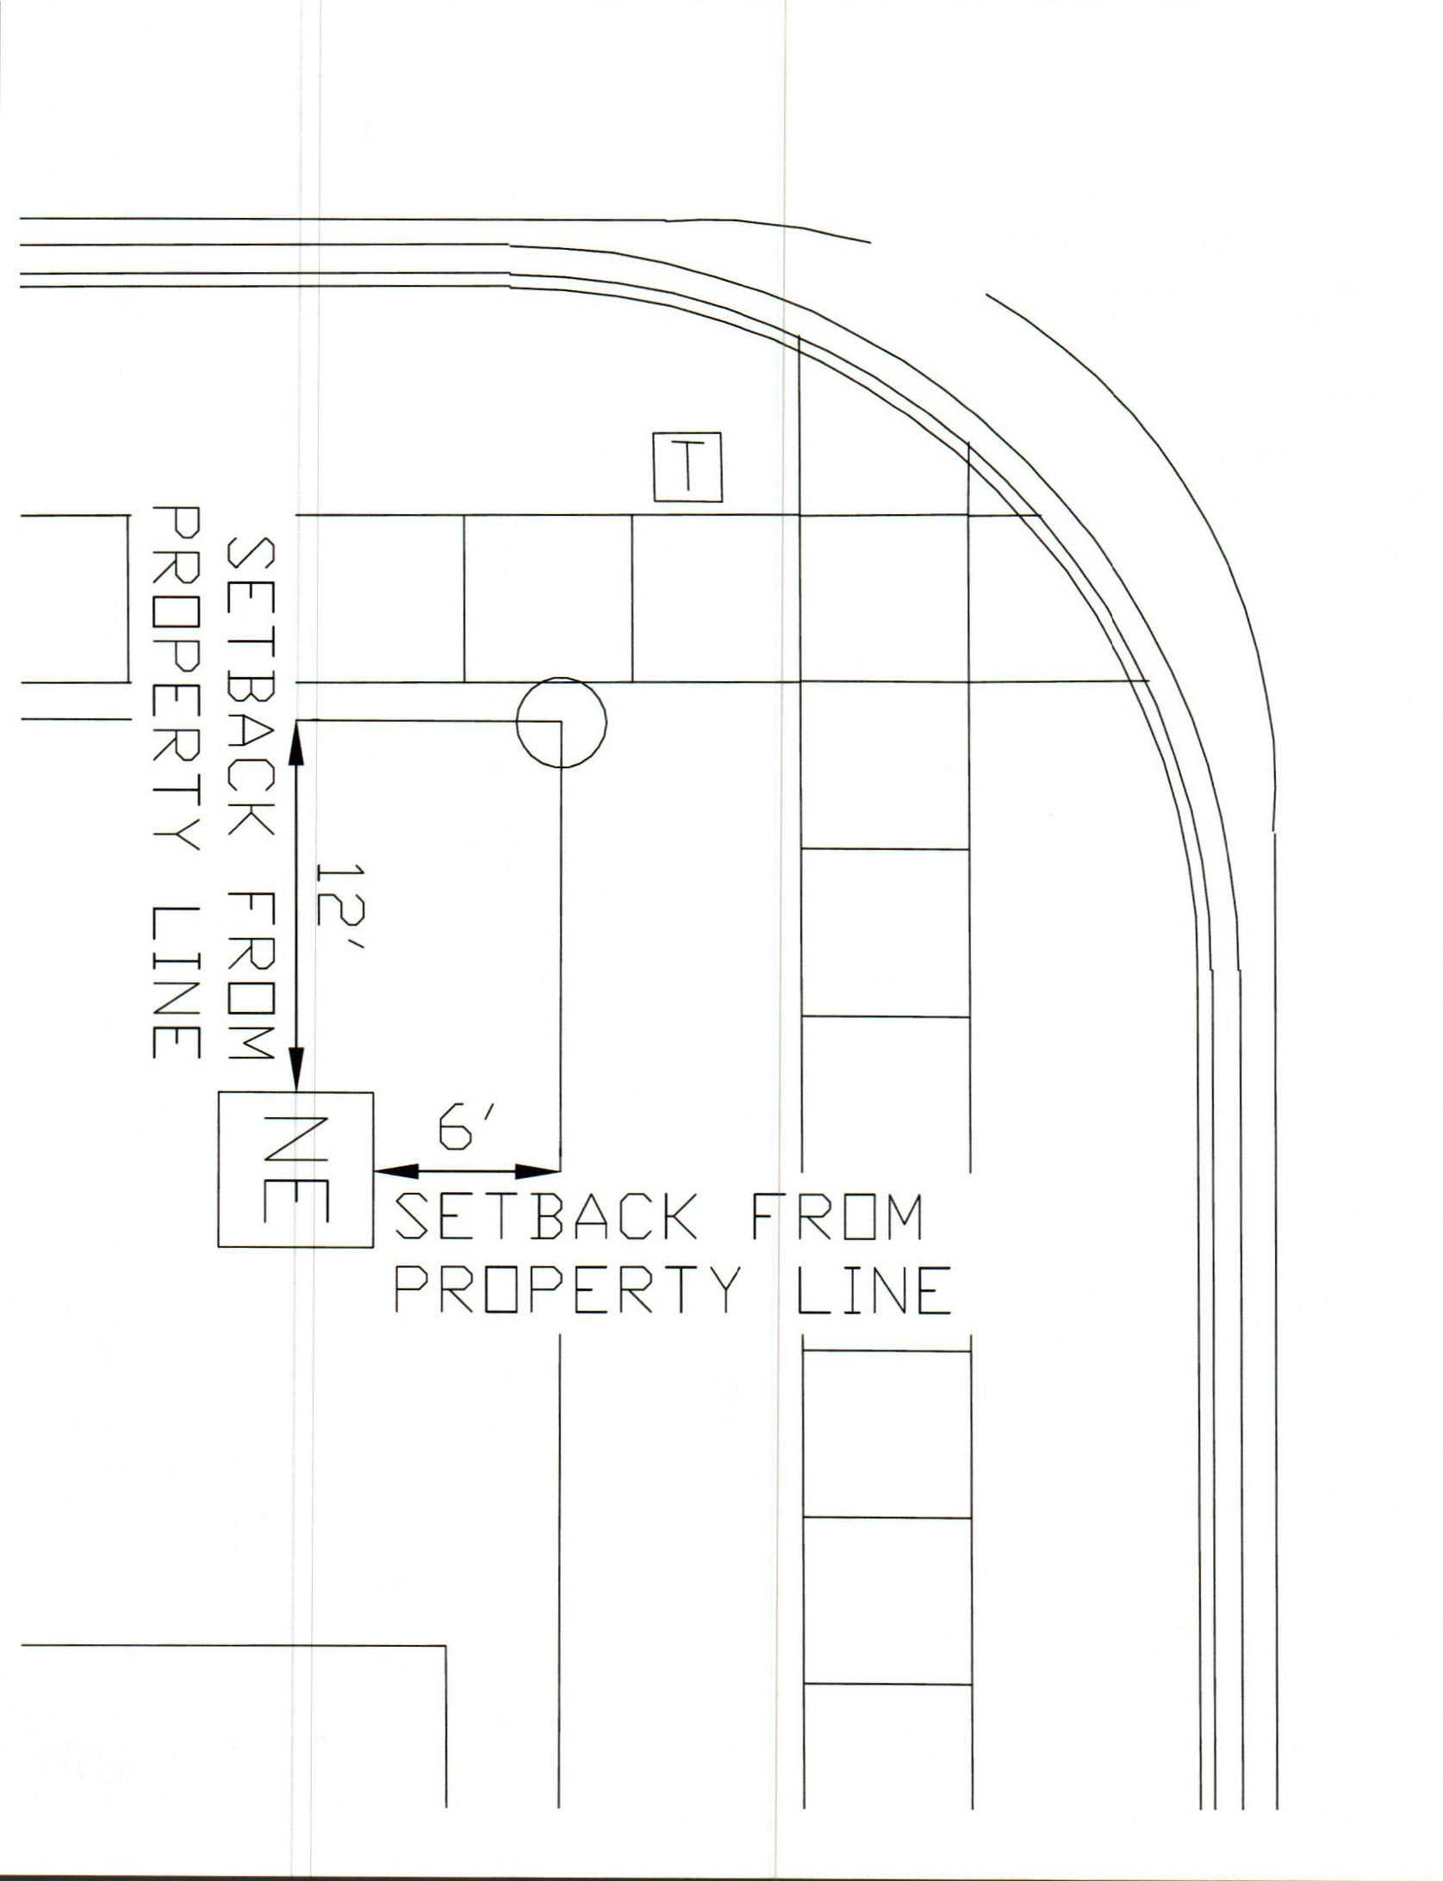

DIAGRAM 2
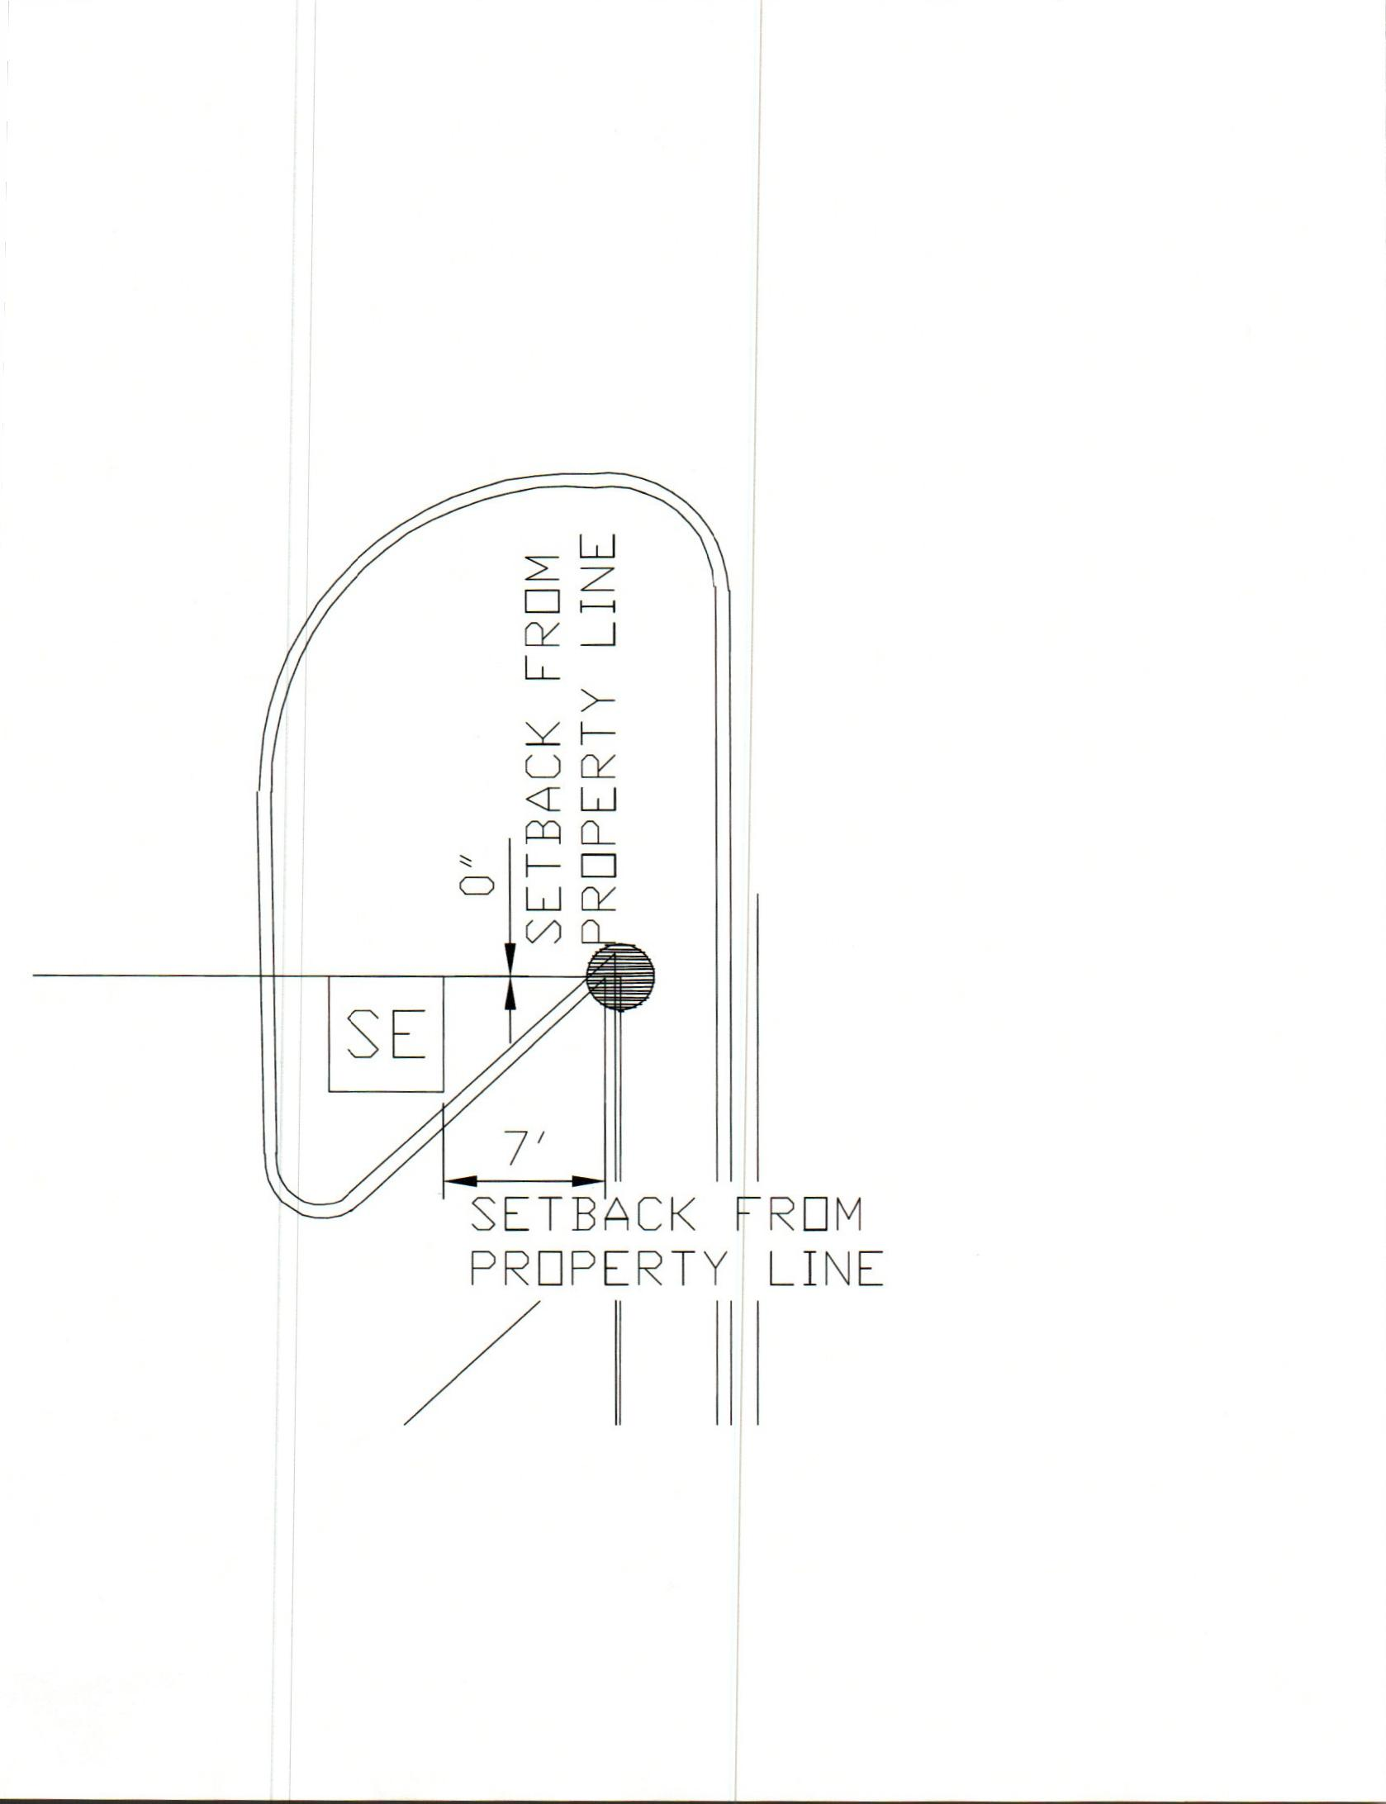

DIAGRAM 3
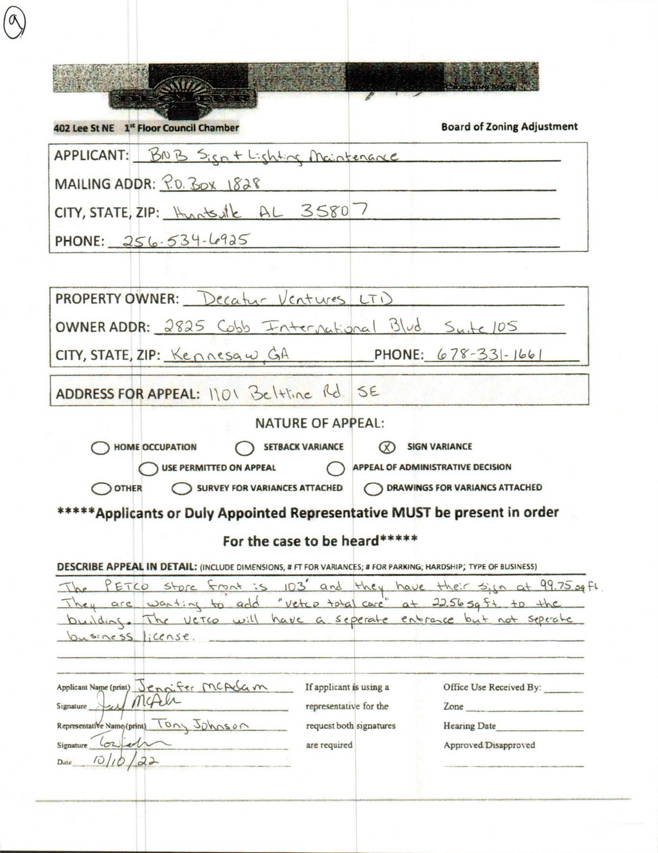

case no. 8 1101 beltline rd se
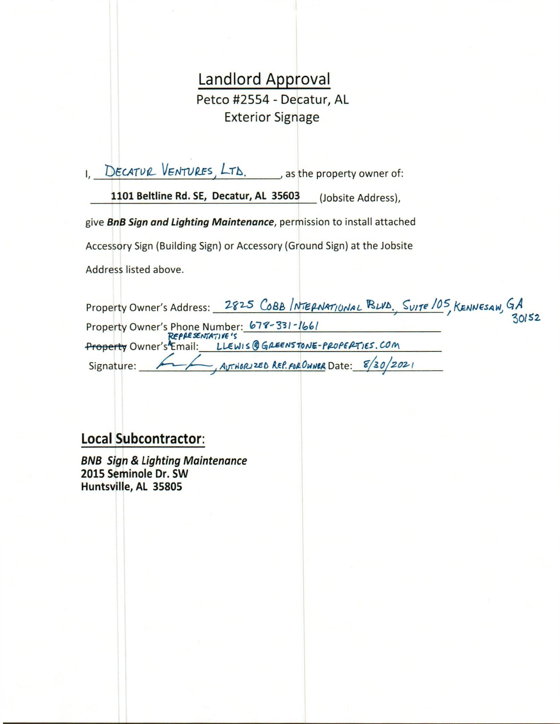

LANDLORD APPROVAL
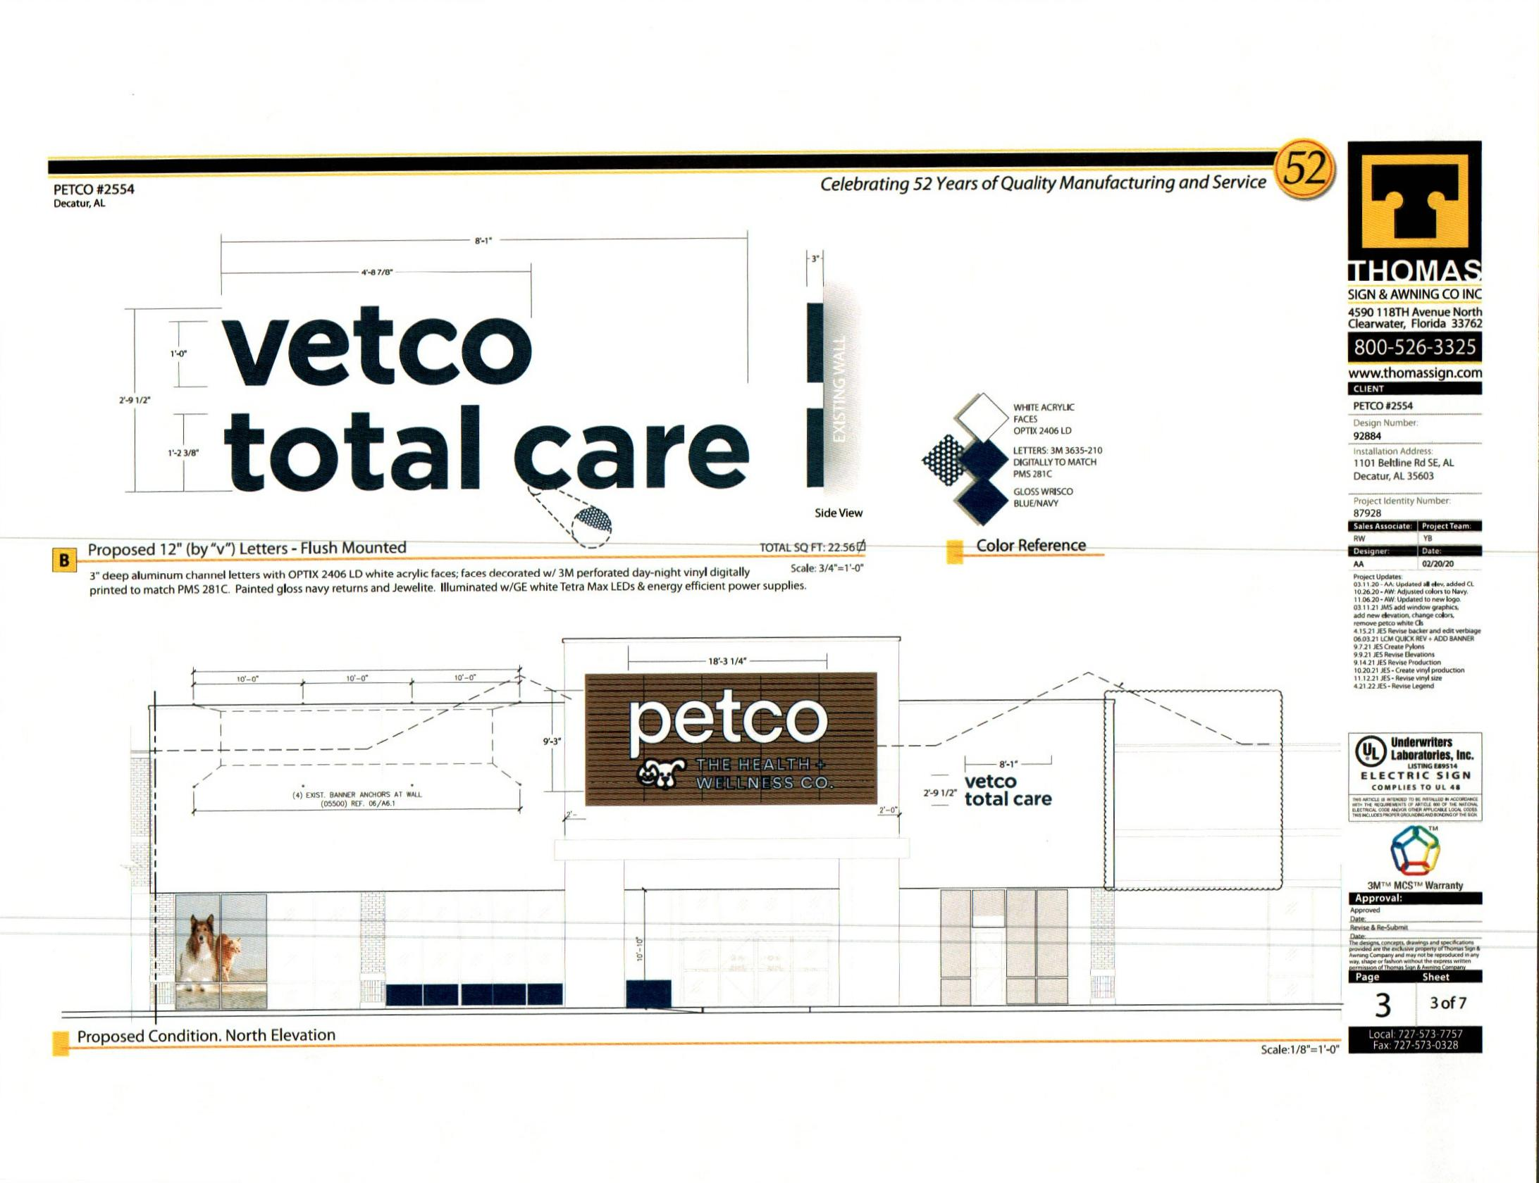

PROPOSED CONDITION: NORTH ELEVATION
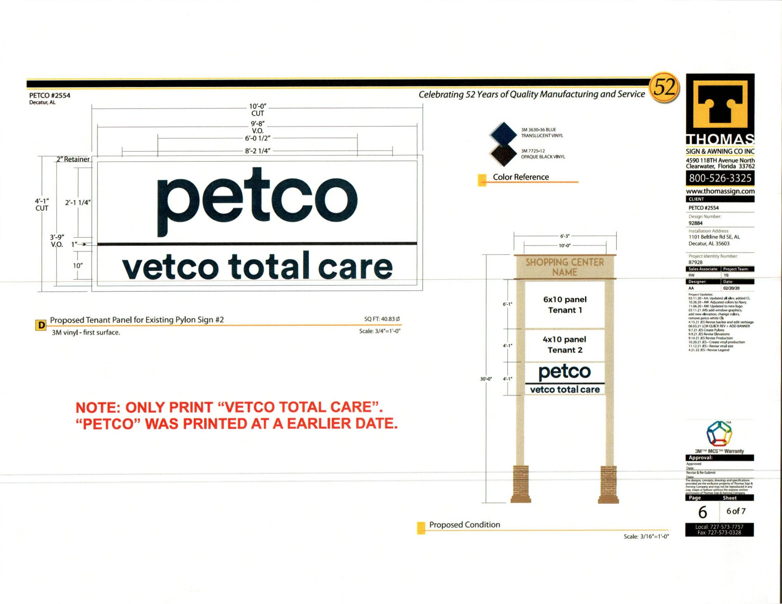

PROPOSED TENANT PANEL for EXISITING PYLON SIGN #2
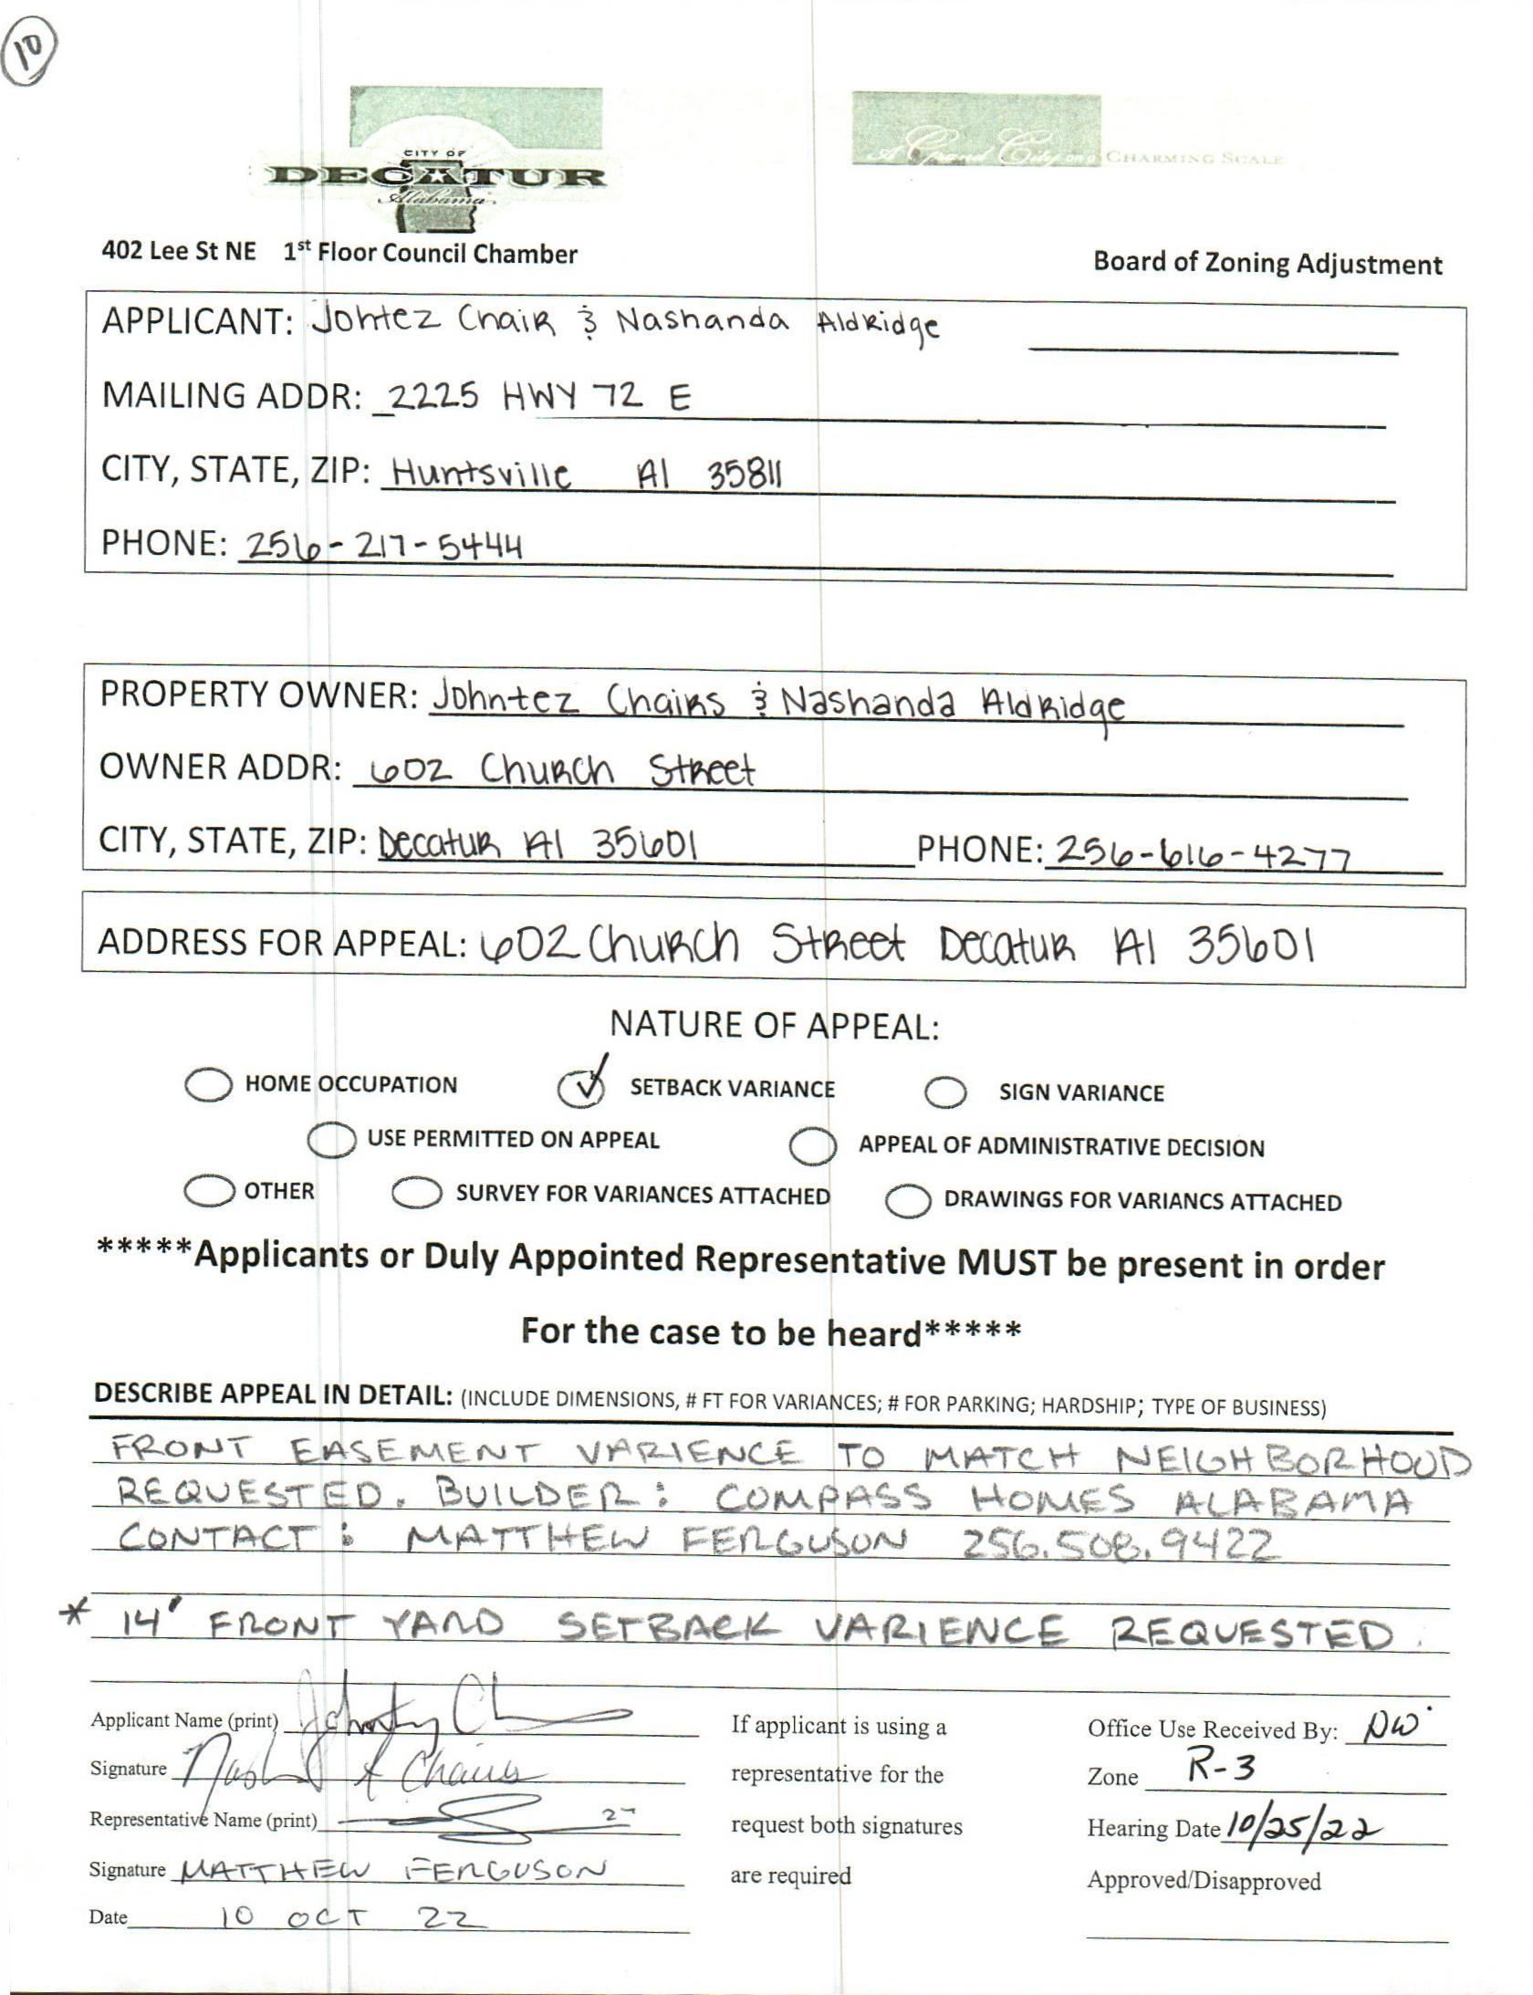

case no. 9 602 church st. nw

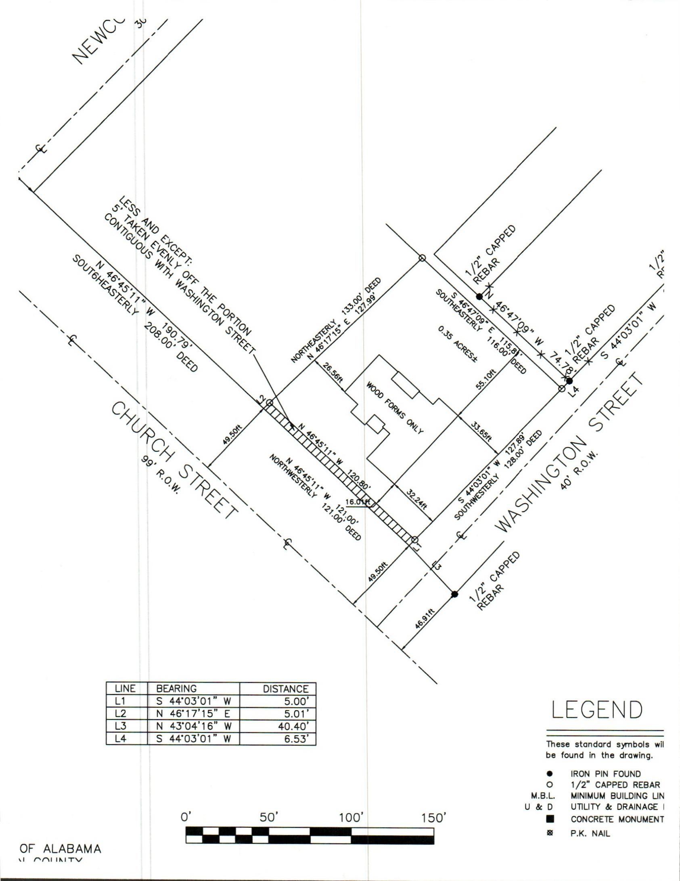

SURVEY

