BOARD OF ZONING ADJUSTMENT

AGENDA

September 2022

Table of Contents
Minutes August 2022 3
AGENDA 17
September 2022 17
case no. 1 620 pumpkin dr. sw 19
INSPECTION SURVEY 20
MAP 21
CASE NO. 2 1401 POINT MALLARD PKWY SE 22
LETTER(EMAIL) 23
SITE PLAN 24
CONSOLIDATION PLAN 25
MAP 26
CASE NO. 3 901 PROSPECT DR. SE 27
SURVEY 28
MAP 29
CASE NO. 4 1312 CEDAR ST SW 30
SURVEY 31
MAP 32
case no. 5 930 cedar st sw 33
PICTURE 34
PICTURE (2) 35
PICTURE (3) 36
MAP 37
CASE NO.6 620 WILSON ST NE 38
MAP 39
CASE NO. 7 801 PROSPECT 40
SURVEY 41
MAP 42

Minutes August 2022

MEMBERS PRESENT: Chair, Delayne Dean, Mr. Steven Thomas, Mr. Brad Townsend

SUPERNUMERARIES: Mr. Larry Waye, Mr. Chester Ayers

COPIED TO: Rev. George Allen

OTHERS PRESENT: Mrs. Ruth Priest, Asst. City Attorney
Mr. Lee Terry, Planning Department
Mr. Bob Sims, Building Inspector
Mrs. Nancy Whiteside, Recorder

Chairperson, Delayne Dean called the meeting to order at 4:00 p.m. in the council chambers on the first floor at City Hall.

Mr. Bob Sims, Building Department, called the roll.

The minutes from the July 2022 meeting were approved without any changes. Mr. Larry Waye motioned to approve the minutes. Mr. Steven Thomas seconded the motion. On a voice vote, the motion carried.

CASE NO. 1-TABLED FROM JULY 2022

Application and appeal Taylor Jones for a 3 foot side yard set-back variance from Section 25-10.10 (2)(e) and a 7.2 foot rear yard set-back variance from Section 25-10.10 (2) (d) for a deck located at 825 Grant St SE, property is located in a R 3-H Historical Residential Single Family District.

Mr. Doug Bachuss of Al Bachuss Law Firm, 118 Moulton St. East presented this case to the Board. Mr. Bachuss stated he was representing Mr. Jones who is requesting the variance in setback line.

Mr. Bachuss stated Mr. Jones had constructed a deck that is located mostly behind his home located at 825 Grant St. SE. and it does come into the side yard setback.

Mr. Bachuss stated the setback of the side yard is six feet.

Mr. Bachuss stated a survey, prepared by Mr. David Fagerman, has been provided.

Mr. Bachuss stated the survey reflects the layout of the deck and shows installation to the rear yard setback and side set back and at one point is at 4.1 feet

Mr. Bachuss stated the home has an existing offset house encroachment of 4.6 feet and the deck in relation to that house encroachment is just about five inches.

Mr. Bachuss stated the back of the deck extends into the rear yard setback going toward the garage and an alley and the deck in relation to the garage is not that much different.

Mr. Bachuss stated Mr. Jones is asking for relief from the Board to recognize the location of the deck, which is not covered, helps Mr. Jones ingress and egress from the back of the house

Mr. Bachuss stated a fence hides the deck.

Mr. Bachuss stated the deck is not visible from the front of the house because of the fence.

Mr. Bachuss stated Mr. Jones believes the deck is in keeping with the neighborhood.

Mr. Bachuss stated the neighborhood has other structures that would block Grant St. and block the visibility of the deck.

Mr. Bachuss stated Mr. Jones was asking for approval of that encroachment center of those setbacks.

Chair Dean asked for questions from the Board.

Mr. Steven Thomas asked Mr. Bachuss if Mr. Jones was aware the house was in the historical district, Mr. Bachuss responded Mr. Jones was aware the house is in the historical district.

Mr. Steven Thomas asked Mr. Bachuss if Mr. Jones was aware living in the historical district required approval to have any modifications to the house. Mr. Bachuss responded Mr. Jones was aware he needed approval.

Mr. Steven Thomas asked Mr. Bachuss if Mr. Jones had received a Certificate of Appropriateness for his modification.

Mr. Bachuss stated there was initial approval but was still under a presentation to the historical preservation committee for approval of the final project.

Mr. Steven Thomas asked Mr. Bachuss to clarify exactly what Mr. Jones had received from the historical committee.

Mr. Bachuss stated Mr. Jones had received an initial Certificate of Appropriateness but is being reviewed due to time lapses and presentation of what the full project is.

Mr. Steven Thomas as Mr. Bachuss if the appropriateness he received was different from what Mr. Jones has built, Mr. Bachusss agreed.

Mr. Steven Thomas asked if that meant Mr. Jones had built something that he had not received appropriateness for, Mr. Bachuss stated not as of yet.

Mr. Bachuss stated Mr. Jones was going back to the Historic Preservation Committee and asking for approval for this at the same time that he has filed for consideration by BOZA as well.

Mr. Steven Thomas verified that Mr. Jones had not gone back before the Historic Preservation Committee for the final approval and that Mr. Jones had built something outside of the current appropriateness. Mr. Bachuss replied yes.

Chair Dean asked Mr. Bachuss what was the hardship.

Mr. Bachuss stated the hardship was having egress off the deck.

Mr. Steven Thomas asked Mr. Bachuss if the deck was new or a replacement of an old deck. Mr. Bachuss stated it was a new deck.

Mr. Taylor Jones 825 Grant St SE stated he originally got approval for a deck, and after the work began some adjustments were made and got into some cost because it had already been done by his friend, and the deck is underneath the roof line and in line with a bay window and is not outside any perimeters.

Mr. Jones gave a descriptive description of the deck.

Mr. Jones stated he wanted to build a screened in patio but after he received the estimate on the materials for the job he received a stop work order.

Mr. Jones stated after he received the first stop work order his whole yard was in disarray.

Mr. Jones stated part of the deck was finished but it was dangerous for any guest to come over

Mr. Jones stated that Ms. Caroline (Caroline Swoope, Historic Preservation Specialist) stopped by and shut the job down.

Mr. Jones stated he waited several months and it was so disturbing to his life he had to go ahead and deck it to get the construction out of the way.

Mr. Jones stated to reset all of the posts the hardship would be about four thousand dollars.

Mr. Jones stated the deck cannot be seen from the front or the rear.

Mr. Jones stated the deck was a distraction and so was the house and living there was a distraction.

Mr. Jones stated this project has disturbed the peace for himself and would like to make it a deck.

Mr. Jones stated he would like to cut off the posts that are twisted due to time, that was going to support the roof structure. Then go back to the Historic Preservation Committee with a new design and plan from anything that they are disturbed about but the footprint is there.

Mr. Jones stated again, it would be a financial hardship on him to redo the deck.

Chair Dean asked for further questions from the Board.

Mr. Brad Townsend asked Mr. Jones if that is a bay window that is a four six. Mr. Jones responded yes.

Mr. Brad Townsend stated that the bay window was a grandfathered encroachment and the deck would be five inches past that. Mr. Jones responded yes.

Mr. Brad Townsend asked how tall the deck was.

The response was 3 feet tall from someone in the audience.

Chair Dean asked Mr. Jones how tall the outdoor fireplace that is attached to the door. Mr. Jones responded the perimeter is 20 feet and is built to code and any guidelines especially the historic guidelines.

Mr. Steven Thomas asked Mr. Jones why he received the first stop work order.

Mr. Jones replied due to the encroachment.

Mr. Steven Thomas asked Mr. Jones if the fireplace was on the Certificate of Appropriateness he had received earlier or was it added onto the project.

Mr. Jones responded it was an addition too.

Mr. Steven Thomas asked Mr. Jones if the paperwork, which was submitted to the Historic Preservation Committee, was used to get the Certificate of Appropriateness.

Mr. Jones responded that yes, it was the paperwork he provided to get the Certificate of Appropriateness.

Mr. Steven Thomas told Mr. Jones that Certificate of Appropriateness is what he was committed to doing and when he went outside of the Certificate of Appropriateness he then had an opportunity to go back to the Historic Preservation Committee, and asked Mr.Jones if that was correct.

Mr. Jones responded that the Historic Preservation Committee said that they would never approve it and the whole deck was already built.

Mr. Steven Thomas asked Mr. Jones if that included the fireplace.
Mr. Jones said he could not remember if it included the fireplace because it had been so long.

Mr. Jones presented a piece of paper that he said came from the Building Department and had it inspected, which Mr. Jones said it was built great.

Mr. Jones stated he even had a drawing, which came from someone in the Building Department.

Mr. Steven Thomas asked Mr. Jones if he had a building permit.

Mr. Jones responded he did not purchase a building permit because everything was already built, and he did not think he had to have a permit he only thought he needed a Certificate of Appropriateness

Mr. Jones stated he received the stop work order when the deck had only 20 boards left to install.

Mr. Jones stated he went back to the Historic Preservation Committee after the design grew bigger and wanted to roof the deck and was trying to work with them.

Mr. Jones stated he felt there were some prior discrepancies from some people on the board with him and his girlfriend, and felt there were some situations harbored in to assemble the process of the job being completed.

Chair Dean reiterated that Mr. Jones had a Certificate of Appropriateness, did not follow what the Certificate of Appropriateness approved, and went outside of what was approved which led to the stop work order and asked Mr. Jones if that was correct.

Mr. Jones responded he should have mapped out the timeline before he came before this board.

Mr. Jones stated he could tell by the audience, that there would be some interjections so he would go ahead and talk about financial hardship and deprivation on having to adhere to the Certificate of Appropriateness.

Chair Dean reiterated to Mr. Jones that he had a particular design or layout and had gone outside of the specs of what was approved.

Mr. Jones responded he did not even realize he was going outside of the first Certificate of Appropriateness but it was almost built so he tried to draw everything up for the Historic Preservation Committee to get a second Certificate of Appropriateness.

Mr. Jones stated the Historic Preservation Committee was not going to approve the Certificate of Appropriateness and after four months of the whole yard being messed up and receiving a second stop work order for the whole yard being destroyed.

Chair Dean reminded Mr. Jones that regardless of approval at this meeting today it would still be contingent on the Historic Preservation Committee approval, Mr. Jones understood.

Chair Dean asked for further questions from the Board or the public.

Mr. Larry Waye asked Mr. Jones if he had ever purchased a building permit for any work from the City of Decatur.

Mr. Jones responded no sir because he did not realize he was supposed to have purchased a building permit.

Ms. Jackie Joiner, 820 Grant St SE came forward to offer her support for the project stating the deck was beautiful and before Mr. Jones moved into the home the area had an unsafe feeling. She is pleased with what Mr. Jones has done with the property so far.

Mr. Bob Sims, Building Department, had no comment.

Mr. Lee Terry, Planning Department, asked for the condition if voted yes that it is conditional on receiving a new Certificate of Appropriateness.

Mr. Brad Townsend motioned to approve this case with the condition that a new Certificate of Appropriateness be obtained. Mr. Larry Waye seconded the motion. Three voted in favor of the motion and 2 voted against the motion. Thus, this case was not approved.

CASE NO. 2-

Application and appeal of Spence Searcy and Sam Bryan for a use permitted on appeal from Section 25-11 for an R-4 Multi-family use in a B-2 General Business District for multiple properties located at 1401 Point Mallard Parkway SE. The properties are located in a B-2 General Business District. The parcel numbers for this case are the following:

Parcel: 03-09-32-4-002-007.000
Parcel: 12-03-05-1-001-002.000
Parcel: 12-03-05-1-001-001.000

This case was moved to the end of the agenda and later dismissed no one came forward to present the case to the Board when called.

CASE NO. 3

Application and appeal of Greystone Properties of Decatur, LLC & Land Services, LLC to modify the requirements of Section 25-10.1 (I) to allow for a 40% lot coverage, a 15 foot front yard setback, a 15 foot rear yard setback, a 8 foot side yard setback for the exterior lots, and to eliminated the additional building setback because of height requirements. Variance is conditional upon approval of PRD-7 rezoning by the City Council. Property is located at 4101 Central Ave. SW; property is located in a AG-1 Agricultural District.

Mr. Blake McAnally with Pugh Wright McAnally Civil Engineers 310 8th Av. NE presented this case to the Board. Mr. McAnally stated he was representing the applicants and the company that is pursuing the property for development.

Mr. McAnally stated his company had made submittals, in late June, to the Planning Department for a PRD-7, Planned Residential Development. This decision will be made at the next Planning Commission meeting, which will be held in the month of September.

Mr. McAnally stated a rezoning application had been submitted to take it from an AG-1 to a PRD-7.

Mr. McAnally stated this had been through Planning Commission and recommended for approval.

Mr. McAnally stated the city council would vote on the rezoning of the property Tuesday night September 6.

Mr. McAnally stated it is anticipated that the development plan request will be approved and the rezoning approved to pursue varainaces to the PRD-7.

Mr. McAnally explained what the PRD-7 developments are.

Mr. McAnally stated that the developer is planning to construct attached and detached homes in this area.

Mr. McAnally gave a brief history of the developer.

Mr. McAnally stated the request today was for front, side and rear yard setback variances.

Mr. McAnally stated what the proposed lot sizes would be.
Mr. McAnally stated a request for a change in maximum percentage lot coverage per building is also being requested today.

Mr. McAnally stated a height variance was also being requested.

Mr. McAnally stated that the zoning ordinance being used to standardize buildings today is over forty years old and should soon be replaced with the new zoning ordinance which will have all of the request presented today addressed be modified to a modern design

Chair Dean asked for questions from the Board.

Mr. Brad Townsend asked Mr. McAnally if he is expecting these new homes to be approximately 20 feet tall.

Mr. McAnally stated it was possible.

Mr. McAnally stated the townhomes would be higher than 20 feet because they will have a garage with a second story.

Mr. McAnally stated the homes would be only one story.

Chair Dean verified with the Planning Department if the request is approved it would all coincide with the new zoning ordinance.

Mr. Lee Terry, Planning Department, stated this request would coincide with the new zoning ordinance.

Chair Dean asked for further questions from the Board or the public.

There were no comments.

Mr. Bob Sims, Building Department, had no comments.

Mr. Lee Terry, Planning Department, had no comments.

Mr. Larry Waye motioned to approve this case as submitted. Mr. Brad Townsend seconded the motion. On a roll-call vote the motion carried.

Meeting adjourned at 4:45 p.m.

__________________________
Delayne Dean, Chair

Sec. 25-10.1. - Planned residential development districts.
SHARE LINK TO SECTIONPRINT SECTIONDOWNLOAD (DOCX) OF SECTIONSEMAIL SECTIONCOMPARE VERSIONS
(A)
Purpose. The purpose of this section is to permit flexibility in the development of substantial tracts of land by permitting a variety of residential uses in accordance with a specific plan for large scale developments. Planned residential developments are of such a nature as to require specific regulations separate and apart from those of general application to the other districts created in the zoning ordinance. Said planned residential developments are intended to permit exceptions and variations from standard zoning regulations to permit flexibility in the development of the real estate affected; which can result in; a maximum choice in the types of environment and living units open to the public; the preservation of open space, trees, and other natural features; the development of recreation areas; an efficient use of land resulting in smaller networks of utilities and streets; and the creation of an environment of a stable character in harmony with surrounding development.
(B)
Definition. A Planned Residential Development District is a tract of land consisting of five (5) or more acres, developed as a unit for residential use, which when completed will contain two (2) or more residential buildings. The density, lot size, bulk, yard sizes, and other nonuse standards within the district shall comply with the standards established by the planning commission for each specific planned residential development, subject to the minimum requirements of the particular PRD zone applicable to the area. The various PRD zones created are as set forth below.
(C)
Adoption of ordinance. A Planned Residential Development District of the number hereafter provided for may be created by the city council through the adoption of an ordinance in accordance with the normal procedures providing for the adoption of amendments to the zoning ordinance. Upon the adoption of such ordinance, the area within the district shall be designated on the "City of Decatur, Official Zoning Map" as a "PRD" district, with the PRD number so adopted, and an application for specific planned residential development may be made as hereinafter set forth.
(D)
Submission of development plan for concept approval. Any person seeking approval of a planned residential development within a Planned Residential Development (PRD) District shall submit three (3) copies of the PRD development plan, including all appropriate text, maps, and graphics, to the planning department for transmittal to the planning commission. Said documents shall include, but need not be limited to:
(1)
A land use plan, describing, and indicating the area to be developed for specific uses;
(2)
A master plan, consisting of appropriate text, maps, and graphics, describing the design concept and location of all structures and improvements to be constructed and of proposed streets, parks, other public ways, drainage, public utilities, and other public facilities, provided, however, that detailed engineering plans shall not be required for master plan approval;
(3)
A description, related to the land use and master plan, of the density, location and type of residential units and accessory uses and structures to be developed;
(4)
A developmental schedule which shall include the anticipated starting and completion dates of the total planned residential development; and
(5)
Proposed covenants;
(6)
Such other information as the planning commission shall require.
All documents relating to streets, parks, public ways, drainage, utilities, and other public facilities shall be submitted to the city engineer at the time of original application. The planning commission may provide for the submission of copies of relevant documents to other city departments and agencies at the time of application. The fee for filing an application for a planned residential development shall be one hundred dollars ($100.00). All plans and related information shall be sufficient detail to enable the planning commission and other city departments to evaluate the proposed development in accordance with the provisions of this section. Within forty-five (45) days after the filing of the proposed PRD development plan for a planned residential development, the city planning department shall transmit said development plan to the planning commission, together with the department's recommendations and comments.
(E)
Plan review. The planning commission shall investigate and ascertain that the plans for a planned residential development shall comply with the following conditions:
(1)
That the tract of land for the planned residential development comprises not less than five (5) acres. It shall be owned, leased or controlled by a single person or corporation, or by a group of individuals or corporations subject to common control. Conveyance of portions of the area is permissible after original approval of the plan concept by the planning commission.
(2)
That the establishment, maintenance and operation of the planned residential development will not be detrimental to or endanger the public health, safety, morals, comfort or general welfare.
(3)
That the establishment of the planned residential development will not impede the normal and orderly development and improvement or surrounding property for uses permitted in that zoning district.
(4)
That adequate utilities, access roads, drainage and/or other necessary facilities will be provided.
(5)
That adequate measures will be taken to provide ingress and egress so designed as to minimize traffic congestion in the public streets, and that the proposed planned residential development shall be accessible from public roads that are adequate to carry the traffic that will be imposed upon them.
(6)
That the uses contained in the planned residential development are residential in character, except for such accessory uses as the planning commission shall determine are desirable and appropriate with respect to the primary purpose of the development, and except for such uses specifically provided for herein.
To aid in the consideration of a planned residential development, the planning commission may request additional reports and information from the applicant, the city planning department, and any other city officer or department. The planning commission may impose such restrictions and conditions on the planned residential development which are in harmony with the general purpose and intent of this section. It may, upon its own initiative, hold public hearings and make such other investigations as it shall deem necessary.
(F)
Approval of planned residential development. Upon completion of its investigation, the planning commission may approve or reject the development plan as submitted or may approve said plan as modified.
Upon approval of the development plan a copy shall be filed among the records of the Decatur Building Department and the original thereof recorded in the office of the probate court of Morgan County and shall thereafter be binding upon the applicants, their heirs, successors, and assigns, shall limit and control the issuance and validity of permits and certificates, and shall restrict and limit the use and operation of all land and structures within the area designated in the development plan to all conditions and limitations specified in such plan and the approval thereof; provided, however, that the Decatur Building Department may, upon a showing of engineering or architectural necessity therefor, permit minor changes in the location of structures and site improvements, if such minor changes will not change the character of the development, or otherwise cause the development plan to fail to meet the conditions specified herein. Pursuant to the same procedure and subject to the same limitations and requirements by which a development plan was approved, filed and recorded, it may be amended or withdrawn, either partially or completely, if all land and structures remaining comply with all the conditions and limitations of the development plan and approval thereof and all land and structures withdrawn comply with all regulations established by all other subsections of this section.
After the approval and recording of the development plan, the developer may proceed with final engineering and construction plans which shall conform in all respects with the ordinances and subdivision regulations of the City of Decatur. Upon approval of the planning commission the planned residential development may be constructed in phases, provided that each phase shall meet the standards of a subdivision as set forth in the subdivision regulations of the City of Decatur and is in compliance with the approved development plan. The planning commission may enter into such agreements with the developer as may be necessary to effectuate the provisions of the development plan or any specific phase thereof, and may impose such conditions and restrictions upon the establishment, location, construction, maintenance and operation of the planned residential development which it may deem necessary for the protection of the public interest.
(G)
Use regulations.
(1)
Uses permitted. In a PRD District only the following uses are permitted:
(a)
Single-family detached, duplex, townhouses, multiple dwellings and apartments.
(b)
Other uses as permitted in all "R" Districts.
(c)
Neighborhood retail uses and other nonresidential uses limited to those enumerated in the B-1 District as may be specifically and selectively authorized in the approved development plan as to type and size only when integrated by design as an accessory element of the project, and only when located in an area that could be appropriately zoned for said use and approved as provided below, provided that the development is planned for more than four hundred (400) dwelling units.
(d)
Such other uses, including neighborhood retail and other nonresidential uses authorized in a B-1 District, as the planning commission finds to be directly related and necessary to the primary purpose of the development and which are limited to the sale, lease or furnishing of goods or services to residents of the development.
(H)
Use control.
(1)
The development of neighborhood retail uses in PRD Districts shall not be permitted until two hundred (200) or more dwelling units are under construction or completed; provided, however, that this subdivision shall not apply to uses which the planning commission has found to be directly related and necessary to the primary purpose of the development and which are limited to the sale, lease or furnishing of goods or services to residents of the development.
(2)
There shall be a minimum of ten (10) per cent of the total area of the PRD dedicated or reserved as usable common "open space" land. Common "open space" land shall be clearly designated on the plan as to the character of use and development but shall not include:
(a)
Areas reserved for the exclusive use or benefit of an individual tenant or owner, nor
(b)
Dedicated streets, alleys or other public rights-of-way, nor
(c)
Vehicular drives, parking, loading and storage areas.
(3)
Adequate guarantees must be provided to insure permanent retention and maintenance of "open space" land area, either by private reservation for the use of the residents within the PRD or by dedication to the public or a combination thereof.
(4)
Off-street parking shall be provided in accordance with section 25-16 of this [zoning] Ordinance.
(I)
PRD Districts, and layout and design requirements. PRD Districts together with applicable minimum yard, height, area coverage, and density requirements for each district are hereby established as follows:
EXPAND
PRD Districts | Maximum Dwelling Units Per Gross Acre | Maximum Building Height  Stories | Feet | Maximum Percentage Lot Coverage of Buildings on Gross Development | Building Setback Requirements in Feet (at Exterior Boundaries of PRD Site)  Front Rear Side
PRD-1 | 2.0 | 2.5 | 35 | 25 | 40 | 45 | 15
PRD-2 | 2.6 | 2.5 | 35 | 25 | 40 | 45 | 15
PRD-3 | 3.0 | 2.5 | 35 | 25 | 35 | 40 | 8
PRD-4 | 3.5 | 2.5 | 35 | 25 | 35 | 40 | 8
PRD-5 | 4.25 | 3.0 | 40 | 30 | 30 | 35 | 8
PRD-6 | 5.0 | 3.0 | 40 | 30 | 30 | 35 | 8
PRD-7 | 12.5 | N/A | N/A | 35 | 25 | 30 | 8
PRD-8 | 20.0 | N/A | N/A | 35 | 25 | 30 | 8

In addition to the above building setback requirements, for buildings and structures exceeding fifteen (15) feet in height there shall be a distance equal to the required yard plus one additional foot for each foot of building height in excess of fifteen (15) feet, as measured from the exterior property lines of the PRD site.
(Code 1956, § 27-10.1)

AGENDA

September 2022
The Board of Zoning Adjustment of the City of Decatur will hold a public meeting in the COUNCIL CHAMBERS ON THE FIRST FLOOR OF City Hall, 402 Lee Street NE, on Tuesday, September 27, 2022 at 4:00 p.m. And, also broadcast live on City of Decatur You Tube Channel at https://www.youtube.com/c/Cityof DecaturAl for the purpose of hearing the following applications and appeals at which time all interested parties are requested to the be present and will be given an opportunity to be heard. Questions may be submitted via email at bozaquestions@decatur-al.gov.

CASE NO. 1

Application and appeal of Tressia A. Jones for a determination as a use permitted on appeal as allowed in Section 25-95 and as defined in Article VI, as amended and adopted, of the Zoning Ordinance to operate a Day Care Facility. Operating from 7:00 a.m. to 5:00 pm located at 620 Pumpkin Dr. SW, property is located in an R-2 Single-Family Residential District.

CASE NO. 2-

Application and appeal of Spence Searcy and Sam Bryan for a use permitted on appeal from Section 25-11 for an R-4 Multi-family use in a B-2 General Business District for multiple properties located at 1401 Point Mallard Parkway SE. The properties are located in a B-2 General Business District. The parcel numbers for this case are the following:

Parcel: 03-09-32-4-002-007.000
Parcel: 12-03-05-1-001-002.000
Parcel: 12-03-05-1-001-001.000

CASE NO. 3

Application and appeal of Johnny E. Coker of the Zoning Ordinance from Section 25-14 and Section 25-10.10 (2) (c) for a 24.8 foot setback variance on the west side of the addition and Section 25-10.10 (2) (e) for a 1.3 foot side yard setback on the east side addition. Located at 901 Prospect Dr. SE, property is located in an R-3 Single Family Zoning District.

CASE NO. 4

Application and appeal of Michael B. Butler of an appeal of an administrative decision from Section 25-2(1) of the Zoning Ordinance in order to place an accessory structure in the side yard. Property is located at 1312 Cedar ST SW in an R-3 Single Family Residential District.

CASE NO. 5

Application and appeal of Florentino Leyva of an administrative decision from Section 25-10.9 of the Zoning Ordinance in order to have a second residence on the same lot as an existing residence, located at 930 Cedar St. SW, property is located in an R-2 Single Family Residential District.

CASE NO. 6

Application and appeal of JRKG Properties, LLC from Section 25-20 of the Zoning Ordinance in order to place a fence on the corner of Eighth Av. NE and Market St. NE property is located in an M-2 General Industrial District.

CASE NO. 7

Application and appeal of JRKG Properties, LLC from Section 25-14, 25-10.10 (c), 25-10.10 (d) of the Zoning Ordinance in order to create two non-conforming lots. With both having a 15 foot front and rear yard setback on the Eighth Av SE side and a 25 foot rear yard setback for the property facing Prospect Dr. SE. Property is located in a R-3 Single Family Residential District.

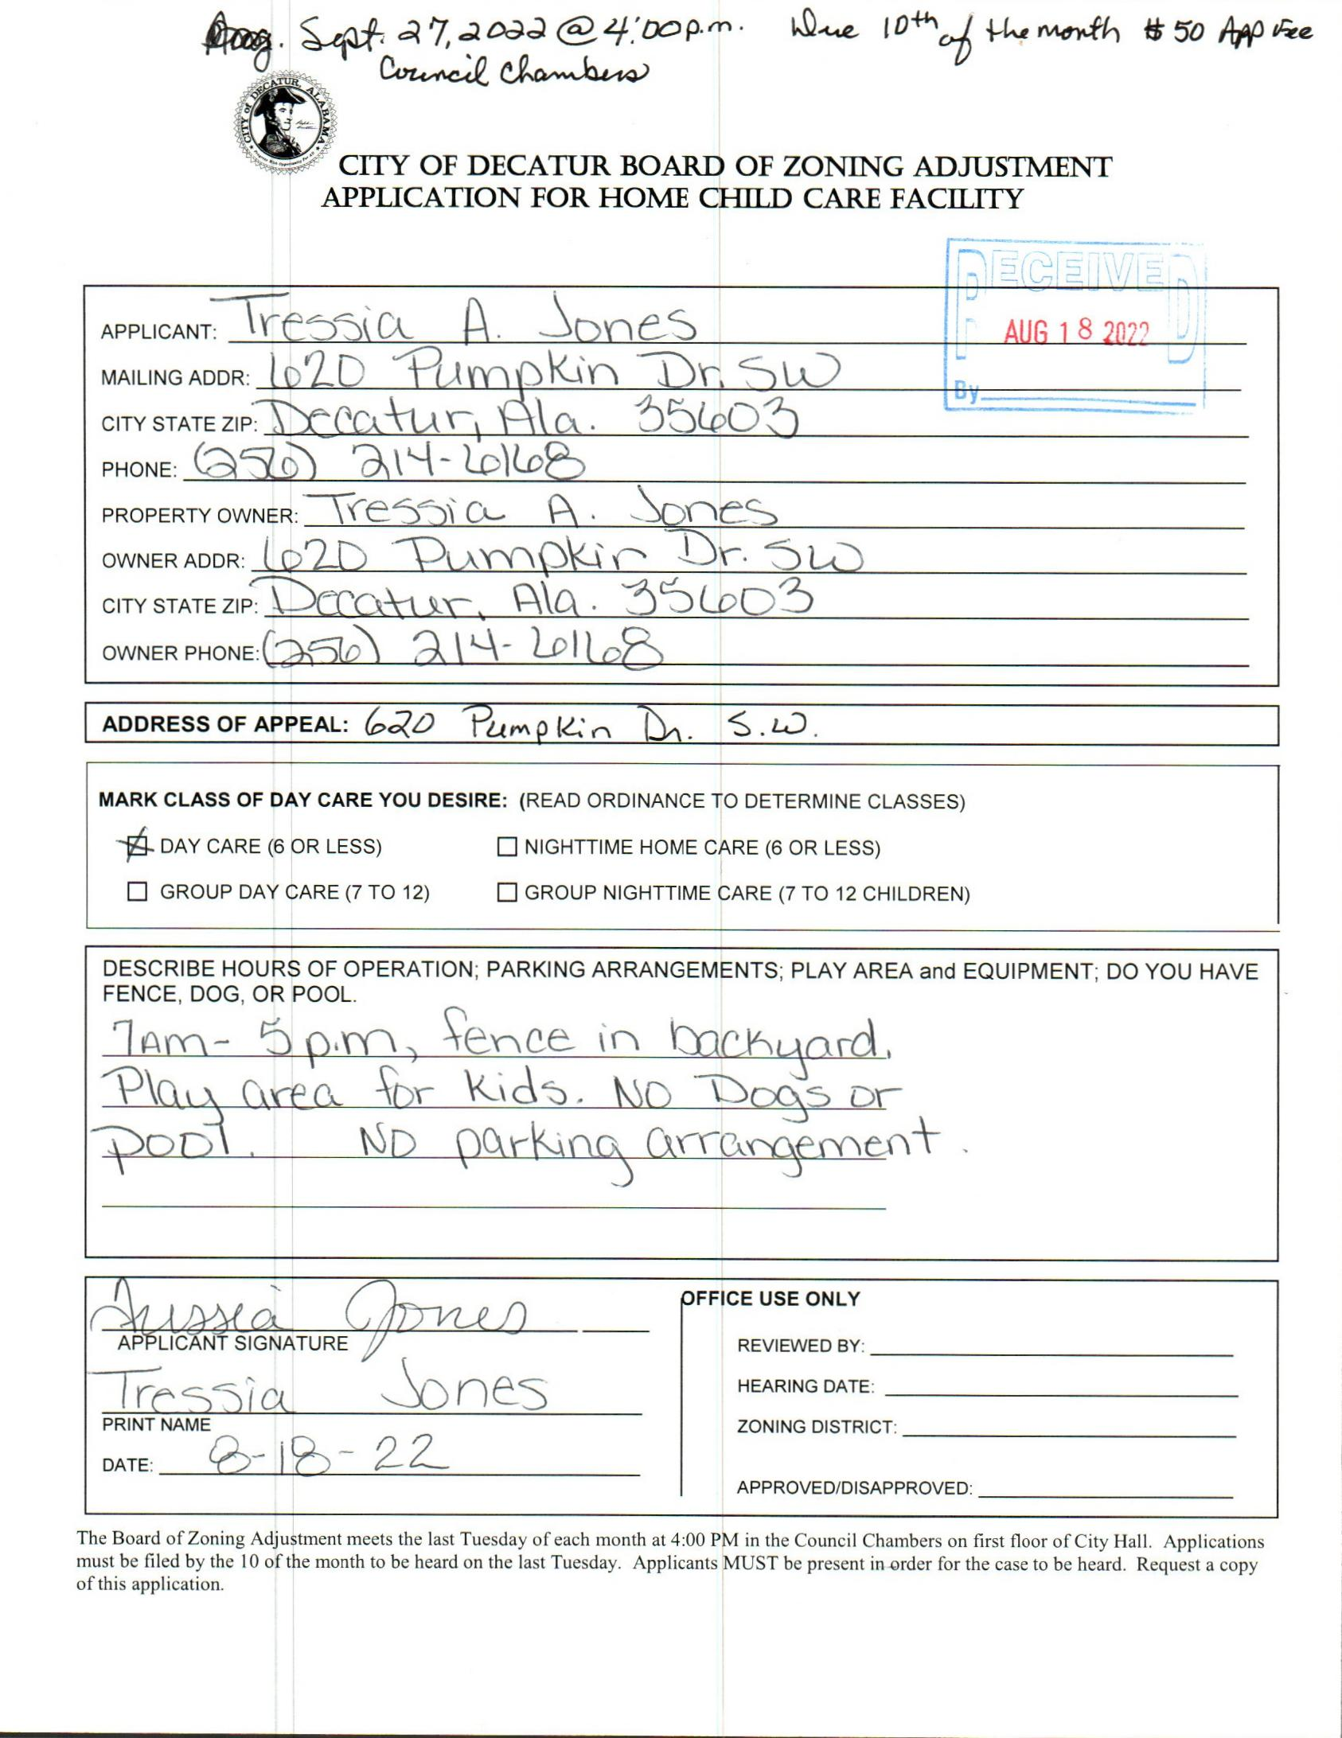

case no. 1 620 pumpkin dr. sw
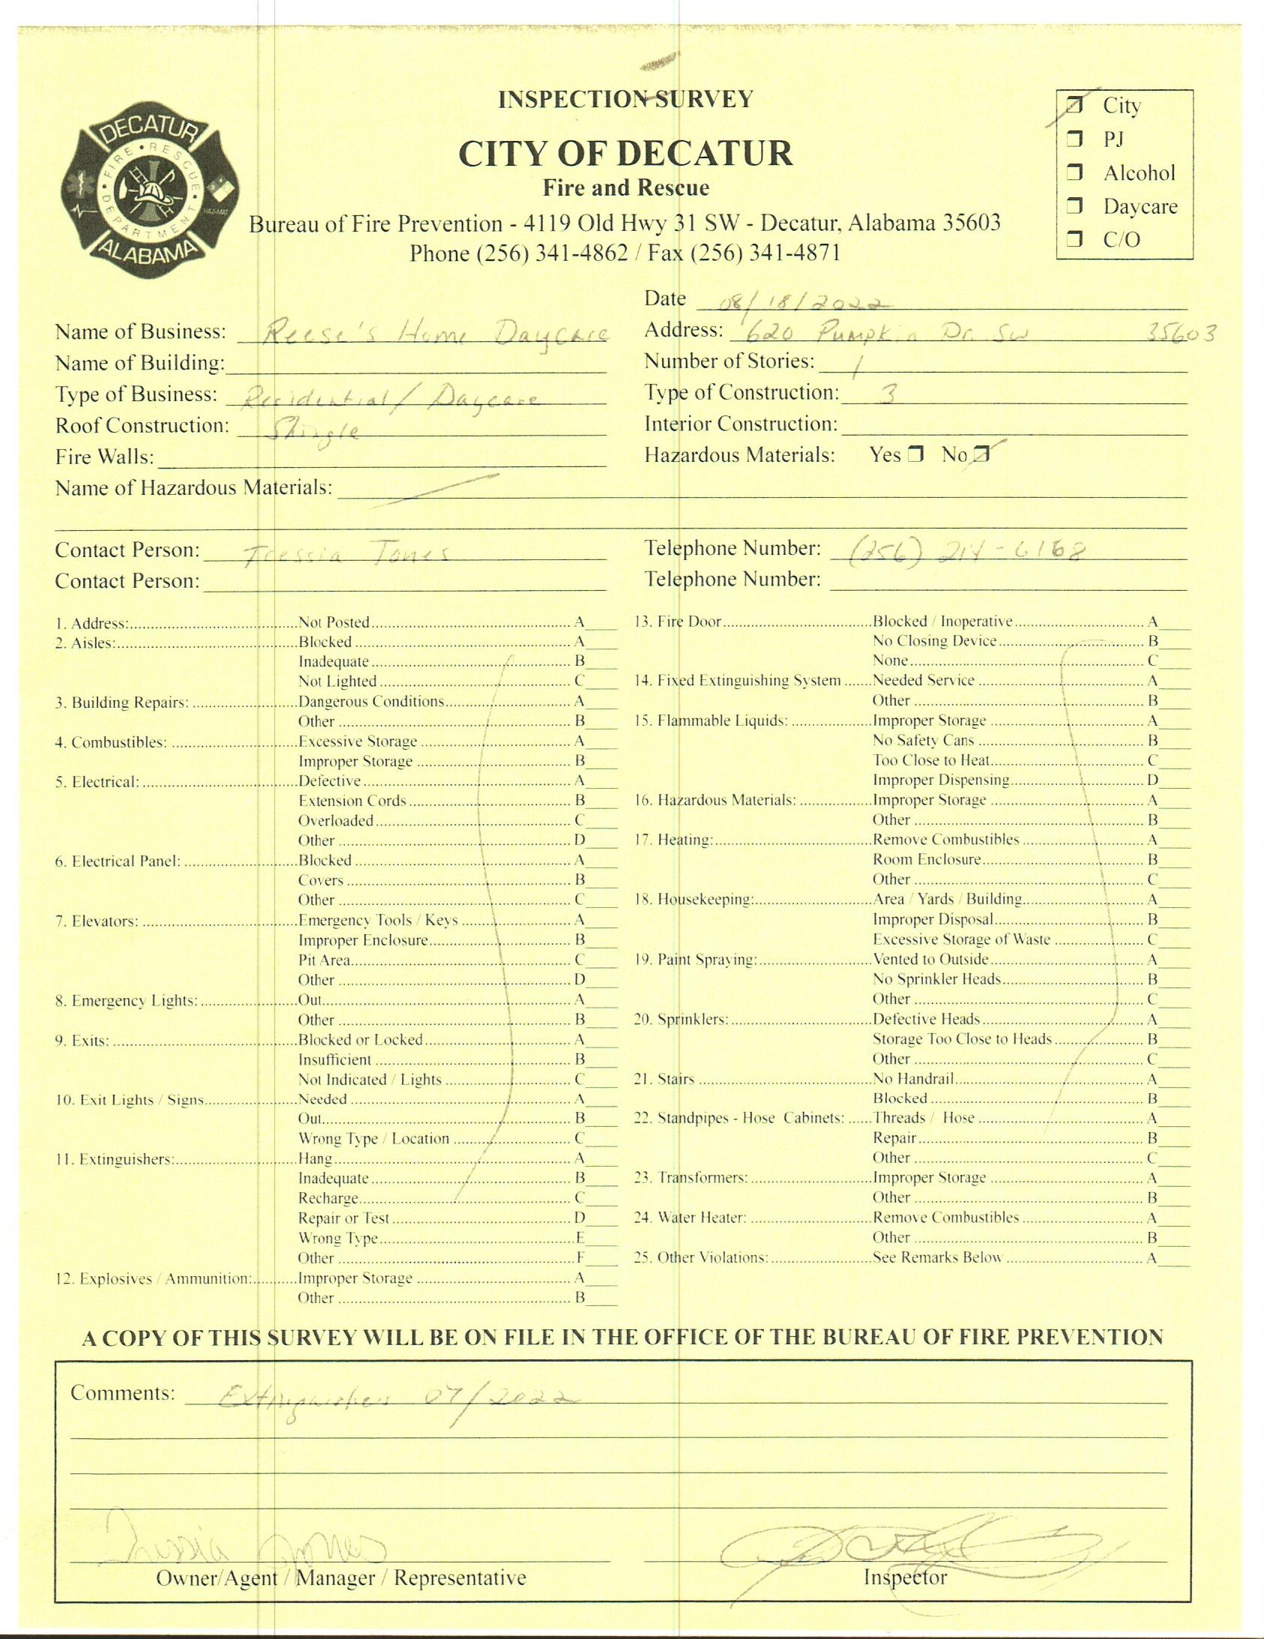

INSPECTION SURVEY
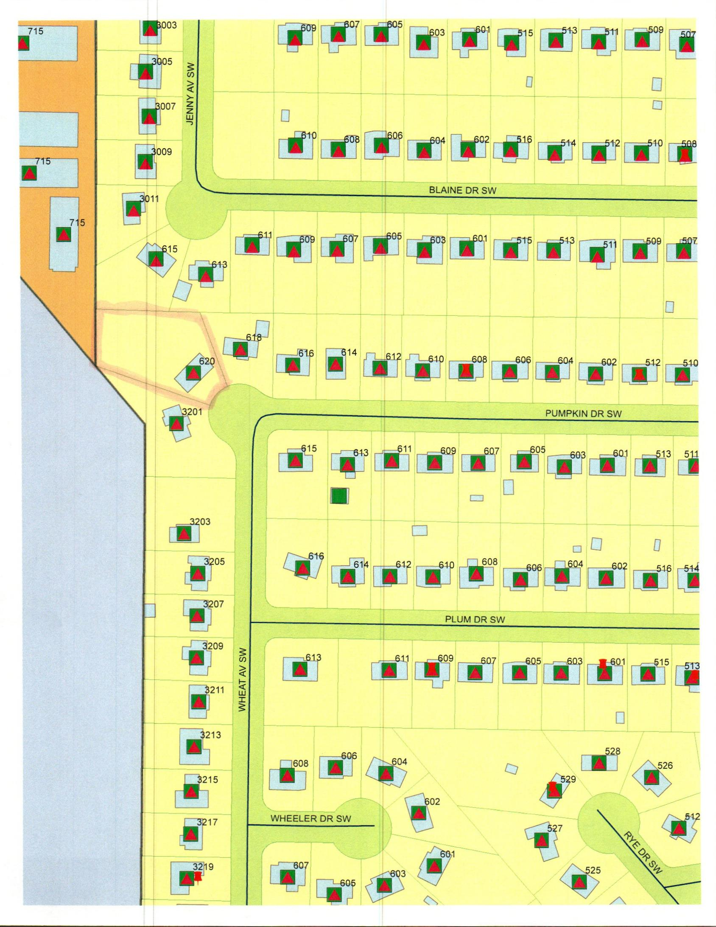

MAP
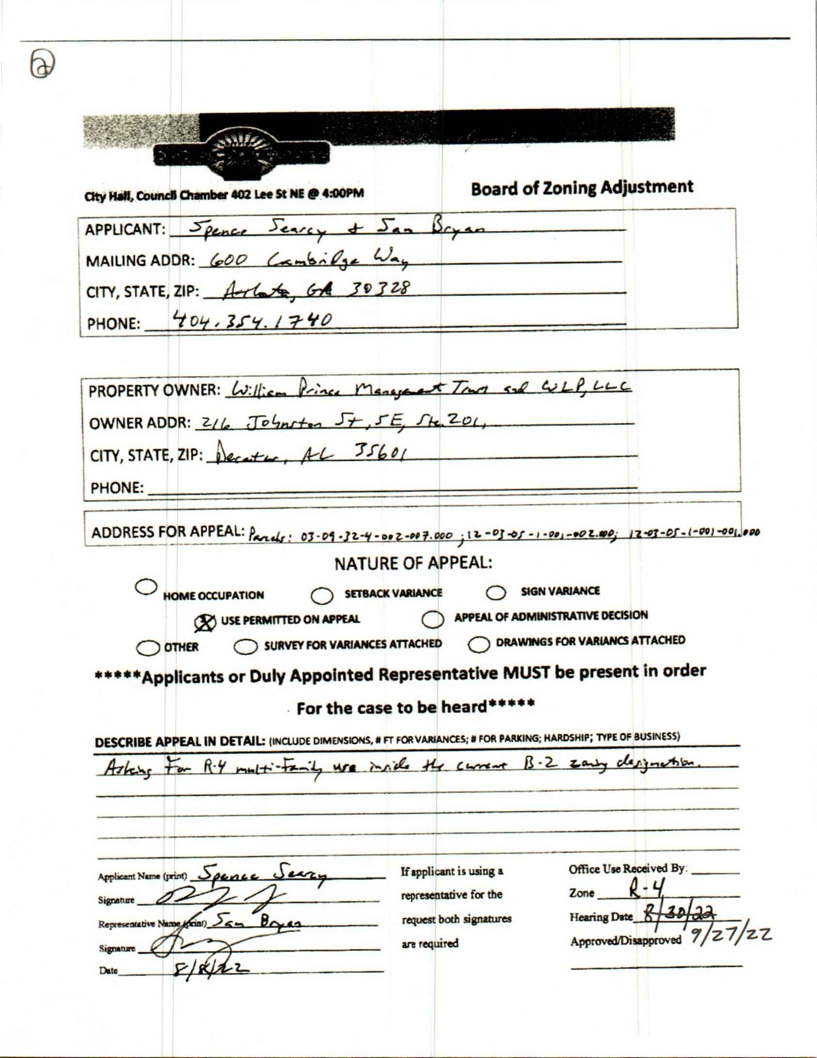

CASE NO. 2 1401 POINT MALLARD PKWY SE
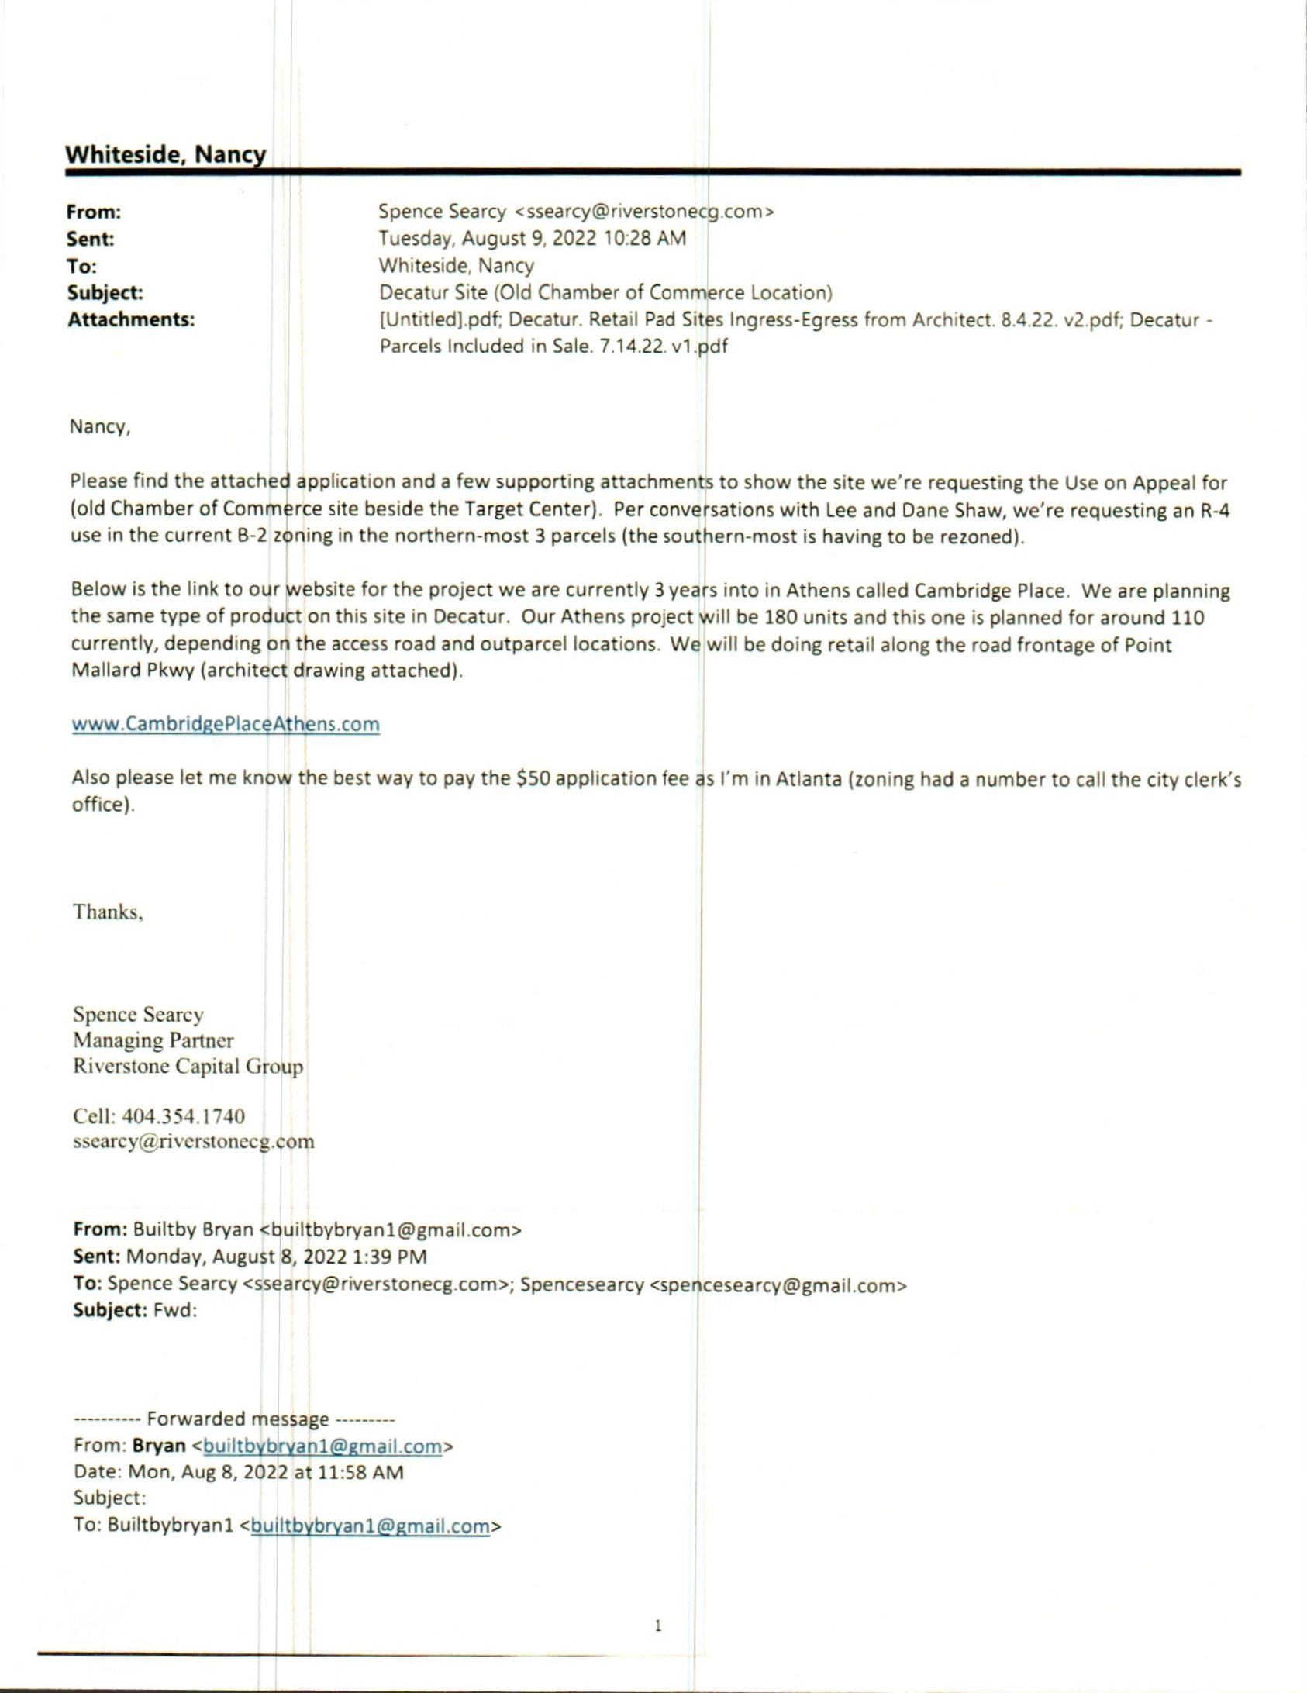

LETTER(EMAIL)
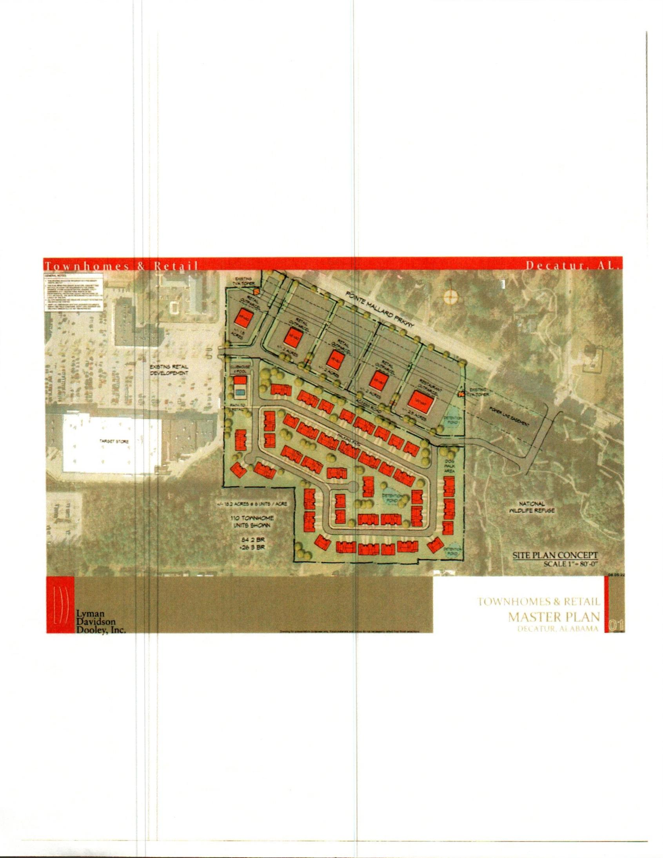

SITE PLAN
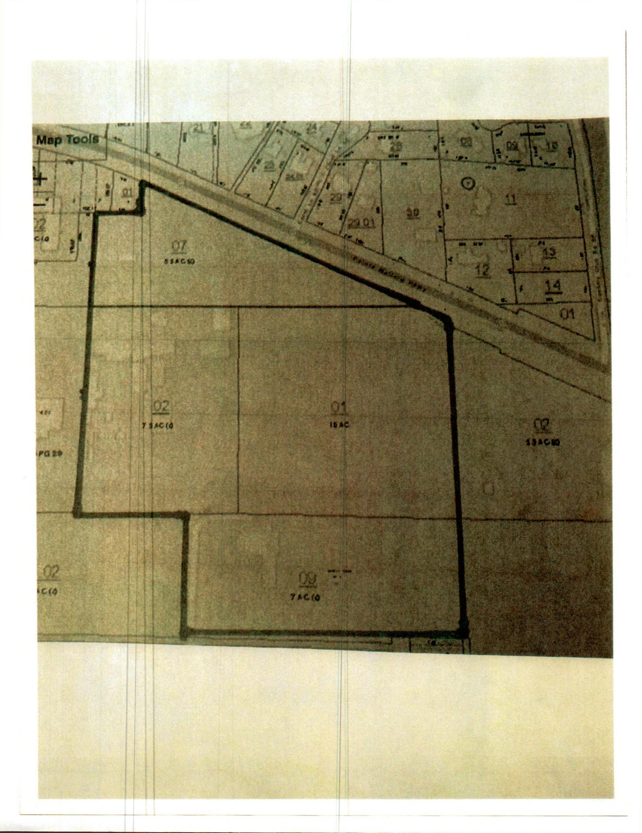

CONSOLIDATION PLAN
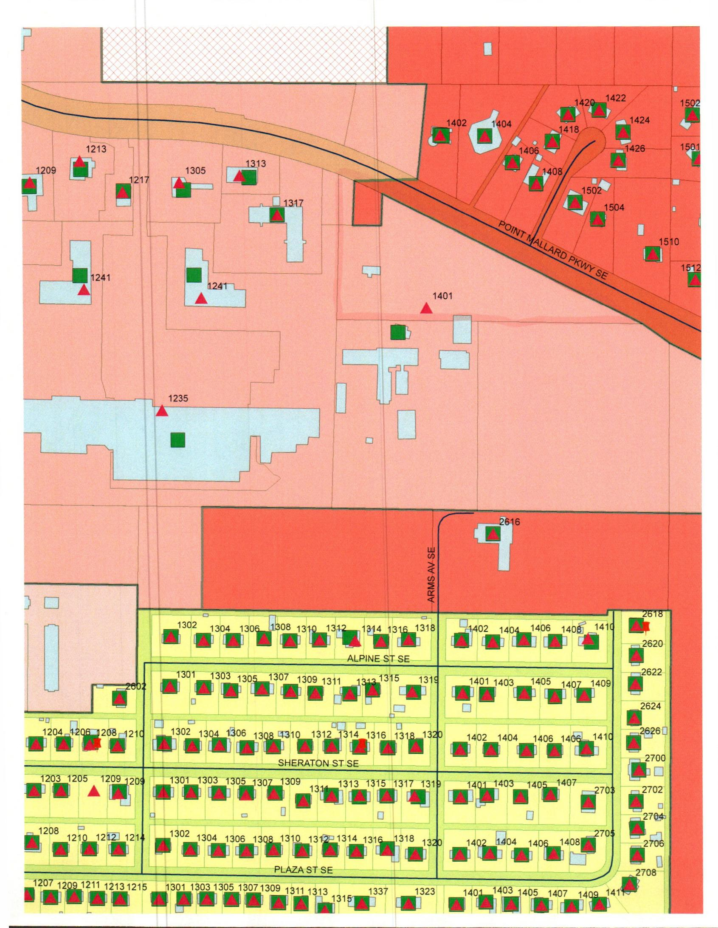

MAP
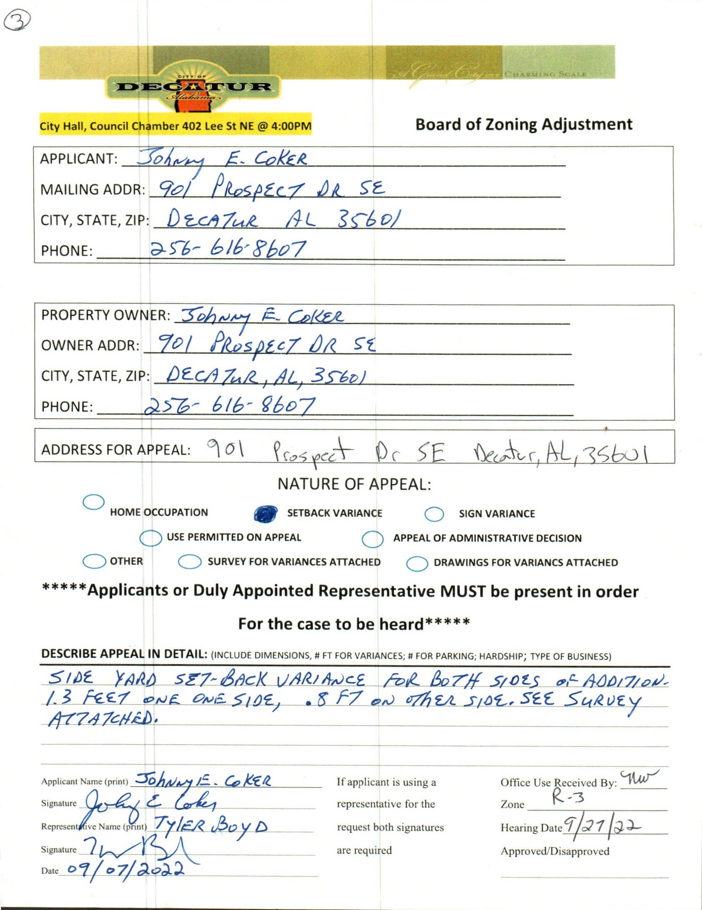

CASE NO. 3 901 PROSPECT DR. SE
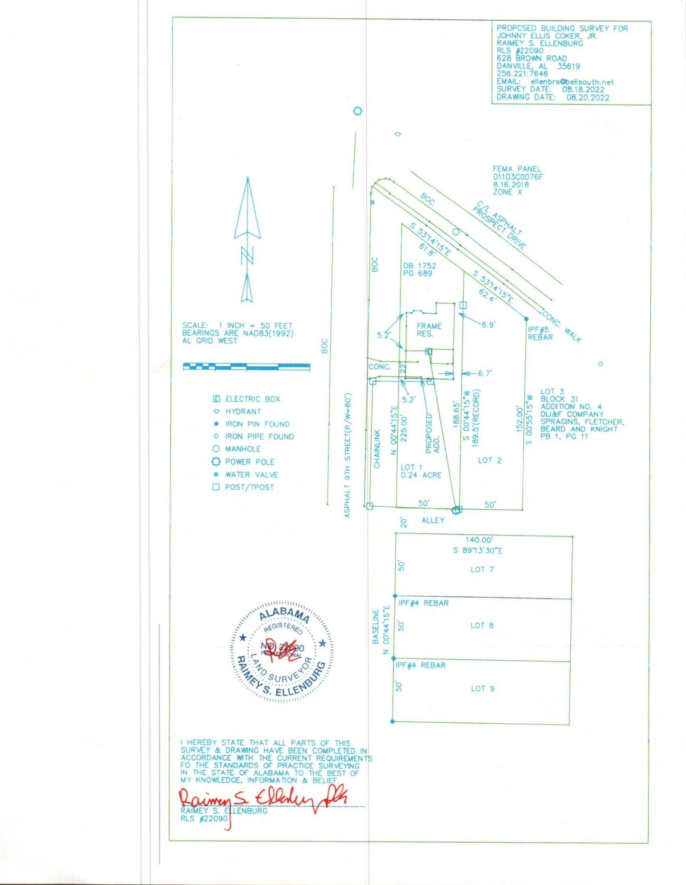

SURVEY
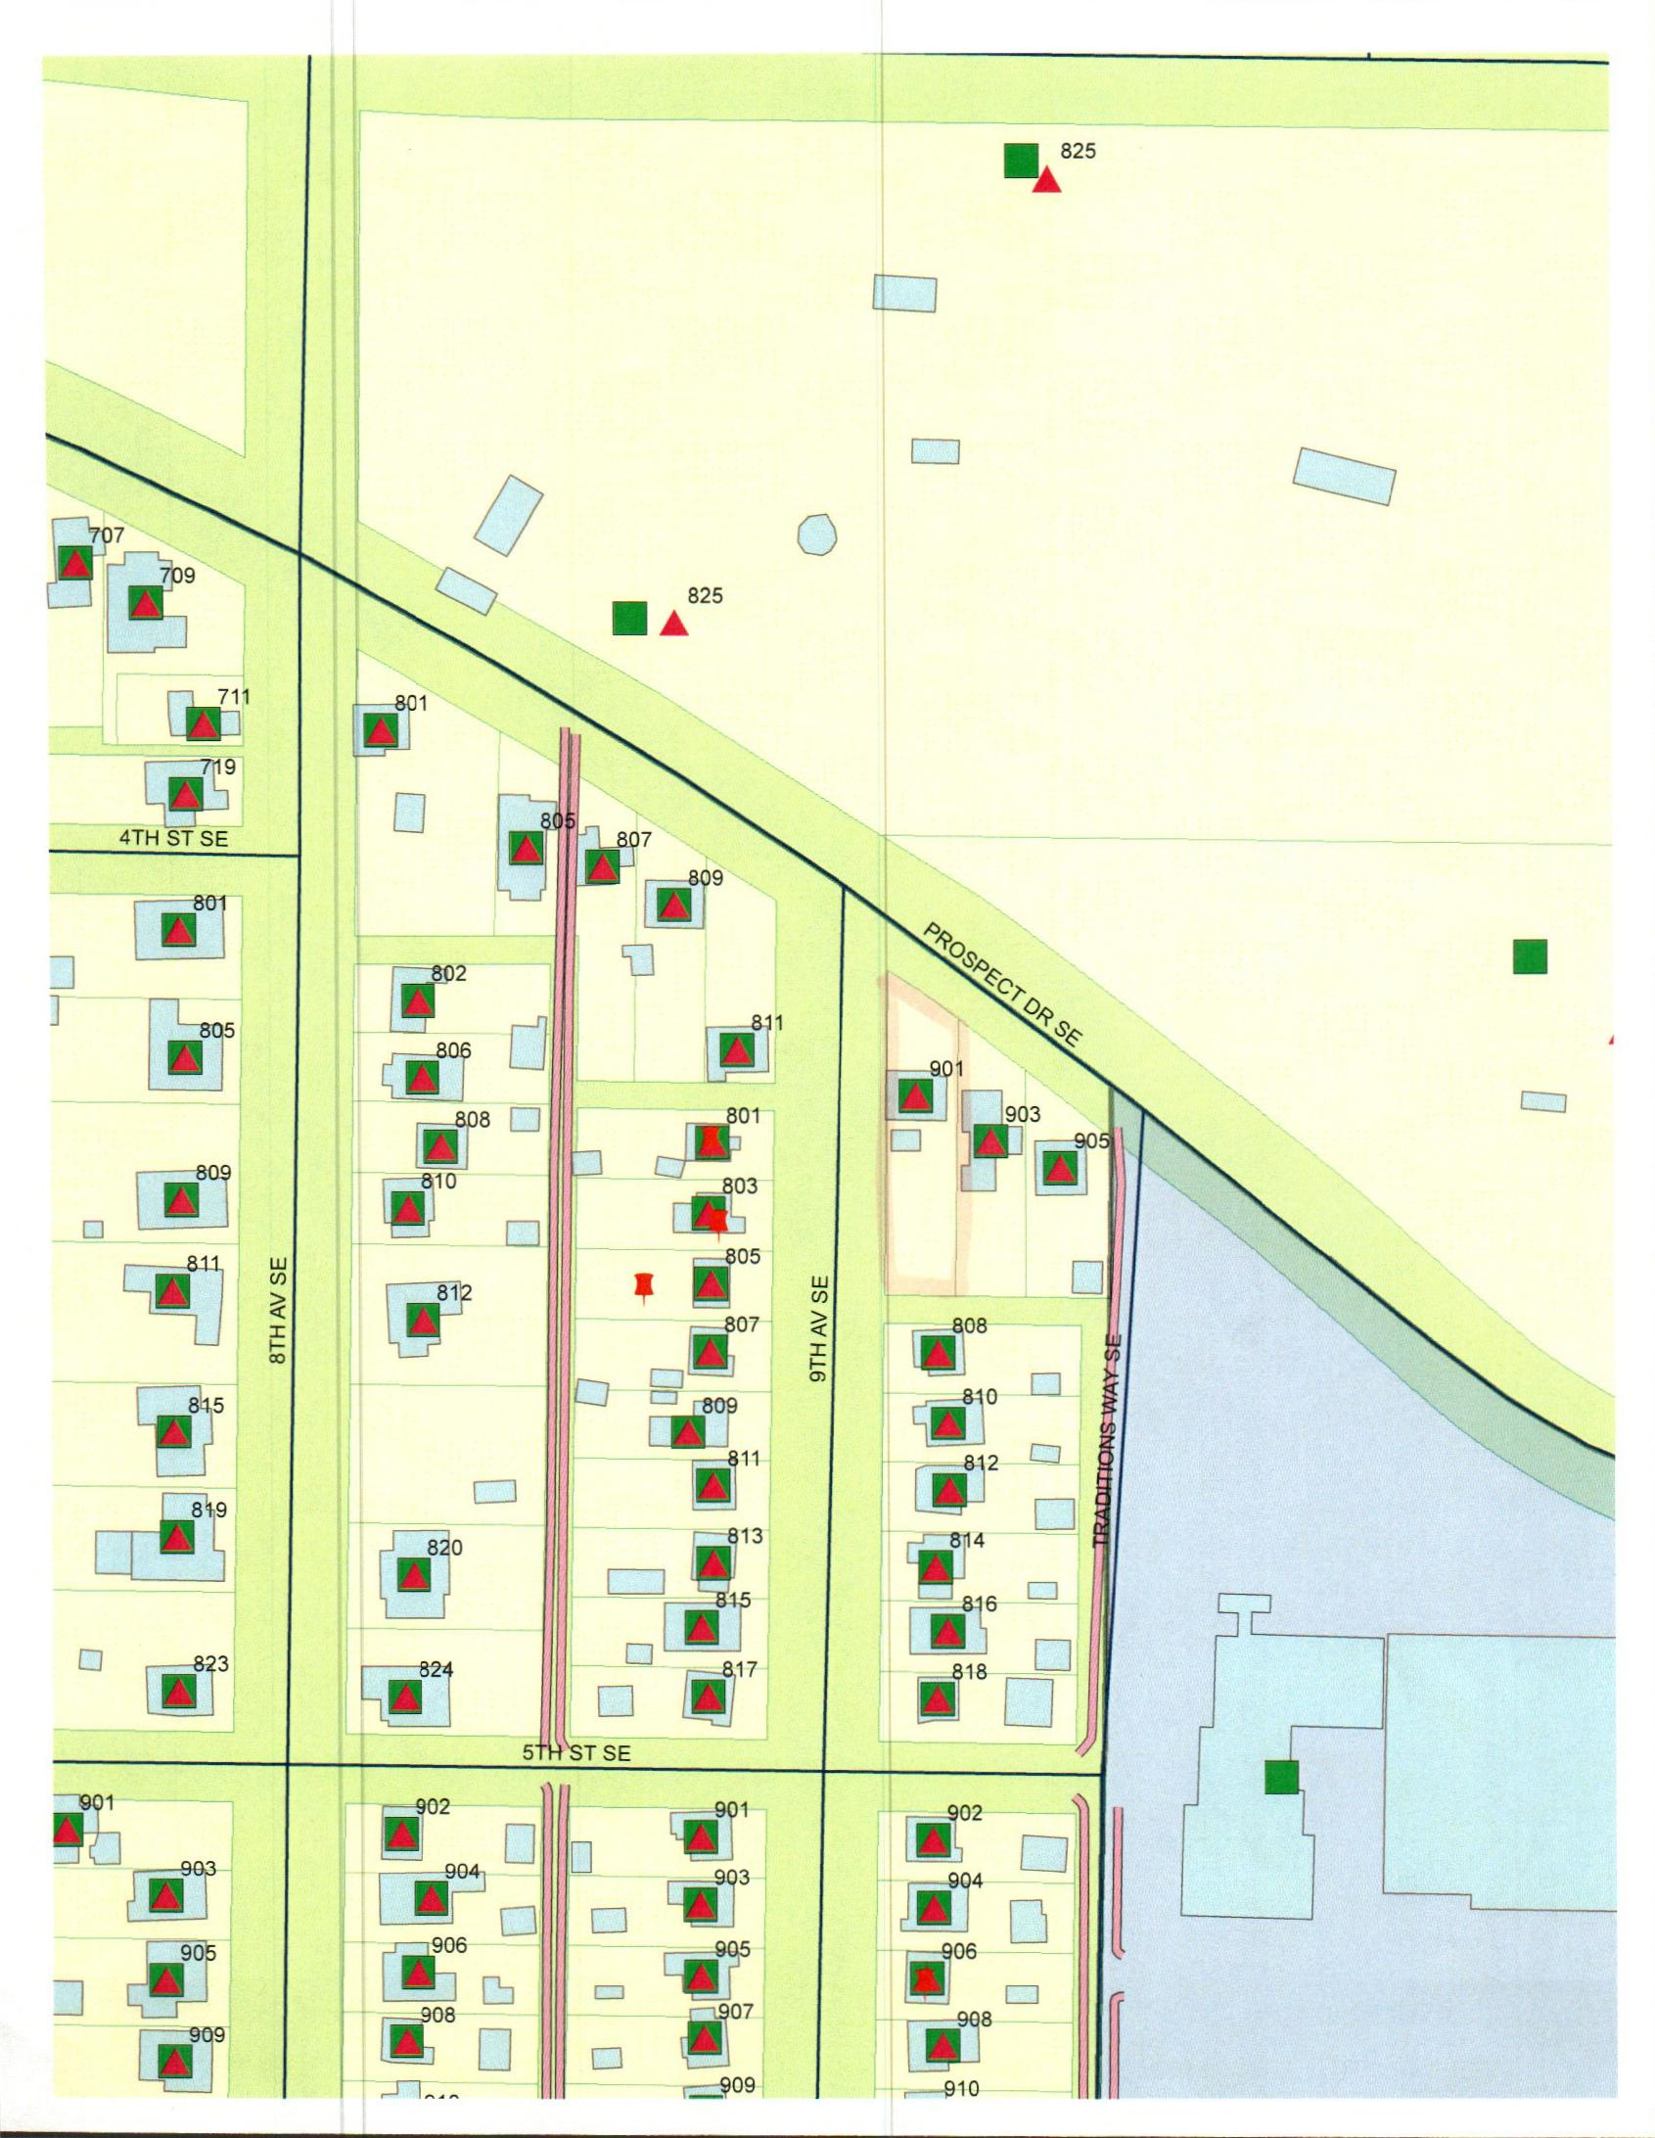

MAP
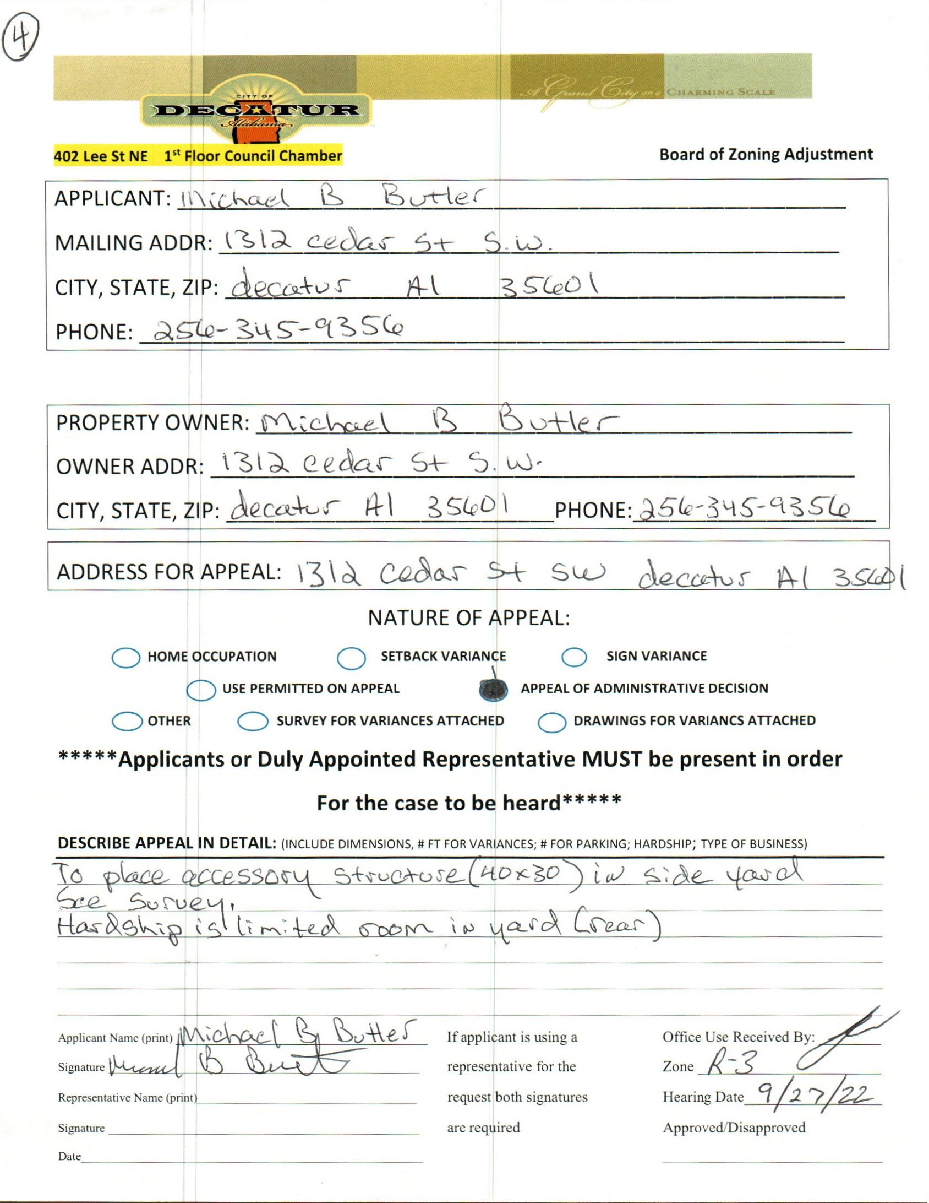

CASE NO. 4 1312 CEDAR ST SW
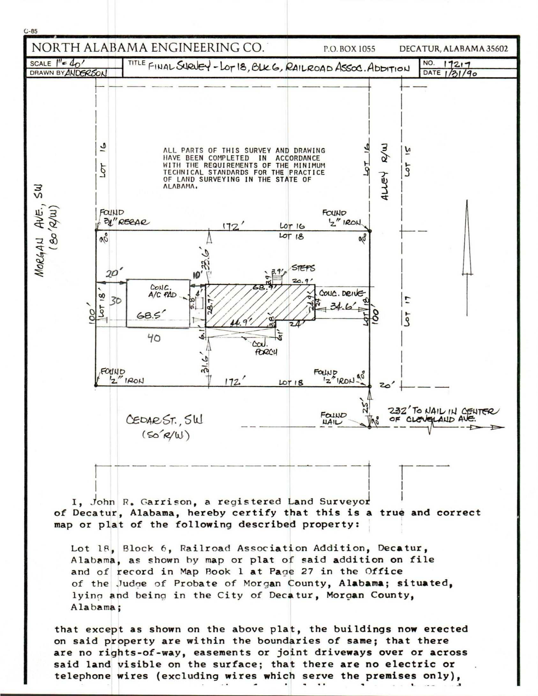

SURVEY
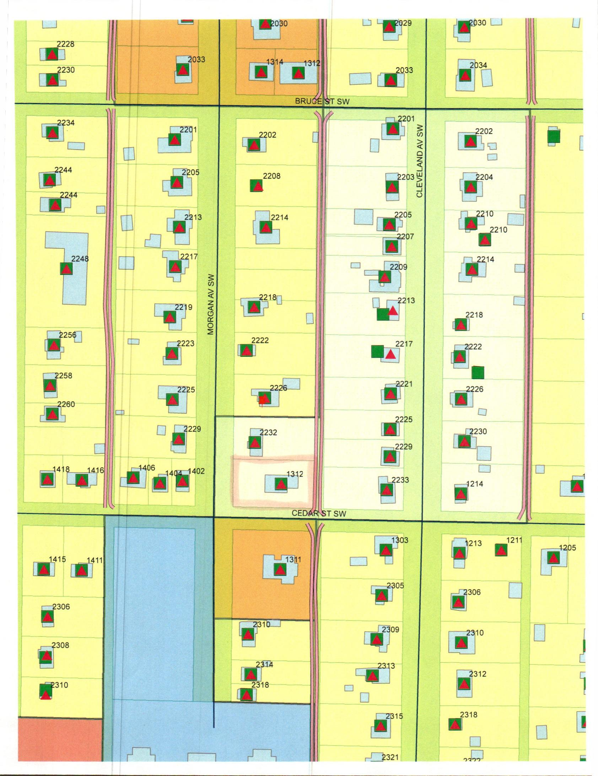

MAP
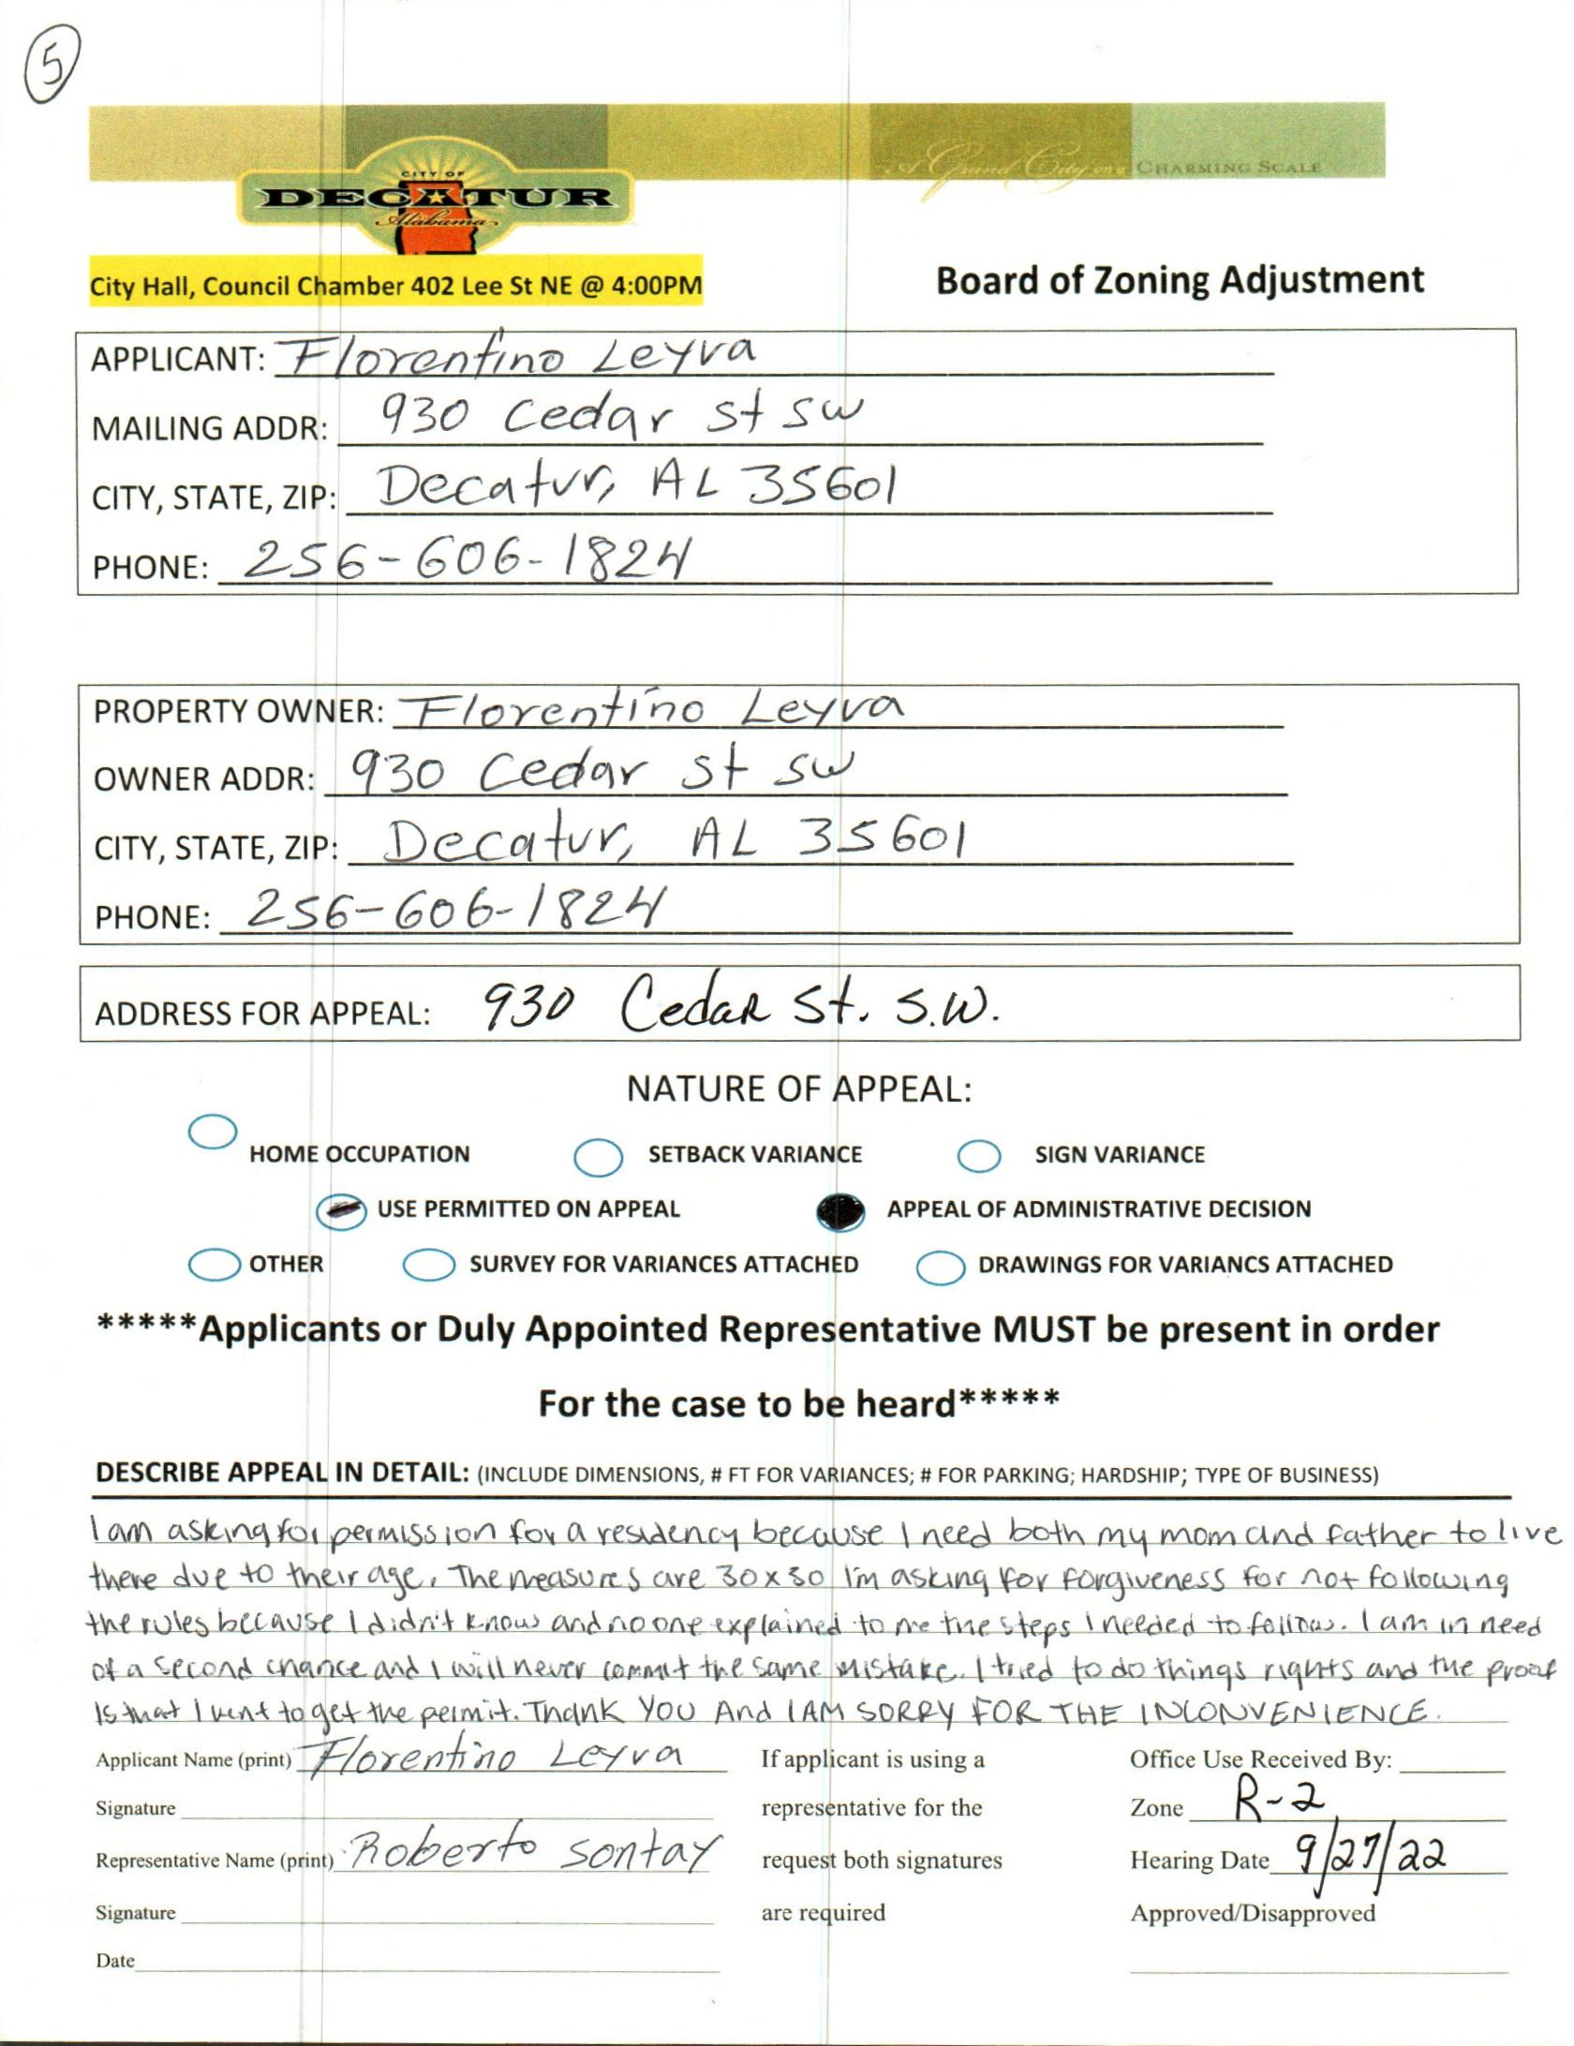

case no. 5 930 cedar st sw
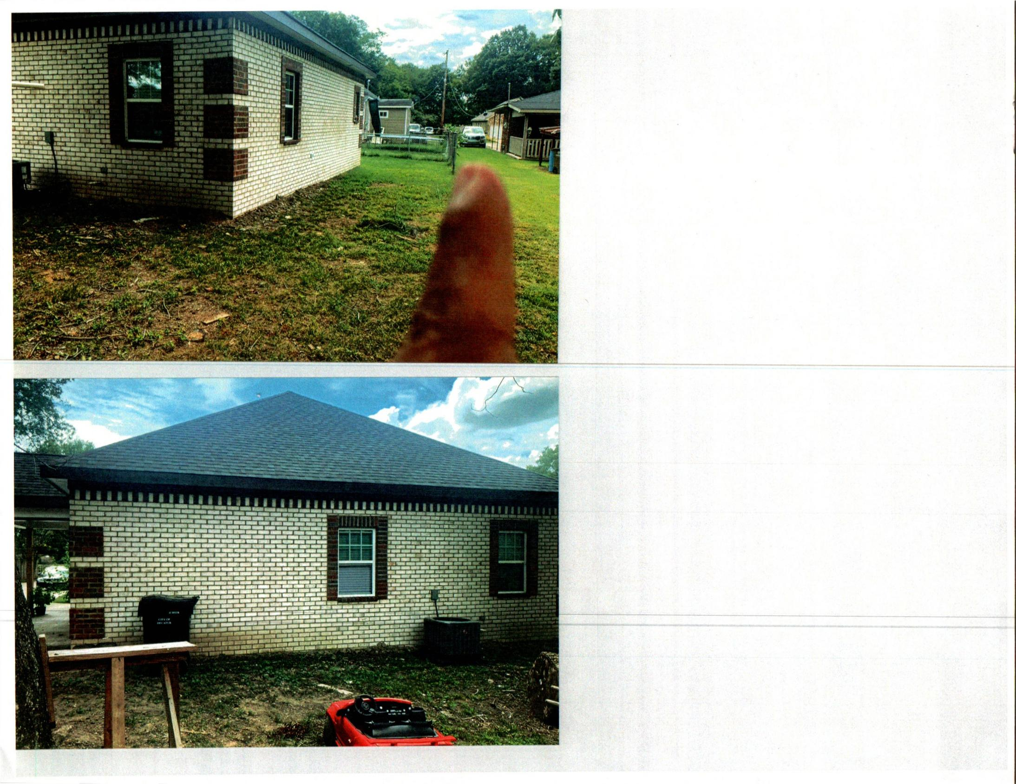

PICTURE
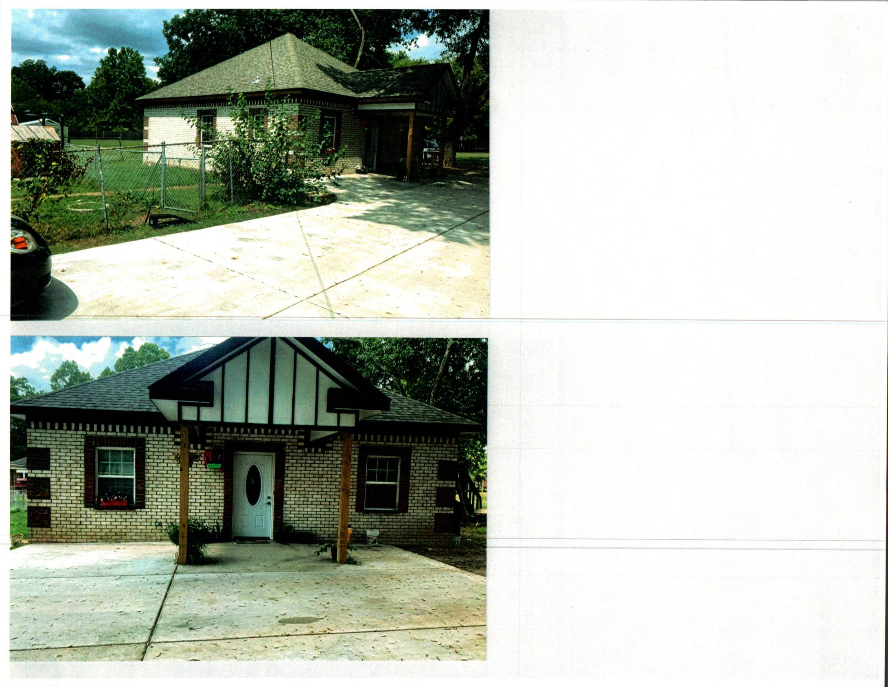

PICTURE (2)
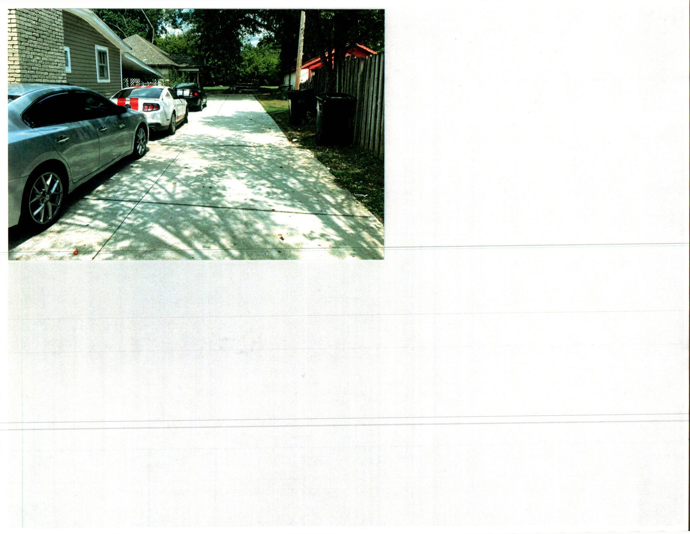

PICTURE (3)
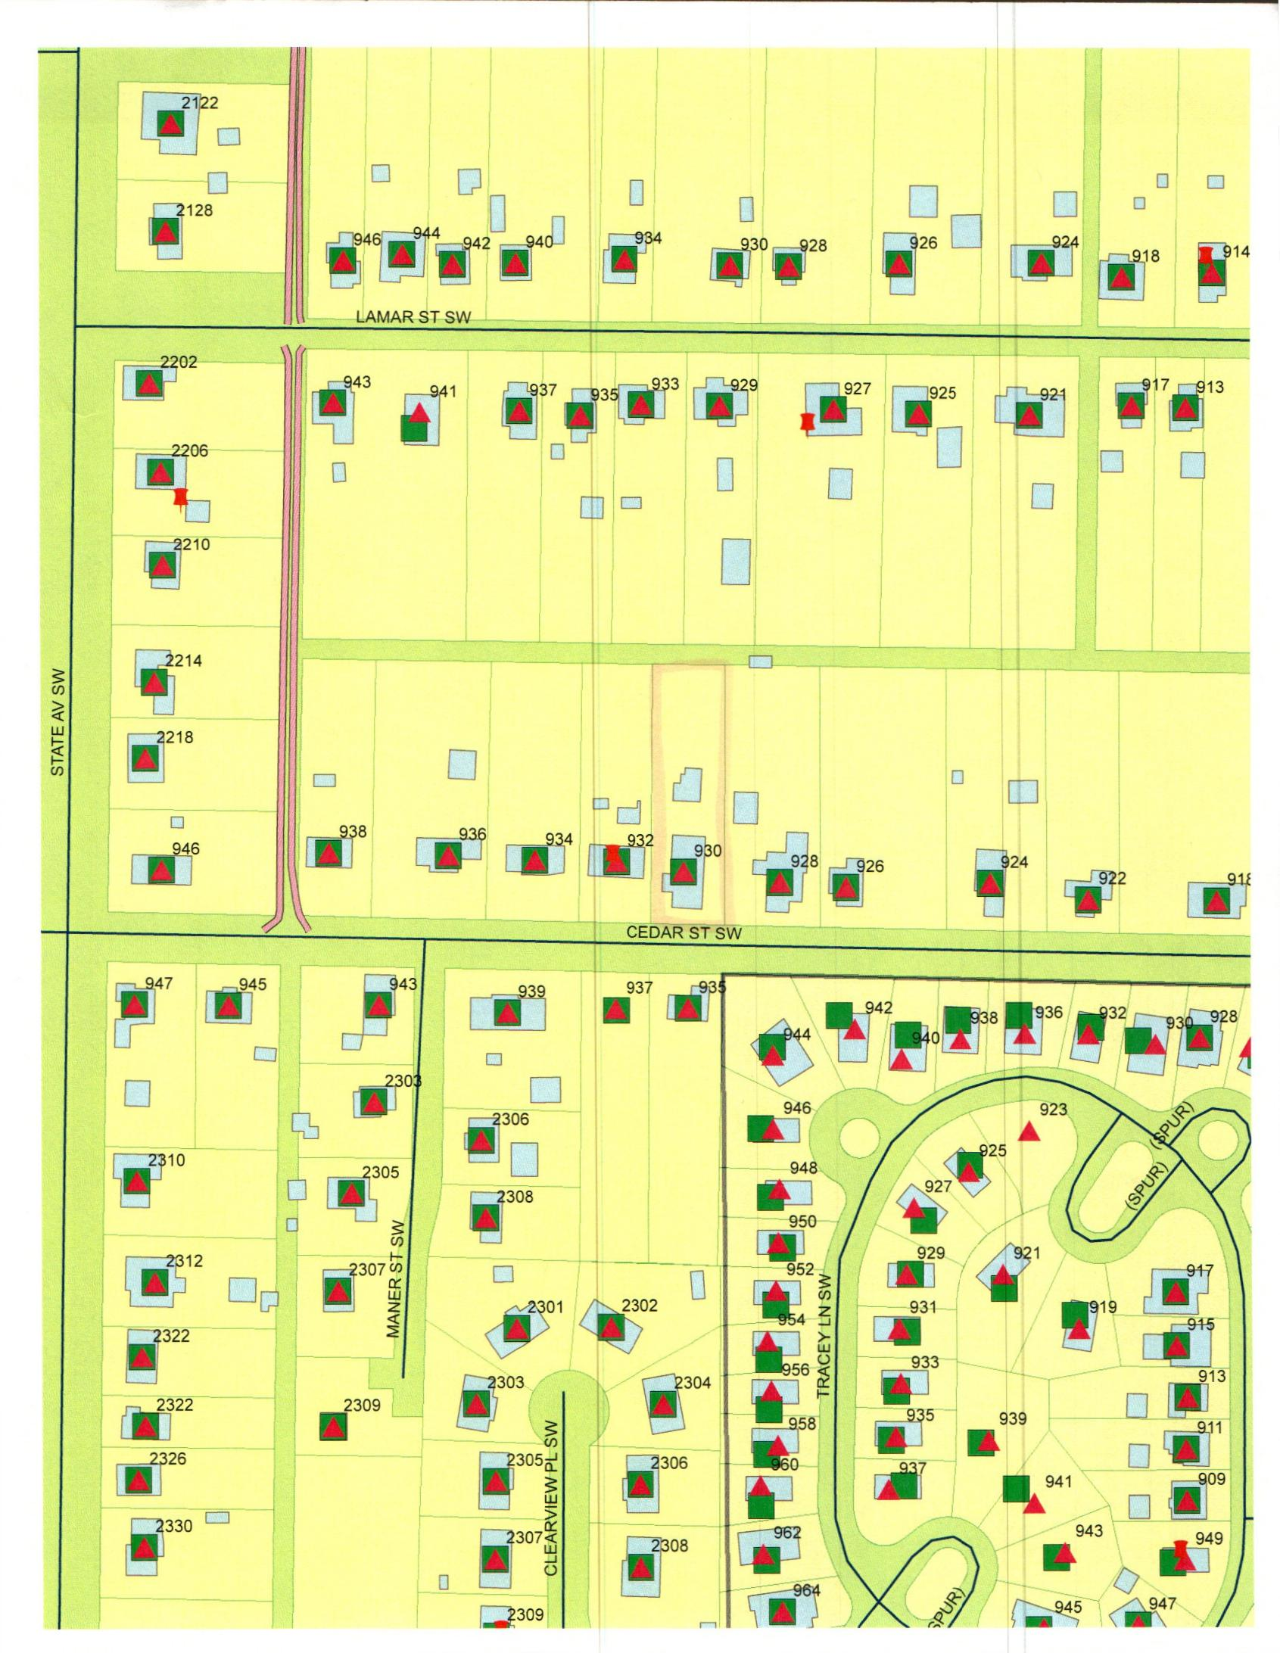

MAP
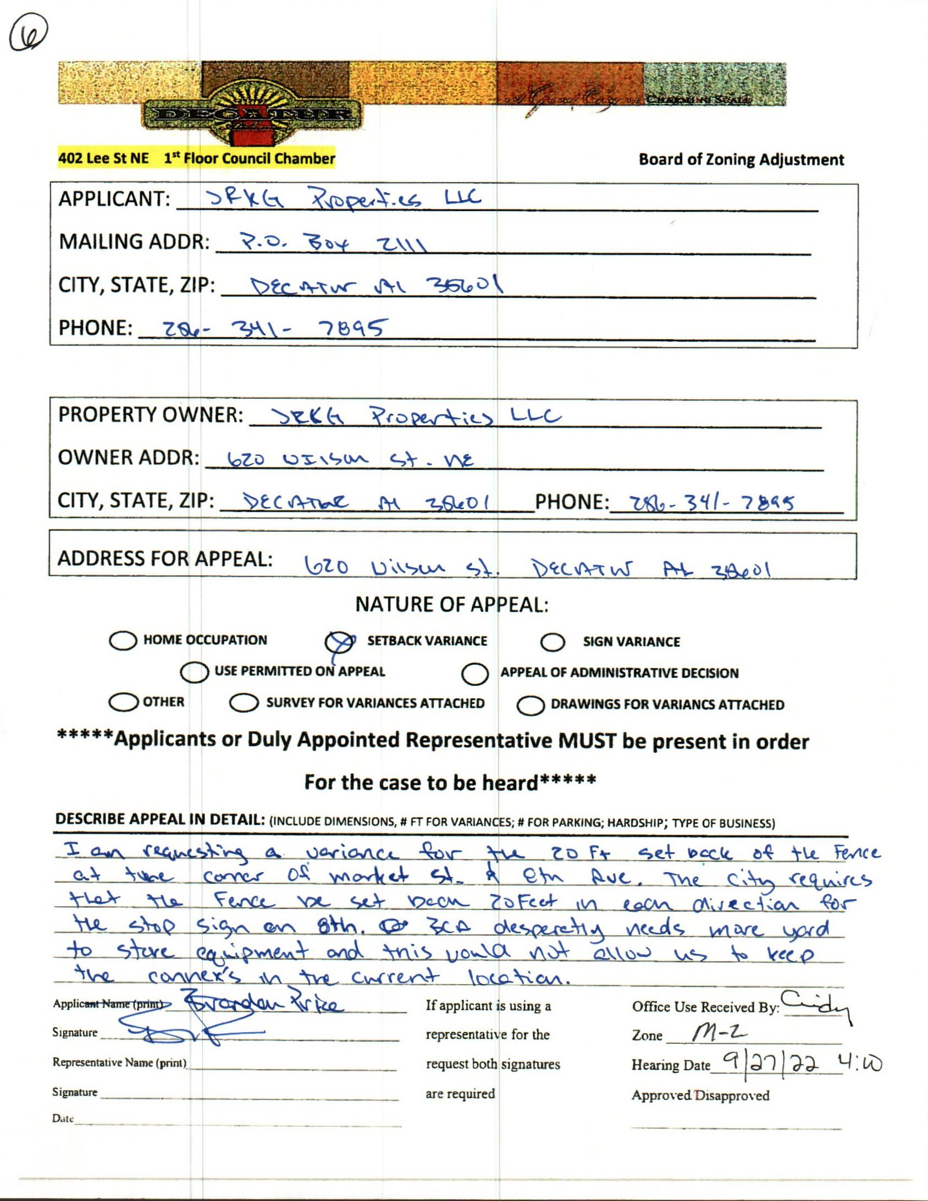

CASE NO.6 620 WILSON ST NE
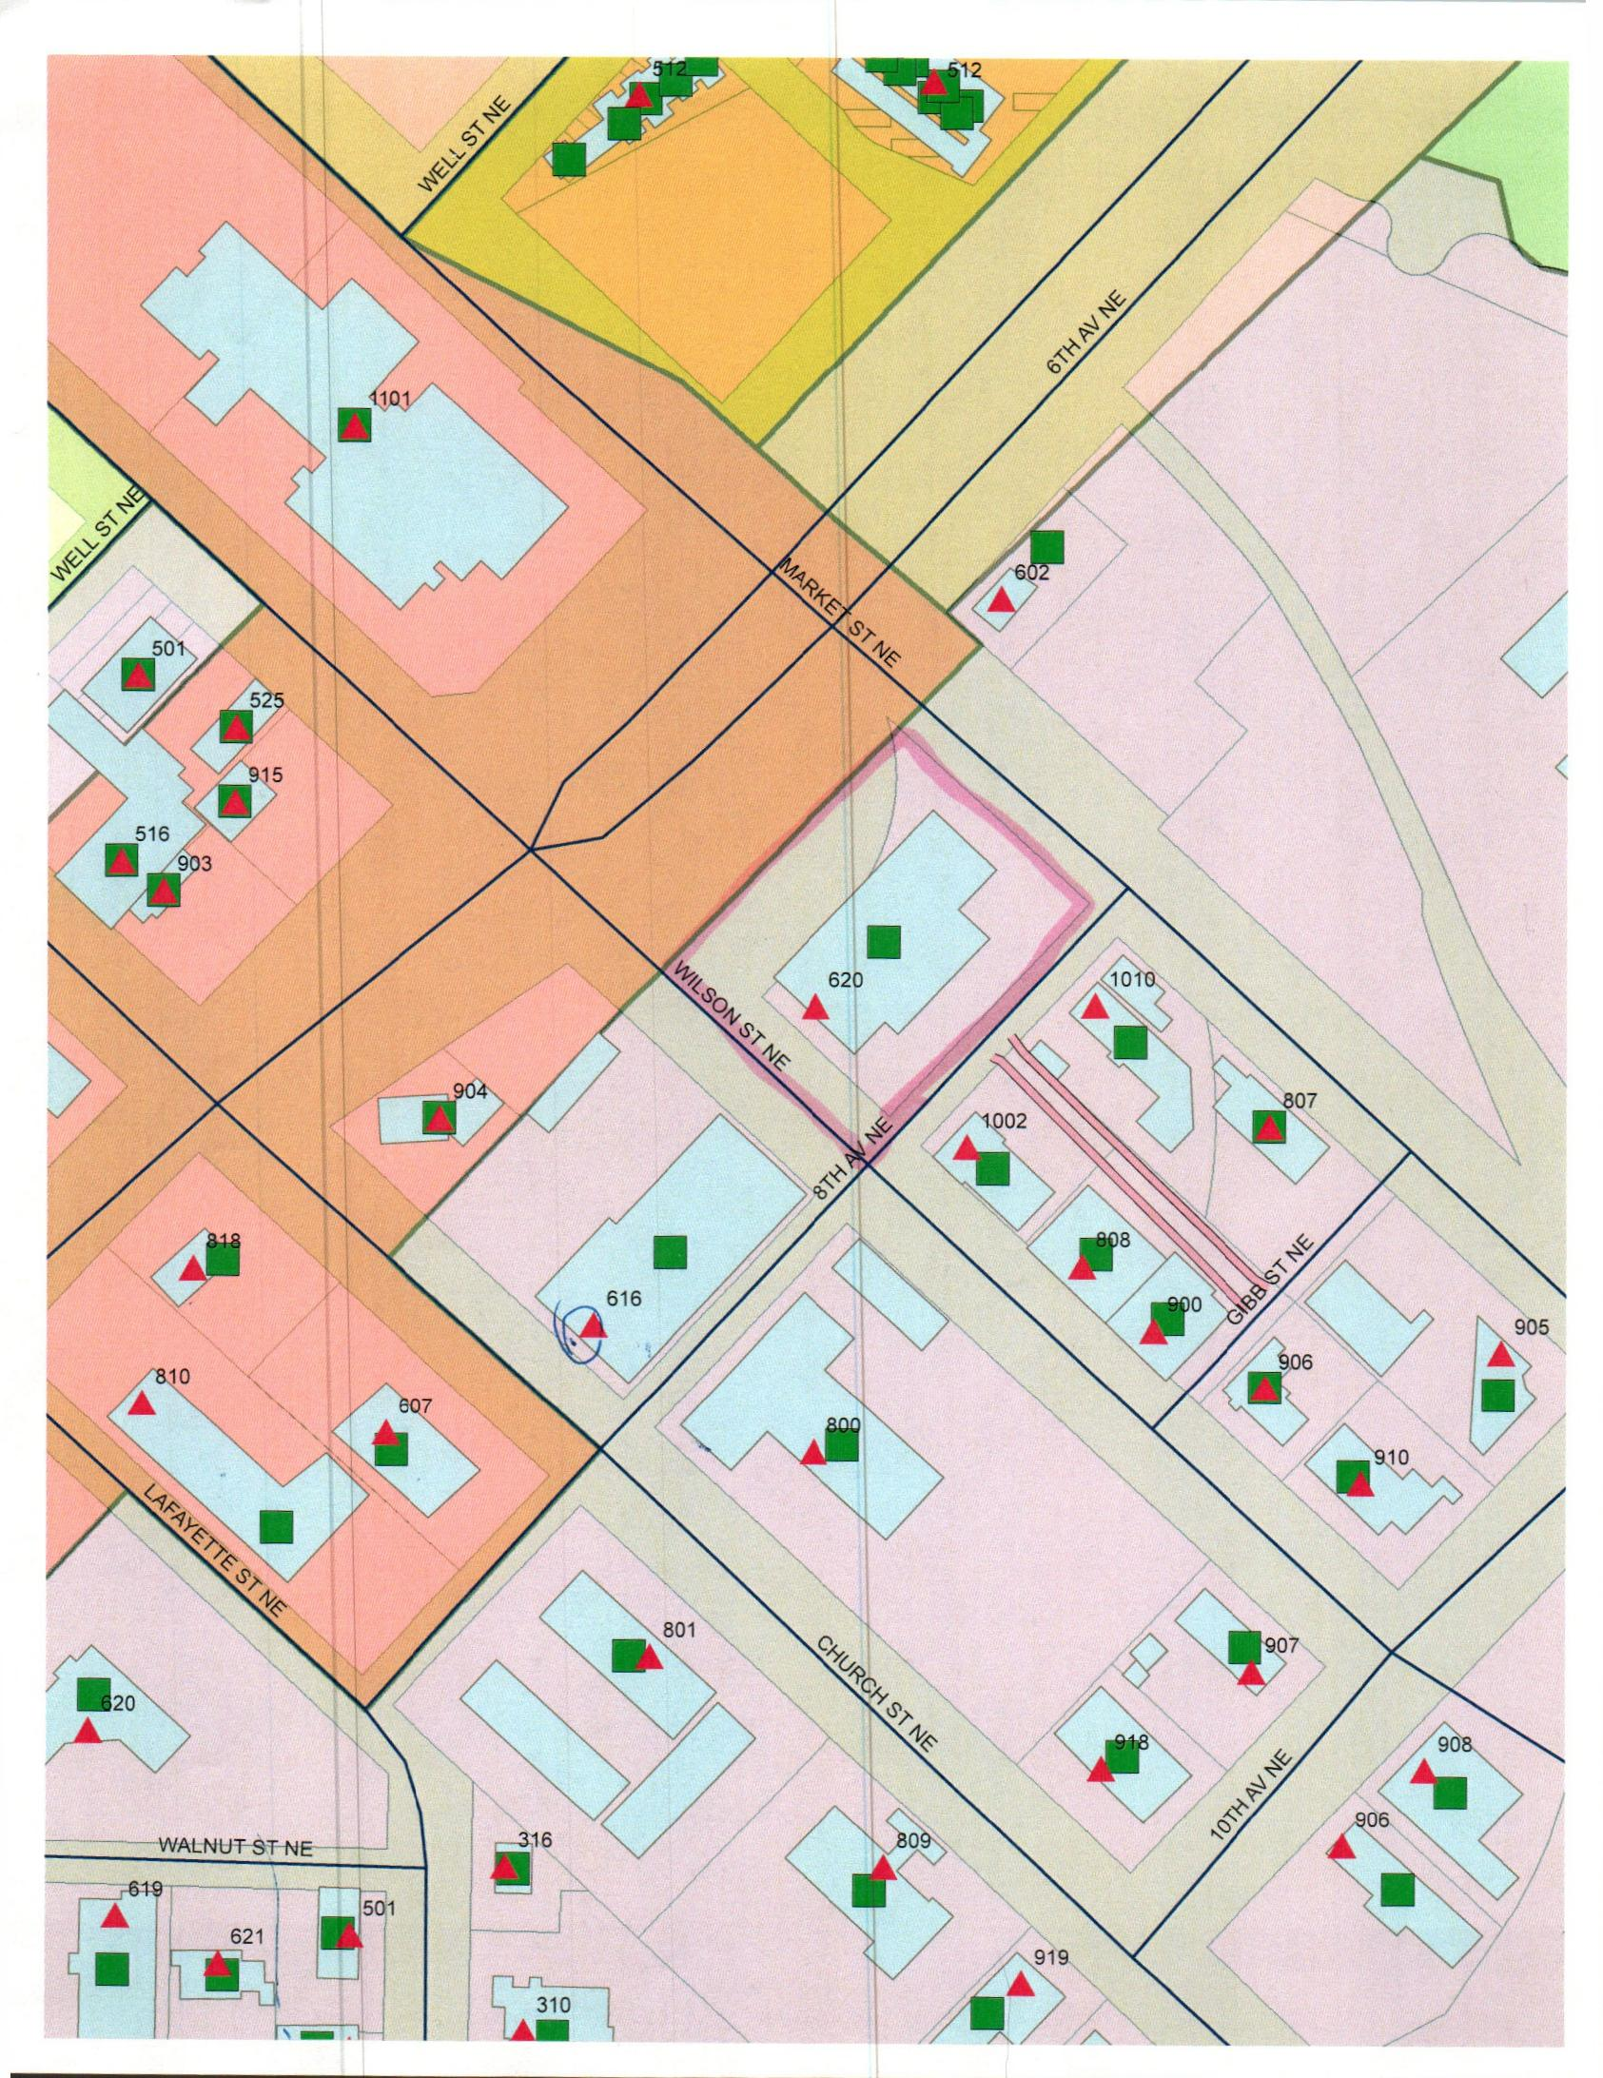

MAP
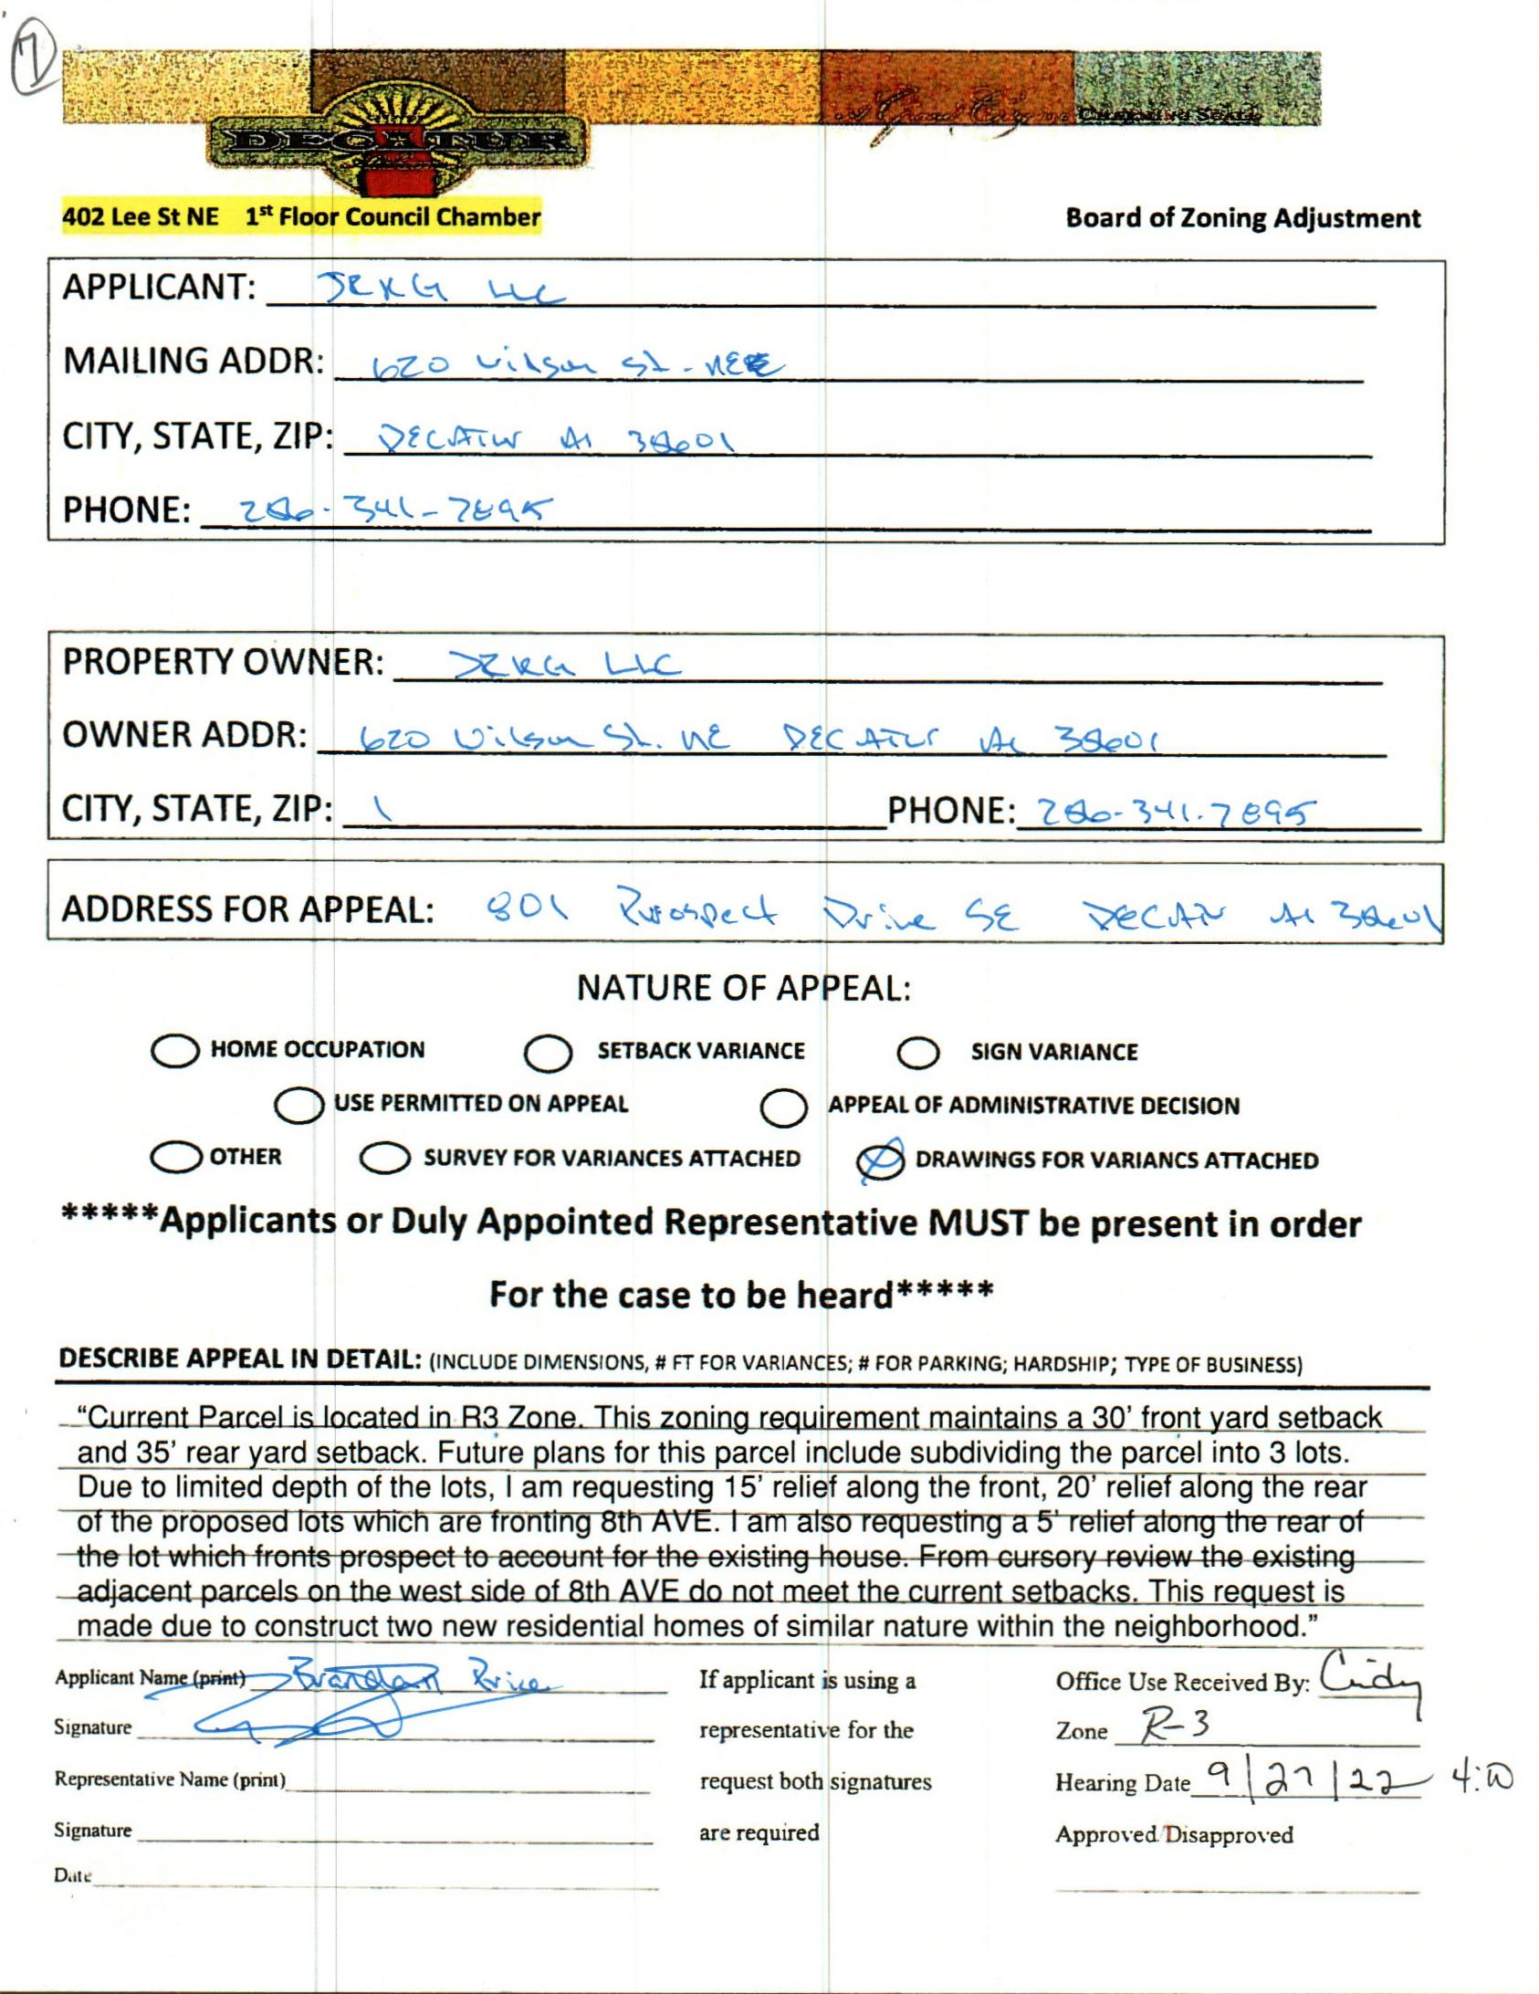

CASE NO. 7 801 PROSPECT
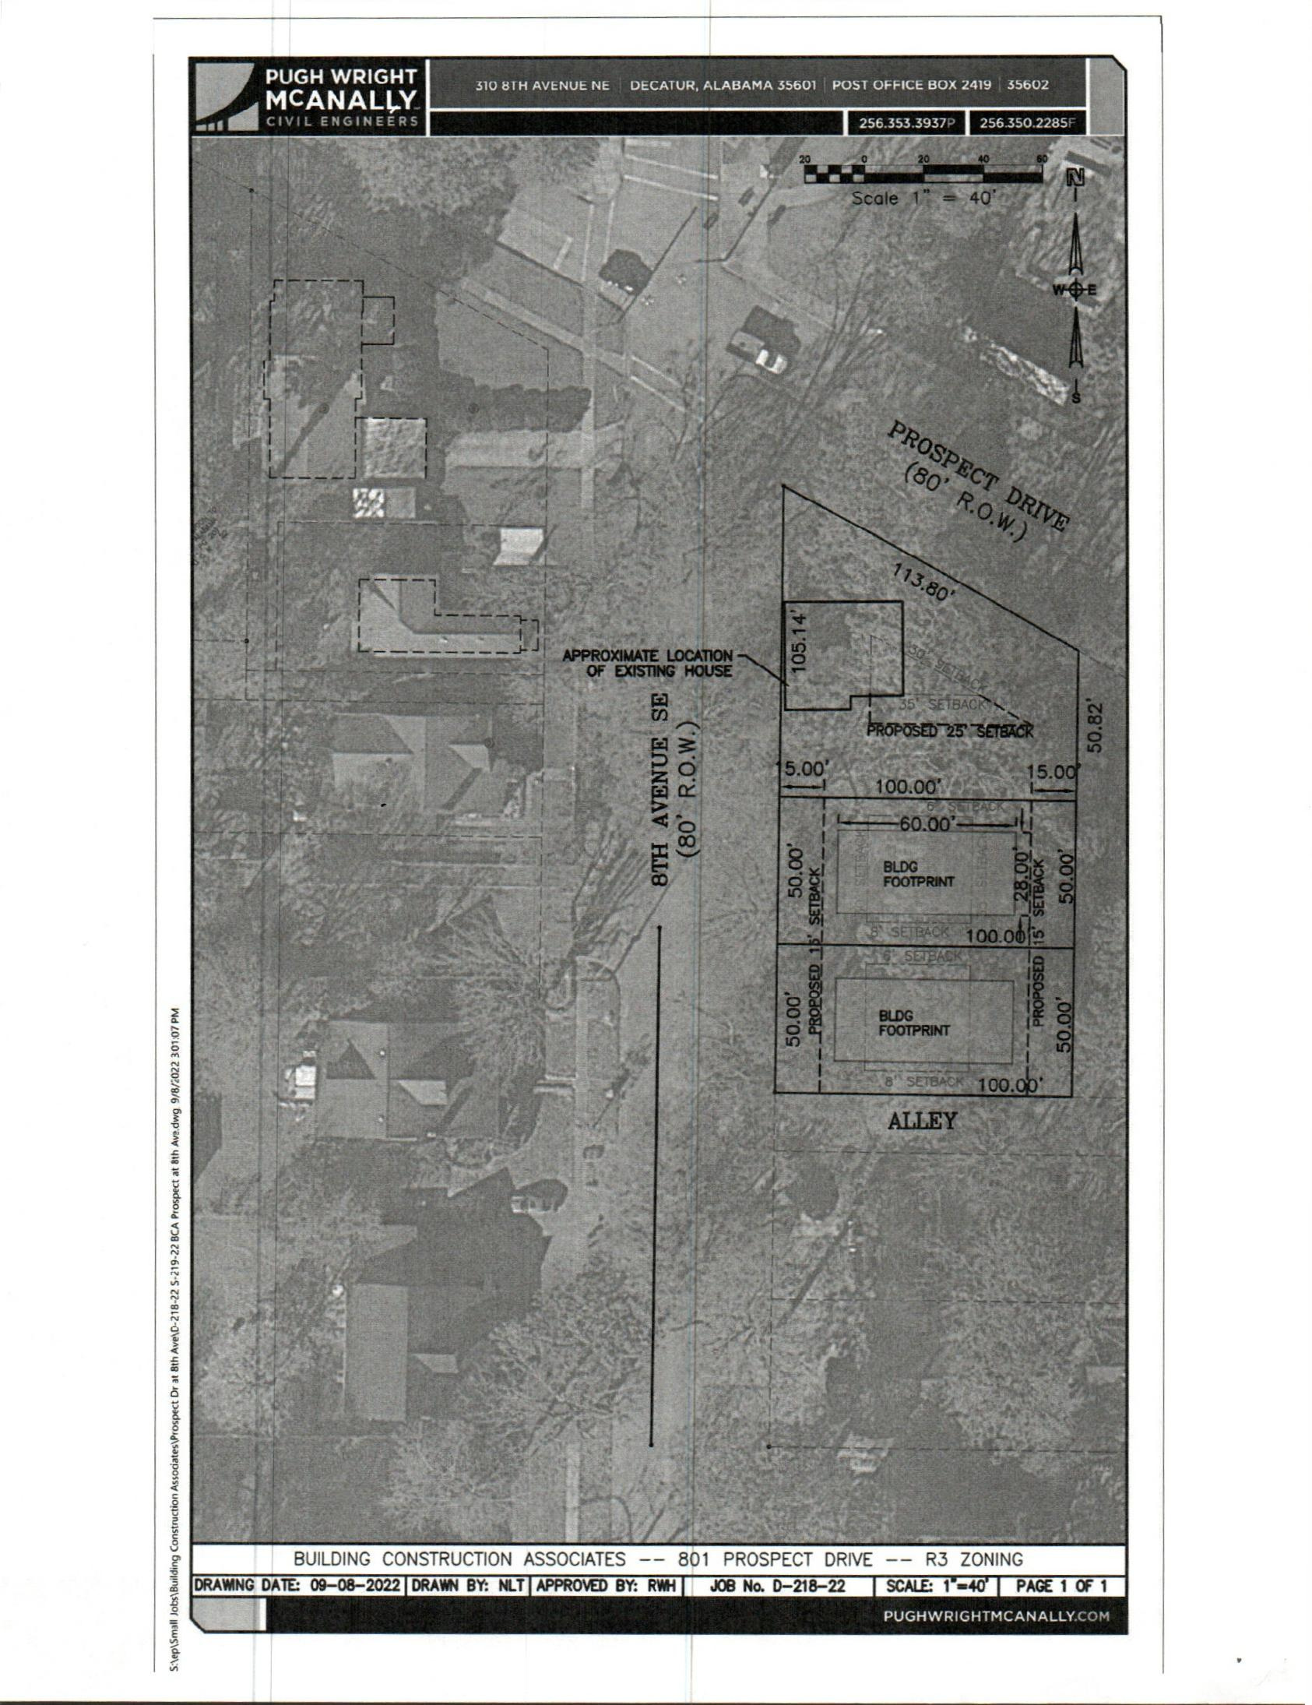

SURVEY
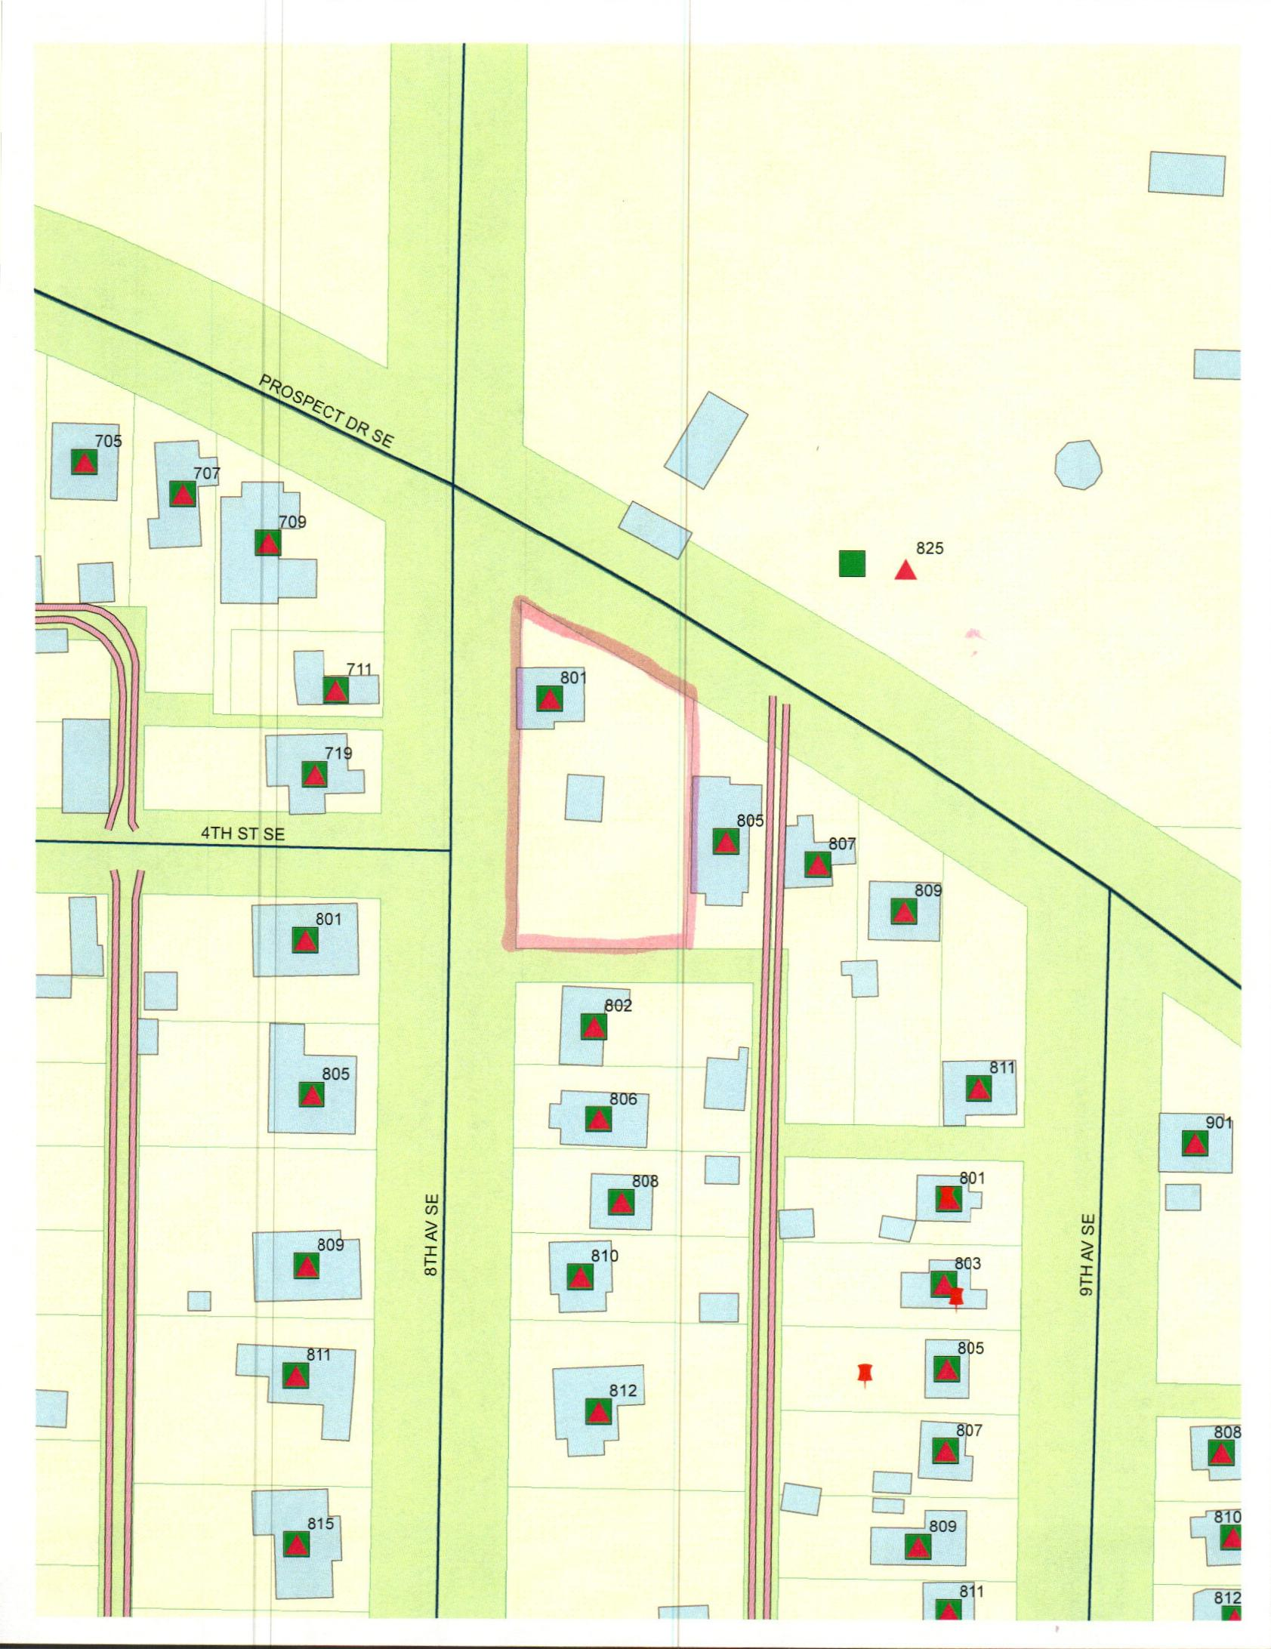

MAP

