FINAL PUBLIC NOTICE
The City of Decatur has applied for Federal Emergency Management Agency (FEMA) funding through the Alabama Emergency Management Agency (AEMA) as an Applicant.
Under the National Environmental Policy Act (NEPA), federal actions must be reviewed and evaluated for feasible alternatives and for social, economic, historic, environmental, legal, and safety considerations. Under Executive Order (EO) 11988 and EO 11990, FEMA is required to consider alternatives to and to provide a public notice of any proposed actions in or affecting floodplains or wetlands. EO 12898 also requires FEMA to provide the opportunity for public participation in the planning process and to consider potential impacts to minority and low-income populations. This notice may also fulfill requirements under Section 106 of the National Historic Preservation Act (NHPA).
Funding for the proposed project will be conditional upon compliance with all applicable federal, tribal, state, and local laws, regulations, floodplain standards, permit requirements and conditions.
Applicant: City of Decatur
Project Title: Point Mallard “non completed work”
Location of Proposed Work: Morgan County, City of Decatur, Alabama
Name of Structure: Point Mallard Aquatic Center – Floating dock
Address of Structure: 2901 Point Mallard Dr SE, Decatur, AL 35601

Facility | Address | Latitude | Longitude | Date of Construction
Point Mallard Aquatic Center | 2901 Point Mallard Dr SE, Decatur, AL 35601 | 34.57062 | 34.57062 | 1980

Special Flood Hazard Area Zone: The site is located in an AE Zone/Floodway. Confirmation of location in a Special Flood Hazard Area (SFHA) was determined by the Morgan County Flood Insurance Rate Map, Panel Number: 01103C0079F. The proposed work conforms to all applicable State of Alabama and local floodplain regulations. During the storm event, the Point Mallard Aquatic Center’s floating dock got damaged by floodwaters and high winds. There is a potential for the facility to be impacted by future flooding events due to its location within the AE Zone and Floodway. Portions of the proposed work will take place in wetlands per the United States Fish and Wildlife Service National Wetlands Inventory but will have little potential to impact or affect wetland values.
Proposed Work and Purpose:
The City of Decatur is requesting funds to remove and replace the Point Mallard Aquatic Center floating dock. The applicant plans on replacing wood decking, 70FT x 8 FT x 3 FT deep, 14 standard rubber boat bumpers, 12 standard boat cleats, 10 surface pier waterproof lights back to pre-disaster with in-kind materials. The applicant also plans on preventing repetitive damages by making repairs that will incorporate best updated construction practices (codes and standards) by replacing damaged pilings. Additionally, the new pilings would be constructed above the 500-year flood elevation levels to help prevent the dock from floating away. Repairing the floating dock will allow for a continuation of open space use for recreational activities.

Project Alternatives:

Alternative #1 (no action alternative): If no action is not taken to restore the damage to the floating dock, it will impact tourism for the City of Decatur.
Alternative #2: Relocation of Point Mallard Aquatic Centers floating dock is not practical nor cost-effective. The floating dock is functionally dependent and allows for recreational activities for the City of Decatur.

Comment Period: Comments are solicited from the public, local, state or federal agencies, and other interested parties in order to consider and evaluate the impacts of the proposed project. The comments should be made in writing and addressed to the City of Decatur. All comments are due within 15 days of this notice. The City of Decatur will forward comments to applicable regulatory agencies as needed.

Interested persons may submit comments, obtain more detailed information about the proposed action, or request a copy of the findings by contacting: U.S. Department of Homeland Security, Federal Emergency Management Agency – Region IV - EHP, 3003 Chamblee Tucker Rd – Office #255, Atlanta, GA 30341-4112 or by email at FEMA-R4EHP@fema.dhs.gov. Please include in the subject line of the email “DR-4426-AL EHAD.” Comments should be sent in writing at the above address within 15 days of the date of this notice.
POSTED ON: (Tuesday, November 3, 2020)
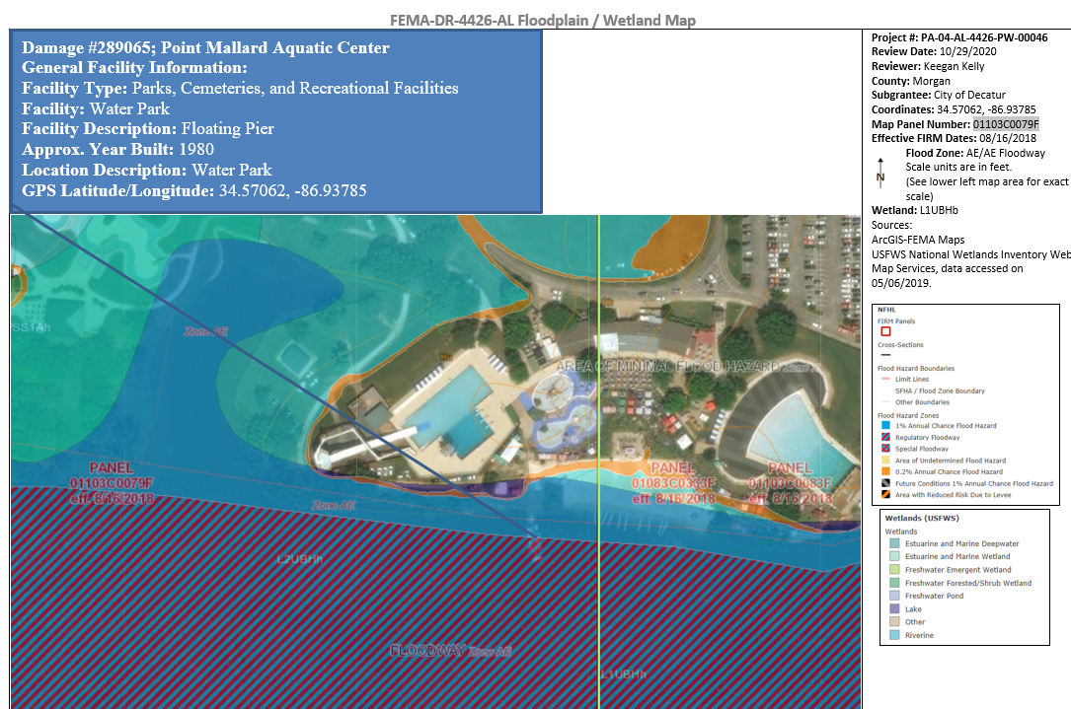
End of Notice

